**Installation of loft insulation**

**1 Introduction**

To maximise the energy and CO2 savings achieved with each installation, this document sets out the requirements that should apply to any professional installation of cold roof loft insulation (in addition to any contract and scheme rules that may apply). This document has been developed by industry, with DECC and Ofgem, in a process facilitated by the Energy Efficiency Partnership for Homes.

* 1. **Definitions**

A loft for the purposes of this specification is the attic space directly below the roof of a domestic dwelling, not used for accommodation but often for storage.

A cold roof is a situation created by insulation of a loft at joist level (whereas a warm roof is created by insulation at rafter level).

**2 General requirements**

All installers contracted to perform loft insulation works shall:

(a) Undertake the measures without detrimental effect on the dwelling;

(b) Explain all measures to be undertaken, including ancillary works such as removal of boards; obtain the client’s approval prior to works commencing; and ensure that the client is satisfied with the work;

(c) Ensure that the measures do not compromise the safety of the household or the contents and structure of the dwelling;

(d) Work in a manner ensuring their own safety and that of the householder and any other parties.

(e) Ensure that all legal and statutory obligations in relation to the work are met.

**2.1 Cleanliness and tidiness**

The contractor carrying out the installation works shall leave the fitted materials, the areas being worked on and surrounding areas clean and undamaged.

All debris directly resulting from the insulation of the loft space is to be removed by the installer, immediately following completion of the work.

**2.2 Manufacturers’ instructions**

All approved materials shall be installed in accordance with the respective manufacturers’ instructions. If a manufacturer’s instructions contravene or render not applicable any clause in this specification, then the specification shall have priority over the manufacturer’s instructions.

For sprayed PUR foam insulation, all material should be installed in accordance with the relevant certificate from a UKAS-accredited third party certification body, by an installer approved by the Certificate holder.

**3 Materials**

**3.1 Minimum insulating performance**

3.1.1 If applicable, the local building regulations requirements should be met.

3.1.2 If building regulations do not apply, the client or programme requirements should be met.

3.1.3 In no circumstances should the final U-Value exceed 0.16 W/m2K. U-value calculations shall be in accordance with BR443 and use λ90:90 data [1].

**3.2 Approval**

All materials used shall be approved by the relevant authority and covered by the relevant industry standards (BS or EN, where available) or UKAS-accredited third party certification.

**3.3 Suitable materials for loft insulation (informative)**

The following list is non-exclusive, other materials and systems may be used if they comply with clauses 3.1 and 3.2. The industry standards governing these materials are listed in Appendix 2: Index of Industry Standards.

• Mineral wool rolls and slabs

• Blown mineral fibre granules or pellets

• Blown cellulose fibre

• Wool-based batts

• Spray applied rigid closed-cell polyurethane (PUR) insulation

• Rigid foam board

• Pipe and tank insulation

**4 Scope and extent**

**4.1 Coverage**

The insulation works shall cover the entire loft space, including all tanks and pipes, unless there is a compelling reason, which must be documented (see clause 5.7.6).

**4.2 State of repair**

An initial survey of the loft space is to be carried out prior to commencement of any works. This shall be documented, retained by the contractor and a copy attached to the certificate (see section 5.7.1). No works shall be carried out unless the state of repair of the roof space meets the requirements below:

**4.2.1 Ventilation**

Ventilation is a necessary requirement of loft spaces to prevent the risk of harmful condensation forming. This is particularly the case when additional insulation is fitted, as the loft space will be colder in winter than previously. If there are distinct signs of inadequate ventilation pre-installation, such as mustiness, wet or dry rot or mould growth, the works shall not progress until the ventilation issue is addressed. Recommended remedial action should be recorded in the survey.

The ventilation requirements are detailed in clause 5.1.2.

**4.2.2 Rainwater penetration**

There shall be no visible rainwater penetration or evidence of such penetration.

**4.2.3 Ceiling condition**

The ceiling shall be in a good visible state of repair.

**4.2.4 Electrical connections**

There shall be no visible defects in the electrical wiring of the roof space, e.g. trailing cables or exposed wires.

**4.2.5 Roof members**

There shall be no visible corrosion of the structural metal connections in the roof members.

**4.2.6 Leakage**

There shall be no evidence of leakage from existing water supply pipeworks or tanks.

**4.2.7 Ventilation impediment**

Where existing insulation has been pushed into the eaves and is impeding the necessary ventilation, this should be moved prior to the top-up being carried out. If necessary, insulation interrupters/rafter trays should be fitted to ensure the air path remains open. Refurbishment products are available for this purpose.

**4.2.8 Irreparable ceiling holes**

There shall be no penetrations through the ceiling that cannot be sealed (see section 5.1.1)

**4.3 Other variations**

**4.3.1 Pre-existing insulation**

(a) Existing loft insulation which is still fit for purpose shall be left in situ and topped up to achieve at least the U-Value specified in section 3.1. Examples of insulation being unfit for purpose include health and safety concerns (e.g. due to vermin infestation or bird litter).

(b) Existing water tank insulation shall not be modified if compliant with clause 5.2; existing pipe insulation shall not be modified if compliant with section 5.3 of this specification.

(c) Sections of un-insulated pipework included in the roof space insulation works, which lie wholly below the upper level of the new material and are completely covered by it, do not require insulating.

(d) Additional roof space is considered separately for the purposes of qualification for loft insulation work. Where a roof space exists over a building extension which has had insulation fitted (usually under the relevant Building Regulations), this area may be ignored when calculating the thickness of existing insulation in the original loft spaces.

(e) Where insulation is present around pipework and this does not meet the standards laid out in this document, then this should be removed and the correct size of pre-formed material applied. If removal of the old material is likely to cause damage to pipes resulting in leaks, etc., then pre-formed material with a larger than normal bore may be fitted over the existing material.

**NOTES:** 1 Where pre-formed insulation cannot be used refer to 5.3.3.

2 The total insulation value must be at least as high as specified in clause 5.3.2

**4.3.2 Asbestos**

Important: Asbestos and asbestos-containing Materials (ACMs) are sometimes found in the loft spaces where it is used to insulate water tanks and pipes etc., and in heating systems for flues etc.

All ACMs can be highly dangerous if disturbed. When encountering ACMs in a loft space, installers should follow their own procedures. Refer to www.hse.gov.uk/asbestos for further guidance and legal requirements associated with asbestos.

If an installer identifies a water tank or pipes made out of Asbestos or ACMs and decides that installing a tank jacket may release asbestos containing particles, the loft insulation work must not proceed. The customer should be advised to have the tank replaced under controlled conditions and then re-apply for the loft to be insulated. The customer should also be advised that completing the loft insulation without insulating the cold water tank would significantly increase the risk of the tank freezing in cold weather.

**5 Insulation works**

**5.1 Roof spaces**

**5.1.1 Ceiling holes and gaps**

All holes at ceiling drops for pipes and other services shall be sealed where practically possible using silicone sealant, foam, tape, or a combination of these. Holes or gaps in the ceiling too large to fill require building work which would need to take place before any loft insulation works.

**5.1.2 Ventilation**

All ventilation inlets in the roof space inadvertently sealed during the installation or blocked with the original insulation material shall be cleared. If necessary, insulation interrupters/rafter trays should be fitted to ensure the air path remains open. Refurbishment products are available for this purpose.

If no designed ventilation exists in the roof space, refer to BS 5250 [2]. In addition, the following recommendations may be used including when using blown or spayed insulation materials:

Ventilation in the roof space shall be the equivalent of a continuous 10mm gap at low level with an insulation interrupter/rafter tray over the top of the insulation to provide at least a 25mm gap (to account for underlay drape and rafter centres) if soffit or fascia ventilation already exists. Additional ventilation in the soffit or on the fascia may need to be added. If this is not possible then tile or slate ventilators should be used to provide the guaranteed air path from loft space to outside atmosphere on either side of the roof at low level. Ensure that any penetrations through the underlay are properly detailed and protected. High level ventilation: the equivalent of a continuous 5mm gap should also be considered if the roof pitch is in excess of 35 degrees or the span in excess of 10m. In all cases, ventilation of the loft space should not be made worse by the loft insulation installed and be sufficient to prevent the harmful effects of condensation. Effective sealing of gaps in the ceiling will also limit the risk of condensation forming within the loft space.

**5.1.3 Vertical walls**

The thickness of insulation fitted to vertical loft walls e.g. dormer walls, shall be sized to suit the wall (timber frame) thickness. Any insulation installed under this provision, must satisfy the roof space ventilation requirement detailed in section 5.1.2Ventilation.

**5.1.4 Cavity Walls**

The insulation material shall not enter the cavity of any cavity wall. To minimise cold bridging, where possible, the loft insulation should link to the cavity wall insulation (if present).

**5.1.5 Clearance from flues or chimneys**

The insulation material shall be retained a minimum of 75mm, maximum 150mm from flues or metal chimneys, unless the insulating product is non-combustible or of limited combustibility as defined by Building Regulations approved documents, such as a reaction to fire classification of A1 or A2 in accordance with BS EN 13501-1 [3]. Where the product meets these criteria the insulation shall be installed up to the outer casing of the flue or chimney.

**5.1.6 Clearance from electrical apparatus**

The insulation material shall be retained at a minimum of 75mm (maximum 150mm) from all electrical apparatus penetrating the ceiling.

In the case of loose insulation material a permanent physical restraint shall be used, (e.g. boarding or expanded metal rings). Any cable passing over such a restraint shall be protected against damage by the restraint.

Where the electrical apparatus is a recessed light fitting that is not type “F-capped”, the fitting shall either be replaced with a fitting that is certified “F-capped” or have covers placed over them which are certified “F-capped” in accordance with relevant industry standards. [4] Once all downlighters are fitted with “F-capped” certified equipment, they shall be covered by insulation material without leaving a gap.

The “F-capped” symbol Any transformers or ballast units (e.g. for halogen or LED lighting) shall be placed on a suitably sized plate (typically 150x150mm) made from non-combustible material, which sits on top of the insulation. Transformers or ballast units must not be buried under insulation material unless they are specifically approved for this purpose.

**5.1.7 High-ampere electric cables**

Electric cables supplying immersion heaters, electric showers, electric cookers, socket outlets or any other apparatus over 6 amp rating shall not be covered by thermal insulation. Cables to these appliances shall be lifted above the insulation. If this is not possible, the insulation must be retained at a minimum distance of 75mm from these cables along their entire length in the loft area to provide adequate ventilation for these cables to prevent them from overheating.

**5.1.8 Existing boards**

Where the loft of a dwelling has boards covering all or part of the loft floor, these should be removed prior to the insulation being applied. The removal may be carried out by the installer, the client or a third party.

Where boards are to be retained for storage, access or other purposes, the steps detailed on the following page 7 are to be followed.

Depending on the roof pitch, a distance of 1500mm or more will be required between the eaves area and the outer edge of any existing board, for the installer to be able to block joist tunnels tightly. Any boards too close to the eaves to be blocked tightly will have to be removed.

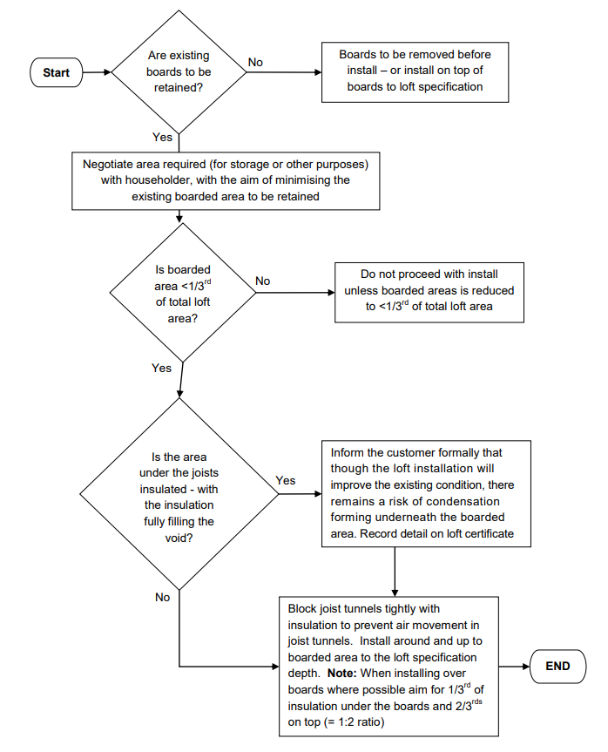

**5.1.9 Additional requirement for spray applied rigid closed cell polyurethane (PUR) foam**

Sprayed PUR foam insulation should only be applied by an installer approved by a manufacturer holding the relevant certificate from a UKAS-accredited third party certification body.

**5.2 Cold Water Tanks**

**5.2.1 Tank jacket**

The cold water supply tank must have a new or existing insulation jacket fitted which complies with relevant industry standards [5]. Where a standard jacket cannot be fitted, one must be constructed which shall:

(a) be tightly fitting but not airtight;

(b) be opaque;

(c) be of material not likely to fragment nor contaminate any condensate which may form on its underside;

(d) exclude insects;

(e) be securely fixed in position;

(f) not impart taste, colour, odour or toxicity to the water;

(g) not promote or foster microbial growth under the conditions where the tank is installed;

(h) be of material which is corrosion resisting or will be coated internally with corrosion resisting material;

(i) be arranged to accommodate any vent or expansion pipes in closely-fitting, purpose-made holes or sleeves;

(j) be made of materials compatible with those of the tank.

(k) be of solid construction and able to support in excess of its own weight.

**5.2.2 Surrounding insulation**

A cold-water tank located 300mm or more above the ceiling joists shall be completely enclosed and insulated, i.e. the insulation shall be applied to the underside of the tank.

If the tank is located less than 300mm above the joists, the insulation shall form a continuous layer with the tank insulation, as illustrated below:

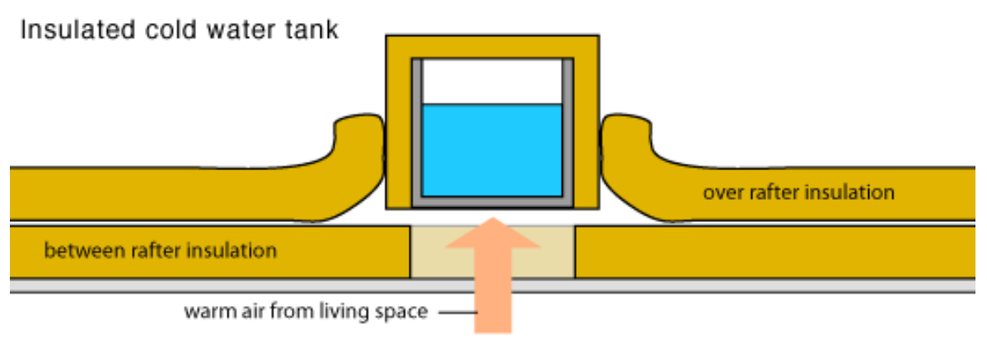

[source: <http://www.greenspec.co.uk/loft-insulation.php>]

**5.2.3 Tank accessibility**

The insulation when applied to the tank shall take into account any domestic hot water expansion pipe outlets and the insulation shall be easily removable for access to the inside of the tank.

Neither the insulation nor the fastenings shall interfere with the correct operation of the water control valve and mechanism.

**5.2.4 Tank insulation thickness**

The minimum insulation thickness of the tank insulation shall be as specified in the relevant industry standard(s). [6]

**5.2.5 Insulating jacket**

A correctly sized insulating jacket, tested and approved to the relevant industry standard [7], will be fitted to the cold water storage tank.

**5.3 Pipe insulation**

**5.3.1 Domestic Hot Water Pipes and Central Heating Pipes**

For the prevention of heat loss all domestic hot water pipes and central heating pipes in the loft shall be insulated over their entire length. Insulation at control and isolating valves shall be arranged to allow ready access to the operating facilities of such.

The minimum thickness of the insulating material shall be as required in the Domestic Building Services Compliance Guide: 20101¹.

**NOTE:** Any hot water pipes in the loft should have been insulated during installation of the heating appliance. Heat-resistant pipe insulation needs to be used to insulate these pipes. It is not the responsibility of the loft insulation installer to supply this. Any lack of hot water pipe insulation should be reported to the householder.

**5.3.2 Water Supply and Expansion Pipes**

All pipes containing water or which shall contain water at infrequent intervals (excluding overflow pipes) shall be insulated over their entire length. Insulation at control and isolating valves shall be arranged to allow ready access to the operating facilities of such.

The minimum thickness of the insulating material shall be as specified in relevant industry standards [6] and applicable water bylaws 2, 3.

**5.3.3 Pipe insulation materials**

Pre-formed thermal insulating materials must be used and be applied to pipework in accordance with the manufacturer’s recommendations. Where pre-formed insulation

Details on actual thicknesses of insulation to meet these requirements can be found in the TIMSA Domestic and Non Domestic Heating, Cooling and Ventilation Guide, Section 6: <http://timsa.associationhouse.org.uk/default.php?cmd=210&doc_category=98>

For an example, see <http://www.ukcopperboard.co.uk/literature/pdfs/Installation-Tips/Insulation-and-Bylaw-requirements.pdf>

Further details on thicknesses of insulation to meet these requirements can be found TIMSA Domestic and Non-Domestic Heating, Cooling and Ventilation Guide Section 7.1 (<http://timsa.associationhouse.org.uk/default.php?cmd=210&doc_category=98>).

cannot be used, (e.g. two pipes clipped together or single pipe clipped to woodwork or wall), then a proprietary type of strip insulation (e.g. fibre glass strip with plastic backing) may be used. The thermal resistance of this type of installation must be the same as the equivalent pre-formed material

**NOTE:** Care must be taken when using an alternative insulation material, in these situations, not to over-tighten the fixings.

**5.3.4 Gaps at insulation material joints**

No gaps shall be visible where the insulating material is joined. Joints must be covered with appropriate insulation tape and the length of the pipe insulation at a minimum of 500mm centres, tape should be applied in such a manner to cover the circumference of that pipe insulation at least 3 times.

**5.3.5 Foreseeable mechanical strain**

Additional protection shall be applied to the insulation via a suitable covering where foreseeable mechanical damage can be inflicted upon the insulating material.

**5.3.6 Durability of pipe insulation**

All insulation shall be properly secured. Where tape is used to secure the insulation, a good quality material should be chosen that will remain in place for several years without loosening or becoming ineffective.

**5.3.7 Stop cocks and other protruding features**

Stop cocks, pipework with oversized joints (e.g. “speed-fit” pipework) or other protruding features shall be insulated using either oversized pipe insulation or where this is not possible, other means providing at least the same level of insulation shall be used, e.g. spiral pipe wrap.

**5.4 Insulation and draught-proofing of loft hatches**

**5.4.1 Required level of insulation**

The loft hatch cover shall be completely insulated as far as practical to at least the same U-Value degree as the rest of the roof space. As a minimum, the requirements of the current Building Regulations (Part L) shall apply.

**5.4.2 Loft hatch insulation cover**

A proprietary product specifically designed for both insulating and draught proofing a loft hatch shall be installed. The installation shall comply with the manufacturer's fitting instructions. Products used shall be CE marked or carry an EU declaration of conformity.

**5.4.3 Special requirement for blown fibrous materials**

In the case of blown fibrous materials, a suitable barrier shall be provided around the loft hatch to ensure that the insulating material does not fall into the dwelling when the loft hatch cover is opened (in line with applicable industry standards).

**5.4.4 Loft ladders**

A proprietary product specifically designed for insulating and draught proofing a loft hatch that incorporates a ladder or stairwell shall be installed. The installation shall comply with the manufacturer's fitting instructions. Products used shall be CE marked or carry an EU declaration of conformity.

Proprietary products are available. If insulating a loft hatch with a mounted ladder is not practically possible, it should be draught proofed in accordance with relevant industry standards [8], and the reason why insulation is impossible clearly stated on the certificate. Failure to source a suitable, available proprietary product is not an adequate reason for not insulating the loft hatch.

**5.5 Access Walkways**

Where an access walkway is required for access to the water tank(s)4 or other appliances in the loft, or the client commissioned the installation of a walkway and/or storage platform, the following installation requirements apply:

**5.5.1 Structural integrity of joists**

Prior to fitting the new walkway, the state of repair of the existing ceiling and support joists will be determined. The ceiling structure shall be capable of supporting the weight of the new walkway, the existing and new insulation material and the loads imposed during the installation of these measures. Otherwise a walkway shall not be installed.

**5.5.2 Clearance and insulation under the walkway**

The walkway area is to be cleared of all items and material except any existing insulation material laid between the joists. This should be repositioned as necessary to provide the maximum insulation under the walkway. Check that there are no junction boxes, cables or pipes that project above the level of the ceiling joists. If possible re-route these away from the path of the new walkway.

**5.5.3 Materials and minimum dimensions**

Timber or flooring grade chipboard, having a minimum thickness of 18mm will be used to form the walkway. It will have a minimum width of 300mm to allow entry of the panels or boards through a normal loft hatch.

**5.5.4 Path and construction**

The panels will be laid from as near the loft hatch opening as possible to adjacent to the water tank or other appliance.

Where the walkway is laid across joists (i.e. the walkway runs perpendicular to the joists), all panel to panel joints shall be either on the joist line, or additional noggins shall be used.

The panels shall not extend over the bearers by more than 50mm in any direction.

**5.5.5 Panels attachment**

All panels will be secured to the joists, using zinc plated, countersunk screws. These must be screwed flush with the top surface of the panel, or slightly recessed.

A walkway is required to the water tank if the tank is over 1,000mm apart from the nearest edge of the loft hatch.

There will be a minimum of four screws per panel. Nails must not be used as panel/board fixing.

**5.5.6 Insulation around the walkway**

Insulation material is to be installed underneath walkways, but never on top. Quilt material is to be laid up to the edge of the panels. Where blown material is used, arrangements must be made to retain the material off the top surface of the walkway.

**5.6 Warning Labels**

Two labels shall be fixed on two adjacent sides of the loft access to warn the householder of the dangers when entering a loft space. Particular reference is to be made to the insulation material covering the ceiling joists[, if applicable].

**NOTE:** These labels must be fitted, even where a new access walkway has been installed.

DANGER CEILING JOISTS ARE COVERED BY INSULATION MATERIAL. THE FLOOR BETWEEN THE JOISTS IS FRAGILE. IT WILL NOT CARRY YOUR WEIGHT. YOU SHOULD NOT ENTER UNLESS A CRAWL BOARD IS PLACED ACROSS THE JOISTS.

**5.7 Self-certification of “Roof Space Insulating Works”**

After completion of the work, the installer shall provide a signed and stamped certificate which shall be pinned up in the roof space adjacent to the point of access.

The certificate shall contain the following information:

5.7.1 A copy of the pre-installation survey

5.7.2 The installer company’s name and registered address, as well as the name or employee number of the individual who undertook or oversaw the installation.

5.7.3 Address at which the insulation was installed.

5.7.4 The date on which the work was carried out.

5.7.5 The area of the roof space insulated in m².

5.7.6 The approximate proportion of the area left uninsulated, if applicable, together with a justification.

5.7.7 The material including the name of the manufacturer, its thermal conductivity (λ90:90) and the relevant British Standard or certificate from a UKAS accredited third party certification body used for insulating:

(a) the roof space;

(b) the cold water tank;

(c) the pipe work;

(d) the loft hatch.

5.7.8 The installed [average] thickness in mm of all the materials for:

(a) the roof space (settled thickness for blown materials);

(b) the cold water tank;

(c) the pipe work;

(d) the loft hatch.

5.7.9 The materials used for the lid of the cold water tank, the name of the manufacturer and the relevant British Standard or certificate from a UKASaccredited third party certification body.

5.7.10 Advice on the action to be taken if the insulation material becomes damaged or wet.

5.7.11 The certificate shall also contain the following comment: The insulation fitted in the loft is an integral part of the building energy efficiency provision and should not be removed or disturbed unless for essential work. If such work is undertaken and the insulation has to be moved it should be carefully replaced in its original position, particular care should be made to maintain any ventilation paths especially at the eaves.

**Appendix 1: required thicknesses for achieving target U-Values**:

The following table specifies the required thickness of the various materials to achieve target U-Values of 0.16W/(m²K) as required by the 2010 building regulations.

**Note:** U-values shall be calculated using the conventions and methods set out in BR443 [9]. Indicative thicknesses required for specific insulation materials can be seen in the table below. Any required thickness T (in millimetres) can be estimated from the target U-Value U (in W/(m²K)) and the respective material's thermal conductivity k (in W/mK) by using the following formula:

T [mm] = 1/U * k * 1000

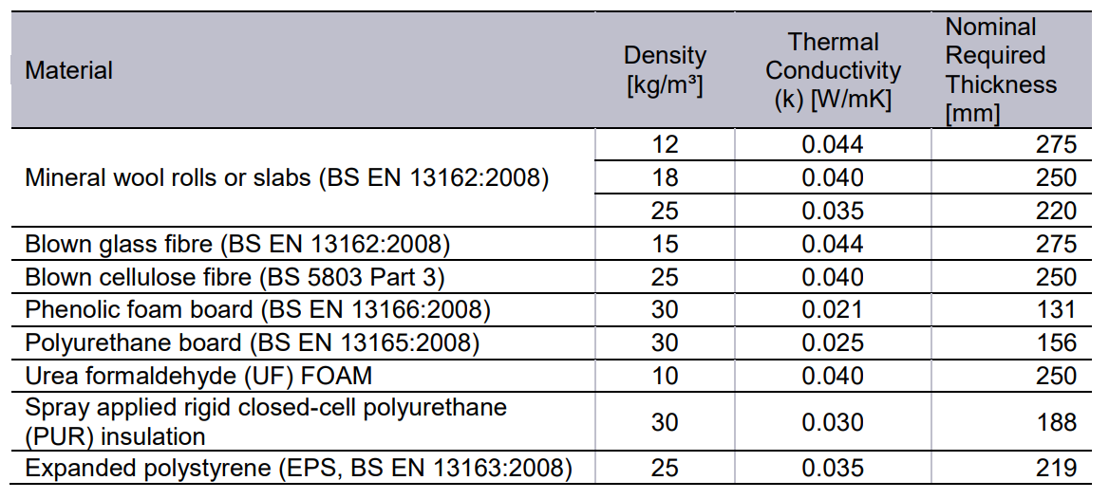

For all materials: Where a certification document (e.g. BBA approval or other certificate from a UKAS accredited third party certification body) gives a different k value than the table above, the certificate should have priority.

For materials not listed in the table (e.g. sheep's wool or polyester), please refer to the relevant certification documents (e.g. BBA approval or other certificate from a UKAS-accredited third party certification body) for thermal conductivity. Indicative required thicknesses can be calculated using the formula above, but this cannot replace λ90:90 calculations in accordance with BR443.

**Appendix 2: Index of Industry Standards**

**Reference: Section 3.3 Suitable materials for loft insulation**

The following list is informative only, and not binding or comprehensive. New standards may have been published, and/or standards may have been superseded or updated since the release of this specification.

**Mineral wool rolls and slabs**

- BS EN 13162:2008: Thermal insulation products for buildings. Factory made mineral wool (MW) products. Specification

(confirmed current on 2011-01-05)

**Blown mineral wool granules or pellets**

- BS EN 14064-1:2010: Thermal insulation products for buildings. In-situ formed loosefill mineral wool (MW) products. Specification for the loose-fill products before installation

- BS EN 14064-2:2010: Thermal insulation products for buildings. In-situ formed loosefill mineral wool (MW) products. Specification for the installed products

(both confirmed current on 2011-03-04)

**Blown cellulose fibre**

- BS 5803-3:1985: Thermal insulation for use in pitched roof spaces in dwellings. Specification for cellulose fibre thermal insulation for application by blowing

- BS 5803-4:1985: Thermal insulation for use in pitched roof spaces in dwellings. Methods for determining flammability and resistance to smouldering

- BS 5803-5:1985: Thermal insulation for use in pitched roof spaces in dwellings. Specification for installation of man-made mineral fibre and cellulose fibre insulation (all confirmed current on 2011-06-14) –

ENs under development

**Phenolic foam board**

- BS EN 13166:2008: Thermal insulation products for buildings. Factory made products of phenolic foam (PF). Specification.

(confirmed current 2011-11-18)

**Wool-based batts**

- No agreed industry standards available.

- BBA approval available.

- European Technical Approvals (ETAs) available via the Common Understanding of Assessment Procedure (CUAP).

**Spray applied rigid closed-cell polyurethane (PUR) insulation**

- No agreed industry standards currently available, but Euro Norm (EN) under development.

- BBA approval available.

**Polyester fibre mats (delivered in rolls)**

- No agreed industry standards available

- BBA approval available

- European Technical Approvals (ETAs) available via CUAP.

**Rigid foam board**

**• Polyurethane boards:**

- BS EN 13165:2008: Thermal insulation products for buildings. Factory made rigid polyurethane foam (PUR) products. Specification (confirmed current on 2011-03-14)

- BS 4841, 2006, parts 1 to 6

(confirmed current on 2011-03-14)

**• Expanded polystyrene (EPS) boards**

- BS EN 13163:2008: Thermal insulation products for buildings. Factory made products of expanded polystyrene (EPS). Specification

(confirmed current on 2011-03-14)

**• Extruded polystyrene (XPS) boards**

- BS EN 13164:2008: Thermal insulation products for buildings. Factory made products of extruded polystyrene foam (XPS). Specification

(confirmed current on 2011-03-14)

**Appendix 3: Other referenced Industry Standards (informative)**

As with Appendix 2, the following list does not claim to be binding or comprehensive. Particularly, standards may have been updated or superseded.

[1] The method for calculating lambda 90:90 (to include the impact of moisture absorption under humidity) is governed by: BS EN ISO 10456:2007: Building materials and products. Hygrothermal properties. Tabulated design values and procedures for determining declared and design thermal values. (confirmed current on 2011-06-15)

[2] BS 5250:2002: Code of practice for control of condensation in buildings. (confirmed current on 2011-11-30)

[3] BS EN 13501-1:2007+A1:2009: Fire classification of construction products and building elements. Classification using test data from reaction to fire tests (confirmed current on 2011-02-09)

[4] BS EN 60598-1:2008: Luminaires. General requirements and tests BS EN 60598-2-2: 1998: Luminaires. Particular requirements. Recessed luminaires (confirmed current 2011-06-15)

[5] BS 5422:2009: Method for specifying thermal insulating materials for pipes, tanks, vessels, ductwork and equipment operating within the temperature range -40°C to +700°C (confirmed current on 2011-01-05)

[6] BS 6700:2006+Amendment 1:2009: Design, installation, testing and maintenance of services supplying water for domestic use within buildings and their cartilages. Specification (confirmed current on 2011-01-05)

[7] BS 7181:1989: Specification for storage cisterns up to 500 L actual capacity for water supply for domestic purposes (confirmed current on 2011-01-05)

[8] BS 7386:1997: Specification for draughtstrips for the draught control of existing doors and windows in housing (including test methods) (confirmed current 2011-03-30)

[9] BRE 2006: Conventions for U-value calculations, 2006 edition. Author: Brian Anderson, BRE Scotland http://www.bre.co.uk/filelibrary/pdf/rpts/BR_443_%282006_Edition%29.pdf (accessed 2011-06-21