HORLEY TOWN COUNCIL | 

Invitation to Tender (ITT)

Michael Crescent Centenary Park Playground
Horley
RH6 7LG

Closing Date: 15 December 2023

Horley Town Council
Council Offices
92 Albert Road
Horley RH6 7HZ

Tel: 01293 784765

Contact Leisure & Facilities Officer: Helen Maan
Email: helen.maan@horleysurrey-tc.gov.uk
Web: www.horleysurrey-tc.gov.uk
- GENERAL REQUIREMENTS
Horley Town Council is proposing to replace the majority of its playground equipment at the above site with new equipment to be used by children with ages ranging from 2 to 12 years.

Experienced play area installers are invited to tender for the contract.
It is anticipated that construction work will be carried out in Spring 2024 with the playground ready for use from July 2024. Please refer to the ‘site information’ section of this tender for the background information to the site. All prices are to be net, excluding VAT.

Companies must be registered with the API (Association of Play Industries) to tender for this contract. Please supply copies of current certificate for accreditations for the above membership plus details of any other relevant accreditations.
- PROJECT INFORMATION
Name of project: Michael Crescent Centenary Park Playground Upgrade
Project budget: Up to £70,000
Location: Michael Crescent Centenary Park, Horley RH6 7LH
Responsible Officer: Helen Maan
email: helen.maan@horleysurrey-tc.gov.uk

IMPORTANT: A site visit is essential to assess access, gain detailed measurements, location of nearby properties and access points to and around the site. The play area is an open site and suppliers are welcome to visit the site at their own convenience without penalty.

3. TENDER PROCESS
3.1 Horley Town Council wishes to employ a Principal Contractor to carry out the supply and installation of new play equipment and safety surfacing for an age range of 2 to 12 years.

3.2 Tenderers are required to submit a fixed price lump sum tender on the Form of Tender provided with this document.

3.3 Tenders should be returned in a sealed envelope marked private and confidential bearing no company identification and marked TENDER - MICHAEL CRESCENT PLAY AREA to:

Town Clerk,
Horley Town Council,
Council Offices
92 Albert Road
Horley RH6 7HZ

by 13:00 hours on 15 December 2023

The following should be submitted:

● Quotation Breakdown form
● A copy of your certificate of public liability insurance
● A copy of your company’s Health and Safety Policy
● A copy of your company’s API (Association of Play Industries) certification

3.4 Designs should be presented on A4 and A2 as well as a digital image in a standard format (JPG, PNG, etc).

3.5 Horley Town Council does not bind itself to accept any tender. The Council reserves the right to delete any items from the tender should the tender exceed the budget. No payment will be made in respect of any expenses incurred by the tenderers in submitting a tender.

3.6 Please refer any questions by email to helen.maan@horleysurrey-tc.gov.uk or by telephone 01293 784765.

3.7 Sustainability
Priority will be given to Contractors who share the Town Council’s environmental policies including:
  - Packaging
  - Transport
  - easy/affordable equipment to maintain.

4. PROJECT AIMS
4.1 To provide an innovative, inclusive modern play area to suit children with ages ranging from 2 years to 12 years

4.2 To supply and install new play equipment, safety surfacing and perimeter fencing

4.3 The play area must suit toddlers and children of all abilities.

5. SITE INFORMATION
5.1 The Contractor should visit the site at Michael Crescent, Horley RH6 7LH at their own expense to satisfy themselves as to the conditions on site that may affect in any manner whatsoever the execution of the works detailed hereafter.

5.2 Compound - A designated compound will be agreed prior to works commencing. The area must be secure and safe and must not impact on facilities.

6. DESIGN BRIEF
  - Play equipment and surfacing must comply with BSEN 1176 and 1177 as well as other relevant industry standards and best practice guidelines.
  - An overall theme to the equipment is desirable but not compulsory
6.3 The Sutcliffe equipment is to be retained in its current location and this section of the play area should not be included in the new works.
  - Design the play area to minimise the maintenance required.
  - The redesigned play area should have some elements which allow inclusive play.
  - The play equipment shall be laid out to allow adult supervision of younger children
6.7 The play area shall provide a well-rounded play solution for children up to 12 years of age so that it's both visually exciting and physically challenging for children.
  - New areas of safety surface will need to be created, and existing surfacing will need to be removed and replaced as necessary.
  - No wooden equipment should be included in the design.
  - The equipment provided must deliver the following play elements:

- Climbing
- Interactive play
- Rocking
- Rotating
- Sliding
- Swinging

6.11 Demolitions
All unwanted play equipment, seats and bins, shall be removed from the site and taken to an appropriate disposal site.
  - Benches and Bins.
The design must include the provision of adequate seats and bins.
  - Fencing
The existing wooden fencing is to be replaced with 1.0m high Standard Bow Top Railings

  - Gates
The existing gate is to be replaced by a new gate which must comply with playground safety regulations.
  - Equipment Guidelines
The proposed equipment must assist the Council in discharging its responsibilities under the Disability Discrimination Act i.e. all-inclusive play and accessibility and must conform to the current standards, BSEN 1176, and be independently certified as compliant with this standard.

6.16 Safety Surfacing
This must meet the requirements of BSEN 1177 and be certified to BSEN 1177 and BS 7188. The surface should be either:
- Resin bonded shredded rubber mulch.
or
- Wet Pour Rubber
The aim is to achieve a natural effect and the surface shall reflect this.

- CONTRACTOR’S LIABILITIES
Ownership, liability and responsibility for insurance of the play area and installation works will remain with the Contractor until a satisfactory RoSPA post-Installation Report has been accepted by Horley Town Council
Storage of new play equipment, machinery and equipment, etc during the construction period will be the responsibility of the Contractor.

- REINSTATEMENT

The installation works shall provide a finished site, suitable for use on completion. The site shall be left clean and tidy at the end of the contract and must be handed over in pristine condition.
Damage to surrounding areas shall be minimized and any damage within or outside the completed site shall be reinstated to the satisfaction of the Council. Areas of disturbed ground left after the removal of the old equipment shall be included within the reinstatements.
- SAFETY AND SECURITY

During construction the site must be securely fenced with Heras fencing. The contractor shall make all necessary arrangements to secure the site at the end of each working day and to safeguard the equipment left on site overnight. (Safeguarded equipment can be left in the car park adjacent to the grassed area, if required.) All vehicles shall be parked so as to not cause a hazard or nuisance to local residents, other vehicles or pedestrians. The site must comply with Health & Safety Regulations under the current CDM regulations.
- BUDGET
The budget for the works is £70,000 (excluding VAT).

11. SITE MANAGEMENT DURING INSTALLATION

11.1 A project co-ordinator or single point of contact must be nominated by the successful tenderer who should be readily contactable to deal with any queries and problems that may arise.

11.2 The play area must be contained within security fencing – Heras temporary security fencing or similar, supplied by the Contractor, whilst work is in progress and Heras temporary security fencing should remain in place until a satisfactory RoSPA Post-Installation Inspection and Report has been completed and submitted to the Parish Council.

11.3 The Contractor will need to supply the Town Council with a copy of their site Risk Assessment, Method Statement and a copy of their public liability insurance before the start of the project.

12. MAINTENANCE AND AFTERCARE

12.1 A full schedule of maintenance requirements is to be provided once the play area is completed. This should include a breakdown of items, specifications and maintenance requirements to assist with the future site management, inspections and maintenance.

12.2 Please provide details of your own and manufacturer guarantees and warranties on equipment, safety surfacing and installation works with the Tender.

12.3 The works will be subject to an independent Post-Installation Inspection (PII) before the project is signed off (as per the pricing and payment section). The Contractor shall undertake any remedial issues identified as part of the PII report, as part of the existing project cost. The play area must not be opened for public use until the PII has been signed off to the satisfaction of the Town Council.

13. PRICING AND PAYMENT
13.1 Payment will be upon satisfactory completion of the works and following receipt by the Town Council of a satisfactory RoSPA Post-Installation Report. This report should be commissioned, paid for and supplied to Horley Town Council by the Contractor before the play area is released back to the Town Council.

14. TIMETABLE FOR PROJECT
Date | Action | Closing Date
30.10.23 | Publish tender using Contract Finder and by email notification to companies that have expressed an interest.
15.12.23 | Tender Offer Submission Deadline.
16.12.23 | Full evaluation of tenders to select shortlist of preferred designs as per evaluation criteria.
date tba | Full Council meeting to select preferred supplier.
date tba | Contractor notified

15. EVALUATION AND AWARD CRITERIA
To ensure that tenders are evaluated fairly, the tables below aim to identify the scoring criteria and evaluation methodology:

Scoring system

Category | Weighting
Maintenance requirements | 10
Experience of similar works | 30
Play value | 10
Presentation | 10
Cost | 40
Max score available | 100

16. PROCUREMENT PROCESS
The procurement process will be conducted and in compliance with The Public Procurement Regulations 2015 as amended. The objective is to be fair, transparent and proportionate based on the type of project and to ultimately selection the most economically advantageous tender (MEAT).

The play area is an open site and suppliers are welcome to visit the site at their own convenience without penalty.

17. MAP OF PLAY AREA
Below is a map showing the play area:
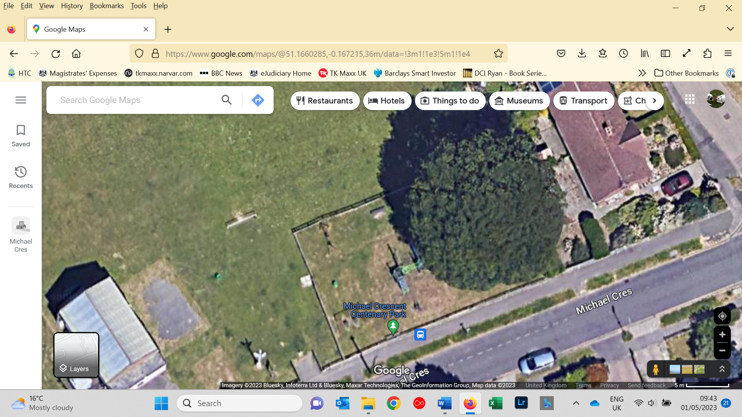
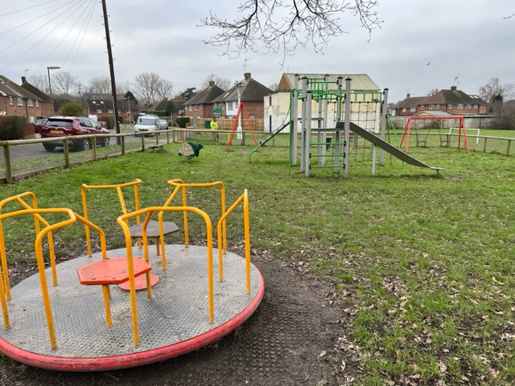

18 TENDER SUBMISSIONS

Tenderers should submit quotes and graphics to the Town Clerk, Council Offices, 92 Albert Road, Horley RH6 7HZ.

Questions about the Invitation to Tender may be raised via email to helen.maan@horleysurrey-tc.gov.uk or by telephone 01293 784765.

This invitation to tender does not constitute an offer and the Town Council does not undertake to accept the lowest of any tender. The Council will not reimburse any tendering costs.

19 REFERENCES
In addition to your tender, please include two businesses references obtained in the last two years. Please include the contact names and telephone numbers of referees.

