Framework Schedule 6 (Order Form Template and Call-Off Schedules)

Order Form
CALL-OFF REFERENCE: PS/24/01 – Provision of SonarQube Enterprise Edition
THE BUYER: Driver and Vehicle Licensing Agency
BUYER ADDRESS Long View Road, Morriston, Swansea, SA6 7JL.
THE SUPPLIER: Bytes Software Services
SUPPLIER ADDRESS: Bytes House Randalls Way, Leatherhead, KT22 7TW
REGISTRATION NUMBER: 01616977
DUNS NUMBER: 225273754
SID4GOV ID: [Insert if known]

[Buyer guidance: This Order Form, when completed and executed by both Parties, forms a Call-Off Contract. A Call-Off Contract can be completed and executed using an equivalent document or electronic purchase order system.
If an electronic purchasing system is used instead of signing as a hard-copy, text below must be copied into the electronic order form starting from ‘APPLICABLE FRAMEWORK CONTRACT’ and up to, but not including, the Signature block
It is essential that if you, as the Buyer, add to or amend any aspect of any Call-Off Schedule, then you must send the updated Schedule with the Order Form to the Supplier]

APPLICABLE FRAMEWORK CONTRACT
This Order Form is for the provision of the Call-Off Deliverables and dated [Insert date of issue].
It’s issued under the Framework Contract with the reference number RM6068 for the provision of Technology Products and Associated Services.

CALL-OFF LOT(S):
[Insert the relevant lot number(s)
- Lot 1 Hardware & Software, & Associated Services
- Lot 2 Hardware & Associated Services
- Lot 3 Software & Associated Services
- Lot 4 Information Assured Products & Associated Services

CALL-OFF INCORPORATED TERMS
The following documents are incorporated into this Call-Off Contract. Where numbers are missing we are not using those schedules. If the documents conflict, the following order of precedence applies:
- This Order Form including the Call-Off Special Terms and Call-Off Special Schedules.
- Joint Schedule 1(Definitions and Interpretation) RM6068
- The following Schedules in equal order of precedence:
[Buyer guidance: delete any Schedules in bold that you do not need for this Call-Off Contract. Add any additional Schedule needed, providing it is within scope of the framework agreement. Remove any bold text remaining before finalising this Order Form. Remove this guidance too.]
- Joint Schedules for RM6068
  - Joint Schedule 2 (Variation Form)
  - Joint Schedule 3 (Insurance Requirements)
  - Joint Schedule 4 (Commercially Sensitive Information)
  - [Joint Schedule 6 (Key Subcontractors) ]
  - [Joint Schedule 7 (Financial Difficulties) ]
  - [Joint Schedule 8 (Guarantee) ]
  - [Joint Schedule 9 (Minimum Standards of Reliability) ]
  - Joint Schedule 10 (Rectification Plan)
  - Joint Schedule 11 (Processing Data)
  - [Joint Schedule 12 Supply Chain Visibility]
- Call-Off Schedules for [Insert Call-Off reference number]
  - [Call-Off Schedule 1 (Transparency Reports)] ]
  - [Call-Off Schedule 2 (Staff Transfer) ]
  - [Call-Off Schedule 3 (Continuous Improvement) ]
  - [Call-Off Schedule 5 (Pricing Details) ]
  - [Call-Off Schedule 6 (ICT Services) ]
  - [Call-Off Schedule 7 (Key Supplier Staff) ]
  - [Call-Off Schedule 8 (Business Continuity & Disaster Recovery) Part [A/B] ]
  - [Call-Off Schedule 9 (Security) Part [A/B/C] ]
  - [Call-Off Schedule 10 (Exit Management) Part [A/B] ]
  - [Call-Off Schedule 11 (Installation Works) ]
  - [Call-Off Schedule 12 (Clustering) ]
  - [Call-Off Schedule 13 (Implementation Plan and Testing) ]
  - [Call-Off Schedule 14 (Service Levels) ]
  - [Call-Off Schedule 15 (Call-Off Contract Management) ]
  - [Call-Off Schedule 16 (Benchmarking) ]
  - [Call-Off Schedule 17 (MOD Terms) ]
  - [Call-Off Schedule 18 (Background Checks) ]
  - [Call-Off Schedule 19 (Scottish Law) ]
  - [Call-Off Schedule 20 (Call-Off Specification) ]
  - [Call-Off Schedule 21 (Northern Ireland Law) ]
  - [Call-Off Schedule 22 (Lease Terms) ]
  - [Call-Off Schedule 23 (Optional Provisions) Part [A/B] ]
- CCS Core Terms (version 3.0.6)
- Joint Schedule 5 (Corporate Social Responsibility) RM6068
- [Call-Off Schedule 4 (Call-Off Tender) as long as any parts of the Call-Off Tender that offer a better commercial position for the Buyer (as decided by the Buyer) take precedence over the documents above.]
- Annexes A to E Call-Off Schedule 6 (ICT Services)
No other Supplier terms are part of the Call-Off Contract. That includes any terms written on the back of, added to this Order Form, or presented at the time of delivery.

CALL-OFF SPECIAL TERMS
The following Special Terms are incorporated into this Call-Off Contract:
[Insert terms to revise or supplement Core Terms, Joint Schedules, Call-Off Schedules; or none]
[Special Term 1 ]
[Special Term 2. ]
[Special Term 3. ]
[None]

CALL-OFF START DATE: 09 April 2024
CALL-OFF EXPIRY DATE: 08 April 2026
CALL-OFF INITIAL PERIOD: 2 Years
CALL-OFF OPTIONAL EXTENSION 1 Years
PERIOD

CALL-OFF DELIVERABLES
[Buyer guidance: complete Option A or, if Deliverables are too complex for this form, use Option B and Call-Off Schedule 20 instead. Delete the option that is not used.]
[Option A: [Name of Deliverable][Quantity][Delivery date][Details]]
[Option B: See details in Call-Off Schedule 20 (Call-Off Specification)]

LOCATION FOR DELIVERY
[Buyer guidance: Insert location for delivery]

DATES FOR DELIVERY OF THE DELIVERABLES
[Buyer guidance: complete Option A or, if the delivery timetable is too complex for this form, use Call-Off Schedule 13 Part A instead. Delete the option that is not used.]
[Option A: Delivery date details]
[Option B: See details in Call-Off Schedule 13 (Implementation Plan & Testing)]

TESTING OF DELIVERABLES
[Buyer guidance: complete Option A if there is no requirement for testing of Deliverables, or Option B if the test regime can be detailed in the Order Form or, if the testing regime is too complex for this form, use Option C and Call-Off Schedule 13 Part B instead. Delete the options that are not used.]
[Option A: None]
[Option B: Insert i. details of Tests to be performed
ii. Test Period
iii. Test Success Criteria]
[Option C: See details in Call-Off Schedule 13 (Implementation Plan & Testing)]

WARRANTY PERIOD
The warranty period for the purposes of Clause 3.1.2 of the Core Terms shall be [Buyer guidance: insert minimum warranty period. Minimum is 90 days]

MAXIMUM LIABILITY
The limitation of liability for this Call-Off Contract is stated in Clause 11.2 of the Core Terms.
[Buyer guidance: you can change the cap on liability in Clause 11.2 where you have made an appropriate risk assessment and sought the necessary management approvals. Unlimited liability is not permitted]

The Estimated Year 1 Charges used to calculate liability in the first Contract Year is [Insert Estimated Charges in the first 12 months of the Contract. The Buyer must always provide a figure here]

CALL-OFF CHARGES
[Buyer guidance: Use Option A or, if charging model is too complex to detail in this form or must be embedded, use Option B and Call-Off Schedule 5 instead. Delete the option that is not used.]

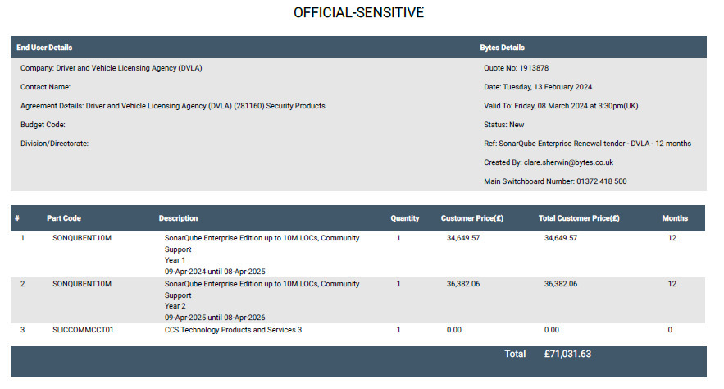
The Charges will not be impacted by any change to the Framework Prices. The Charges can only be changed by agreement in writing between the Buyer and the Supplier because of a Specific Change in Law or Benchmarking using Call-Off Schedule 16 (Benchmarking) where this is used.

REIMBURSABLE EXPENSES –

NOT APPLICABLE

PAYMENT METHOD
The payment method for this Call-Off Contract is BACS via Purchase Order numbers.

BUYER’S INVOICE ADDRESS:

Shared Services Arvato
5 Sandringham Park
Swansea Vale
Swansea
SA7 0EA
Or alternatively electronic invoices can be issued to:
Ssa.invoice@dftssc.gsi.gov.uk

BUYER’S AUTHORISED REPRESENTATIVE
Simon Rees
ITS Supplier Relationship Manager
Simon.rees1@dvla.gov.uk
Longview Road, Swansea, SA6 7JL.

BUYER’S ENVIRONMENTAL POLICY

BUYER’S SECURITY POLICY

Security Clearance (Mandatory)

Level 1

Tenders are required to acknowledge in their tender response that any Contractors’ Staff that will have access to the DVLA site for meetings and similar (but have no access to the DVLA systems), must be supervised at all times by DVLA staff.

SUPPLIER’S AUTHORISED REPRESENTATIVE
Chris Swani
Divisional Director Strategic Frameworks & Bids
Chris.swani@bytes.co.uk
Bytes House Randalls Way, Leatherhead, KT22 7TW

SUPPLIER’S CONTRACT MANAGER
Char Budd
Account Manager
Char.budd@bytes.co.uk
Bytes House Randalls Way, Leatherhead, KT22 7TW

PROGRESS REPORT FREQUENCY
N/A

PROGRESS MEETING FREQUENCY
NA

KEY STAFF
N/A

KEY SUBCONTRACTOR(S)
N/A

COMMERCIALLY SENSITIVE INFORMATION
NA

SERVICE CREDITS
NA

ADDITIONAL INSURANCES
N/A

GUARANTEE
N/A

SOCIAL VALUE COMMITMENT
N/A

For and on behalf of the Supplier: Bytes Software Services
Signature: jnijnijsninsinsin
Name: Chris Swani
Role: Divisional Director Strategic Frameworks & Bids
Date: 05/03/2024

For and on behalf of Buyer:
Signature: B N Green
Name: Nicola Green
Role: Commercial Specialist
Date: 5th March 2024

[Buyer guidance: execution by seal / deed where required by the Buyer].

