Reference Number: T-23-002
Contract for: Hire of Christmas Lighting Display

VOLUME TWO – APPLICANTS OFFER (2)
This document must be completed and returned in the published format. Failure to comply with this instruction may result in your Submission being discounted.

Closing time and date for return of submission:
12:00 (Noon) – 12 June 2023

Name of Applicant:

Contents
Section 1: General Notes 3
Section 2: Suitability Assessment 4
Section 3: Requirements 13
Specification - Core Requirements 13
Specification - General Preambles 17
Specification - Managing Quality 23
Scheme of Works - Details of Christmas Lighting Scheme 26
SECTION 4 Method Statements (award questions) 38
SECTION 5: Certificates and Declarations 42
Pricing Schedule Declaration 42
Certificate of Undertaking and Absence of Collusion or Canvassing 43
Certificate of Confidentiality 44
Commercially Sensitive Information 44
Conflict of Interest 44

Section 1: General Notes
This document should be read in conjunction with the supporting information contained within Volume 1 “Invitation to Tender - Background Information, Instructions and Conditions of Tender” and associated documents also referenced.
This document and associated documents will form the basis of the Applicants formal tender response. Care should be taken to ensure that it is completed accurately, and all information required to submit a compliant tender is done ahead of submitting any final response.

Section 2: Suitability Assessment

Notes for completion

- The “Authority” means the contracting authority, or anyone acting on behalf of the contracting authority, that is seeking to invite suitable candidates to participate in this procurement process.

- “You” / “Your” refers to the potential supplier completing this Suitability Assessment i.e. the legal entity responsible for the information provided. The term “potential supplier” is intended to cover any economic operator as defined by the Public Contracts Regulations 2015 (referred to as the “regulations”) and could be a registered company; the lead contact for a group of economic operators; charitable organisation; Voluntary Community and Social Enterprise (VCSE); Special Purpose Vehicle; or other form of entity.

- Please ensure that all questions are completed in full, and in the format requested. If the question does not apply to you, please state ‘N/A’. Should you need to provide additional information in response to the questions, please submit a clearly identified annex.

- The Authority recognises that arrangements set out in section 1.2 of the standard Suitability Assessment, in relation to a group of economic operators (for example, a consortium) and/or use of sub-contractors, may be subject to change and will, therefore, not be finalised until a later date. The lead contact should notify the authority immediately of any change in the proposed arrangements and ensure a completed Part 1 is submitted for any new organisation relied on to meet the selection criteria. The authority will make a revised assessment of the submission based on the updated information.

- For Part 1 every organisation that is being relied on to meet the selection must complete and submit the self-declaration.

- For answers to Part 3 - If you are bidding on behalf of a group, for example, a consortium, or you intend to use sub-contractors, you should complete all of the questions on behalf of the consortium and/ or any sub-contractors, providing one composite response and declaration.

The Authority confirms that it will keep confidential and will not disclose to any third parties any information obtained from a named customer contact, other than to the Cabinet Office and/or contracting authorities defined by the regulations, or pursuant to an order of the court or demand made by any competent authority or body where the Authority is under a legal or regulatory obligation to make such a disclosure.

Part 1: Your information and the bidding model.
You must answer all questions in parts 1 and 2. If you are the supplier, you must answer all questions in part 3 as well. [Contracting Authorities to change this instruction if all members of the group or required to submit a completed part 3]
Bidders must ensure that every organisation on which they will rely to meet the selection criteria completes and submits their own answers and declaration for part 1 and 2.
Yes ▢ No ▢ N/A ▢

Section 1 | Your information
Question number | Question | Response
1.1(a) | Name (if registered, please give the registered name)
1.1(b) – (i) | Registered address (if applicable) or head office address
1.1(b) – (ii) | Registered website address (if applicable)
1.1(c) | Trading status  a) - public limited company  b) - private limited company  c) - limited liability partnership  d) - other partnership  e) - sole trader  f) - third sector  g) - other (please specify your trading status)
1.1(d) | Date of registration (if applicable) or date of formation.
1.1(e) | Registration number (company, partnership, charity, etc if applicable).
1.1(f) | Registered VAT number.
1.1(g) - (i) | Are you registered with the appropriate professional or trade register(s) specified for this procurement in the Member State where your organisation is established? | Yes ▢  No ▢  N/A ▢
1.1(g) - (ii) | If you responded yes to 1.1(h) - (i), please provide the relevant details, including the name of the register and registration number(s), and if evidence of registration is available electronically, please provide  - the website address,  - issuing body  - reference number.
1.1(h) - (i) | For procurements for services only, is it a legal requirement in the country where you are established for you to:  a) possess a particular authorisation, or  b) be a member of a particular organisation,  to provide the requirements specified in this procurement? | Yes ▢  No ▢
1.1(h) - (ii) | If you responded yes to 1.1(j) - (i), please provide additional details of what is required, confirmation that you have complied with this and, if evidence of compliance is available electronically, please give the website address, issuing body and reference number.
1.1(i) | Relevant classifications (state whether you fall within one of these, and if so which one)  a) Voluntary Community Social Enterprise (VCSE).  b) Sheltered Workshop.  c) Public service mutual.
1.1(j) | Are you a Small, Medium or Micro Enterprise (SME)? | Yes ▢  No ▢
1.1 (k) | Details of Persons with Significant Control (PSC), where appropriate:  - Name  - Date of birth  - Nationality  - Country, state or part of the UK where the PSC usually lives  - Service address  - The date he or she became a PSC in relation to the company ;  - Which conditions for being a PSC are met:  - Over 25% up to (and including) 50%  - More than 50% and less than 75%  - 75% or more  (Please enter N/A if not applicable)
1.1(l) | Details of your immediate parent company:  - Full name of immediate parent company,  - Registered or head office address,  - Registration number (if applicable),  - VAT number (if applicable),  Please enter N/A if not applicable)
1.1(m) | Details of ultimate parent company:  - Full name of ultimate parent company,  - Registered or head office address,  - Registration number (if applicable),  - VAT number (if applicable),  (Please enter N/A if not applicable)
Please note: A criminal record check for relevant convictions may be undertaken for the preferred supplier and all relevant persons and entities (as described above).

Please provide the following information about your approach to this procurement:
Section 1 (cont.) | Bidding model
Question number | Question | Response
1.2 | Please indicate if you are bidding as a single supplier or as part of a group or consortium?  If you are bidding as a single supplier please go to Q 1.3.  If you are bidding as part of a group or consortium (including where you intend to establish a legal entity to deliver the contract, or you are a subcontractor), please tell us:  - The name of the group/consortium.  - The proposed structure of the group/consortium, including the legal structure where applicable.  - The name of the lead member in the group/consortium.  - Your role in the group/consortium (e.g. lead member, consortium member, subcontractor).  - If you are the lead member in the group/consortium, whether you are relying on other consortium members to meet the selection criteria (i.e. are you relying on other consortium members for economic and technical standing and/or technical and professional ability?) and, if so, which criteria you are relying on them for
1.3 | If you are proposing to use subcontractors please provide the details for each subcontractor.  - Name  - Registration number  - Registered or head office address,  - Trading status  - Public limited company  - Private limited company  - Limited liability partnership  - Other partnership  - Sole trader  - Third sector  - Other (please specify your trading status)  - Registered VAT number  - SME (Yes/No)  - The role each subcontractor will take in providing the works and /or supplies e.g. key deliverables - if known  - The approximate % of contractual obligations assigned to each subcontractor, if known  - Is the subcontractor being relied upon to meet the selection criteria (i.e. are you relying on the subcontractor for economic and technical standing and/or technical and professional ability?) and, if so, which criteria are you relying on them for?
1.4 | Lots Where applicable, please tell us which lot(s) you wish to bid for? | Answer

Part 2: Exclusion Grounds
Please answer the following questions in full. Note that every organisation that forms part of your bidding group/consortium, as well as every organisation that is being relied on (including subcontractors being relied on) to meet the selection criteria must complete and submit responses to part 1 and the declarations in part 2.
Section 2 | Grounds for mandatory exclusion
Question number | Question | Declaration
2.1 (a) | Within the past five years, anywhere in the world, have you or any person who:  - is a member of the supplier’s administrative, management or supervisory body or  - has powers of representation, decision or control in the supplier,  - been convicted of any of the offences within the summary below and listed in full on the webpage?
 | Participation in a criminal organisation. | Yes ▢  No ▢
 | Corruption. | Yes ▢  No ▢
 | Terrorist offences or offences linked to terrorist activities. | Yes ▢  No ▢
 | Money laundering or terrorist financing. | Yes ▢  No ▢
 | Child labour and other forms of trafficking in human beings. | Yes ▢  No ▢
 | Any other offence within the meaning of Article 57(1) of the Directive as defined by the law of any jurisdiction outside England, Wales or Northern Ireland. | Yes ▢  No ▢
 | Any other offence within the meaning of Article 57(1) of the Directive created after 26th February 2015 in England, Wales or Northern Ireland. | Yes ▢  No ▢
2.1(b) | If you have answered yes to any part of question 2.1(a), please provide further details, including:  - date of conviction and the jurisdiction,  - which of the grounds listed the conviction was for,  - the reasons for conviction,  - the identity of who has been convicted.  If the relevant documentation is available electronically please provide:  - the web address,  - issuing authority,  - precise reference of the documents.
2.1(c) | If you have answered yes to any part of the question above please explain what measures have been taken to demonstrate your reliability despite the existence of relevant grounds for exclusion. (Self cleaning).

Section 3 | Mandatory and discretionary grounds relating to the payment of taxes and social security contributions
The detailed grounds for mandatory and discretionary exclusion of a supplier for non-payment of taxes and social security contributions, are set out on this webpage, and should be referred to before completing these questions.
Question number | Question | Declaration
3.2(a) | Please confirm that you have met all your obligations relating to the payment of taxes and social security contributions, both in the country in which you are established and in the UK.  If documentation is available electronically please provide:  - the web address,  - issuing authority,  - precise reference of the documents | Yes ▢  No ▢
3.2(b) | If you have answered no to 3.2(a) please provide further details including the following:  - Country concerned,  - what is the amount concerned  - how the breach was established, i.e. through a judicial or administrative decision or by other means.  - if the breach has been established through a judicial or administrative decision please provide the date of the decision,  - if the breach has been established by other means please specify the means.
3.3 | Please also confirm whether you have paid, or have entered into a binding arrangement with a view to paying, the outstanding sum including, where applicable, any accrued interest and/or fines. | Yes ▢  No ▢
Please Note: We reserve our right to use our discretion to exclude your bid where we can demonstrate by any appropriate means that you are in breach of your obligations relating to the payment of taxes or social security contributions

Section 4 | Grounds for Discretionary Exclusion
The detailed grounds for discretionary exclusion of an organisation are set out on this webpage, and should be referred to before completing these questions.
Question number | Question | Declaration
4.1 | Within the past three years, anywhere in the world, have any of the situations summarised below and listed in full on the webpage applied to you?
4.1(a) | Breach of environmental obligations?  To note that environmental law obligations include Health and Safety obligations. See webpage. | Yes ▢  No ▢
4.1(b) | Breach of social law obligations? | Yes ▢  No ▢
4.1(c) | Breach of labour law obligations? | Yes ▢  No ▢
4.1(d) | Bankruptcy or subject of insolvency? | Yes ▢  No ▢
4.1(e) | Guilty of grave professional misconduct? | Yes ▢  No ▢
4.1(f) | Distortion of competition? | Yes ▢  No ▢
4.1(g) | Conflict of interest? | Yes ▢  No ▢
4.1(h) | Been involved in the preparation of the procurement procedure? | Yes ▢  No ▢
4.1(i) | Prior performance issues? | Yes ▢  No ▢
4.1(j)  4.1(j) - (i)  4.1(j) - (ii)  4.1(j) –(iii)  4.1(j)-(iv) | Do any of the following statements apply to you ?  You have been guilty of serious misrepresentation in supplying the information required for the verification of the absence of grounds for exclusion or the fulfilment of the selection criteria.  You have withheld such information.  You are not able, without delay, to submit documents if/when required.  You have undertaken to unduly influence the decision-making process of the contracting authority to obtain confidential information that may confer upon you undue advantages in the procurement procedure, or to negligently provide misleading information that may have a material influence on decisions concerning exclusion, selection or award. | Yes ▢  No ▢  Yes ▢  No ▢  Yes ▢  No ▢  Yes ▢  No ▢
4.4 | If you have answered YES to any of the questions in 4.1, or NO to question 4.2, please explain what measures have been taken to demonstrate your reliability despite the existence of a relevant ground for exclusion. (Self cleaning)

Section 7 | Additional Questions including Project Specific Questions
Question number | Question | Response
7.1 | Insurance  Please confirm whether you already have, or can commit to obtain, prior to the commencement of the contract, the levels of insurance cover indicated below:  Employer’s (Compulsory) Liability Insurance = £10m  Public Liability Insurance = £10m  *There is a legal requirement for certain employers to hold Employer’s (Compulsory) Liability Insurance of £5 million as a minimum. See the Health and Safety Executive website for more information: http://www.hse.gov.uk/pubns/hse39.pdf | Yes ▢  No ▢  Yes ▢  No ▢
7.3  7.3 (a) | Health and Safety  Please describe the arrangements you have in place to manage health and safety effectively and control significant risks relevant to the requirement (including risks from the use of contractors, where relevant). Please use no more than 500 words. Where relevant please self-certify that your organisation has a Health and Safety Policy that complies with current legislative requirements.

Section 3: Requirements

Specification - Core Requirements
Background

    - This section sets out the requirements for the actual Tender and responses will be evaluated in line with the Award Criteria. The Applicants should draw their attention to the support and guidance details as set out in “Volume 1”.
    - The Council is looking to partner with Newquay Business Improvement District (Newquay BID) to expand on the existing Christmas Lighting scheme and therefore the Supplier will be required to quote separately for the extended sections within the scope of this Contract.
    - The Newquay BID Scheme will require new infrastructure and power supply for any lighting Scheme in those sections. Newquay BID will be responsible for liaising with the successful bidder on any areas outlined in ‘Section 2 – Newquay BID Scheme’ as well as having separate contractual arrangements with the Supplier.
    - The Council will list its current lighting stock and approximate age / condition for the bidder to determine whether there is any feasibility to using existing stock to reduce the amount of lighting required to be hired.
    - The Council is open to considering purchase of new lighting stock where this can be demonstrated that it can reduce the cost of the hire agreement over contract period.
    - In carrying out the works the Supplier shall take due accord to the Institute of Lighting Processionals guidance “PLG06 Guidance On Installation And Maintenance Of Seasonal Decorations And Lighting Column Attachments”
https://theilp.org.uk/publication/plg06-guidance-on-installation-and-maintenance-of-seasonal-decorations-and-lighting-column-attachments/
Supplier Obligations
    - The supplier will be responsible for:
  - Purchase and / or hire and / or manufacture illuminations to meet the approved designs.
  - Ensure all fixtures and fittings (catenaries, eyebolts etc.) are tested and certified to an approved standard, ensuring they are safe to bear the lights over the required period of time.
    - The Supplier is to provide all materials, labour and plant and all carriage, freightage, implements, tools and whatever else may be required for the proper and efficient execution and completion of the works.
    - In addition the Supplier will be responsible for all necessary costs associated with the operations, including training costs and licences for employees, plus licences to work on highway as might be necessary.
Design and Installation
    - The Supplier would be required to proactively work with the Council to finalise the design of the Christmas Lighting Scheme determining which display and lighting methods are appropriate for each section of Town keeping the Scheme within the annual budget.
    - The Supplier will produce a scheme containing details of recommended designs for the identified areas which require cover. The scheme should contain details of all costings associated with the project and must be able to satisfy the following requirements:

- The lights need to be specifically for outdoor use and to look attractive and be visible during the daytime as well as after dark.
- All decorations should be designed to be fit for purpose and have an Ingress Protection (IP) of at least IP66.
- No decorations that contain flashing red, yellow or green lamps will be allowed within 10m, or within the motorist’s sight lines, of a set of traffic signals, light controlled pedestrian crossing facility or zebra crossing.
- Consideration shall also be given to the brightness of selected motifs and to the way that the light pools to avoid any interference with CCTV cameras.
    - Upon finalising design of the scheme the Supplier will be responsible for all aspects of the Christmas Lighting Scheme including:
- Provide the lighting products required for the scheme ensuring they are properly tested and functioning prior to installation.
- Identifying and appointing an accredited installer who will install, test, maintain the products and infrastructure and remove the scheme after the Christmas period.
- Provide storage for the lighting products throughout the length of the hire contract.
Electrical Standards
    - The Supplier will be responsible for liaising with the Highways Authority and applying for any necessary permissions to work on Highways and erect Street Lighting.
    - Support the Council, where necessary, with any information required by the National Grid to calculate energy usage of the Christmas Lighting Scheme during the hire period.
    - Ensure all relevant safety tests are undertaken on the electrical infrastructure, anchor points and brackets.
    - All electrical components shall be tested and all wiring, connections etc. should be certified safe.
    - The Council will expect to see all required certification, to include (but not necessarily limited to) the following:
  - Each individual decoration should be subject to an electrical conformance (PAT) test which should form part of the electrical test documentation submitted to The Council. This documentation will also include the initial installation and commissioning electrical certification certificates.
  - Test labels, indicating the date of test and type of test, must be clearly evident in the electrical compartments for each decoration.
  - A statement of compliance with BS7671 and BS7909.
  - Submitting all relevant documentation including a scheme timetable by September.

Christmas Tree
    - As part of the scheme there will be a requirement to dress a 9m (30ft) Christmas Tree with lighting owned by the Council. The tree is situated outside the Municipal Offices, Marcus Hill, Newquay, TR7 1AF. The Supplier should give consideration to the following when installing lights / decorations in trees:
  - During windy / storm events, the significant movement of the tree / branches can damage the lighting.
  - If the tree or part fails during high winds the electrical apparatus can result in a safety hazard for the public and the tree teams who may attend to address the tree failure.
  - If a tree fails during windy weather, the reason for failure and any subsequent claim may be attributed to the lights being attached.
  - The lights must be attached to the tree in a way that doesn’t damage the tree.
  - No pruning is carried out to the tree to facilitate attachment of the lights.
  - The Supplier responsible for installing the lights is aware that for any subsequent tree failure (normally during windy weather) they could be implicated in any subsequent claims.
  - If the lights are present between January and November, The Council may need to request removal to carry out essential works. However, all efforts will be made to minimise the impact of this.
Key Timescales
    - Ensure the Christmas Lighting Scheme is installed no later than the 2nd week in November and taken down no later than the 2nd week of January in each year of the contract period.
    - Provide dedicated support and assistance on the evening of the “switch on” event each year of the hire contract to assist with any technical matters that may arise and in doing so ensure that the “switch on” event is a success.
    - Summary of key dates for Year 1, 2 and 3 below: -
 | Year 1 | Year 2 | Year 3
Install and test illuminations in time for the official live or virtual Switch On event | By w/c 06/11/2023 | By w/c 11/11/2024 | By w/c 10/11/2025
Decorate the three Christmas Trees, install feature | By w/c 06/11/2023 | By w/c 11/11/2024 | By w/c 10/11/2025
A team (including Supervisor) onsite on the afternoon / evening of either the live or virtual Switch On Event | Exact date TBC | Exact date TBC | Exact date TBC
Provide a maintenance service for the period covered | From installation date to removal date | From installation date to removal date | From installation date to removal date
Switch off and removal of all illuminations from the identified sites to be after 12th day of Christmas but by | 12/01/2024 | 17/01/2025 | 16/01/2026

    - Annually the Supplier’s designated project manager will be required to meet with the Council to cover the following:
  - Finalise the project plan and milestones
  - Share project key contact details
  - Agree processes for communication
  - Agree final designs for scheme with Council team
Operating Hours
    - It is anticipated that the Supplier will install lighting within the city centre outside of normal working hours (08:00 to 17:00 hrs) to minimise disruption to businesses and the public.
    - The Council’s working hours are from 09:00 – 17:00 hrs, Monday to Thursday and 09:00 – 16:30 hrs on Friday (excluding weekends and Bank holidays).
    - The Supplier must provide and maintain throughout the duration of the installation of the lights an “Out of Normal Working Hours Emergency Service” to avoid danger to health or serious damage to buildings and other structures. This service must be provided 24 hours each day throughout the festive period including weekends and bank holidays.
    - Out of Hours: Monday to Thursday 17:00hrs – 09:00hrs; from Thursday 1700 hrs through to Friday 09:00 hrs, and weekends from 16:30 from Friday through Saturday, Sunday, to 09:00 hrs on Monday. Bank Holidays also deemed Out of Hours.
    - When working out of hours the Supplier shall ensure that Operatives are mindful to residence in order to avoid disturbance.

Specification - General Preambles
    - In addition to the specific Core Requirements the Supplier accepts to comply with the below requirements as part of the contract:
- Responsible for the Health and Safety of their employees and the public liability towards occupants to premises service users and the general public. Evidence of compliant health and safety training including Risk Management, Control of Substances Hazardous to Health (COSHH) training should be held on file by the Supplier and be made available to the Council throughout the duration of the contract should it be requested.
- Ensure that Operatives appointed to work on the Contract are suitable and sufficiently qualified and experienced to perform the activities required under the Contract.
- Provide adequate supervision of Operative staff to ensure that the performance standards are met, and to ensure that they perform their duties in a way that reflects positively on Council as commissioning organisation.
- Ensures that none of its employee’s smoke or vape in any Council premises or when engaged on delivering services under the contract.
- Maintain its own public liability insurance for the duration of the Contract.
- Ensure that all staff have the relevant training and ability to carry out the tasks set out on the specification.
- Be solely responsible for breakage or theft by the Supplier’s employees or agents.
Street Works
    - All works related to this contract are on public highways and footpaths. Accordingly the supplier shall ensure that they have all necessary licences and permissions to work on the public highways. In performing the duties as set out under this contract the Supplier shall ensure the comply in full with the Safety at Street Works and Road Works (A Code of Practice), compliance with relevant obligations under the New Road and Street Works Act (1991) and An Introduction to the Use of Portable Vehicular Signals
https://assets.publishing.service.gov.uk/government/uploads/system/uploads/attachment_data/file/321056/safety-at-streetworks.pdf
https://assets.publishing.service.gov.uk/government/uploads/system/uploads/attachment_data/file/509198/introduction-use-portable-vehicular-signals.pdf
https://www.legislation.gov.uk/ukpga/1991/22/contents
Storage of Materials and Equipment
    - The Supplier will be responsible for storage of materials, both when not installed as well as any necessary storing for installation and dismantling of displays. All such facilities shall be properly cleaned and maintained in a tidy state. The Council shall not be liable for loss of materials stored within these facilities.
Provision of Services
    - The Supplier will be responsible for making arrangements for all services and utilities in relation to the work required.

Access to Premises / Sites
    - The Supplier shall be mindful of operations being undertaken in public areas and for residence and seek to keep disruption from noise and obstructions to an absolute minimum.
    - The Suppliers Operatives are therefore required to be mindful of this and also be mindful working in locations where particular consideration is to be made to a range of stakeholders including:
- Vulnerable Adults;
- Visitors to the premises and schemes who may be unaware that work is being carried out;
- Persons with visual, hearing or mobility impairment;
- On occasions potentially violent, abusive or aggressive persons;
- Persons with limited understanding of the English language;
- Persons with particular requirements because of their ethnic, religious or other backgrounds,
- Children,
- Animals.
Security
    - As part of their duties the Supplier’s Operatives shall be required to report any concerns, and for these concerns to be relayed to the respective Council Authorised Personnel as soon as practically possible. If the situation or concern is deemed an emergency then the relevant emergency services should be called without delay.
    - The Supplier’s Operatives will be required to ensure that they have ID visible during the time they are onsite either via an approved lanyard, or card holder clipped to the Operatives apparel.
    - By undertaking their duties, the Supplier’s Operatives shall be mindful of their actions in a manner that prevents unauthorised persons access to plant, materials and equipment that may cause harm, theft or damage as a result of their actions.
Supplier Operatives Apparel and Identification
    - Supplier Operatives will be required to look professional and presentable when working on Council premises. Apparel for Supplier Operatives will be practical for the Services performed, but readily distinguish the Operative as an appointed person to work on the premises. To help provide clarity to others, all Operatives will have the same outfit / uniform which includes clear reference to the Supplier’s company name / logo.
    - All Operatives attending any site must carry an identity pass, stating the name and address of the company, the name of the employee and a passport size photograph of that employee.
    - All qualified personnel e.g. Highway Electrical Registration Scheme (HERS) registered carrying out work on site should be in possession of valid registration cards at all times whilst on site. Those registered to other Competency schemes should be able to produce similar documentation. Any operational staff unable to produce valid documentation must be asked to leave site immediately.
Disposal of Waste
    - Disposal of waste arising from the Suppliers operations in delivery of the Services and the safe disposal of such waste will form part of the Supplier’s responsibilities under the Contract.
    - In the event that any of that waste is hazardous waste the Supplier shall ensure that such waste is appropriately disposed of.
    - If the Supplier wishes to dispose of any waste arising from the Contract themselves they must ensure they hold an up to date and appropriate Waste Carrier’s Licence.
Health and Safety matters
    - The Supplier is reminded of their obligations under the Health and Safety at Work Act 1974 and other supplementary Health and Safety Regulation that is relevant.
    - The Supplier shall note the following and undertake due measures to ensure Health and Safety Regulations, Codes of Practice and Guidance are duly undertaken and complied with in any resulting contract but not limited to:
- Health & Safety at Work Act 1974
- Management of Health & Safety at Work 1999
- Provision & Use of Work Equipment Regulations 1998
- British Standard Codes of Practice. For example, BS 7671Requirements for Electrical Installations; BS 7909 Code of Practice for Temporary Electrical Systems for entertainment and related purposes
- The Electricity at Work Regulations 1989
- The Regulations for Electrical Installations by the Institution of Electrical Engineers
- The Electrical Supply Regulations
- The Rules and Regulations of the Local Electricity, Gas and Water Authorities
- The requirements of the Local Fire Authorities
- Portable Appliance Regulations
- The requirements of the Construction (Design and Management) Regulations. The Construction, Design and Management (CDM) Regulations. There is a short guide on the CDM regulations
    - The Supplier will be responsible for ensuring that when applying the relevant and necessary Regulations, Codes of Practice and Guidance that they are following the up to date and current editions the relevant documents.
    - The Supplier should inform the Council of any unsafe feature or any matter of cause of public concern at any location at which the services are being provided.
    - During the carrying out of the operations the Supplier is to keep on the site a competent person in charge who shall be empowered to receive and act upon any instructions given by the Council or its representative.
    - It will be the responsibility of the Supplier to undertake Risk Assessment for the programmed inspection works and any resulting repairs post inspections in line with the Management of Health and Safety at Work Regulations 1999 (https://www.hse.gov.uk/simple-health-safety/risk/index.htm).

    - A record to be keep of all risk assessments and Control of Substances Hazardous to Health (COSHH) data and to supply a copy to the Council upon request.
    - In the event that a Health and Safety incident occurs resulting in injury or not, then this shall be reported as soon as practically possible by the Supplier to the Council’s Authorised Officer. This does not forgo any wider responsibilities and duties that the Supplier may have under the Health and Safety Legislation such as notifiable incidents.
    - Among other matters the Suppliers attention is drawn to specific Health and Safety considerations which will require to be managed:
Working at Heights:
    - The Supplier will be mindful that the activities will inevitably require elements of work to be carried out at height. All operations are to be carried out in a manner that wherever possible avoids the need for the operative to gain access to areas via means of steps, platforms or other temporary vertical staging.
    - Ladder access should not be used without the provision of the correct equipment. In the case where access is required by means of steps, mobile platforms or other temporary vertical staging means, then a work at height assessment should be carried out and agreement of the Council’s Authorised Officer obtained.
    - Where access is required by means of mobile platforms or vertical lifts then the appropriate training of operatives is essential including ensuring that they have correct licence to operate the equipment, e.g. Mobile Elevating Works Platform licence.
    - In all instances of working from height then a work at height assessment should be carried out and agreement of the Council’s Authorised Officer obtained. Access equipment for short duration (e.g. step ladders) must be provided by the Supplier and evidence of suitable training in correct use of equipment may be required. Suppliers working unsafely at height will be instructed to cease with immediate effect.
    - Operatives will need to be mindful that when working from height in order to avoid dropping of materials, equipment and tools and ensure that areas below operations at height are kept clear from persons entering zones directly below those operations.
    - When working from height operatives will be required to wear hard hats to BS EN 397.
Trips, slips and falls:
    - The prevention of trips, slips and falls will be a key priority as part of the Services being performed, especially considering the Services being carried out in both operational and public settings. When undertaking Services, suitable warning signage shall be prominently displayed at approach points to the Services being carried out, along with suitable signage / protection being in place around areas being worked on, and protection of leads / cables to appliances that can cause hazards to others in the area.
    - To remain effective and ensure premises users do not become complacent, hazard warning signs must be removed as soon as practicable after the hazard is eliminated.

Personnel Protective Equipment (PPE):
    - The Supplier will ensure that the Supplier’s Employees are provided with, and use, required PPE when undertaking their duties. When working in external sites, where there is likely pedestrian and / or vehicular access in the vicinity then the Operatives shall be required to wear class 2 high visibility vests.
Electrical Equipment:
    - All electrical equipment used shall have suitable safety checks (including Portable Appliance Testing – PAT where they apply) and certification and used in compliance with manufacturer’s instructions.
Training:
    - New and existing Operatives shall be responsible for providing suitably trained and qualified Operatives to fulfil the requirements of the Contract, and have appropriate refresher training in relation to Health and Safety. In the event of lone working the Supplier shall have a clear policy in how this is to be operated.
Fixings and Anchor Points
    - The Supplier shall ensure that all fixing points are robust and secure prior to using as part of the displays. Any concerns must be reported to the Council’s Authorised Officer as soon as possible ahead of using.
    - Similarly, fixings from items to be installed as part of the display must be robust and fit for purpose, noting that the external environment will be subject to climatic conditions within a autumn / winter season.
Working around stakeholders / General Environment:
    - As highlighted elsewhere, the works are to be carried out in an operational or public environment with mixed stakeholders and hazards and care must be taken to avoid risk to both operatives working in the premises and overall public safety.
    - The Supplier will be be responsible for ensuring safe operations are carried out both for operatives and members of the public.
    - Key risks associated with this which will need to be considered, mitigated and managed in fulfilment of the services could be, but not limited to:
- Working in limited lighting conditions / darkness
- Wind and rain
- Cold (including frost, ice / snow)
    - The Supplier shall also be mindful that Newquay is in an extremely aggressive environment when considering sea and the risk of corrosion to metals. Due care should be taken to this when considering suitable fixtures and fittings but also when checking suitability of existing fixtures intended for use.
Electrical Works
    - Electrical works must only be carried out by qualified electrical technicians, in line with suitable trade body such as National Inspection Council for Electrical Installation Contracting (NICEIC) https://niceic.com/.
    - In addition typically, the industry standard for training and assessment of competence on or near the highway is the Highway Electrical Registration Scheme (HERS) which is a requirement of the National Highways Sector Scheme 8 (NHSS 8). However other alternative schemes are also available so it’s down to the Operator to satisfy themselves as to the suitability of the people they employ.
    - Prior to connecting with any electrical supplies all necessary checks and tests must be carried out.
Substances
    - The Supplier shall comply with all aspects of Control of Substances Hazardous to Health (COSHH) Regulations, with all substances being handled, used and ultimately disposed of in line with manufacturer’s recommendations and COSHH Regulations.
    - COSHH Assessments and Material Safety Data Sheets for all substances used on Council premises will need to be made available to the Council by the successful applicant. COSHH folders should be made available to all staff carrying activity on the facilities who will also be provided with appropriate training.
    - In addition, Operatives will as part of delivery of the services, be required to work with substances that at variable temperatures may become hazardous, such as hot water for through cleaning, and as such due precautions shall be taken.
Utilities
    - The Supplier shall be aware that the works are in public areas which will have a number and range of utilities and services owned by Statutory Undertakers, some of which will be visible and some which are not. Accordingly as part of risk assessments the Supplier shall ensure that they under in carrying out the works they make all due efforts to identify location of utilities and ensure any necessary protection is made, to avoid both danger and injury to Operatives and members of the public, plus damage to the services.
    - The liabilities related to damage or injury from Statutory Service will rest with the Supplier.

Specification - Managing Quality
Quality Control
    - The Supplier shall look to monitor the Services performed to ensure that this fulfils the required Standards as set out in the Contract, this shall include:
- Ensuring Operatives are suitably supervised
- Providing quarterly summary to the Council’s Authorised Personnel in relation performance issues and as summary of the issues raised action taken.
- The Supplier shall have suitable procedures in place around monitoring and reporting findings to inspect work carried out by Operatives and ensure corrective actions are carried out where work falls below what is deemed as acceptable.
Reporting of defects
    - The Supplier shall be responsible for reporting any Defects in relation to the premises that may affect the ability to effectively fulfil the requirements of the Contract. Any reports should be made within 3 working days of this becoming to the attention of the Supplier. If the defect presents a danger or Health and Safety concern, then this shall be reported at the first available opportunity.
    - As part of day-to-day operations of the Supplier’s Operatives where noticing areas of maintenance requirements then this should also be raised with the appropriate Authorised Personnel for that site.
Customer Care
    - Key objectives from the Contract is to ensure the following:
- Resources are managed efficiently and effectively.
- Value for money is achieved.
- Service standards as set out are consistently maintained.
Key Performance Indicators
    - Key Performance Indicators (KPIs) are identified in Table 1 below.
    - In the event of Service Failures, as part of the Contract the Council reserves the right for the Authorised Personnel to issue Default Notices.
    - Where possible the aim will be for the Council to work constructively with the supplier to avoid the need to resort to such action but will form part of the options available to the Council under the Contract. In the event of a Default Notice being issued, it shall only be issued from the Authorised Personnel, and done in a way that clearly outlines the area of Service Failure (including references to location / date / time), the means of corrective action required and the timeline within which the Service Failure is to be corrected.
    - The Supplier will be required to correct the Service Failure in line with the Default Notice timelines. Where the Supplier views the Default Notice is unmerited or inaccurate then this shall be raised as soon as possible to the Supplier Manager.
    - Persistent or repeated Services Failures, and / or incident / issues which constitute a serious Service Failure(s) may result in the Council terminating the Contract in accordance with the Conditions of Contract.

    - Should it be established that the prescribed standards are not being maintained, a deduction in the next monthly bill equal to 1 full day’s Contract payment will be made until the facilities are brought back up to the identified standards. This will be determined, and deduction period concluded by re inspection and confirmation by the Council’s authorised officer.
    - When the Supplier is informed of an issue, it is expected to adhere to the following response times to complete the task with competent persons:
Day | Time | Priority 1 | Priority 2 | Priority 3
Every day (including Bank Holidays) | 24hrs | Same Calendar Day - within 2 hours of call to fix to the Supplier | Next Working Day from reports registerd to supplier by 3 pm on previous Working Day | 3 Working Days from reports registerd to supplier by 3 pm on previous Working Day

- Priority 1 – Emergency response e.g. an incident which generates a an immediate / imminent Health and Safety risk
- Priority 2 – Urgent maintenance e.g. a lighting fault but with no imminent Health and Safety risk
- Priority 3 – Non-urgent maintenance e.g. flickering lights
    - A comprehensive KPI regime will set out clear expectations, behaviours and results from both the Supplier and the Council.
    - The Supplier’s performance will be measured and reviewed throughout the installation, maintenance and removal period to monitor performance, effectiveness and efficiency. The Supplier will be measured against the following KPIs:
Design / Installation / Removal of Scheme
- Health and safety documentation including load test certificates of fixtures to be submitted no later than 1 week before installation (Target 95%)
- Test illuminations and submit the relevant certificates no later than 1 week after installation (Target 95%)
- Undertake the switching off of the lights on and removal a by targeted dates (Target 100%)
Maintenance
- Percentage of Priority 1 calls completed within specified time (Target 100%)
- Percentage of Priority 2 calls completed within specified time (Target 95%)
- Percentage of Priority 3 calls completed within specified time (Target 95%)
    - If the Supplier falls behind on any element of the task, a meeting shall be arranged with the Council to discuss the impact and any action to be taken to remedy this.

    - If the Supplier finds they are unable to deliver the service to the required standards, they are required to notify the Council at the earliest opportunity.
    - The Supplier shall provide information and records on the performance of delivering the service in such a form as the Council may reasonably require.
    - Further KPI’s will be subject to agreement between the parties throughout the Contract and the methods to be used for measuring Supplier performance against the KPI’s listed above will be determined prior to Contract commencement.
    - Regular review and monitoring of Health and Safety procedures and standards will be required. This would include monitoring of any issues in relation to Health and Safety both as part of ongoing supervision by the Supplier as well as any incidents that may occur. Supplier able to demonstrate suitable no / low level of incidents both in number and severity, as well as clearly able to demonstrate H&S review and monitoring is regularly and effectively happening.

Scheme of Works - Details of Christmas Lighting Scheme
Section 1 – Newquay Town Council Scheme
    - Below are details of the electrical connection points and whether the required illumination is pole mounted or a cross street catenary. As stated in section 1 the Council will work with the successful bidder to determine which lighting product is most suited to each location. All connections are 16A 240V IP44 from an unmetered power supply.
1 A. Fore Street / Bank Street, Newquay.
Connection Point | Road Name | Motif Type
1 | Fore Street | Pole Mounted
2 | Fore Street | Pole Mounted
3 | Fore Street | Pole Mounted
4 | Bank Street | Cross Street Catenary
5 | Bank Street | Cross Street Catenary
6 | Bank Street | Cross Street Catenary
7 | Bank Street | Cross Street Catenary
8 | Bank Street | Cross Street Catenary
9 | Bank Street | Cross Street Catenary
N/A | Bank Street / Fore Street | Cross Street Catenary – 350 metres string lighting

Location Plan (Fore Street/Bank Street)
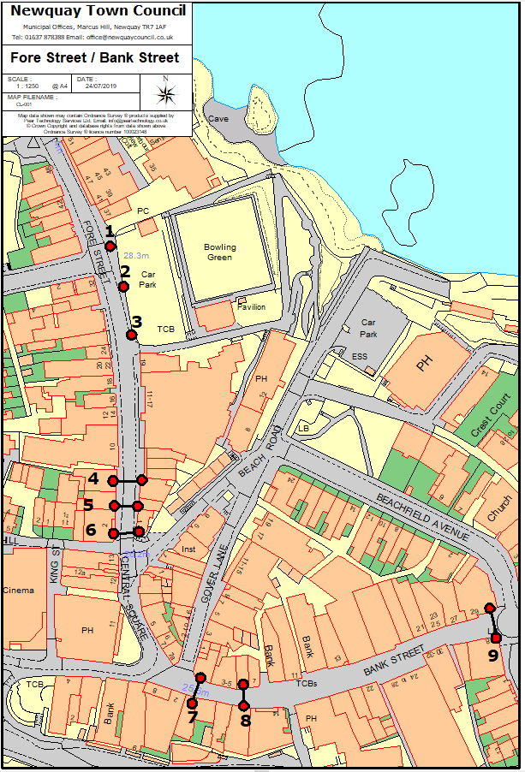

1 B. East Street, Newquay
Connection Point | Road Name | Motif Type
10 | East Street | Pole Mounted
11 | East Street | Pole Mounted
12 | East Street | Pole Mounted
13 | East Street | Pole Mounted
14 | East Street | Pole Mounted
15 | East Street | Pole Mounted
16 | East Street | Pole Mounted
17 | East Street | Pole Mounted
N/A | East Street | Cross Street Catenary – Due to high wind in this section of Town consideration should be given to the type of display used here

Location Plan

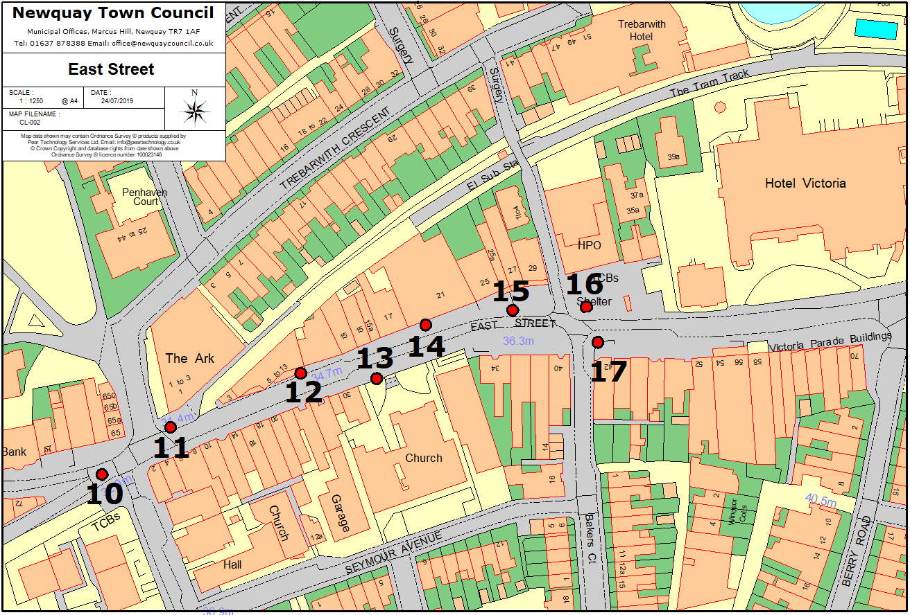

1 C. Cliff Road, Newquay
Connection Point | Road Name | Motif Type
18 | Cliff Road | Pole Mounted
20 | Cliff Road | Pole Mounted
22 | Cliff Road | Pole Mounted
24 | Cliff Road | Pole Mounted
25 | Cliff Road | Pole Mounted
26 | Cliff Road | Pole Mounted
27 | Cliff Road | Pole Mounted
28 | Cliff Road | Pole Mounted
29 | Cliff Road | Pole Mounted
30 | Cliff Road | Pole Mounted
31 | Cliff Road | Pole Mounted
32 | Cliff Road | Pole Mounted
33 | Cliff Road | Pole Mounted
34 | Cliff Road | Pole Mounted
36 | Cliff Road | Pole Mounted
38 | Cliff Road | Pole Mounted
39 | Cliff Road | Pole Mounted
40 | Cliff Road | Pole Mounted
41 | Cliff Road | Pole Mounted
43 | Cliff Road | Pole Mounted
44 | Cliff Road | Pole Mounted
46 | Cliff Road | Pole Mounted
48 | Cliff Road | Pole Mounted
49 | Cliff Road | Pole Mounted

Location Plan
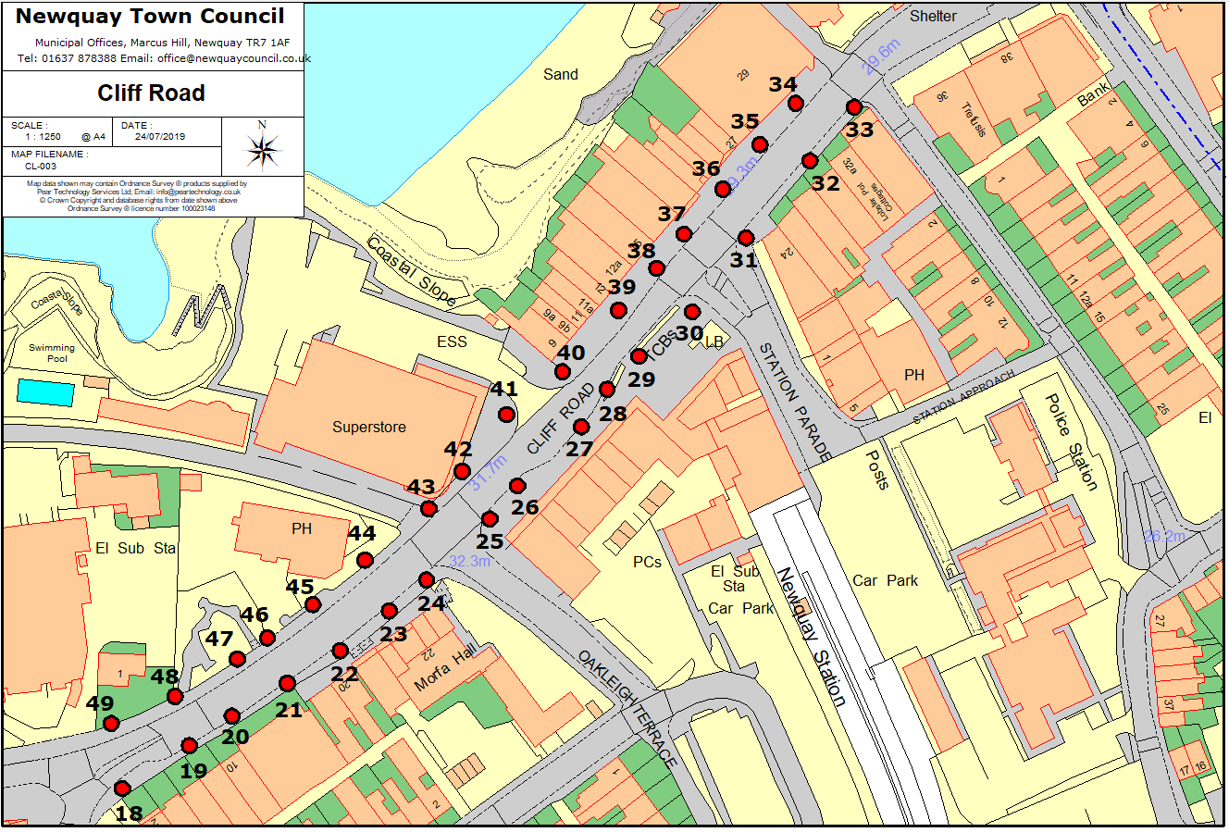
Section 2 – Newquay Business Improvement District Scheme
2 A. Fore Street
Connection Point | Road Name | Motif Type
51 | Fore Street | Side Bracket to Building
52 | Fore Street | Side Bracket to Building

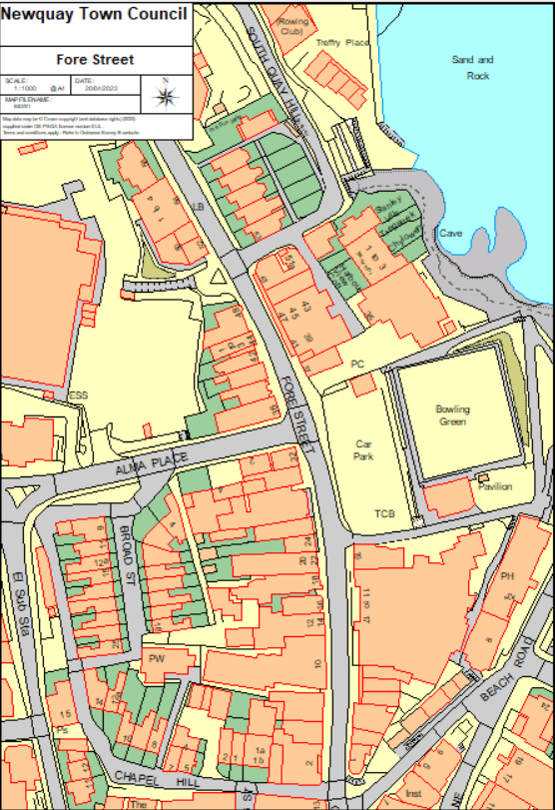

51
52

2 B. Beach Road / Gover Lane
Connection Point | Road Name | Motif Type
53 | Beach Road | Side Bracket to Building
54 | Beach Road | Side Bracket to Building
55 | Gover Lane | Side Bracket to Building
56 | Gover Lane | Side Bracket to Building
57 | Gover Lane | Side Bracket to Building
58 | Gover Lane | Side Bracket to Building
59 | Gover Lane | Side Bracket to Building

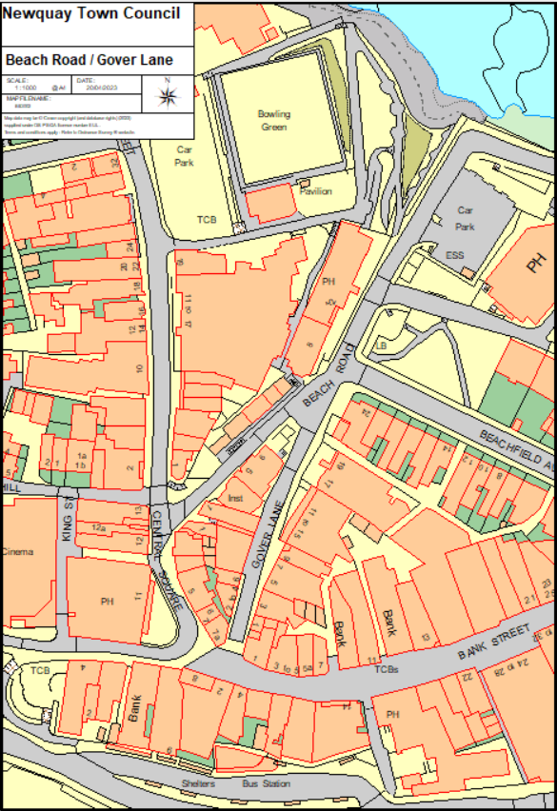
59
58
57
56
55
54
53

2 C. Bank Street
Connection Point | Road Name | Motif Type
N/A | Bank Street / Fore Street | Cross Street Catenary – 250 metres string lighting

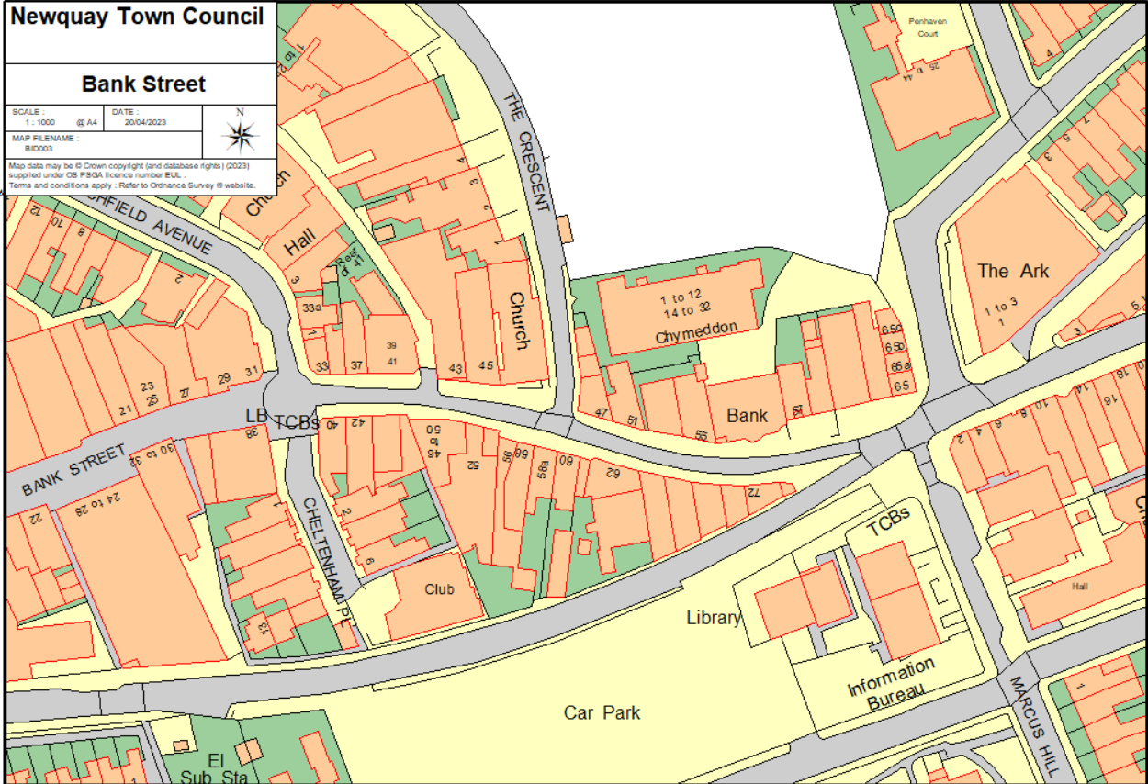

SECTION 4 Method Statements (award questions)

    - The tenderer will be required to submit details of past experience with similar service contract, contract references and details of related accreditation for the employees within the tenderers organisation.
SUPPLY / DESIGN, INSTALLATION, MAINTENANCE AND DISMANTLING
SUPPLY AND DESIGN OF CHRISTMAS LIGHTS
With reference to the accompanying Specification, General Preambles and Schedule of Works please provide details on how you would look to work with the Council around the supply and coordination of the design and sign off of the scheme with the Council.
Please provide details on your proposed approach around supply of lights and decorations during the contract (including utilising of any existing current Council stock).
What would a good response look like?
A good response will see clarity in how the bidder aims to meet the requirements as set out. It will provide details on how you would work with the Council around designing and planning the installations in a timely manner to meet the required timescales.
The response should provide clarity to the clarity on the locations as to where the specific designs are to be installed.
The response would provide confidence as to surety of supply and the capacity to both obtain the necessary numbers to meet the volume coverage required.
In addition, a good response would provide details on the logistics and resources required to meet expectations on timescales.
A good response would make clear reference back to the key parts of the Specification, General Preambles and / or Scheme of Works and provide relevant details and clarity to how the bidder would deliver against the requirements.
Overall the response would provide confidence on the contractors professional ability to deliver quality outcome and in a timely manner. The response would provide details on suitable experience and how this experience would be applied in the delivery under any contract that is awarded.
SUPPLIER RESPONSE:

INSTALLATION (to include transportation)
With reference to the accompanying Specification, General Preambles and Schedule of Works please provide details on how you would look to work with the Council around the Installation of the Christmas lights. This would include details on how you would work to ensure the lights are fixed and secured, tested and operational for switch on within the timescales as required.
What would a good response look like?
A good response will see clarity in how the bidder aims to meet the requirements as set out. It will provide details on how you would go about the installation of the Christmas lights in a timely manner to meet the required timescales.
The response should provide clarity around ways of working from transporting of lights from storage / delivery onto site, operational practices from fixing to testing of lights then how you would support around switch on of the lights.
A good response would provide the Council with confidence that the contractor has the required resources (e.g. people, vehicles, plant and equipment) and experience to install onsite in a timely and professional manner that also ensures Health and Safety considerations are duly taken into account. This would include providing details of the team who will be used to deliver the services described their knowledge and experience gained on other projects and how this will be utilised to deliver this contract.
The response could provide details on schedules to be used, the logistics that would be considered and how key Health and Safety matters would be dealt with, this would include risk assessments and management of staff, understanding of the key risks and liaison with the Council, plus clarity and evidence that the performance standards would be met.
The response would provide confidence for the Council that with the Health and Safety considerations the supplier are paramount importance, by including methodologies for testing installation of the illuminations and example risk assessment.
A good response would make clear reference back to the key parts of the Specification, General Preambles and / or Scheme of Works and provide relevant details and clarity to how the bidder would deliver against the requirements.
SUPPLIER RESPONSE:

MAINTENANCE AND DISMANTLING
With reference to the accompanying Specification, General Preambles and Schedule of Works please provide details on how you would look to work with the Council around the operational maintenance of the Christmas lights during the season and also then the dismantling and removal to safe and secure storage ahead of the next season. This would include details on how you would work in regard to call out to fix faults (taking into account the different priority from call to fix).
What would a good response look like?
A good response will see clarity in how the bidder aims to meet the requirements as set out. It will provide details on how you would go about the ongoing maintenance that would be required during the course of the installation of the Christmas lights and how you would work with the Council in ensuring that the lights are removed within the required timescales.
The response should provide clarity around ways of working from a maintenance perspective, both around communication with the Council on reporting of fault and update on work carried out, to the transporting of lights from site back to safe storage during period where the lights are not required.
A good response would provide the Council with confidence that the contractor has the required resources (e.g. people, vehicles, plant and equipment) and experience to maintain the lights in line with the performance standards as set out in a timely and professional manner that also ensures Health and Safety considerations are duly taken into account. A good response would again make reference to methodologies and approach for maintenance and dismantling of the illuminations, including example risk assessment.
A good response would include providing details of the team who will be used to deliver the services described their knowledge and experience gained on other projects and how this will be utilised to deliver this contract.
A good response would make clear reference back to the key parts of the Specification, General Preambles and / or Scheme of Works and provide relevant details and clarity to how the bidder would deliver against the requirements.
SUPPLIER RESPONSE:

CONTRACT MANAGEMENT AND ADMINISTRATION
CONTRACT MANAGEMENT AND ADMINISTRATION
With reference to the accompanying Specification, General Preambles and Schedule of Works please provide details on how you would look to work with the Council around ensuring the successful performance of the Contract and administration of necessary systems. Please include in your response a programme with key milestones.
What would a good response look like?
A good response would provide details on how the supplier would look to work with the Council in a way that promotes a professional and successful working relationship, on that is responsive to needs in relation to fulfilling the contract and also is one where staff are professional in their dealings with the Council, public and community.
As such a good response may include details on key staff, there experience and qualities to support such expected behaviours, as well as details on professionalism in dealing with the wider project management, and accounting and administrative functions necessary to support a successful contractual relationship with the Council.
Critically a good response would provide details on the supplier’s systems and process in place that would be applied to this contract in respect of maintaining performance, record keeping and compliance with Health and Safety Regulations, this would also include details on how the Council would be able to make timely contact with the supplier and ensure timely and professional response back.
A good response would provide details on how timescales are to be met through appropriate levels of project management, with a programme of key milestones and resources.
A good response would make clear reference back to the key parts of the Specification, General Preambles and / or Scheme of Works and provide relevant details and clarity to how the bidder would deliver against the requirements.
SUPPLIER RESPONSE:

SECTION 5: Certificates and Declarations
CONDITIONS OF TENDER
Reference number and Title of Contract: Shall be as per the Reference Number and Title of Contract as detailed on page one (1) of this Volume Two (2) Applicant’s Offer
1. | By submitting a Tender, Applicants are agreeing to be bound by the terms and conditions without further negotiation or amendment.  I/We fully accept the terms and conditions of contract for the provision of goods/works/services
2. | Having examined the tender documents for the provision of the above goods/works/services, we offer to provide the said goods/works/services in conformity, without qualification, therewith for the sum/sums enclosed at Schedule 5 of this Bid.
3. | The Authority does not bind itself to accept the lowest or any Tender, and reserves the right to accept a Tender either in whole or in part, for such item or items specified in the Invitation to Tender, and for such place or places of delivery as it thinks fit, each item and establishment being for this purpose considered as tendered for separately.
4. | I/We the undersigned DO HEREBY UNDERTAKE on the acceptance by the Authority of my/our Tender either in whole or in part, to supply (or perform the services), on such terms and conditions and in accordance with such specifications (if any), as are contained or incorporated in the Invitation to Tender. I/We agree and declare that the acceptance of this Tender by letter on behalf of the Authority, whether for the whole or part of the items included therein, will constitute a Contract for the supply of such items, I/We agree to enter into a further agreement for the due performance of the Contract, and I/We declare that I am/We are acting as the Delegated Authority for the purposes of signing off this Tender, and therefore, the Contract.

Pricing Schedule Declaration

    - Applicants are required to complete the Schedule 1 - Price. These costs will form the basis of the Bid submission. All prices shall be stated in pounds sterling and exclusive of VAT. If there is no charge for an item, please state none.
    - The fee proposal should include all members of the proposed team.
    - As a minimum, all prices submitted must remain fixed and firm for twelve (12) months from date of Contract commencement. In support of this, please detail exactly how long your prices will remain fixed for.
    - The Council does not expect the Applicant to implement any price increases throughout the life of this Contract.
I / We offer to supply the goods or services as per the pricing schedule above, in accordance with the Specification, terms and conditions and all other documents forming the Contract.

Certificate of Undertaking and Absence of Collusion or Canvassing
CERTIFICATE OF UNDERTAKING AND ABSENCE OF COLLUSION OR CANVASSING
The Applicant shall sign the below Certificate of Undertaking and Absence of Collusion clearly indicating whether they sign as a Consortium or Member of Consortium (Box A), or as a single body and/or individual (Box B) by striking through Box A or B, whichever does not apply.
Box A – Consortium
I/We the undersigned do hereby certify that:-
- the consortium’s tender is bona fide and intended to be competitive;
- the consortium has not entered into any agreement with any person outside the consortium with the aim of preventing Tenders being made or asked the amount of another Tender of the conditions or which the Tender is made;
- the consortium has not informed any person outside the consortium other than the person calling for the Tenders the amount or approximate amount of the Tender except where the disclosure in confidence of the approximate amount of the Tender was necessary to obtain insurance premium or other quotations necessarily required for the preparation of the Tender;
- the consortium has not caused or induced any person to enter into such an agreement as is mentioned in (b) above or to inform the consortium of the amount or the approximate amount of any rival Tender for the Contract.
- the consortium has not and will not canvass or solicit any Member, Officer or employee of the Authority in connection with the preparation, submission and evaluation of this Tender or award or proposed award of the Contract and that to the best of my knowledge and belief, no person employed by the consortium or acting on the consortium’s behalf has done or will do such an act.
- I/We further undertake that the consortium will not do any of the acts mentioned in (b), (c), (d) and (e) above before the hour and date specified for the return of the Tender.
Box B – Single Body and/or Individual
I/We the undersigned do hereby certify that:-
- My/our Tender is bona fide and intended to be competitive and I/we have not fixed or adjusted the amount of the Tender by or under in accordance with any agreement or arrangement with any other person;
- I/we have not indicated to any person other than the person calling for the Tender amount or approximate amount of the proposed Tender except where the disclosure in confidence of the approximate amount of the Tender was necessary to obtain insurance premium or other quotations necessarily required for the preparation of the Tender;
- I/we shall have not entered into any agreement or arrangement with any other person that they shall refrain from Tendering or asked the amount of any Tender to be submitted;
- I/we have not offered to pay or give any sum of money or valuable consideration directly or indirectly to any person for doing or having done or causing or having caused to be done in relation to any other Tender or proposed Tender for the said work any act or thing of the nature specified and described above.
- I/we hereby certify that I/we have not and will not canvass or solicit any Member, Officer or employee of the Authority in connection with the preparation, submission and evaluation of this Tender or award or proposed award of the Contract and that to the best of my knowledge and belief, no person employed by me/us or acting on my/our behalf has done or will do such an act.
- I/we further undertake that I/we will not do any of the acts mentioned in (b), (c) and (d) above before the hour and date specified for the return of the Tender.

Certificate of Confidentiality
CERTIFICATE OF CONFIDENTIALITY
I/we hereby agree with the Authority that I/we shall not at any time divulge or allow to be divulged to any person any information, confidential or otherwise, relating to information passed to me regarding this project.
It is appreciated by the parties that in the event of negotiations in respect of the proposed Contract being entered into between the Authority and my organisation that it may be necessary to share information with colleagues within my organisation. In this event this confidentiality clause may be waived to allow such information sharing to take place but not further or otherwise.

Commercially Sensitive Information
The Authority may be obliged to disclose information in or relating to this Bid following a request for information under the Freedom of Information Act (FOIA) or Environmental Information Regulations (EIR). Please outline below items which you consider are confidential and genuinely commercially sensitive and which should not be disclosed in respect of your Bid. I declare that I wish the following information to be designated as Commercially Sensitive.
The reason(s) it is considered that this information should be exempt under Freedom of Information Act FOIA) or Environmental Information Regulations (EIR) is:

Conflict of Interest
CERTIFICATE OF CONFLICT OF INTEREST
I/we hereby notify the Authority that I/we consider the following declaration to be a conflict of interest (Applicant to insert details of the conflict of interest):

I/we hereby understand that in accordance with Article 24 of the Public Contract Regulations 2015 that the Authority is obliged to take appropriate measures to effectively prevent, identify and remedy conflicts of interest arising in the conduct of procurement procedures so as to avoid any distortion of competition and to ensure equal treatment of all economic operators.

Signatures

Signed*: | Date:
Name (in block capitals):

In the capacity of: (State official position, i.e. Director, Manager, etc.)

*(It must be clearly shown whether the Applicant is a limited company, statutory corporation, partnership or single individual, trading under his own or another name, and also if the signatory is not the actual Applicant, the capacity in which they sign or are employed).

See definition of SME https://ec.europa.eu/growth/smes/business-friendly-environment/sme-definition_en
UK companies, Societates European (SEs) and limited liability partnerships (LLPs) are required to identify and record the people who own or control their company. Companies, SEs and LLPs are required to keep a PSC register, and must file the PSC information with the central public register at Companies House. See PSC guidance. Overseas bidders are required to provide equivalent information.
Only information that relates to the persons with powers of representation, decision or control within the meaning of regulation 57(2) can be considered in relation to the mandatory exclusion grounds and other details are requested for information only.
This applies to all supply chain members and/or subcontractors, where their identity is known at this stage, irrespective of whether you are relying on them to meet the selection criteria. Where a supply chain member and/or subcontractor has been identified in response to this question, any resulting subcontract entered into with that subcontractor for that part of the works, services or supplies identified in response to that question will not be subject to the requirement for contracts to advertise the subcontracting opportunity, as set out in PPN 01/18.
see Notes for Completion
https://assets.publishing.service.gov.uk/government/uploads/system/uploads/attachment_data/file/551130/List_of_Mandatory_and_Discretionary_Exclusions.pdf
https://assets.publishing.service.gov.uk/government/uploads/system/uploads/attachment_data/file/551130/List_of_Mandatory_and_Discretionary_Exclusions.pdf

