Logo 1 – Hi Vis Jackets Left Breast (small) and centre back (large) colour as per below artwork



Logo 2 – FR Jacket left breast (small) colour as per below artwork

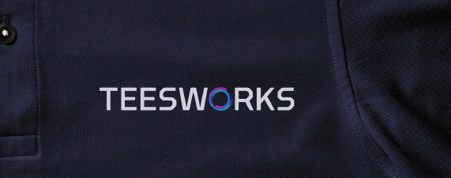

Logo 3 – Hard Hat front centre, colour as per below artwork

