TTC_ICT_2017-2021 Invitation to Tender for the Supply of ICT Hardware and Provision of Support

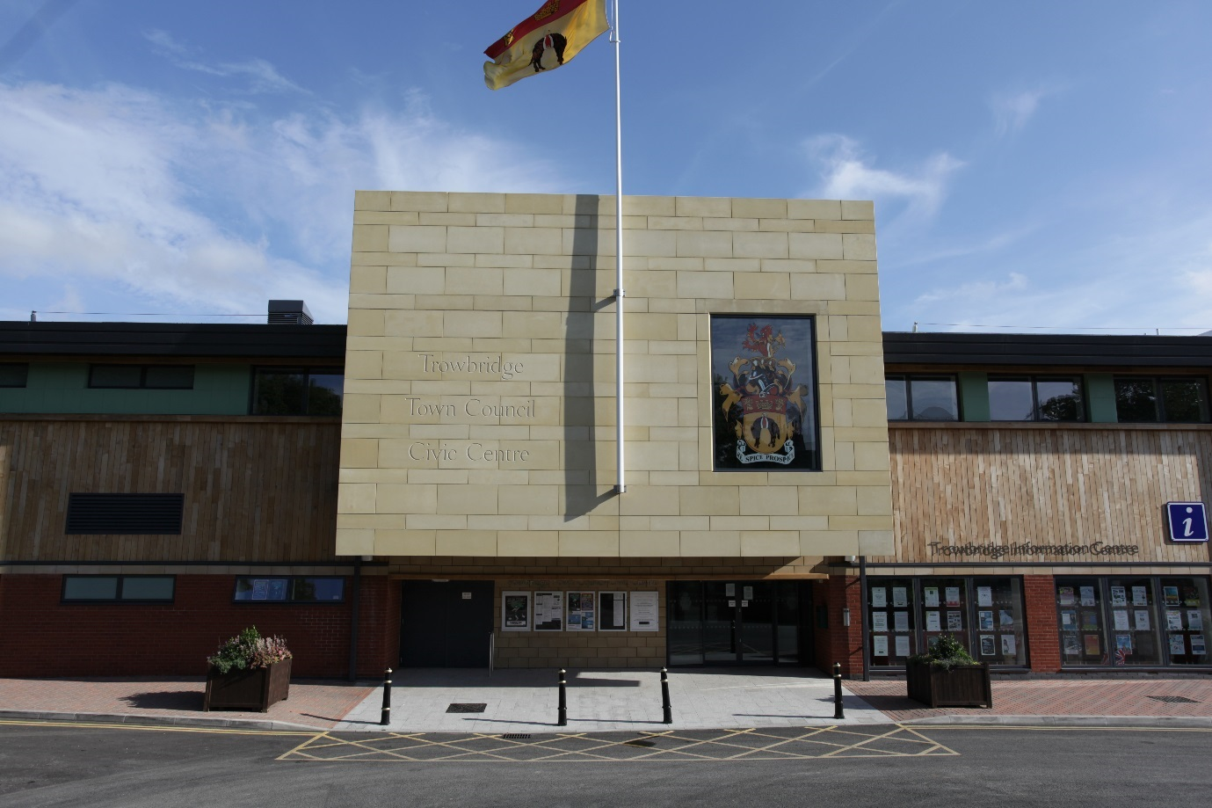

APPROVED FINAL

Contents

Instruction to Tenderers 4
Tender Application Form 18
Sections 1-7 Questionnaire 18
Section 8 Weighted Criteria 18
Form of Offer 27
Tender Submission Checklist 30

Instruction to Tenderers

- Completion and Submission of Tender Documents

  - All tenders must be completed in English and, where applicable, signed in ink.

  - All tenders must be submitted in accordance with the documentation and
requirements provided herein. This must not be amended in any way.

  - Tenders may be rejected if the required information is not given at the time
of tendering.

  - Suppliers should submit One hard copy and One electronic copy of their tenders preferably on a USB memory stick or CD.

  - Completed tender documents must be submitted in a plain sealed envelope and returned to the Facilities Manager at the Civic Centre (see label enclosed at the end of this document) with name of the supply and service being tendered for clearly marked, before the closing date. The envelope must not identify the name of your company.

  - The Council would advise that tenders sent by post be registered or sent by Recorded Delivery. An official receipt should be obtained for each Tender delivered by hand.

  - Tenderers are advised that manually delivered Tenders can only be accepted during normal office hours i.e. between 9.00 am to 5.00 pm Monday to Friday. Tenders sent by special delivery or delivered by hand will not be accepted on either weekends or on Public and Statutory Holidays.

  - The return date for this tender should be no later than FRIDAY 24th March 2017 at 12 noon. Any clarification messages regarding this opportunity must be emailed to karl.buckingham@trowbridge.gov.uk

  - Please ensure that you allow sufficient time to follow the instructions provided. Trowbridge Town Council is not obliged to accept the lowest or any tender.

  - TTC cannot accept responsibility for postal or delivery delays.

  - Under no circumstances will late tenders responses be considered.

  - TTC will not be responsible for any costs or expenses incurred by the
Tenderer in connection with the preparation or delivery or evaluation of the Tender.

1.13 Your attention is drawn to the enclosed Terms of Offer where all the requirements for completing and submitting a tender can be found. Failure to comply with these instructions may result in your tender being rejected.
Terms of Offer

- Information and confidentiality
1.1 Information that is supplied to tenderers as part of the procurement exercise is supplied in good faith. However, tenderers must satisfy themselves as to the accuracy of such information and no responsibility is accepted for any loss or damage of whatever kind or howsoever caused arising from the use by the tenderers of such information, unless such information has been supplied fraudulently by Trowbridge Town Council.

1.2 All information supplied to tenderers by Trowbridge Town Council in connection with this procurement exercise shall be regarded as confidential. By submitting an offer the tenderer agrees to be bound by the obligation to preserve the confidentiality of all such information.

1.3 This Offer and its accompanying documents shall remain the property of Trowbridge Town Council and must be returned on demand.

1.4 If tenderers provide any information to Trowbridge Town Council in connection with this procurement exercise, or with any Contract that may be awarded as a result of this exercise, which is confidential in nature and which a tenderer wishes to be held in confidence, then tenderers must clearly identify in their offer documentation the information to which tenderers consider a duty of confidentiality applies. Tenderers must give a clear indication which material is to be considered confidential and why you consider it to be so, along with the time period for which it will remain confidential in nature. The use of blanket protective markings such as “commercial in confidence” will no longer be appropriate. In addition, marking any material as “confidential” or equivalent should not be taken to mean that Trowbridge Town Council accepts any duty of confidentiality by virtue of such marking. Please note that even where a tenderer has indicated that information is confidential, Trowbridge Town Council may be required to disclose it under the FOIA (Freedom of Information Act) if a request is received.

1.5 Trowbridge Town Council cannot accept that trivial information or information which by its very nature cannot be regarded as confidential should be subject to any obligation of confidence.

1.6 In certain circumstances where information has not been provided in confidence, Trowbridge Town Council may still wish to consult with tenderers about the application of any other exemption such as that relating to disclosure that will prejudice the commercial interests of any party.

1.7 The decision as to which information will be disclosed is reserved to Trowbridge Town Council, notwithstanding any consultation with you.

2. Samples
2.1 Tenderers should not need to submit samples of any items offered. However if a need to provide samples is critical in choosing the correct supplier these samples shall be provided free of charge.

3. Prices
3.1 Prices must be stated in accordance with the Tender Application Form and must remain open for acceptance until 90 days from the closing date for the receipt of offers.

3.2 Prices must be firm (i.e. not subject to variation) for the period of the contract subject only to any variation provisions contained in the contract documents.

4. Tender documentation and submission
4.1 Tenders should be submitted for all goods and services only and not selected. The desire of the Town Council is that there is only one point of contact. The only exemption for this would be the requirement to have direct correspondence with any leasing companies for hardware.

4.2 The goods and/or services offered should be strictly in accordance with the specification.

4.3 Tenders must comprise of:
- Completed Sections 1-7 Questionnaire
- Completed Sections 8 Weighted Criteria
- Signed Form of Offer
- Tender submission checklist

4.4 The Form of Offer must be signed by an authorised signatory: in the case of a partnership by a partner for and on behalf of the firm: in the case of a limited company, by an officer duly authorised, the designation of the officer being stated.

4.5 The Form of Offer and accompanying documents must be completed in full. Any Offer may be rejected which:
- contains gaps, omissions or obvious errors; or
- contains amendments which have not been initialled by the authorised signatory; or
- is received after the closing time.

4.6 All queries or difficulties should be directed to the e-mail address below.

4.7 Project lead times should be indicated where possible.

Also, all companies interested in bidding should upon receipt of the tender
document send a formal e-mail to the address below indicating the tender for
which they will be submitting a bid. karl.buckingham@trowbridge.gov.uk

5. Official Amendments
  - Should it be necessary for Trowbridge Town Council to amend the tender
documentation in any way, prior to receipt of tenders, all tenderers in receipt of documents will be notified simultaneously. If deemed appropriate, the deadline for receipt of tenders will be extended.

6. Assumptions
6.1 Tenderers must not make assumptions that Trowbridge Town Council has
experience of their organisation or their service provision even if on a current or previous contract. Tenderers will only be evaluated on the information provided in their response. Embedded documents or hyperlinks must not be used unless requested.

7. Canvassing
  - Any tenderer who directly or indirectly canvasses any official of Trowbridge Town Council concerning the award of contract or who directly or indirectly obtains or attempts to obtain information from such official concerning the proposed or any other tender will be disqualified. This should not, however deter any supplier seeking clarification in relation to the tender.

8. Sustainable Development & Socially Responsible Procurement Benefits
  - The Government is committed to sustainable development, sustainable
procurement and socially responsible procurement and Trowbridge Town Council would wish to see tenderers adopt a sustainable approach.

9. The Evaluation Process

9.1 The tender evaluation process shall be completed in two stages: 1. Selection and 2. Award

9.2 Tenderers will need to fully meet the requirements of Stage 1 to progress on to Stage 2

9.3 The contract will be awarded on the basis of value or money. The weightings assigned will be as follows:

Most Economically Advantageous Criteria: | Weighting %
Cost | 100%
Total | 100%

Where weighting is applied to non-cost criteria, the scores for such shall be allocated on the following basis:

Assessment | Score Awarded | Interpretation
Excellent | 5 | Excellent response with detailed supporting evidence and no weaknesses. Response demonstrates that the Tenderer will provide excellent services if awarded.
Good | 4 | Good response with good supporting evidence and minimal weaknesses. Response demonstrates that the Tenderer will provide good services if awarded.
Satisfactory | 3 | Satisfactory responses with satisfactory supporting evidence but lacks sufficient detail to award a higher mark. Response demonstrates that the tenderer will provide satisfactory services if awarded.
Poor | 2 | A response/answer/solution with reservations. Lacks convincing detail and the methodology to be applied. Medium risk that the proposed approach will not be successful
Very Poor | 1 | An unacceptable response with serious reservations. Limited detail of methodology to be applied. High risk that the proposed approach will not be successful
Unacceptable | 0 | Failed to address the question.

A score of 2 or less will render the submission ineligible and it will be withdrawn from process.

9.4 The successful Tenderer will be required to execute a formal agreement. The Council’s written acceptance of the Tender will form a binding contract between the Council and the successful Tenderer.

9.5 Unsuccessful suppliers may request feedback from the adjudication panel if required.

9.6 All costs and expenses associated with presentations shall be borne by the Tenderers.

STATEMENT OF REQUIREMENTS

10. Background
Trowbridge Town Council is the first tier of local government for the County Town of Wiltshire, serving a population of over 40,000 and providing a range of services for the community. The council has over 50 employees across 4 departments.

10.1 Project background:
Our current IT set-up is one that has been in place for 15+ years but one that hasn’t adapted to the ICT modernisation or to the growth of the Council and its users. Users currently have a full desktop Client Machine (Fat Client) with large power supplies running power hungry hardware connecting to one physical server which hosts 3 virtual servers. Security of such set-up is mainly defined by Group Polices set within Active Directory. Security with this set-up is not as secure as the proposed Thin Client Set-up.
Most users are in the Civic Centre, one user connects via VPN and 5 users connect via an optic cable linking the Museum to the Civic Centre. The Server room is in the Civic Centre. All phone lines come into the Civic Centre where the PBX is located. The Museum uses the fibre link to access the server, PBX and broadband.
Our broadband is provided by means of bonding a VirginMedia 200mb service to a BT 40mb service using Peplink Balance 380.
Wifi within the Civic Centre is distributed over 5 access points with two networks, one for internal and a guest network. We use Ruckus Wireless ZoneDirector to administer and configure the AP’s.
Virtual servers are currently ‘HyperV’ and are as follows:
Vserv1 – Hosting AD, File Storage, Security, Print Drivers
Vserv2 – Exchange Server (Now backed-up and shut down since O365 introduction)
Vserv3 – MODES achieve database and Rendezvous bookings software.

Current switches are 5+years old
Server 5+ years old
Client machines 3-7 years old mostly running windows 7
Phones 2-5 years old and PBX 5 years+
Wifi infrastructure 3+ years old

10.2 Partners/Software:

The below list of partner software is used by various officers in different departments. In some cases, some are configured using netshare attributes under AD control. These will require setting up in any proposal being offered in consultation with their corresponding providers. Further information can be found in 12.

RBS Software, Omega (Finance) and Allotments
NFS Rendezvous, Facility booking software
Pear Technology, PTM Mapper Pro (Mapping system)
MODES, Museum achieve database system
Evolvi Rail Tickets system
Papercut Print Management
Paxton Access Control
Priva (TC Vision) Building Management System
Maximizer, Sports booking system

11. Detailed Specification (Leased equipment)

11.1.a High Spec Thin Clients x 40

Lease suppliers must fully satisfy this specification as a mandatory requirement.
40 x Thin Client Machines with following minimum specification or equivalent Operating system:

Windows embedded 8 Standard 64bit OS
8GB MLC M.2 SSD
4GB DDR3l-1600 SODIMM
USB
23’ LED Screen with audio.
Clint machine to Screen mount
Stand with adjustable height
Wireless Keyboard and Mouse
Relevant Licences to operate

11.1.b
1 x Thin client with increased performance and graphics, duel 23” screens with audio, duel screen desk mount, Wireless Keyboard and Mouse and relevant licences to operate.

11.1.c Lease of 3/4 years, next business day, return to base, on-site repair, swap out and accidental damage.

11.2a High Spec Core Server Replacement (File storage, Virtual Servers, AD etc)

19” Rack mount Server
Intel 8 Core CPU or similar
48gb RAM
3 x 2 TB Hard drives in AID 5 array
Hardware RAID Card
Single Power Supply
Dual Gigabit LAN
DVD RW Drive
Microsoft Windows Server 2012+
Server should achieve an upgrade on our 1gb network. i.e a 10gb backbone
Rack Mount UPS – Uninterruptable Power Supply to suit
Lease of 3/4 years, next business day, return to base, on-site repair, swap out and accidental damage.

11.2b High Spec Terminal Server Replacement

19” Rack mount Server
Twin (Two processors) Intel 8 Core CPU or similar
48gb RAM
3 x 2 TB Hard drives in AID 5 array
Hardware RAID Card
Single Power Supply
Dual Gigabit LAN
DVD RW Drive
Microsoft Windows Server 2012+
Server should achieve an upgrade on our 1gb network. i.e a 10gb backbone
Lease of 3/4 years, next business day, return to base, on-site repair, swap out and accidental damage.

11.3 Core Network Switch Replacement

4 x Rack Mounted Network Switches upgrading our 1gb network to a 10gb network. (1 dedicated to phones)
Lease of 3/4 years, next business day, return to base, on-site repair, swap out and accidental damage.

11.4 VoIP Phone System

28 x Desktop SIP Phones
1x Desktop Switch Phone (Reception)
1x Portable (Handheld)
New PBX system should utilise the benefits of SIP Technology
Installation of new dedicated internet connections for phones only
Allowance for programming of individual VM, Auto Answer, Day and night modes with different auto answer options, Call forwarding, international restrictions, Music on hold, Call pick up
Easy to use admin centre for the ICT officer to be able to make changes.
Relevant licences to operate.
Lease of 3-4 years, next business day, return to base, on-site repair, swap out and accidental damage.

11.5 Upgrade to Wi-Fi Network

11.5a 3 x Additional Ruckus Access points (Subject to Survey) for location at Trowbridge Museum
2 x Additional Ruckus Access points for black spots at the Civic Centre
Reconfiguration of existing Ruckus wireless controller
Creation of 3 wireless networks. 1 x internal/hidden, 1 x Guest for Civic Venue, 1 x Guest for Trowbridge Museum. Both guests require data capture for marketing purposes.

11.5b Option to replace existing Wireless set-up

11.6 Security

Business grade security software (Eset or similar) to best manage and reduce any threats of viruses to the council’s network and ICT systems. The suite should work in harmony with any policies that are determined by the active directory and should provide regular reports to the Facilities Manager.

11.7 Microsoft O365

Hosting and licencing for Microsoft Office 365 Business Premium

11.8 Broadband

To host broadband for the Civic Centre, Museum, Longfield Community Centre, and a Community Hub. (Details for current requirements can be requested if not already mentioned)

11.8 ICT Support Contract

The support agreement must be one that is consistent and proactive from the offset. The below is a minimum level expected from the support contract highlighting what is essential to our organisation:

- Dedicated account manager who understands the council’s business and requirements
- Proactive monitoring of all hardware with a status report being sent to the Facilities Manager daily
- Proactive scanning for viruses or threats to the hardware
- Programmed engineer site visits every 3 months to carry out system maintenance
- Online reporting of faults (Ideally where individuals can report a fault which is directed to the Facilities Manager who then approves the log)
- 4-hour window for remote support
- Next day window for site support
- Support to Microsoft 0365
- Support to the bonding appliance for the broadband

12. General information on Third Party Software
12.a RBS Software Technical Specification
OS requirements:
- Windows Server 2003
- Windows Server 2008
- Windows Vista
- Windows 7
- Windows 8
- Windows 10
Not MAC Compatible unless virtual windows environment is set up.
Programs and data can be stored on any Windows compatible network file system.

Current Omega Financial Software:
All machines running the package must have Borland BDE administrator software installed to control database access.
Database: Paradox file-based.
Program space requirements: 50Mb
Data space requirements: approx. 10Mb per set of accounts (so max 1Gb)
Backup requirements: Package has built-in backup system, which stores data in zip file format.
Future Rialtas Suite – Omega
Going forward the system is changing to the Rialtas Suite, which is a Firebird Server Database, however it still requires a Windows Operating System as the Rialtas Suite will not operate on a NAS drive.
The server (can be installed locally or on a Server) with the suite loaded on to the PC locally.

12.b NFS Rendezvous Booking Software Technical Specification
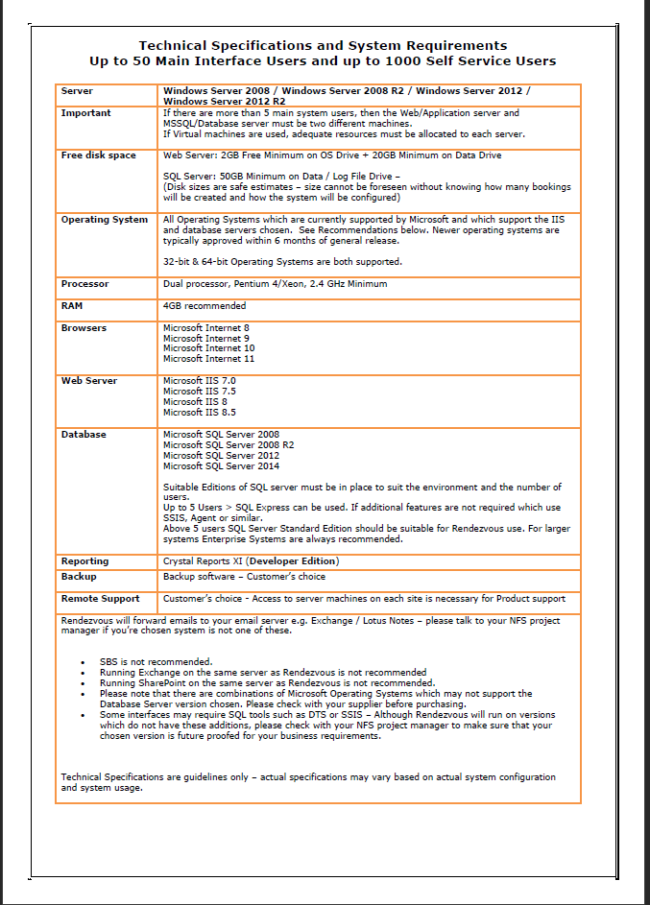
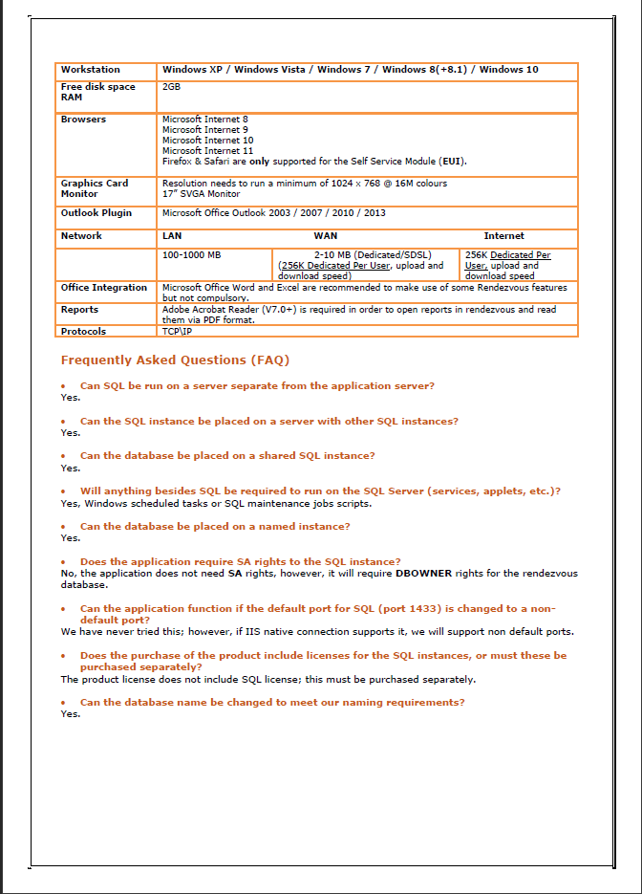

12.c Pear Technology Technical Specification
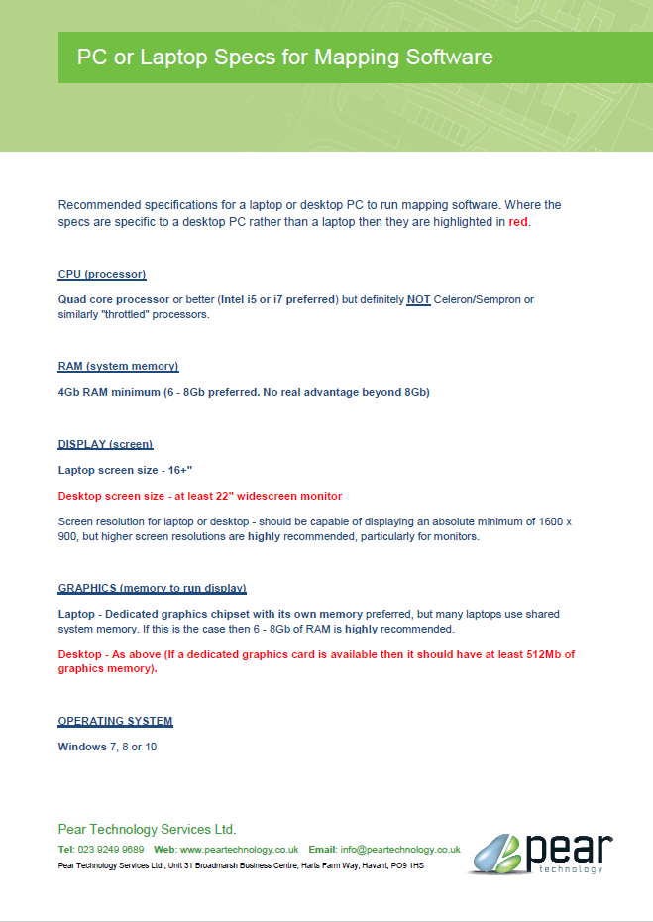

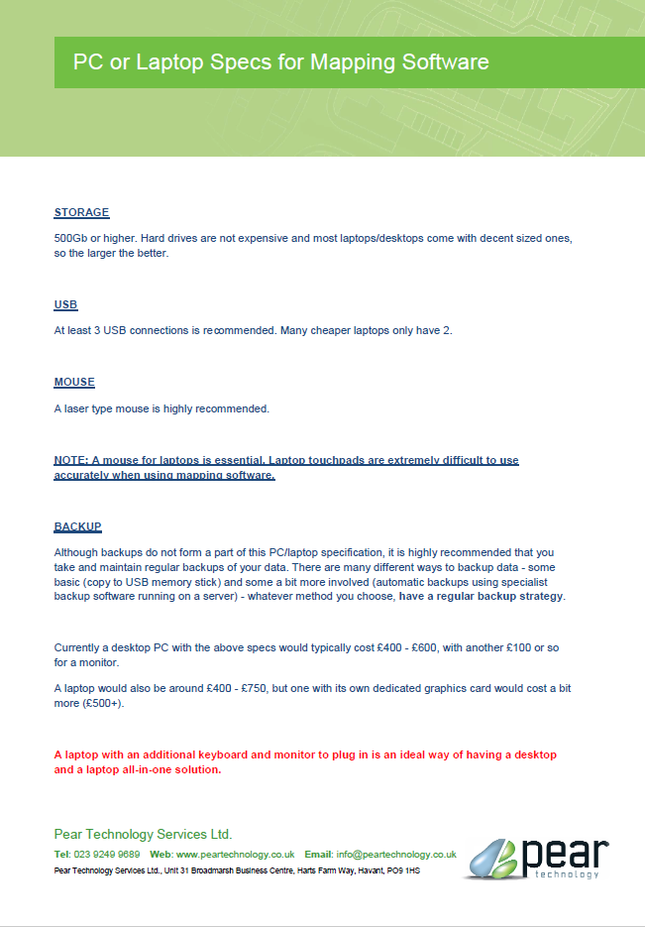

12.d MODES Software Technical Specification
General

Modes is a Server/Client based system so is ideally suited to a Thin Client type set up. The Modes Client or Workstation program would be installed on the required number of client machines (currently 3 but could be increased subject to purchase of enhanced license). The server program and all associated data, resource files and accompanying images are installed and accessed on a server.
Modes Complete runs on both 32-bit and 64-bit operating systems.
Modes Complete will not run on Linux or Mac operating systems.

Server specification

The Modes Complete Server requires a Windows operating system, such as Windows Server 2003, Windows Server 2008 or Windows Server 2012. It may also be run on Windows XP, Vista, Windows 7, Windows 8 or Window 10.
For optimum performance a dedicated server is recommended with a minimum of 4GB RAM, and a fast network (for example 100Mbit).
Modes Complete Server can be run on a server shared with other applications, but
performance will be slower. 2GB RAM should be reserved for Modes Complete Server.
Modes Complete Server can be run on a virtual server. Data files should be stored on the same physical machine as the application. NAS drives and other external devices are not recommended for live databases.
Image files and other resources may be stored on any drive or network location.
The system uses an integrated NexusDB database, and does not require SQL.
The Server application requires 5.5 MB of disc space plus 225MB for resource files
The system requires approximately 15MB – 20MB of space for each 1000 records, not including images and other multimedia files which may be linked to the database.

Client specification

The Modes Complete Client will run on Windows XP, Vista, Windows 7, Windows 8 or Windows 10 with at least 4GB of RAM.
A minimum screen resolution of 1024 x 768 pixels is recommended. The display should be set to 96 dpi (‘normal’, ‘smaller’ or ‘100%’) as some control functions will be lost if the display is set to 20 dpi (‘ large’, ‘medium’ or ‘125%’).
The Client application requires 86.5 MB of disc space.

12.e Evolvi Rail Tickets Technical Specification
Unable to provide specification for tender document

12.f Printers and Papercut Print Management Technical Specification

Operating System
- Windows Server 2016 / 2012 / 2012 R2 / 2008 / 2008 R2 / 2003 SP2, Windows 10*, Windows 8*, Windows 7*, Windows Vista*
(core, server, advanced server, enterprise edition, 64-bit edition, workstation*, professional* versions all supported)
Microsoft Clustering Services supported at all application layers
- Apple Mac OS X 10.8 or higher
- Novell Open Enterprise Server 2 Linux (OES 2 SP1, SP2 (with hotfix applied) or SP3) and Novell OES 11.
- Most modern Linux distributions including Red Hat 6.0+, Novell SUSE 11.0+, Debian 6.0+, and others (requires GNU glibc 2.11 or higher)†

Memory
- 768MB minimum supported (2GB or higher recommended)
Most modern print servers should have a base of 4GB of memory. Note that PaperCut will only use 1/4 of the available memory by default, so plan to have 4GB of memory minimum to allow PaperCut to use up to 1GB, or by Increasing the memory available to PaperCut.

Hard Disk
- 300 MB, plus additional storage for logs and print history. When using Print Archiving (off by default) then a minimum of 100GB of free disk space is recommended.
Most modern print servers should have a base of 60GB to 500GB of storage available.

12.g Paxton Access Control Technical Specification
We currently use Net2 from their range with access to the software via remote desktop to vserv1. More details on Net2 can be found on their website.

12.h Priva Building Management System Technical Specification
The BMS software is currently on a stand-alone client machine which is connected by Remote Desktop. The software is programmed and maintained by Matrix Ltd. The software requires updating and the intention is for this software to be loaded on the server which would allow smoother remote desktop sessions and to allow the sub-contractor to connect remotely.
12.I Maximiser, Sports Booking System Technical Specification
Moving from SQL Server to a cloud based system, no server requirements required at time of tender.

Tender Application Form

Sections 1-7 Questionnaire

Section 8 Weighted Criteria

Completion of sections 1-8 of this application are mandatory for all tenderers.
Tenderers must fully satisfy these requirements to progress to second stage. Failure to do so will result in exclusion from the second stage tender evaluation process.

1. | BUSINESS DETAILS
 | Name of the organisation in whose name the tender is submitted:
 | Contact name for enquiries about this bid:
 | Contact position (Job Title):
Address:

Post Code:

Telephone number:

Fax number:
 | E-mail address:
 | Website address (if any):
 | Company/Charity Registration number (if this applies):
 | Date of Registration:
Registered address if different from the above:
Post Code:
 | VAT Registration number:
 | Is your organisation:  (Please tick one) |  | i) a public limited company?
 |  |  | ii) a limited company?
 |  |  | iii) a partnership
 |  |  | iv) a sole trader
 |  |  | v) other (please specify)
 | Name of (ultimate) parent company (if this applies):
 | Companies House Registration number of parent company (if this applies):
Is your organisation a:

- SME (Small & medium sized enterprise - a business that has 1 to 250 employees)
- SEE (Social Economy Enterprise – has a social, community or ethical purpose; operates on a commercial business model; is profit making but not profit taking)
- VOC (Voluntary or Community)
- Large Enterprise (a business that has 250+ employees)
 |  | INSURANCE
 |  | Please provide details of your current insurance cover |  | Value
 |  | Employer’s Liability: |  | £
 |  | Public Liability: |  | £
 |  | Other (please provide details): |  | £

 | QUALITY ASSURANCE
 | Does your organisation hold a recognised quality management certification for example BS/EN/ISO 9000/PQASSO or equivalent? If yes, please provide evidence of certification. |  | Yes / No
 | If not, does your organisation have a quality management system? |  | Yes / No
 | If you do not have quality certification or a quality management system, please explain why:

 | HEALTH & SAFETY
 | Does your organisation have a written health and safety at work policy? |  | Yes / No
 | Does your organisation have a health and safety at work system? |  | Yes / No
 | If “No”, to either of the above please explain why:

 | ENVIRONMENTAL MANAGEMENT
 | Does your organisation have an environmental management system? |  | Yes / No
6.2 | If “No” to the above please explain why:

 | PROFESSIONAL AND BUSINESS STANDING
 | Do any of the following apply to your organisation?
 | Is in a state of bankruptcy, insolvency, compulsory winding up, receivership, composition with creditors, or subject to relevant proceedings | Yes / No
 | Has been convicted of a criminal offence related to business or professional conduct | Yes / No
 | Has committed an act of grave misconduct in the course of business | Yes / No
 | Has not fulfilled obligations related to payment of social security contributions | Yes / No
 | Has not fulfilled obligations related to payment of taxes | Yes / No
 | Is guilty of serious misrepresentation in supplying information | Yes / No
 | Is not in possession of relevant licences or membership of an appropriate organisation where required by law | Yes / No
 | If the answer to any of these is “Yes” please give brief details below, including what has been done to put things right.

7 | RELEVANT EXPERIENCE
 | Please provide evidence that demonstrates your experience and ability to deliver the types of goods and/or services to the Council taking into account the duration, scope, complexity, value of the potential contract and be of a comparable size.
 | Contract start date | End date (if applicable) | Contract Value | Org. in receipt of your products /services | Contact  Name & Address
 | Please tick if we can contact the organisations above for a reference

8 | Please make your offer as per below. All the information requested within the documents must be clearly detailed. Please do not alter the format or product details of the spread sheet. This document will ensure that all suppliers are tendering on a “level playing field” and allow accurate comparison between proposals.  Prices should be supplied in pounds sterling, excluding VAT. There should preferably be no minimum order quantity requirements (exceptions to this rule should be highlighted).  The specification and pricing schedules will form the basis of the core contract price lists and should also demonstrate your ability to supply a significant proportion of the required service.
  8. PRICING weighting 100%
Item No. | Description | Tenderers response - cost per item | Tenderers response -cost in total (incl. discount) (excl. VAT)
1 | HIGH SPEC THIN CLIENTS  Lease suppliers must fully satisfy this specification as a mandatory requirement.  40 x Thin Client Machines with following minimum specification or equivalent Operating system:  Windows embedded 8 Standard 64bit OS  8GB MLC M.2 SSD  4GB DDR3l-1600 SODIMM  USB  23’ Led Screen with audio.  Clint machine to Screen mount  Stand with adjustable height  Wireless Keyboard and Mouse  Relevant Licences to operate  1 x Thin client with increased performance and graphics, dual 23” screens with audio, duel screen desk mount, Wireless Keyboard and Mouse and relevant licences to operate.  Lease of 3/4 years,
2 | HIGH SPEC CORE and TERMINAL SERVERS  19” Rack mount Core Server  Intel 8 Core CPU or similar  48gb RAM  3 x 2 TB Hard drives in AID 5 array  Hardware RAID Card  Single Power Supply  Dual Gigabit LAN  DVD RW Drive  Microsoft Windows Server 2012+  Server should achieve an upgrade on our 1gb network. i.e a 10gb backbone  Rack Mount UPS – Uninterruptable Power Supply to suit  19” Rack mount Terminal Server  Twin (Two processors) Intel 8 Core CPU or similar  48gb RAM3 x 2 TB Hard drives in AID 5 array  Hardware RAID Card  Single Power Supply  Dual Gigabit LAN  DVD RW Drive  Microsoft Windows Server 2012+  Server should achieve an upgrade on our 1gb network. i.e a 10gb backbone  Lease of 3/4 years, next business day, return to base, on-site repair, swap out and accidental damage.
3 | CORE NETWORK SWITCHES  4 x Rack Mounted Network Switches upgrading our 1gb network to a 10gb network. (1 dedicated to phones)  Lease of 3/4 years, next business day, return to base, on-site repair, swap out and accidental damage.
4 | VoIP PHONE SYSTEM  28 x Desktop SIP Phones  1x Desktop Switch Phone (Reception)  1x Portable (Handheld)  New PBX system should utilise the benefits of SIP Technology  Installation of new dedicated internet connections for phones only  Allowance for programming of individual VM, Auto Answer, Day and night modes with different auto answer options, Call forwarding, international restrictions, Music on hold, Call pick up  Easy to use admin centre for the ICT officer to be able to make changes.  Relevant licences to operate.  Lease of 3-4 years, next business day, return to base, on-site repair, swap out and accidental damage.
5 | OPTION TO UPGRADE WIFI  3 x Additional Ruckus Access points (Subject to Survey) for location at Trowbridge Museum  2 x Additional Ruckus Access points for black spots at the Civic Centre  Reconfiguration of existing Ruckus wireless controller  Creation of 3 wireless networks. 1 x internal/hidden, 1 x Guest for Civic Venue, 1 x Guest for Trowbridge Museum. Both guests require data capture for marketing purposes.  Option to replace existing Wireless set-up, must be quoted as a separate item.
6 | SECURITY  Business grade security software (Eset or similar) to best manage and reduce any threats of viruses to the council’s network and ICT systems. The suite should work in harmony with any policies that are determined by the active directory and should provide daily reports to the Facilities Manager.
7 | MICROSOFT O365  Hosting and licencing for Microsoft Office 365 Business Premium (Currently 46 licences)
8 | BROADBAND  To host broadband for the Civic Centre, Museum, Longfield Community Centre, and a Community Hub.
9 | ICT SUPPORT CONTRACT  Minimum level expected from the support contract highlighting what is essential to our organisation:  - Dedicated account manager who understands the council’s business and requirements  - Proactive monitoring of all hardware with a status report being sent to the Facilities Manager daily  - Proactive scanning for viruses or threats to the hardware  - Programmed engineer site visits every 3 months to carry out system maintenance  - Online reporting of faults (Ideally where individuals can report a fault which is directed to the Facilities Manager who then approves the log)  - 4-hour window for remote support  - Next day window for site support  - Support to Microsoft 0365  - Support to the bonding appliance for the broadband

Form of Offer

Form of Offer

TTC_ICT_2017-2021 Invitation to tender for the supply of ICT hardware and provision of support
Period of contract: 36months with an option to extend for a further period of 12 months

FORM OF OFFER
I / We [insert name of tenderer] (‘the Tenderer’) of [insert address of tenderer]
Agrees:

1.1 That this Tender and any contracts arising from it shall be subject to the Terms of Offer, the enclosed Terms and Conditions of Contract and Supplementary Conditions of Contract and all other terms (if any) issued with the Invitation to Offer; and

1.2 to supply the goods and/or services in respect of which its offer is accepted (if any) to the exact quality, sort and price specified in the Offer Schedule in such quantities, to such extent and at such times and locations as ordered; and

1.3 that this offer is made in good faith and that the Tenderer has not fixed or adjusted the amount of the Offer by or in accordance with any agreement or arrangement with any other person.

The Tenderer certifies that it has not and undertakes that it will not:

1.3.1 communicate to any person other than the person inviting these offers the amount or approximate amount of the offer, except where the disclosure, in confidence, of the approximate amount of the offer was necessary to obtain quotations required for the preparation of the offer, for insurance purposes or for a contract guarantee bond;

1.3.2 enter into any arrangement or agreement with any other person that he or the other person(s) shall refrain from making an offer or as to the amount of any offer to be submitted.

2 / We [insert name of tenderer] (‘the Tenderer’) of [insert address of tenderer]

Name (print):

Signature:

Title:

The Form of Offer must be signed by an authorised signatory: in the case of a partnership, by a partner for and on behalf of the firm; in the case of a limited company, by an officer duly authorised, the designation of the officer being stated.

Return Address Label:

The Facilities Manager
Trowbridge Town Council
The Civic Centre
St Stephen’s Place
Trowbridge
Wiltshire
BA14 8AH

TTC_ICT_2017-2021 Invitation to tender for the supply of ICT hardware and provision of support

Period of contract: 36months with an option to extend for further period of 12months

CLOSING DATE:
FRIDAY 24th MARCH by 12 noon

Tender Submission Checklist

Tenderers should confirm that the following requirements have been met within their tender by placing a tick in the box opposite

Completed Tender Application Form
- Sections 1-7 Questionnaire
- Sections 8 Weighted Criteria
- Signed Form of Offer
- Clearly Marked Envelope using Return Address Label

