**Improving Connections, Permeability and Wayfinding in Waterloo and South Bank – Strategy and Delivery Plan**

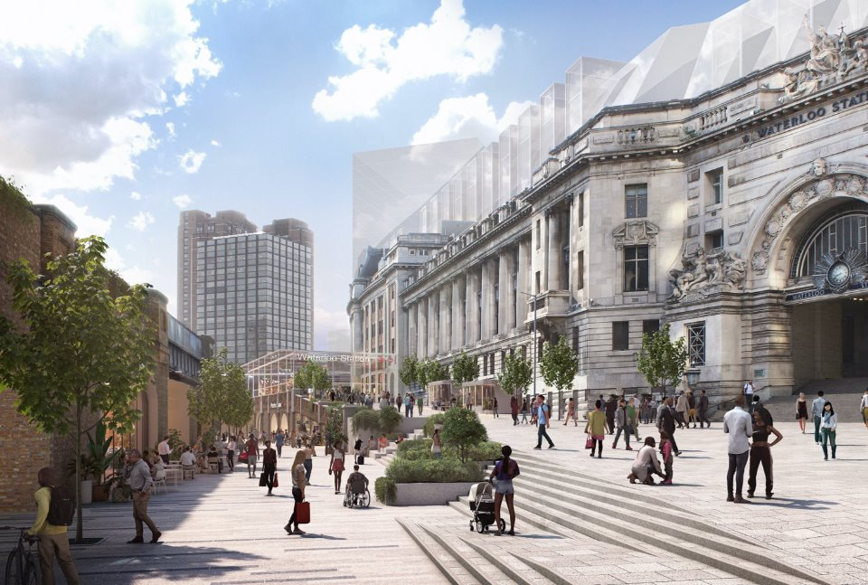**Credit :Grimshaw Architects**

**Client:** London Borough of Lambeth

**Indicative Budget:** Up to £80,000 (Including expenses, excluding VAT)

**Deadline for submission:** 12pm, Monday 11th November 2024

**CONTENTS:**

1. Introduction Page 3
2. Background Page 4
3. Project Objectives Page 6
4. Study Area Page 7
5. Project Stages and Outputs Page 8
6. Expertise Requirements Page 12
7. Governance Page 12
8. Budget and Timeline Page 13
9. Achieving Social Value Page 13

Appendix 1 – Key Policy and Strategy Drivers Page 14

**COMMISSION PURPOSE**

1. **INTRODUCTION**
   1. In 2022 a group of key partners, including Lambeth Council, Network Rail, South Bank Employers’ Group, South Bank and We Are Waterloo BIDs, LCR Property, as well as local developers HB Reavis, Bourne Capital and SB Royal Holdings Ltd , appointed a multi-disciplinary team led by Grimshaw Architects to develop a strategic masterplan for the transformation of Waterloo Station and the surrounding neighbourhood. This was completed in Autumn 2023, setting out a cohesive [vision and strategic framework](https://www.lambeth.gov.uk/housing/regeneration-projects/waterloo-station-vision) to support the transformation of the station into a world-class multimodal hub, fully integrated into the surrounding areas, and with more welcoming, sustainable and people-centric spaces around it.
   2. The vision was successfully launched in March 2024 and partners continue to work together, to sustain momentum and alignment through the next stages of the project. This includes ongoing feasibility work to further develop the proposals and opportunities identified in the vision, and where possible, to deliver improvements in the short term.
   3. In line with this, the local authority has identified a number of ‘quick win’ projects to deliver small but impactful transformations in the short term, including public realm interventions to improve connections and public spaces, as well as strategies to support the local economy and its communities.
   4. The overarching aim of this commission is to address one of the key challenges facing the area – a lack of connectivity and permeability, with the station acting as a major barrier to connectivity across the neighbourhood. Its interface with the public realm is currently poor, with main exits/entrances focused on one side of the station, making the area confusing and difficult to navigate. There is a need for clearer routing and more amenable journeys to key areas and destinations around the station, including St. Thomas’ Hospital, the South Bank, Leake Street, Lower Marsh and The Sidings.
   5. The main aspiration, therefore, is to improve the way people experience movement and journeys across the area by enhancing, highlighting and strengthening connections to key destinations, neighbourhoods and communities surrounding the station.
   6. This is the first piece of work the local authority is bringing forward to begin to deliver against the Masterplan vision, and as such we want it to match the ambition and high-quality of the work undertaken to date
   7. The work should result in a creative wayfinding strategy - including placemaking guidelines and ideas, and a series of proposals for practical and tactical interventions that can be delivered in the short term.
   8. These interventions should build on and speak to the different areas’ needs, strengths and unique characters, and help create inviting spaces that evoke a sense of identity and belonging.
   9. These should be developed through a meaningful engagement and co-design process, which allows key community groups, including young people and children, to play an active role in influencing and shaping these proposals.
   10. Partnership has been key to the success of the Masterplan and has meant a cohesive vision and plan which looks beyond the environs of the station to the surrounding area – considering improvements to the public realm and connections into the communities which surround it, benefiting the experience of residents, workers, local businesses, stakeholders, and the wider community, and stitching together the many component parts of the area into a coherent whole.
   11. The Council works with and through a number of partnerships in the area and while the commission will be led and managed by Lambeth Council, it will be delivered in partnership with the local Business Improvement Districts (BIDs) and other key local stakeholders.
   12. The Waterloo and South Bank area has a history of strong community involvement and of partners coming together to affect change. The Waterloo Station Masterplan demonstrated the strength of those partnerships, bringing together the Council, Network Rail and TfL with South Bank Employers’ Group, the Business Improvement Districts, landowners and other partners. As a result, collaboration is an essential part of the development of this project.

1. **BACKGROUND**
   1. Waterloo and South Bank plays a vital and central role in London’s economy and culture as one of the capital’s most successful tourist areas with its world-renowned cultural institutions, attracting around 30 million visitors a year.  The South Bank is home to The Royal Festival Hall, Hayward Gallery, BFI and National Theatre whilst the Old and Young Vics on The Cut mean audiences traversing the area on a daily basis.
   2. It is home to the borough’s key growth sectors, increasingly becoming a leading business district with emerging specialisms in medical technology (medtech) and the green economy, as well as its established creative and digital base
   3. Part of the Central Activities Zone, Waterloo and South Bank is poised to undergo once in a generation levels of development. Major investments are being made, with several high profile planned developments delivering residential, commercial, cultural, and community infrastructure. Complemented by the presence of Kings College London and St Thomas’ Hospital the area is a bustling central London location, with a rich mix of activity, as well as a much-loved local neighbourhood.
   4. At its heart, Waterloo Station, one of the UK’s busiest railway stations – is used by 100 million people every year, and with excellent transport links across London and the UK, plays a key role in enabling and supporting this growth.
   5. However, the station itself acts as a barrier to connectivity across the neighbourhood. Its interface with the public realm is currently poor and coupled with a lack of intuitive wayfinding, results in a confusing pedestrian environment, severing communities and making journeys across the area difficult and unpleasant.
   6. The Masterplan provides a cohesive long-term vision for the station and its surrounding environment, with clear proposals that seek to respond to the challenges the station and wider area face, whilst building on its strengths and opportunities to help the area realise its full potential. It sets out a vision for a station and public realm that easily connects to nearby neighbourhoods and cultural institutions and transforms Waterloo and South Bank into a healthier, safer and sustainable neighbourhood, with an integrated world-class station and civic hub at its heart.
   7. The vision is underpinned by a series of themes and principles, providing a cohesive framework for the delivery of the proposed transformations, as outlined below:

* Theme 1 – A connected, permeable and integrated place: Improving access and movement within and around the station through new and improved routes and connections to key anchor destinations such as South Bank, St Thomas’ and the emerging SC1 district; increasing pedestrianisation in key areas around the station providing better access and civic presence; and promoting active travel through improved cycle routes and infrastructure.
* Theme 2 – Welcoming, accessible, and green public realm: Improving the experience of routes and spaces by creating areas of high-quality, safe and inclusive public realm and new green infrastructure, promoting equitable access to green and play spaces and encouraging footfall, dwell time and activation of spaces.
* Theme 3 – A thriving, vibrant and diverse place for all: Understanding the area’s context, character and identity and identifying needs and opportunities to inform and support inclusive economic growth and shape potential development opportunities.
* Theme 4 – Sustainable, inclusive growth and opportunities: Identifying opportunities to unlock development opportunities and maximise the potential of underutilised assets to fund improvements across Waterloo and support benefits of new jobs and skills, affordable workspace and community amenities.
* Theme 5 – A resilient, sustainable and healthy Waterloo and South Bank: Proposals identify a series of environmental opportunities and outcomes, including net zero, climate adaptation and resilience, building and energy, air quality, transport and movement, waste, consumption and food, biodiversity and environmental quality, circularity and resources.
* Theme 6 - A world class multimodal hub: Promoting key changes to station concourse and entrances to alleviate congestion, unlocking spaces within and around the station to improve its civic presence and passengers’ arrival experience, as well as connections to and through; this will act as a catalyst to enhance wider connectivity across the area, stitching the station back into the city and enabling the creation of more jobs and better provision of services, assets and amenities.

1. **PROJECT OBJECTIVES** 
   1. The main objective for this commission is to develop a coherent and cohesive **wayfinding** strategy that enhances, highlights and strengthens connections from the station to key destinations and communities in the surrounding area, and significantly improves the journeys and experience of residents, workers, commuters and visitors.
   2. The overarching strategy and set of proposed interventions should celebrate and respond to the different and unique character and identity of the surrounding neighbourhoods and address the specific needs and priorities of those moving through the area, whilst addressing the following key elements:

* Movement: improving access and connections to key areas and attractors around the station and the experience for pedestrians moving through and to these.
* Identity: creating clear and inviting routes that are strongly defined, assisting with people’s navigation of the area.
* Safety: increasing a sense of safety and security through improved quality of spaces and lighting.
* Inclusivity: creating fully accessible and gender and age inclusive routes that make everyone feel welcome and able to move freely and comfortably.
* Cultural heritage: delivering interventions that celebrate, draw on and emphasise the area’s rich cultural offer and that facilitate local communities’ access to arts and culture.
* Local economy: reflecting and drawing out the area’s exciting local economy and growth sectors (arts and culture, med tech, life sciences, green economy) through different interventions.
* Community: celebrating the area’s differences, whilst helping to knit communities together and foster a sense of belonging regardless of which area or neighbourhood people come from.

3.3 **Placemaking**: In the short term, there are several opportunities to improve the public realm, which will support the local economy. This commission is part of a wider programme of projects being developed and delivered following the completion of the masterplan to support these outcomes.

Consideration should therefore also be given to how this project could use creative placemaking interventions to broaden the appeal of the station and its environs.

3.4 **Engagement and co-design**: Meaningful engagement will be key for the development and delivery of the next stages of the masterplan, including this commission. The main aims and aspirations for this engagement will be to:

* Work collaboratively to create spaces that resonate with the aspirations of Waterloo and South Bank residents, visitors and local organisations, and the unique identity of the place.
* Involve under-represented voices – particularly young people and children, as well as established groups previously engaged through the masterplan, in the design of the proposed interventions.
* Ensure engagement with the visitor demographic including station users, passenger groups and hospital users.
* Collaborate with two Lambeth Elevators ([ELEVATE’s youth advisory board](https://elevatelambeth.london/)) to develop a robust and meaningful engagement plan.
* Through creative and adaptative approaches, ensure that the engagement process provides meaningful opportunities for those groups to inform proposed interventions based on their skills, research, local knowledge and lived experience through informal discussions, workshops and surveys.

1. **STUDY AREA**

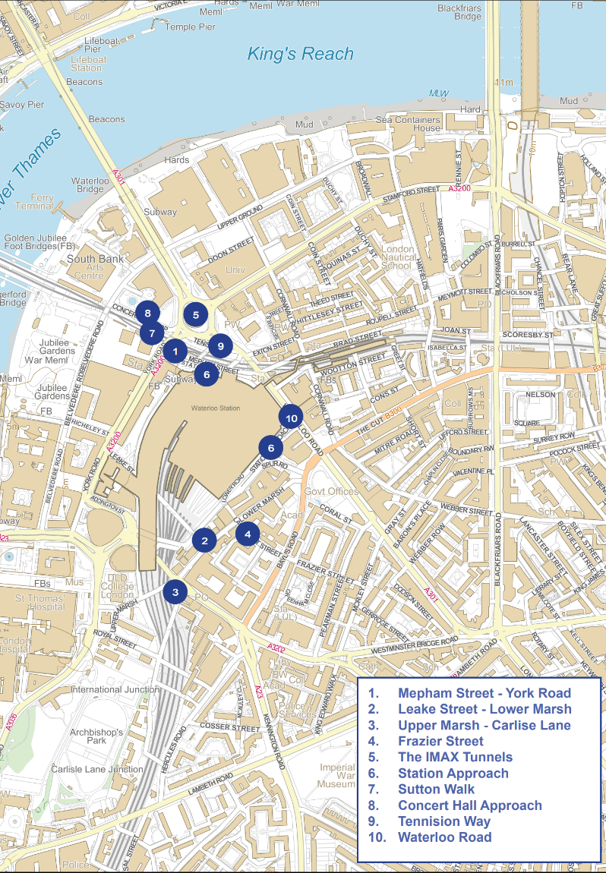

4.1 The study area for this commission is the station and its environs. Key routes and spaces for the commission to address will come from the information gathering stage of the work but we expect that the project scope may include consideration of enhancing and improving connectivity via:

|  |  |
| --- | --- |
| * Mepham Street/York Road | * Leake Street/Lower Marsh |
| * Westminster Bridge Road | * Frazier Street |
| * The IMAX Tunnels | * Station Approach |
| * Sutton Walk | * Concert Hall Approach |
| * Tennison Way | * Waterloo Road |
| * Chicheley Street/York Road | * Upper Marsh/Carlisle Lane |

1. **PROJECT STAGES AND OUTPUTS**

**Key outputs**

* A high-level overarching wayfinding framework that establishes key principles to inform all interventions, drawing on the Masterplan aspirations and referencing the needs and priorities of different routes and places along these routes.
* The framework should also establish a clear and coherent identity that links all the proposed interventions, highlights and celebrates the areas’ strengths, and draws on existing characteristics of the locality.
* Creative and innovative design proposals for each identified key route. The purpose of which will be to improve the ease and experience of moving through/along. Proposals should be at a range of scales for intervention, with deliverability a key consideration. These proposals should also be the result of a meaningful engagement and co-design process with key community groups, with a particular focus on young people and children.
* A Design toolkit, as a practical reference for future branding and wayfinding interventions.
* A Delivery plan including estimated timescales, costs and delivery mechanisms.

**Proposed Project Stages**

|  |
| --- |
| 1. **Project Inception**   To establish a common understanding of the project structure and governance and collectively confirm and agree the project objectives and specification before the work commences.  Specifically, to:   * Understand and agree project objectives * Agree project programme * Discuss and agree approach to engagement and co-design * Discuss and refine the study area and project boundaries * Discuss and agree payment schedule * Undertake a joint walkabout/site visit |

|  |
| --- |
| 1. **Agreement of an Engagement & Co-design Approach**   The strategy and proposals should build upon a meaningful engagement and co-design component. The proposed approach to engagement should be set out as part of the bid submission, and should consider the following:   * Early engagement with partners and wider stakeholder groups to develop a clear understanding of issues and outcomes. * Engagement should be considered throughout the life of the commission. * Innovation in the approach to meaningful engagement and co-design is welcomed. * Consideration should be given to the active participation and involvement of children and young people, to add value to the commission outputs. * The consultant will be expected to engage with our Lambeth Elevators who will act as both ‘ambassadors’ and ‘critical friend’ to support engagement with children and young people specifically. * Lambeth Officers will complete a Child Right’s Impact Assessment for this project and will work with the consultant to ensure relevant information is captured at key points. |

|  |
| --- |
| 1. **Information Gathering and Baseline Analysis**   To review and collate key policy and background information and develop an understandingofcurrent conditions along key routes within the study area.   * Review relevant background documentation from the Council, GLA and key stakeholders (see list of background documents in Appendix 1) including previous studies and design work relevant to this commission. * Review relevant background data provided by the Council and key stakeholders (i.e. crime statistics and passenger surveys). * Audit the effectiveness of current wayfinding measures in place across the area including Legible London and its role in wayfinding locally. * Review the pre-engagement completed with stakeholders to inform this brief. * Undertake movement analysis to confirm and further identify key routes to and from the station and establish how, why and by whom these routes are being used – to establish an understanding of desire lines and wayfinding patterns. * Although the focus of this commission is the area around the station, it may be necessary to conduct movement analysis over a slightly wider area to inform the work given the wider context of the area within London. * Complete a route and space audit: Analysis and assessment of key focus routes and key points along them, providing an overview of current baseline condition and identifying opportunities for improvement, including:   + Mapping of areas of concern – in terms of lack of safety or ease of movement   + Identification of scope for improvement of individual spaces along the routes |

|  |
| --- |
| 1. **Strategy Development**   To create an overarching framework, establishing placemaking and design principles, alongside a clear and coherent identity to link all proposed interventions, addressing the project objectives.  The framework should:   * Establish core ambitions for the area – in relation to connectivity, permeability and identity with consideration given to delivery against the project objectives. * Establish placemaking and wayfinding principles to guide all interventions to improve journeying through the area, particularly to and from the station. * Provide an overview of opportunities for improvement of key spaces and routes identified in Stage 3. * It should also establish a clear and coherent identity to link all proposed interventions, highlighting and celebrating the areas’ strengths, and drawing on existing characteristics of the locality. * Consideration should also be given to alignment with existing wayfinding interventions and area branding, and with existing and pipeline projects and interventions (i.e. VNEB Low Line). |

|  |
| --- |
| 1. **Design Interventions and Toolkit**   To assemble a range of project proposals, or proposed design interventions, to improve journeys along identified key routes, with a design toolkit that can be used to inform future interventions in the area.   * A series of design interventions organised by route creating coherent journeys from or towards the station. * Proposals should respond to the placemaking and wayfinding principles already established. * Proposals should reflect a range of scales and levels of required intervention. * Consideration should be given to:   + 1. Accessibility and ease of movement both at key points and across the whole route generally.     2. Identification of opportunities for meanwhile uses/interventions.     3. Consideration of night-time and daytime functioning and appearance of the focus areas and spaces.     4. Illumination and lighting opportunities should be incorporated into the proposals in sufficient detail.     5. As appropriate, opportunities should be identified for the incorporation of green infrastructure. * As part of a design toolkit; design tools and guidelines should be considered as a reference point for future area branding and the development of future wayfinding interventions to be delivered in the area and/or as part of the Waterloo Station Masterplan. * Further consideration should be given to a digital or online application as well as an application in the physical realm. |

|  |
| --- |
| 1. **Delivery Plan**   To provide a detailed delivery plan, setting out the following:   * Mechanisms for delivery, including opportunities for partnership delivery (including on a short-, medium- and long-term basis). * Estimated costs for interventions at a range of scales. * Possible funding options to support delivery. * Timescales for delivery * Other elements such as site/space ownership, interdependencies (with other projects in the area) and constraints should be identified and included in this plan. |

|  |
| --- |
| 1. **Final Report**   To collate all completed work into one highly visual and accessible final report.  The report will bring together:   * Initial area baseline analysis, including overview of challenges, opportunities and stakeholder/partner aspirations. * Wayfinding and framework addressing principles linked to movement and connections, identity and branding, inclusivity, culture, local economy, community and engagement. * Collection of design intervention proposals by area. * Design Toolkit which allows other partners to deliver against the strategy as required, in a cohesive way. * Detailed delivery plan, including delivery mechanisms, timescales and costs. |

1. **EXPERTISE REQUIRED**

6.1 We are looking for a creative team with strong innovative and creative placemaking credentials. The consultant, or consortium of consultants, is expected to assemble a multidisciplinary team including the following knowledge and skills:

* Place branding/creative and design expertise
* Architecture and/or urban design and placemaking experience (including movement analysis)
* Experience delivering engagement and co-design activities as part of public realm and placemaking projects or strategies

6.2 The assembling of a consortium team is encouraged, given the scope of the work; however, any consortium must have a lead consultant taking on all contractual and project management responsibilities.

1. **GOVERNANCE**
   1. It is important to ensure the strategy and proposed interventions are reflective of local ambition, aligned with the masterplan aspirations and informed and shaped by key stakeholders.

7.2 A client working group will meet fortnightly to review progress and relevant members of the appointed consultant team will be expected to attend these meetings.

7.3 A steering group will be established to provide strategic advice and guidance. It is envisaged it will meet every six week or at key gateways in the commission as relevant; to sign off proposals before they move to the next stage. Relevant members of the appointed consultant team may be asked to contribute to these meetings.

7.4 In addition to these meetings the consultant team/representatives of the consultant team will also be required to attend:

* Information gathering/engagement meetings with key stakeholders at key milestones of the project (to be jointly agreed) but to include at least two events to test the developing strategy with different users
* Two community group or wider community organisation sessions.
* Three children and young people’s workshops or other engagement/co-design events.
* Attendance at one event with stakeholders to present/launch the final report.

1. **BUDGET AND TIMELINE**

8.1 The budget ceiling for this commission is £80,000 excluding VAT. We are seeking competitive tenders and welcome any recommendations on how to maximise the value and output of this commission. The fixed fee should include all expenses, consultation costs, production and printing.

8.2 Requirements of outputs and documents are as follows:

* All outputs should be made available in accessible PDF format, with drawings and any other technical outputs made available in relevant electronic formats, as agreed at project inception.
* The copyright will belong to London Borough of Lambeth.
* A payment schedule will be agreed with the appointed lead consultant.

8.3 Below is the programme timetable providing indicative milestones; to be further discussed with the successful team upon appointment:

|  |  |
| --- | --- |
| **Milestone** | **Date** |
| Contract Award and Inception Meeting | December 2024 |
| Presentation of project methodology and initial findings to stakeholder group | January 2025 |
| Baseline analysis and information gathering complete | February 2025 |
| Emerging strategy sign-off | April 2025 |
| Draft Report Sign Off | June 2025 |
| Final Report Sign Off | July 2025 |
| Launch and delivery | July 2025 |
|  |  |

1. **ACHIEVING SOCIAL VALUE**

9.1 Under the Public Services (Social Value) Act 2012 Councils have a responsibility to consider Social Value in commissioning goods and services and it requires all public sector organisations to consider how the services they commission and procure might improve the economic, social and environmental well-being of the area the contract will support.

9.2 The Council is using the definition of social value as created by The Sustainable Procurement Task Force and widely used in Scotland, Wales, and England. This explains social value as, ‘a process whereby organisations meet their needs for goods, services, works and utilities in a way that achieves value for money on a whole life basis in terms of generating benefits to society and the economy, whilst minimising damage to the environment’.

9.3 The delivery of social value is of upmost importance to the Council and forms part of the Lambeth 2030 vision and within this project will form part of the evaluation that tenderers should respond to. For the purposes of this submission, potential providers should refer to the Council’s policy in demonstrating how they will integrate social value priorities within social, economic and environmental capacities throughout the commission; details of the policy are set out [here](https://beta.lambeth.gov.uk/business-rates-services-and-licensing/selling-services-lambeth-council/council-contract/responsible) .

**APPENDIX – KEY POLICY AND STRATEGY DRIVERS**

1. Key policy and strategy drivers

|  |  |
| --- | --- |
| **Document** | **Summary** |
| [London Plan March 2021](https://www.london.gov.uk/sites/default/files/the_london_plan_2021.pdf) | Sets out Mayor’s policies for how London should grow; includes Waterloo and South Bank as part of Central Activities Zone and an Opportunity Area – 1,500 homes and 6,000 additional jobs. |
| [Lambeth Local Plan](https://www.lambeth.gov.uk/sites/default/files/2021-09/Lambeth%20Local%20Plan%202021.pdf) | Priorities for Waterloo centred around high quality, permeable, safe and accessible public realm together with capacity, accessibility and quality improvements. See Policy PN1 for full scope. The Regulation 18 Draft Site Allocations Development Plan Document will be out to consultation from 10 January (following Cabinet on 13 December) including key sites in Waterloo. |
| [Lambeth Borough Plan](https://www.lambeth.gov.uk/sites/default/files/2023-03/Lambeth_2030-Our_Future_Our_Lambeth.pdf) | Sets the corporate focus and objectives of the Council to 2030: Lambeth – a borough with social and climate justice at its heart. |
| [Waterloo Station Masterplan](https://www.lambeth.gov.uk/sites/default/files/2024-03/WSM%20section%201-%20Introduction_0.pdf) | Provides a cohesive vision and a framework to support the delivery of transformational changes to the station and the surrounding neighbourhood, improving connections into its communities and stitching together the many component parts of this thriving place into a coherent whole. |
| [South Bank & Waterloo Neighbourhood Plan](https://www.sowneighbours.org/_files/ugd/613f49_06134c1930264d71aff106e44edff9c1.pdf) | Creation of new strategic links between the station and Lower Marsh, night-time and cultural use of the under crofts, reduction in pollution. |
| [Waterloo & South Bank Public Realm Framework](https://moderngov.lambeth.gov.uk/documents/s113861/Appendix%201_Waterloo%20and%20South%20Bank%20Public%20Realm%20Framework.pdf) | Proposes a range of high-level design briefs for key streets and public spaces in the neighbourhood. |
| [Waterloo Placemaking Strategy](https://wearewaterloo.co.uk/wp-content/uploads/2023/06/WaterlooPlacemakingStrategyFinal-compressed.pdf) | Created by Allies and Morrisons for We Are Waterloo Business Improvement District in 2022 this document sets out the placemaking narrative for potential public realm interventions in Waterloo. |
| [Waterloo and South Bank Future Neighbourhoods Strategy 2030](https://www.lambeth.gov.uk/sites/default/files/2022-11/Waterloo%20and%20South%20Bank%20FN2030%20Strategy_Final%20-%20Copy.pdf) | Sets out a clear vision to achieving a net zero and resilient neighbourhood by 2030, including improved cycle and green infrastructure, air quality and reduction of traffic. |
| [Lambeth Transport Strategy](https://www.lambeth.gov.uk/transport-strategy) | This strategy sets out how Lambeth will build a transport network that is inclusive, has a positive impact on quality of life and the environment, helping to deliver more homes and jobs and ensuring long term sustainability. See also [Climate Action Plan](https://www.lambeth.gov.uk/sites/default/files/2022-03/Executive-Summary.pdf) and [Kerbside Strategy](https://lambeth-kerbside.org/) for associated reading. |
| [Child Friendly Lambeth](https://www.lambeth.gov.uk/child-friendly-lambeth) | Lambeth are embarking on an ambitious three to five-year programme to be recognised as a UK Committee for UNICEF (UNICEF UK) Child Friendly Community. This borough-wide partnership programme will see participation from the local authority, schools, community and faith groups, voluntary and community sector organisations, local businesses, police, health providers and commissioners. |
| Lambeth Night Strategy | In development - Lambeth’s Night Time Strategy will set out Lambeth’s vision to make sure everyone who lives, works and visits the borough has access to fun and affordable activities, good working conditions, safe neighbourhoods and transport, and relevant services between 6 pm and 6 am. The strategy work is guided by the Lambeth 2030 ambitions to make Lambeth a fair and equitable Borough. |
| [VNEB Low Line](https://www.lambeth.gov.uk/planning-and-building-control/regeneration-projects/vauxhall-nine-elms-battersea-vneb-regeneration) | Vauxhall and Albert Embankment are part of Nine Elms, on the South Bank. Extending from Lambeth Bridge in the north down to Battersea Power Station it is the largest central London regeneration area. By 2030, it will be a distinctive new central London neighbourhood and is a major opportunity for the local community and the whole of London. |
| [South Bank Spine Route Masterplan](https://www.lambeth.gov.uk/sites/default/files/2023-06/South_Bank_Spine_Route_Masterplan_Report.pdf) | The South Bank Spine Route Masterplan sets out designs to enhance the network of streets around Jubilee Gardens, the South Bank Centre, the National Theatre, and Bernie Spain Gardens. The designs reimagine the local streets, prioritising pedestrians and cyclists, improving the public space, and making the area more climate resilient. |