Expression of Interest England Ecosystem Survey Supplier Response
The information collected from this EOI shall inform the requirements and potential future procurement routes for the England Ecosystem Surveys. Please return the completed form to dgc.NCEA.Commercial@defra.gov.uk before 10:00 6th November 2023. The information collated shall be retained for a maximum of 3 years.
Supplier name:
Supplier email:
Are you happy to be contacted about current or future opportunities at Natural England relevant to this expression of interest |  |  |  |  |  |  | ☐Yes  ☐No
Based on the information provided in Appendix 1, and the attached Vegetation and Landscape survey protocol and Project Scope document please:
Clarify which biogeographical zone (BGZ) your organisation could cover
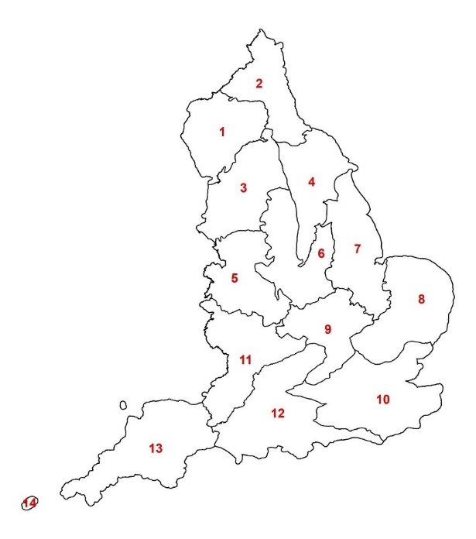 |  |  |  |  | ☐BGZ 1  ☐BGZ 2  ☐BGZ 3  ☐BGZ 4  ☐BGZ 5  ☐BGZ 6  ☐BGZ 7 | ☐BGZ 8  ☐BGZ 9  ☐BGZ 10  ☐BGZ 11  ☐BGZ 12  ☐BGZ 13/14  ☐All of the above
Please confirm the number of monads your organisation could feasibly survey during the following time periods*.
*Please note, the authority will confirm the location of the monads with the supplier, the supplier will not be required to obtain access permissions. We estimate the median time taken for two field surveyors to complete a monad is 4 days (excluding travel).
Time period |  | Estimated number of Soils monads surveyed
August – October
November – January
February – April
Please detail any assumptions that have informed your estimation of how many monads could be surveyed over a three-month period.
Please insert commentary here:
- If you have assumed, based on the survey protocol, that the number of days required to survey a monad is higher or lower than the 8 surveyor days estimate we provided, please provide some detail on your reasoning. Are there any efficiency’s that can be made to reduce the survey time per monad?

Please provide some detail on how you would resource the delivery of field surveys. Your response should provide clarity on whether the supplier would seek to sub-contract some of this work, what proportion of the work they would seek to sub-contract, and how they would go about mobilising sub-contractors. Are there mitigations that can be put in place to reduce the risk of limited sub-contractor capacity?
Please insert commentary here:

Would your organisation have capacity to deliver these surveys?
During the 2024 survey season (from March 2024 onwards) |  |  | ☐ Yes, in full as described above  ☐ Yes, in part  ☐ No, we do not have capacity during this survey season to take on this work.
During the 2025 survey season (from February 2025 onwards) |  |  | ☐ Yes, in full as described above  ☐ Yes, in part  ☐ No, we do not have capacity during this survey season to take on this work.
During the 2026 survey season (from February 2026 onwards) |  |  | ☐ Yes, in full as described above  ☐ Yes, in part  ☐ No, we do not have capacity during this survey season to take on this work.
Please confirm the availability of staff with:
FISC/BSBI level 3 equivalent botanical field skills, or equivalent experience. |  |  |  | ☐ Readily available  ☐ Staff available but they have limited capacity  ☐ We are struggling to recruit staff at this level.
FISC/BSBI level 4 equivalent botanical field skills, or equivalent experience. |  |  |  | ☐ Readily available  ☐ Staff available but they have limited capacity  ☐ We are struggling to recruit staff at this level
FISC/BSBI level 4 or above botanical field skills, or equivalent experience. |  |  |  | ☐ Readily available  ☐ Staff available but they have limited capacity  ☐ We are struggling to recruit staff at this level
If you have any further comments or questions about the England Ecosystem Surveys, please specify these below:

