Statement of Requirements Compliance Matrix Template

SoR | Requirement | Fully Compliant? | Non-Compliance details and Actions to satisfy Contract Requirement | Reference to Relevant Justification in Service Delivery Plan | Reference to other Relevant Artefacts
0221108- DMS_NG_RAT_C2_SoR_DRAFT-v2.9 | SDA 4 – SUPPORT TO BUTEC | [BIDDER COMPLETE] | [BIDDER COMPLETE] | [BIDDER COMPLETE] | [BIDDER COMPLETE]
0221108- DMS_NG_RAT_C2_SoR_DRAFT-v2.9 | SDA 5 – SUPPORT TO MILITARY DIVING
0221108- DMS_NG_RAT_C2_SoR_DRAFT-v2.9 | SDA 7 - TASKING GUIDELINES
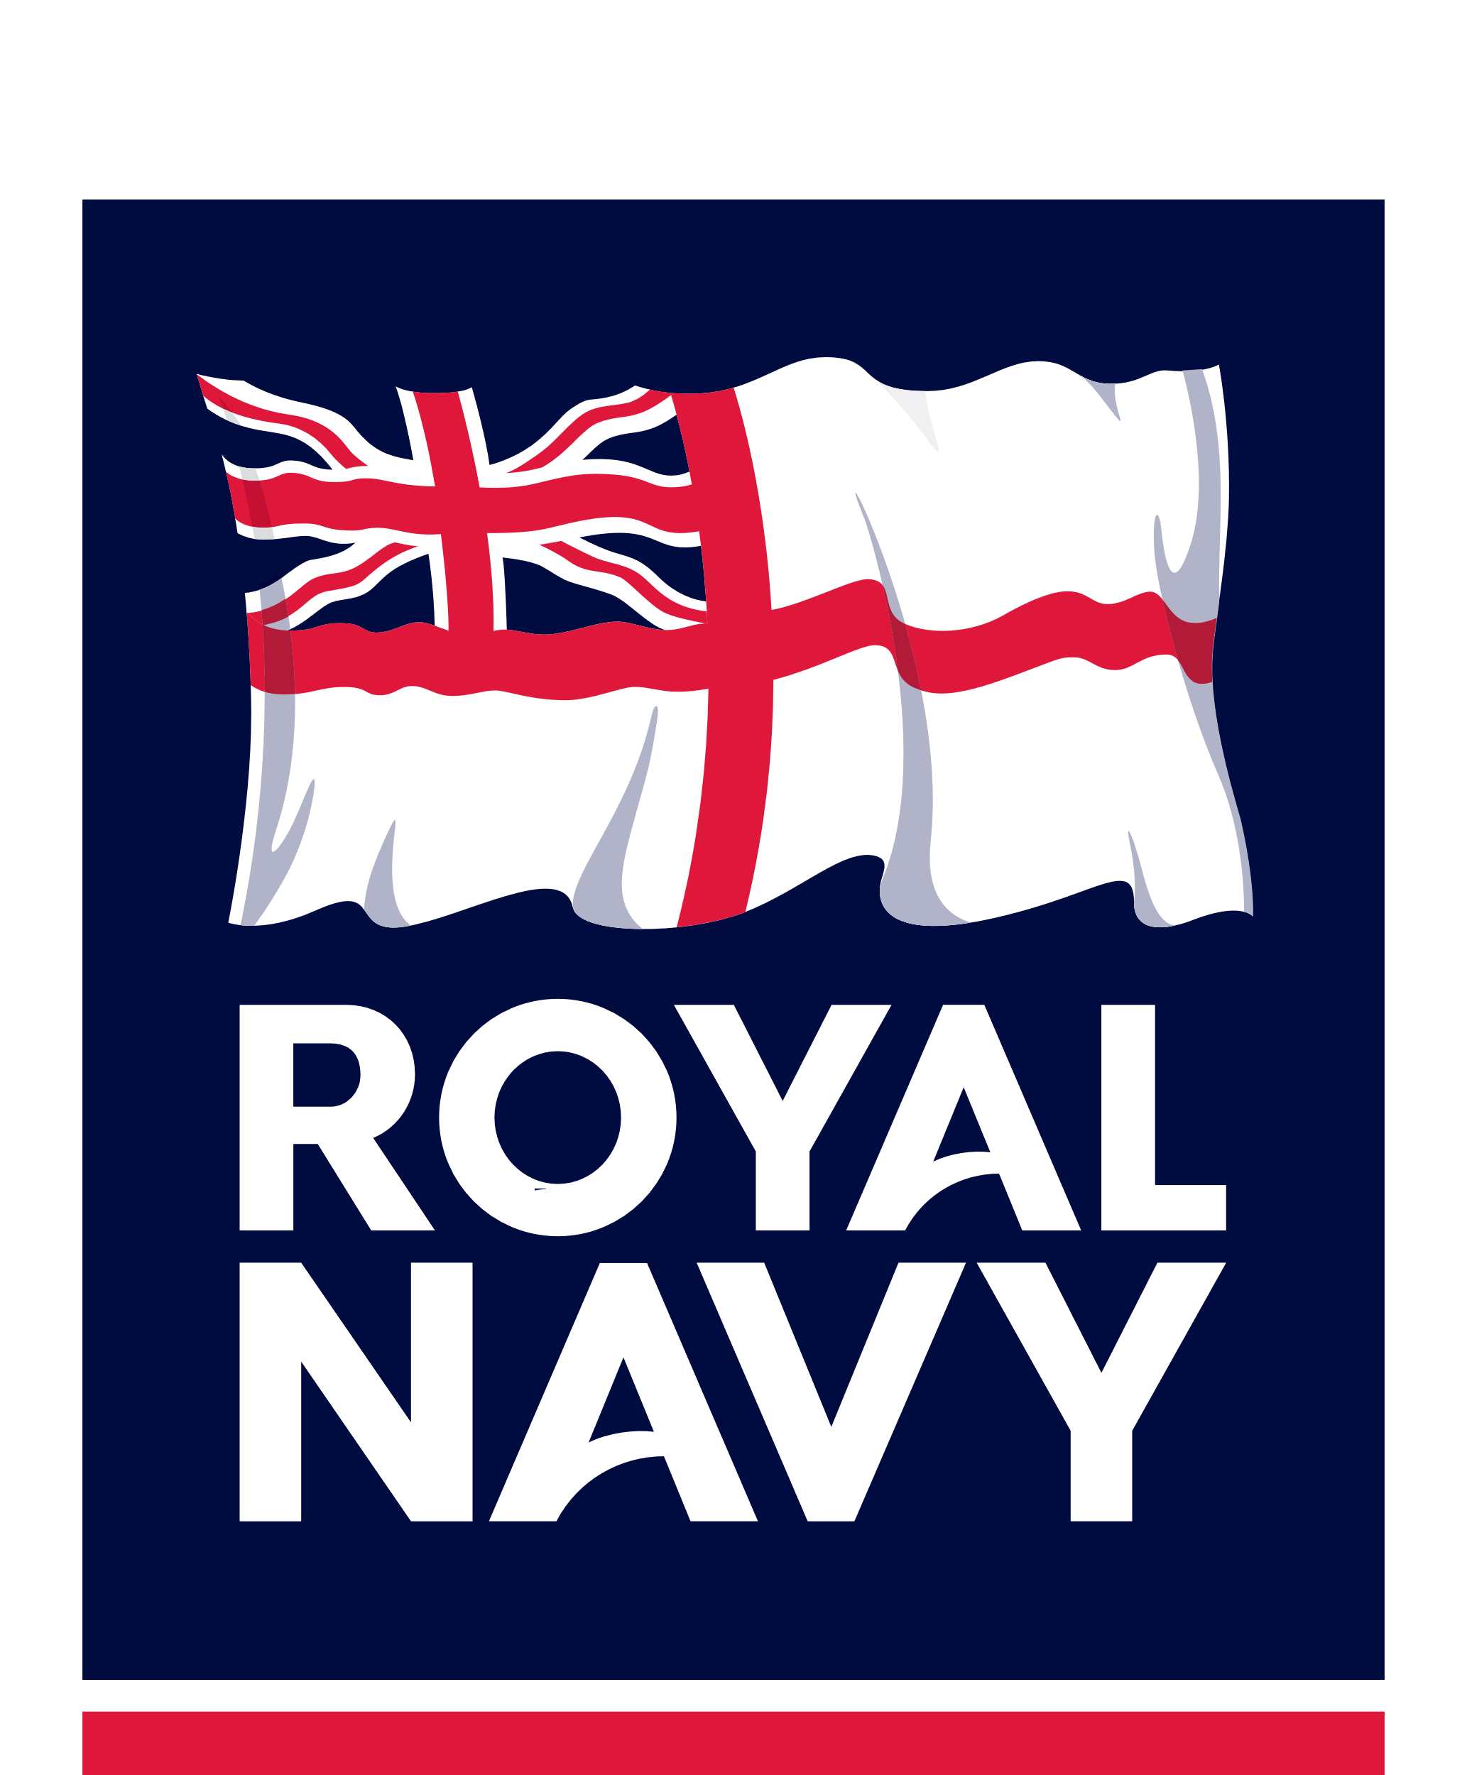
DMS-NG Invitation To Negotiate (ITN) Reference Contract 2 Inshore Support to Military Training, Testing, and Evaluation. (Contract Number 703249454)

