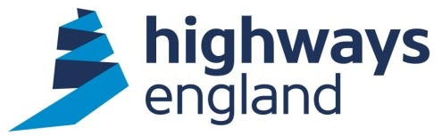  Our ref: Major Projects RP2 Transformation Programme TMO services  To: KPMG LLP  via Bravo | Highways England  The Cube  199 Wharfside Street  Birmingham, B1 1RN  27th May 2020

OFFICIAL SENSITIVE

AWARD LETTER

Dear X,

Management Consultancy Framework Two (MCF2) Lot 3: Complex And Transformation Consultancy Services

Major Projects RP2 Transformation Programme TMO Services

I am directed by Highways England Company Limited to inform you that your Offer dated 10th March 2020 for carrying out the above named contract, is accepted in respect of your proposals for completion in accordance with the Terms and Conditions of the Contract.

This Package Order start date is 1st June 2020, and the completion date is 31st May 2025.

You acknowledge that any documents and information submitted by you as part of your Tender or for validation purposes, represent your proposals for meeting Highways England’s requirements, but do not in any way override or modify those requirements. You will remain liable to comply with all the obligations set out in the documents forming part of the Contract. You will not be relieved from compliance with these obligations by any:

(a) Validation, due diligence or sustainability check carried out by Highways England on any part of your Tender;
(b) Evidence, assumptions or other information provided by you with your
Tender or for the purposes set out in paragraph (a) above; or
(c) Clarification requested by Highways England and provided by you (whether orally or in writing) as part of the assessment process.

You must treat this letter in confidence until Highways England makes any public announcement.

Please complete and return the acknowledgement contained in Annex A of this letter.

Please note that in order to set up a Purchase Order to allow payment, we will need to record your bank details on our payment system. You will be contacted separately to organise this process. You must quote a valid Purchase Order on each and every application for payment. Further details on the invoice process are contained in Annex B of this letter.

Yours sincerely,

Corporate Services Procurement Team

Annex A: Acknowledgement of contract

We acknowledge that Highways England has accepted our offer of 10th March 2020 for the Major Projects RP2 Transformation Programme TMO Services contract.

We acknowledge that a contract now exists between our organisation and Highways England under the terms specified in this letter, the Call Off Order Form and RM6008 framework agreement Terms and Conditions.

Signature
Print name
Position
Organisation

