

Personalised web and mobile PLATFORM

UOW941

Document Objective

The University of Worcester is currently reviewing the market and seeking expressions of interest from suppliers who can fulfil requirements for a personalised web and mobile platform for use by prospective students, applicants, registered students, and staff.

The University currently has approximately 10,000 registered students and 1800 staff.

Background

The University has a requirement for a personalised web and mobile platform that provides access to various University Services and information. The platform will need to allow the University to create customised dashboards for distinct groups, so they can access the information they need in a personalised way.
The dashboards will be accessed using a university account via federated access or anonymous access for prospective students.
A key requirement is that all user groups can access a dashboard through a web browser, or a mobile App which can be downloaded from the Apple or Google Play store.

Personalisation

Dashboards will need to be personalised to meet the differing requirements of staff and students.
For students, the dashboards need to evolve with them from the moment they embark on their journey at the University of Worcester, giving them a personalised, familiar, and seamless experience along every step of that journey from registering interest with the University, to becoming an applicant, through to welcome and induction and finally as a registered student.
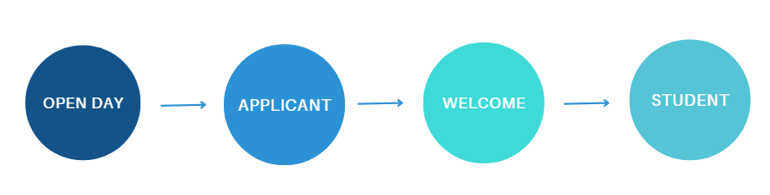
Throughout that journey personalisation is vitally important ensuring we surface only information that is relevant, and send communications are tailored to that audience.
Some Applicants may be International and therefore need to see additional information that home students would not find relevant, or some students may qualify for accommodation so they would need to see information on how to apply.
For a registered student they may study at either the Worcester or Dudley Campus, depending on their location they would need to see different local information such as maps, public transport times or catering offers.
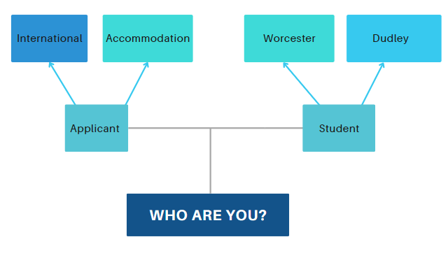

Communication

The platform will be a university wide service and has the capability to reach a wide range of students and staff and therefore will be a powerful tool to communicate and engage. The platform must have features that will allow the University to communicate with staff and students through a variety of ways. Key requirements are:
Dynamic information banners. There is a requirement to have several information banners active on a dashboard that rotate at regular intervals. Banners will be used to surface relevant information and can also link to web content.
Newsfeeds. A feature is required that can surface relevant information via a newsfeed. The Newsfeed will need to have the capability to be linked to multiple internal or external sources, where news articles can be clicked on to reveal more information.
Push notifications. There is a requirement to send push notifications for specific groups that are sent directly to a student or staff members mobile device if they have downloaded the App.

Information tiles.

Each dashboard will need to surface information tiles that are managed and authorised by the dashboard administrator. There are two types of tiles that would normally be used:
Temporary Tiles. This type of tile will be used to surface services or information that is relevant for a limited period, for example, this could be a link to a survey or a particular service that is important or useful at that time of year.
Information Tiles. These tiles can link to, or surface key information from applications such as our Virtual Learning Environment, student records system, timetabling system, MS365 applications such as email, OneDrive, or Calanders. Tiles may also link to external websites, or information within the platforms own Content Management System (CMS).

Content Management System (CMS).

There is a requirement to create content within the platform itself as well as linking or surfacing information from key systems or external websites. The CMS will need to be easy to use and allow administrators to produce professional, attractive content.

Reporting
There is a key requirement for an easy-to-use reporting tool that can be used to measure and report on key metrics. These metrics include:

- The number of clicks on tiles and banners for individual dashboards.
- The number of views or dismissals of push notifications.
- The number of downloads of the App.

Access

The platform must support MS Entra ID to allow seamless authentication to systems.

Administration

The system must be easy to use and administer, allowing dashboard admins to perform basic tasks such as banner creation, sending out push notifications and creating content within the CMS without the need to a high degree or technical knowledge or design skills.
Dashboards should also be easy to create and develop.

Support and Account Management

Any supplier must offer a robust support, development, innovation and account management package, the University seek a supplier who is willing to work in partnership with us to continually improve our system and resolve any issue quickly and effectively.

What is required

- Evidence that you meet the high-level requirements outlined in this document.

- Indicative costs based on meeting the high-level requirements in the document for authenticated and anonymous dashboards, initially there will be six dashboards:

- Worcester Student (Registered students who authenticate)
- Dudley Student (Registered students who authenticate)
- Applicant (student with accounts enabling them to login and access systems but they are not registered.
- Welcome/Induction (Registered students who authenticate)
- Open Day (Anonymous login)
- Staff (Staff who authenticate.

- Indicative costs should reflect a five-year contract. We would also want to see the pricing model for the development of further dashboards during this period.

- An overview of any innovations or features not detailed in the requirements that may be relevant to the University.

- You will need to evidence that you have successfully implemented similar solutions in at least 10 Higher Education institutions.
Please note that the review is to allow us to prepare for budgeting and prioritising workloads and the University will determine from this information the next course of action.
Expressions of Interest should be returned to the following email address – purchasing@worc.ac.uk

No later than Thursday 20th June @ 12 noon

