National Army Museum Visitor Experience Transformation Project

Brief for the Development and Training for Front of House and Visitor Experience at the National Army Museum

August 2016

Contents Page

1. Introduction
2. Scope of works
3. Budget
4. Schedule
5. Project team
6. Tender process
7. Appendices

For information:
Appendix A: Background to the National Army Museum Appendix B: Our Audiences Appendix C: A New Brand
For action:
Appendix C: Form of Tender
Appendix D: Certificate of Bona-Fide Tender
Appendix E: Supplier Statement

1. Introduction

The National Army Museum (NAM) is working to transform its visitor experience. As part of NAM’s commitment to ensuring audience development is at the forefront of its strategic direction and decision-making, NAM is seeking to achieve a set of short and long term outcomes. This includes increased visitor numbers 240,000 (2012-13) to 343,000 (2016-17) and ensuring that that visitor satisfaction levels do not fall below 96%. NAM currently identifies diverse audience groups, which encompass a range of visitors with individual and group needs.

NAM is now looking to appoint a suitably qualified and experienced company to create and deliver bespoke visitor experience training to staff across different departments within the Museum. Visitors will come in to contact with a range of staff across many departments and therefore it will be vital that the company appointed are able to facilitate and deliver a Museum wide, cohesive vision and accompanying training package which transforms our visitor experience. The transformational process must ensure that 2 key objectives are met; Firstly that a visitor experience vision and set of service standards are shaped and agreed to by NAM and through the delivery of training that staff are engaged and empowered to deliver a cohesive visitor experience.

If you want to help us deliver this transformation, and are interested in tendering for this project, this document provides the following information:

- Scope of works
- Schedule
- Tender Process

We would welcome your application to work with us.

2. Scope of Works

NAM is seeking to appoint a company to facilitate, create and deliver a programme, which both shapes and rolls out the visitor experience vision. It should be tailored to meet NAM’s requirements and NAM has identified four phases to this work, which are detailed below.

2.1 Phase One

Facilitation

- To facilitate a collaborative, inter-departmental discussion about what NAM’s visitor experience vision and service standards will look like.

- To base the discussion around the concept of ‘world class’, exploring how this is defined and demonstrated in terms of visitor engagement, delight and can result in a cohesive visitor journey across all visitor touch points.

- To utilise our vision, mission and core values as a springboard for agreeing on a visitor experience charter, which formulates how our visitor experience vision and service standards will be delivered.

Summarise the findings and establish the visitor experience vision and service standards, which:

- Are reflective of our brand model.

- Set us apart from other Museums and Galleries in the delivery of a unique service, which assists in promoting our brand identity.

- Is relevant to all NAM departments, with a particular focus on the visitor touch points.

- Meets the needs of all of our audience segments, with particular emphasis on our four key audience segments: Learning Families, Empathisers, Self Developers and Kids First.

- Contributes to ensuring that visitor satisfaction does not drop below 96%.

2.2 Phase Two

Creation and delivery of training

To create and deliver an interactive and engaging training package for NAM’s departmental visitor experience champions and associated teams. The Departments involved will consist of the following:

- SMT (Total of 6 Staff)

- Collections (2 x visitor experience champions, total 18 staff and tbc volunteers)

- Commercial and Visitor Experience (3 x visitor experience champions, total 30 Staff and 14 Volunteers)

- Development (1 x visitor experience champion, total 3 staff and 2 volunteers)

- Directors Office (Total 2 staff)

- HR (1 x visitor experience champion, total 1 staff and volunteers)

- Operations (1 x visitor experience champion, total 12 staff and volunteers)

- Public Programme (2 x visitor experience champions, total 17 staff and volunteers)

The training needs to:

- Align with the agreed visitor experience vision (agreed to at facilitation phase), NAM’s brand values and NAM’s strategic vision.

- Provide knowledge and understanding of how all departments play a crucial role in contributing to delivering a cohesive visitor experience across NAM and how this enhances the visitor’s experience with NAM’s vision and brand

- Deliver a practical element to give understanding in how to deliver and demonstrate a unique, memorable and individual experience across our audiences, through understanding their needs.

- Deliver a practical element, which defines the difference between visitor satisfaction and visitor delight and how to demonstrate and achieve this across all visitor touch points.

- Be commercially viable in the long-term with a train the trainer package delivered for Visitor Experience champions and a suite of materials to enable the continued delivery of refresher and new starter training.

2.3 Phase Three

Department Specific Training

- Dealing with Difficult Situations and Conflict Resolution
This will be for Commercial and Visitor Experience teams only (33 staff). This should have a substantial practical element in order to engage staff and deliver practical based knowledge for use in difficult situations with visitors.

- Selling Skills
This will be for Welcome and Retail Team only (11 staff). This should have a substantial sized practical element in order to engage staff and deliver practical based knowledge about what selling skills are and how to utilise them, to drive and achieve sales.

- Early Years Communication Skills
This will be for Visitor Experience Team (20 staff) for use in Play Base (NAM’s early years learning facility) and across the gallery spaces. This should include how to introduce learning spaces and activities to both Early Years Children and their accompanying Adults. A specific element will be the introduction/orientation of groups of early years children and accompanying adults to the Play Base space and have a substantial sized practical element in order to engage staff and deliver practical based knowledge.

- Safety of Children and Vulnerable adults.
This will be for Commercial and Visitor Experience team (33 staff)

- Disability Awareness
This will be for Commercial and Visitor Experience team (33 staff). This should include awareness of the Equality Act 2010 and how this connects with the services and facilities we offer.

2.4 Phase Four

Results

At the end of the programme it would be expected that:

- An agreed vision, standard and visitor experience charter is in place.

- Staff and volunteers understand the vision, standards and charter and are able relate these to their area of work.

- Staff and volunteers have the knowledge; ability and confidence to engage NAM’s visitors across all visitor touch points.

- Deliver a ‘world class’ and cohesive visitor experience which enables NAM’s vision and brand to be successfully promoted.

- Are empowered to be innovative in how they approach visitor experience, tailoring to the individual visitor or group.

2.5.NAM’s Requirements in fulfilling these services

NAM is looking for a company with the ability to deliver this programme of work across the Museum. These departments have differing amounts of visitor contact but it is of vital importance that the experience delivered to our visitors is consistent and to the same high standards. We are therefore looking for a company, which can take a holistic approach and facilitate conversation, which ultimately establishes a single vision and understanding. In addition, it is integral that you can communicate in an engaging style and bring substantial practical delivery to the training.

As the scope of works covers a number of different areas for training we would ideally want one supplier, in order for the final product to be consistent and coherent.

As a start you will have:

- Previous experience and success in creating and delivering engaging training, centred on the delivery of visitor experience or customer service, ideally in a museum or visitor attraction site.

- Ability to maintain high-volume, high quality work while meeting tight deadlines.

- Tact and diplomacy in facilitating communication and discussion across departments, with potentially differing individual opinions.

NAM will provide:

- Venues for training to take place

- Diary management for NAM staff provision across the project

3. Budget

All costs for individual elements detailed in the response must be fully disclosed along with all calculations.

Quoted fees must include all of the following:

- Professional fees

- Development, research and design costs

- Training Materials

- Travel and expenses

- Accommodation

- Disbursements

- An estimate of any contingency

- All third party fees

- Report, printing and presentation costs

- All other expenses and costs required in the delivery of the project.

The fees should indicate if they include or exclude VAT.

4. Schedule

NAM would like to discuss the delivery schedule in detail with the appointed company as part of the discovery phase. However, the following list provides some indicative delivery milestones.

- Sept 2016 – Project kick-off, commencement of discovery phased and detailed delivery schedule sign off
- Oct 2016 – Facilitation sessions and generation of visitor experience vision, standards and charter
- Nov 2016 – Sign off of vision, standards and charter. Commencement of training material production
- Dec 2016 - Sign off of training materials
- Jan 2017 – Roll out training with visitor experience champions and all directly visitor facing teams
- Feb - March 2017 – Museum wide and volunteer training roll out, train the trainer completed with visitor experience champions and training material handover

5. Project Team

Project Sponsor Team
Dawn Watkins – Assistant Director (Commercial & Visitor Experience)
Teresa Scott – Assistant Director (Human Resources)

Project Manager
Kathryn Haggerston – Retail and Visitor Experience Manager

6. Tender Process

6.1 Tender Requirements

Proposals should comprise the following.

6.1.1 Response to Brief

Response to the brief should demonstrate:
- A clear methodology statement for the development and delivery of the Works detailed in Section 5.
- An outline work plan identifying key milestones and sign-off points informed by this brief.
- Confirmation of team members, including sub-contractors if relevant.
- Cost plan detailing the tasks and staff responsibilities, daily and hourly rates and expenses.

6.1.2 Tenderers Project Team, Qualifications and Experience

Provide details of three relevant projects that demonstrate qualifications and experience. For each project, include a description of the project, you, your company’s and/or sub-contractors’ role, client, budget and project dates.

6.1.3 Fee

The Fee is to be a fixed sum for the provision of all Works as outlined in the Scope of Works.

The Fee is to include all expenses. This will include travel costs, accommodation, disbursements, reports and all other expenses and costs required in the provision of the Works. The fee should exclude VAT at the prevailing rate.

6.1.4 Instalment Payments

Provide a suggested fee drawdown schedule in your response. NAM reserves the right to amend any suggested drawdown schedule.

6.1.5 Insurance

Please provide copies of up-to-date insurance - NAM requires Public
Liability with a minimum of £10 million, Employers Liability with a minimum £10 million and Professional Indemnity Insurance to the value of £2 million.

6.1.6 References

Provide reference details of three recent contracts that are relevant to this project. Include the name and contact details of the clients’ representatives who could be approached for references. References will be taken up before confirmation of appointment.

9.1.7 Financial

Please provide a copy of the company’s published accounts for the last three years.

6.1.8 All company documentation as requested below:

- The completed Form of Tender (Appendix A)
- The completed Certificate of Bona-Fide Tender (Appendix B)
- The completed Supplier Statement (Appendix C)
- All forms (Appendix A, B and C) should be signed by the Tenderer or, in the case of a Company by the Secretary or other authorised person
- Any other information that is required to clarify the tender.

6.2 Tender Submission

Tenders should comprise 2x hard copies and 1 x electronic on DVD/memory stick of all tender content as outlined below:

- NAM Visitor Experience and Front of House Tender proposal
- The completed Form of Tender (Appendix A)
- The completed Certificate of Bona-Fide Tender (Appendix B)
- The completed Supplier Statement (Appendix C)
- Any other information that is required to clarify the tender.

6.3 Tender Return

Tenders must be submitted no later than 1200hrs on 13th September in a plain envelope labelled only with the address below and clearly marked “Tender – Visitor Experience and Front of House Proposal”. No other marks or wording (including pre-paid franked stamps), which might indicate the identity of the sender, shall appear on the envelope containing the tender.

The tender shall be submitted to:

Mr John Foster
National Army Museum
Royal Hospital Road
Chelsea
London SW3 4HT

Tenders can also be returned via email at the above date and time to: jfoster@nam.ac.uk. The subject of the email should state “Tender –Visitor Experience and Front of House Proposal”. Any electronic tenders received before this date will be rejected.

Tenders are to remain open for acceptance for a period of 60 days.

6.4 Tendering Costs

NAM will not be responsible for or pay for any costs or expenses that are incurred by any tendering consultant in preparing and submitting their tender.

6.5 Contract Award Criteria

The tender board may consist of the following NAM representatives:

- Assistant Director (Commercial & Visitor Experience)
- Retail and Visitor Experience Manager

Tenders will be assessed on the following criteria:

- Response to brief 30%
- Qualifications and Experience 20%
- Project Team and Resourcing 20%
- Fee 30%

Each proposal will be given a score. A proposal considered to be unsuitable shall be rejected at this stage if it does not respond to important aspects of the brief. NAM shall notify unsuccessful tenderers of the rejection of their proposal after completing the selection process.

Tenders will be awarded on the absolute discretion of the Board of NAM, in accordance with internal policies and statutory regulations. NAM is not required to accept the lowest priced tender.

The decision will be final and binding, no correspondence will be entered into.

Short-listed tenders will be invited in to give a ten-minute overview of how they would approach and deliver NAM’s project requirements, followed by questions and answers.

6.6 Tender Programme

The key dates in relation to this tender exercise are detailed below.
Activity | Date
Brief issued | 23 August 2016
Tender submission deadline | 12:00hrs 13 September 2016
Notification shortlisted candidates | 15 September 2016
Interviews | 19 September 2016
Appointment of chosen company | 23 September 2016
Initial project start up meeting – agreement of timings going forward | w/c 26 September 2016

The above programme is indicative of NAM’s timescales. However, the project sits within the BftF Master Programme and may be subject to alteration.

The forward programme will be developed in discussion with the appointed company.

6.7 Enquiries

Any enquiries arising must be submitted in writing via email to:

Kathryn Haggerston, Retail and Visitor Experience Manager, National Army Museum
Email: khaggerston@nam.ac.uk

Enquiries will be answered within three working days.

Appendix A : Background to The National Army Museum

A New Museum

In spring 2017, a new national Museum will open in London. The Museum’s vision is bold. To use its rich historical and developing contemporary collections to foster people’s awareness, understanding and knowledge of the British Army, its soldiers and legacy. And through this exploration, encourage debate about an institution that is little understood but is intrinsically part of our democratic society and enables us to live with the freedoms we enjoy everyday.
Building for the Future
This new Museum is being created through the auspices of the Building for the Future (BFTF) project. Set to cost £23.75million, the project has been funded by a Heritage Lottery Fund grant of £11.5m, with the remainder covered by fundraising carried out by the Museum.
The project is realising the wholesale transformation of the Museum’s offer onsite, offsite and online, across seven main work streams.
1. A wholly new visitor experience. A major restructure of the building has created: five new thematic galleries – Soldier, Army, Battle, Society, Discovery; a new 500m² temporary exhibition gallery; a new three-room learning centre; a new early years learning facility – Play Base; a new research centre and archive; new café; new shop; new boardroom. All are being realised within a building designed to create a more welcoming and engaging physical experience and supported by a fresh approach to public programming (see below).

2. New programmes for learning and outreach. The closure of the Museum has provided unprecedented opportunities to pilot new approaches to delivering our learning purpose and to test how the Museum can extend its reach whilst also providing the depth and breadth of offer required of a national museum. On opening the Museum will offer relevant, thought provoking and challenging opportunities to engage with the Collection and our stories through community engagement and curation, new learning services aimed at early years, schools, families, adults and lifelong learners, and new a public programme that seeks to encourage active participation and debate in a wide range of topics from military history to present day conflicts and world geopolitics. It is a place that will spark conversations.

3. New working models of service delivery and public engagement.
The project has enabled the Museum to review its structure, the ways it fulfils its purpose, the services it offers and its enabling and supporting systems and processes. As the project moves into delivery phase, new teams, processes, services and training are being put in place to deliver an audience-focused, commercially sustainable and more goal driven organisation. This is being facilitated by new working models with a focus on process and cross-departmental and cross-divisional collaboration.

4. A sharper focus on generating income. The new visitor experience whilst creating a more welcoming and engaging physical experience has also sought to ensure a focus on facilities and activities to drive earned income. In order to achieve this commercial spaces and the overall offer within the Museum have been designed to be visible, enticing and reflect the growing expectation of Museum audiences.

5. Better conservation of and access to the Collection. The project has enabled the conservation of thousands of objects for the new displays. In addition, it has enabled a significant programme of digitisation that will provide easier and greater access to the Museum’s national archives online that through an accompanying cataloguing and external partnerships, will provide a modern, flexible and customer-centred online enquiry services, aimed at meeting the needs of a broad range of researchers from the school pupil to the family historian to the expert academic.

6. A new brand and marque
During 2014-15 the Museum worked to create a new brand model to help direct and inform the development of the new Museum. It has influenced every aspect of the new Museum, from permanent displays, to interior design to signage to the extent that the new building physically embodies the new brand, helping to transform the Museum from a dark and traditional place to a modern, bright, and relevant Museum fit for the 21st century.

7. Going digital. Digital transformation underpins much of the new Museum’s work. Whilst attention is necessarily focused on what needs to be done to deliver the modern services expected of a 21st century museum. The creation of the Museum’s new website is seen as the first step in a medium- to long-term digital journey that will see a wholesale review, modernisation and streamlining of the Museum’s systems as digital becomes central not only to realising efficiencies but to delivering a world-class national museum service, locally, nationally and internationally. Digital is central to the Museum achieving a greater sphere of influence and impact and in developing brand awareness.

Appendix B : Our Audiences

The Museum’s Audience Segments

As part of Building for the Future, the Museum has undertaken extensive audience research, working with market research company Morris Hargreaves McIntyre. This work identified the following seven market segments for the Museum before its closure in 2014. The Museum has used these segments to guide the development of the exhibitions and services within the project and to target and monitor audience development work to date within the delivery of the Building for the Future Activity Plan.

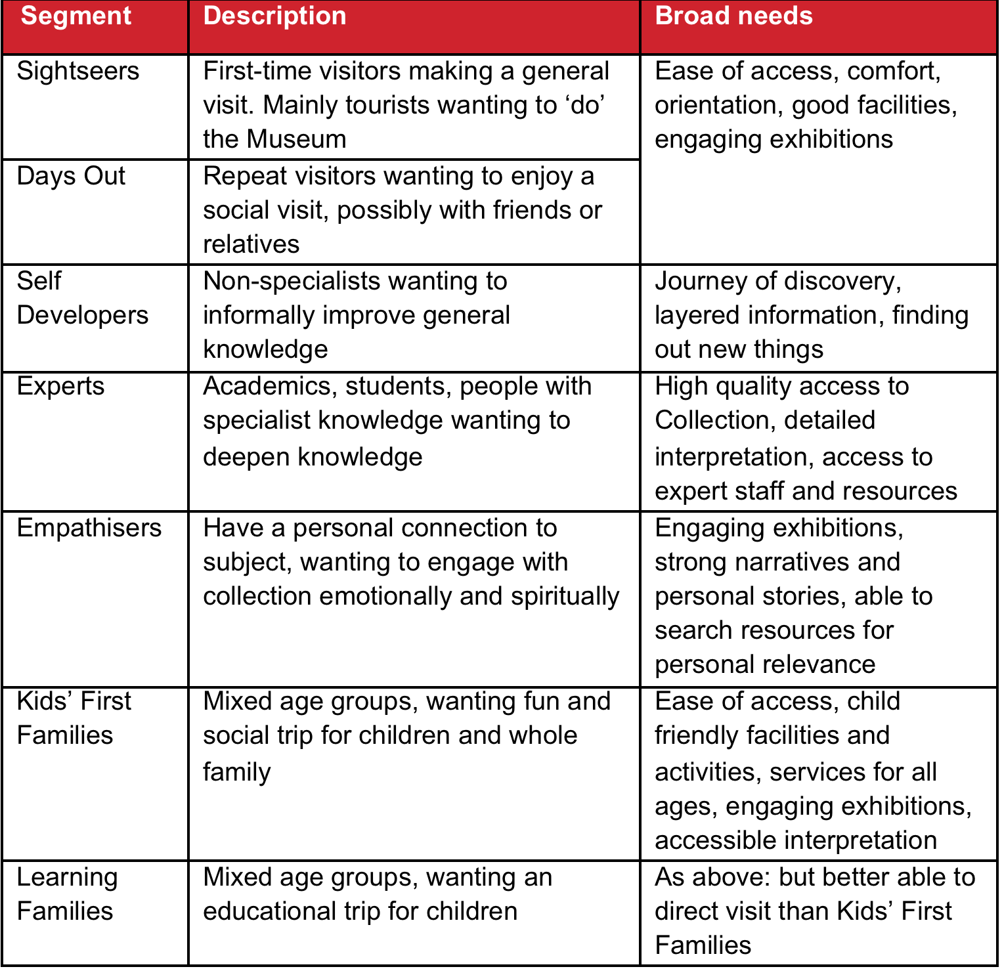
Figure 1: National Army Museum - Visitor segmentation

On opening, the Museum will continue to engage with each the above segments but there will be a particular focus on the following audience segments that have been identified as having the strongest potential for growth in visitor numbers:

- Learning Families
- Kids' First Families
- Empathisers
- Self Developers.

Of these, Learning Families and Kids' First Families will be further prioritised. Whilst project also expects to attract a greater number of curiosity-driven first time visits amongst Sightseers – either from the UK or overseas – these are not seen as a high priority in the short-term.

An important strategy in achieving this growth is to grow participation to reflect the population diversity of modern Britain particularly certain demographic groups who are under-represented in the Museum’s pre-closure audiences:

- Women
- Non-specialists
- Local residents from such culturally and socially diverse boroughs as Southwark, Wandsworth, Hammersmith and Fulham and Lambeth.

In addition, the Museum will continue to build relationships and deepening engagement with:

- Schools – particularly from local socially and culturally diverse boroughs in London
- Students and academics – in military history; social history; politics
- Members of the armed services – active and retired.

And as the Museum seeks greater participation and breadth in its audiences, it is looking to improve participation across Black, Asian and Minority Ethnic (BAME) groups, disability groups, young people, older people and N-Sec 5-8, continuing the work achieved through the Activity Plan.

Appendix C : A New Brand

As part of Building for the Future, the Museum has developed a new brand and approach to visual communications.

The new brand model was developed in 2014-15, and has guided the development of the Museum – from the galleries themselves to the interior design of the Museum and its facilities – the new Museum is literally a physical manifestation of the new brand rather than it being applied after the design of the new Museum.

Whilst detailed information will be provided to the successful consultant, NAM’s new brand model is provided here to convey the nature of our new brand

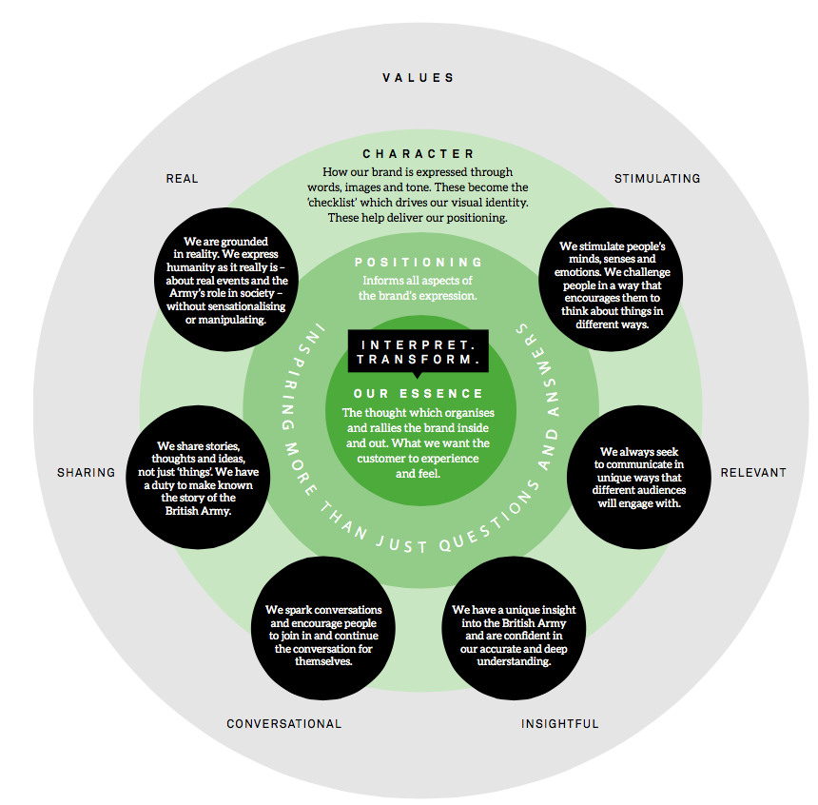
Figure 2: National Army Museum – new brand model
Appendix D: Form of Tender

Tender for: National Army Museum Visitor Experience Transformation Project

To: The Council and Director of the National Army Museum

Sirs,

I/We the undersigned, having examined the enclosed tender documents and Appendices, do hereby offer to execute and complete in accordance with the said documents the works described therein:

For the sum as listed in the attached document:

Tenderer Reference:

I/We hereby affirm our agreement to enter into a contract with the Council of the National Army Museum for the due performance of the Works in the form described by the above said documents.

I/We have completed the Certificate of Bona-Fide Tender included in this document.

I/We understand that the Trustees are not bound to accept the lowest or any tender which may be received nor or responsible for any cost incurred in the preparation of any tender.

I/We declare that this offer is to remain open for acceptance for a period of 60 days from the date fixed for the receipt of tenders.

Signed: ____________________________________________________

In the capacity of

Duly authorised to sign the tender on behalf of:

Date:

APPENDIX E: CERTIFICATE OF BONA-FIDE TENDER

Tender for: National Army Museum Website Project

I/We certify that this is a bona-fide tender and that I/we have not fixed or adjusted the amount thereof by or under in accordance with any agreement or arrangement with any other person.

I/We also certify that I/We have not done and I/We undertake that I/we will not do at any time any of the following acts:

- Communicate to a person other than the person calling for these tenders the amount or approximate amount of the proposed tender except where the disclosure, in confidence, of such amount(s) was necessary to obtain insurance premium quotations required for the preparation of the tender.

- Enter into any agreement or arrangement with any other person that he shall refrain from tendering or as to the amount of any tender to be submitted;

- Offer or pay or give or agree to pay or give any sum of money or valuable consideration directly or indirectly to any person for doing or having done or causing or have caused to be done in relation to any other tender or proposed tender for the said work any act or thing of the sort described above.

In this certificate the word “person” includes any person and any body, association, corporate or un-incorporated; and “any agreement” includes such transaction, formal or informal, and whether legally binding or not.

Signed: ____________________________________________________

In the capacity of

Duly authorised to sign the tender on behalf of:

Date:

APPENDIX F: SUPPLIER STATEMENT

We certify that the information supplied is accurate to the best of our knowledge and that we accept the conditions and undertakings requested in the assessment. We understand that false information could result in our exclusion from the Tender process or the Approved Suppliers List at any time, even after initial inclusion. We also understand that it is a criminal offence to give or offer any gift or consideration whatsoever as an inducement or reward to any servant of a public body and that any such action will empower such body to cancel any contract currently in force and will result in exclusion from the Tender and / or the Approved Suppliers List.

Signed by: _____________________________________________________

Name: (in BLOCK LETTERS) ______________________________________

Title: _________________________________________________________

Date: _________________________________________________________

for and on behalf of: _____________________________________________

This form should be signed by a Director, Partner or other authorised signatory of the organization and returned as part of the Tender Response

