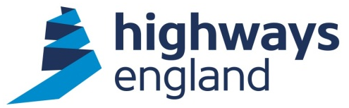  Ref: A303-TP-5.5  Aecom  Via Bravo | REDACTED  REDACTED  The Cube  199 Wharfside Street  Birmingham  B1 1RN  Direct Line: REDACTED  07 April 2020
A303- Technical Partner Contract
Task Order 5.5 Operations

Dear Sirs,

On behalf of Highways England, I am writing to place Task Order 5.5 – Operations under the terms of the A303 - Technical Partner contract.

The commencement date for this Task Order is 13 April 2020 and its completion 31 December 2021 is date no works are to take place after this date. This Task Order will be paid as an Option G Lump Sum contract and the value of this Task Order is £2,086,870.06. This will form Task Order A303-TP-5.5 to the Agreement.

Please refer to the Task Order Call off form attached for further details. Please complete the Contract Data Part 2 and return it via Bravo within 14 days of receipt of this letter.

You will be provided with a copy of the Collaborative Performance Framework (CPF) for Performance Measurement by the Project Manager. The arrangements for measuring performance on this contract should be agreed with the Project Manager at the inception of the work. As an absolute minimum a complete Key Performance Indicator (KPI) will be required in accordance with the CPF guidance and measured against the contract KPIs. This is one of a number of factors that will be considered by Highways England when allocating future work.

Invoices should be sent to FS Payments at Highways England, The Cube, 199 Wharfside Street, Birmingham, B1 1RN, quoting the Project Manager’s name, Blanket Purchase Agreement number and release number, both obtainable from the Project Manager.

Please note you must not make any public announcements and all media enquiries should be directed to the Highways England Press Office.

Please acknowledge receipt of this letter by return.

Yours faithfully,

REDACTED

REDACTED
REDACTED
Highways England Procurement
Email: cip_procurement@highwaysengland.co.uk

