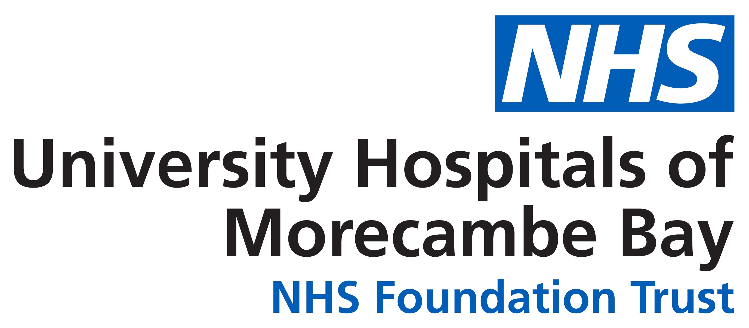

STATEMENT OF REQUIREMENTS

Foundation Trust Membership Database

Brief description of requirement

University Hospitals of Morecambe Bay NHS Foundation Trust (UHMBT) is seeking quotes for an NHS Foundation Trust Membership Database from organisations with already live and available systems.

About the Trust

University Hospitals of Morecambe Bay NHS Foundation Trust (UHMBT) is a University teaching hospital providing community and hospital services across the Morecambe Bay area, covering a thousand square miles in south Cumbria and north Lancashire.

We operate from three main hospitals - Furness General Hospital (FGH) in Barrow, the Royal Lancaster Infirmary (RLI), and Westmorland General Hospital (WGH) in Kendal, as well as a number of community healthcare premises including Millom Hospital and GP Practice, Queen Victoria Hospital in Morecambe, and Ulverston Community Health Centre.

FGH and the RLI have a range of General Hospital services, with full Emergency Departments, Critical/Coronary Care units and various Consultant-led services.
WGH provides a range of General Hospital services, together with an Urgent Treatment Centre, that can help with a range of non-life threatening conditions such as broken bones and minor illnesses.
All three main hospitals provide a range of planned care including outpatients, diagnostics, therapies, day case and inpatient surgery. In addition, a range of local outreach services and diagnostics are provided from community facilities across Morecambe Bay.
Our community services for adults are provided in people’s homes, community centres, clinics, GP Practices, community hospitals and our main hospitals. Our aim is to work with people to help them remain independent, improve their health and manage their conditions through high quality care, advice and support.

What is a Foundation Trust
A Foundation Trust is an independent, public benefit organisation that is not subject to direct control by the Secretary of State for Health. This means we are better able to respond to local needs and are more accountable to our local communities, through our Council of Governors and members.
Our Council of Governors is elected by our public members and staff. Our Governors are responsible for representing public views to the Trust, holding our Board to account, and deciding the appointment and remuneration of our Chairperson and Non-Executive Directors.
We are also accountable to our independent regulator, NHS England & Improvement, who ensure that we work within our terms of authorisation and our constitution. The Care Quality Commission (CQC) inspects the Trust to ensure services are of the highest quality.

UHMBT Membership

Any member of the public over the age of 16, who resides in one the below constituencies (in accordance with the NHS Foundation Trust Constitution) is eligible to become a member:

- Barrow and West Cumbria
- Lancashire and North Yorkshire
- South Lakeland and North Cumbria
- Out of Trust area
- Rest of England

The Trust currently has 5,500 – 6,000 public members.

Members are able to apply via on-line form and have the opportunity to stand for election, receive newsletters and be updated with regard to upcoming membership events.

Please follow the below link to access the Membership page of the Trust web-site for more information:

https://www.uhmb.nhs.uk/get-involved/our-membership

Database/System Requirements

- The system must be able to collect and store new members details and existing members amended details automatically from an on-line form.
- The system must be able to filter by constituency and member name as a minimum.
- The system must have the ability to enable documents/e-mails to be sent to all members individually as though it has been sent from a Trust e-mail account.
- The system must allow access from multiple people and allow input directly to the system as well a via a form (hosted on our web-site).
- The system must allow the user(s) to download details of eligible members and send them (eg) postal voting papers for elections, correspondence etc.
- The system must allow the generation of reports regarding membership utilising the information and demographics contained within the database. (Name/Age/Date of Birth/Address/Post Code/Telephone Number/e-mail address/method of contact etc).

System Interface:

- The system must be able to interface with the Trust’s Governance system which is used for the election process of Public Governors.

Ongoing Support:

- Help Desk support for a minimum of 5 days, Monday to Friday, 09:00 to 17:00h.
- Training for new users.
- Ability to add/rotate users.

Contract Length:

Three Years

Estimated Budget

£25,000 - £30,000 over three years contract period.

