Joint Schedule 2 (Variation Form)
This form is to be used in order to change a contract in accordance with Clause 24 (Changing the Contract)
Contract Details
This variation is between: | The Secretary of State for the Department for Business, Energy and Industrial Strategy (BEIS) “the Buyer")  And  Specialist Computer Centres PLC ("the Supplier")
Contract name: | Provision of Production and Assistive Technology Software  (“the Contract”)
Contract reference number: | TRN4707/11/2020
Details of Proposed Variation
Variation initiated by: | Buyer
Variation number: | 001
Date variation is raised: | 25th January 2023
Proposed variation | £350,000
Reason for the variation: | Extension to budget
An Impact Assessment shall be provided within: | Instantaneous
Impact of Variation
Likely impact of the proposed variation: | Increased budget for business requirements
Outcome of Variation
Contract variation: | This Contract detailed above is varied as follows:  - Increased budget for business requirements  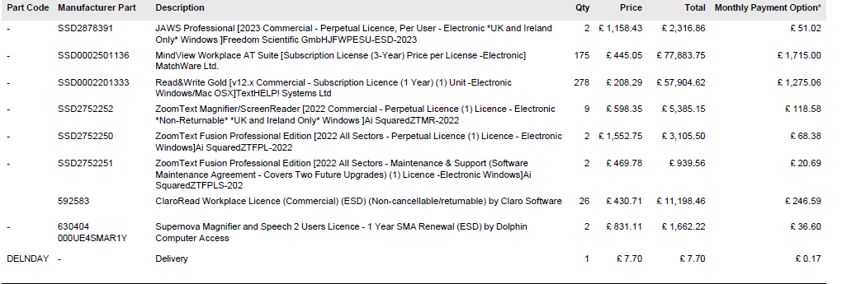
Financial variation: | Original Contract Value: | £ 321,890.40
 | Additional cost due to variation: | £ 350,000.00
 | New Contract value: | £ 671,890.40
- This Variation must be agreed and signed by both Parties to the Contract and shall only be effective from the date it is signed by Buyer
- Words and expressions in this Variation shall have the meanings given to them in the Contract.
- The Contract, including any previous Variations, shall remain effective and unaltered except as amended by this Variation.

Signed by an authorised signatory for and on behalf of the Buyer
Signature
Date
Name (in Capitals)
Address
Signed by an authorised signatory to sign for and on behalf of the Supplier
Signature
Date
Name (in Capitals)
Address

