Request for Information Summary Document –

data quality/governance project

Summary

For Stonewater to become a data driven organisation we need to move from a place of disjointed and disparate data practices, cultures and disciplines, to one of integrity, accuracy, transparency, accessibility and good governance.

Our data is a valuable asset underpinning everything we do to support operational delivery, legal compliance and strategic planning, ensuring that informed decisions are made based on sound evidence. Managed data is also vital as we look to adopt future technologies such as AI.

PROJECT PURPOSE

- Data is spread across disparate systems which lack visibility, controls and ownership and accountability
- Systems do not currently support good data management, with little or no data rules or data validation in existence and point of data entry.
- There is an increasing lack of trust in our data, leading to staff keeping information ‘off system’ in unstructured spreadsheets and databases.
- Data in the core systems is incomplete, inconsistent and in some cases inaccurate and of poor quality.
- Information and reporting is not standardised or centralised.
- There is no master data management.

  - Project Scope

The project proposes that we develop the strategy, and the associated project phases, around the following pillars:
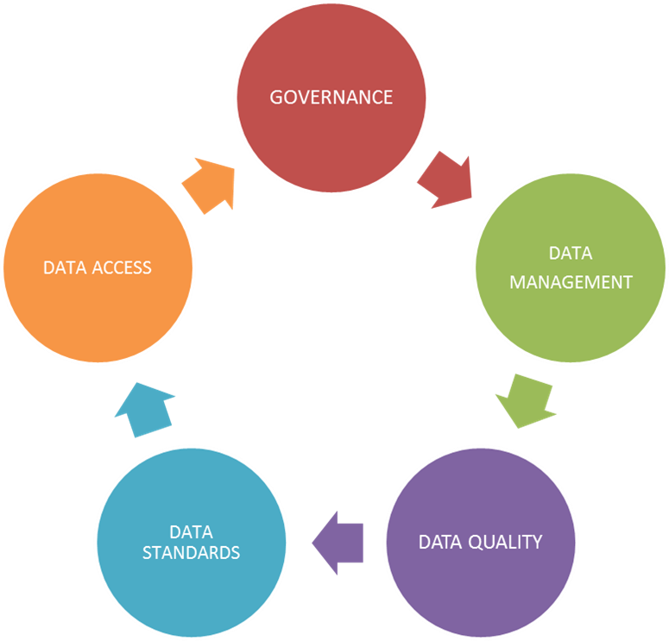

Governance; Create a data driven culture which sets out accountability of data and data systems identifying clear roles through the process from data owners through to data consumers.

Data Management; the life cycle of our data should be managed through agreed policies and procedures, including capture, review and refresh of our data assets.

Data Quality; to identify our primary data fields, based on legal and regulatory requirements, and business criticality. Implementation of validation rules and clarifying ownership to embed these.

Data Standards; Development of a data dictionary/catalogue; Define timeframes for data review and removal; establishing a culture of data quality, ownership and management.

Data Access; Clarifying who needs access to data and ensuring they have the knowledge to interpret it; presenting data in a format that is insightful for its intended audience; complying with data protection and GDPR guidelines.

Data tool requirements

The following are the requirements we require for the data tool;

- A tool that can implement and manage a data governance structure in a centralised hub, allowing us to define data rules and owners from multiple data sources.
- Data cataloguing capabilities
- A Proof of Value (POV) to help us understand the value of our data, and cost of POV.
- A cleansing solution which can utilise the defined data rules to validate source data, picking up invalid and incorrect data utilising fuzzy matching.
- The ability to report on the data accuracy / quality. Both within a dashboard and downloadable reports.
- Access to dedicated support services we can work with in order to best manage the incorporation of any tools / resources.
- The ability to incorporate A.I machine learning into the data cleansing and management in order to improve and automate the process in the long-term.
- A partnership which can help inform the organisation in strategic direction on data.
- Experience in the housing sector
- Be on the G-cloud 11 framework

