

**LIVERPOOL VISION**

**INVITATION TO TENDER**

**for**

**THE 2018 INTERNATIONAL BUSINESS FESTIVAL**

**EVENT SERVICES – AUDITORIUM**

(A procurement under the Public Contracts Regulations 2015

Light Touch Regime).

Contents

Structure of the Invitation to Tender 2

1. Introduction 2

2. Requirement Overview 2

3. Indicative Timetable 2

4. Specification of services or goods required 2

5. Responses required: 2

6. Evaluation 2

Appendix 1 - ITT Instructions and Conditions 2

Appendix 2 – Terms & Conditions of Contract 2

Appendix 3 – Legal Comments Table 2

Appendix 4 – Build and Derig Schedule 2

Appendix 5 – AV Information and Setup 2

# Structure of the Invitation to Tender

This Invitation to Tender (‘ITT’) is divided into a number of specific sections:

1. Introduction

2. Requirement Overview

High level background to the requirement, specified in more detail in section 4.

3. Indicative Timetable

This sets out the dates and times for responding, evaluating, award and service commencement.

4. Specification of Services or Goods required.

This section provides the details of LV’s specific requirements and your Response should ensure these are referred to.

5. Tender Response

This section sets out the information that you are requested to provide, so that Liverpool Vision can assess, evaluate and select the tenderer that best meets its requirements.

6. Evaluation

This section sets out the criteria, weighting and scoring methodology that Liverpool Vision will use to evaluate Responses.

***Appendix 1 ITT Instructions and Conditions***

***Appendix 2 Terms and Conditions of Contract***

***Appendix 3 Legal Comments Table***

***Appendix 4 Build and Derig Schedule***

# Introduction

From 12-28 June 2018, Liverpool will again host the world’s biggest business event –The 2018 International Business Festival.

Liverpool Vision invites companies to tender to supply a number of turnkey auditoria structures for the 2018 International Business Festival.

For more information about the above modules please see section 4: Specification of Goods or Services

Tenderers will need to respond to the requirements listed, considering the evaluation criteria specified and submitting via the process and timelines as indicated in addition to the general requirements specified in section 3 and 4.

***NB: Please note that Liverpool Vision retains the right to select one supplier, multiple suppliers (dependent on proven integration capability) or none (if any one or all of the bids be adjudged by the selection panel as being of an inadequate standard).***

# About Liverpool Vision

Liverpool Vision is a company limited by guarantee, wholly owned by Liverpool City Council.  Its business plan, activities and finances are overseen by a Board of Directors, chaired by the Mayor of Liverpool.  Vision’s purpose is to generate jobs and investment in the city.  It does this by marketing it as a business, investment and leisure location, through the Marketing Liverpool team and by working with the private sector in the city and internationally to generate investment projects.

Liverpool is a global city, one that’s proud of its heritage and culture but also passionate about looking to the future. That makes it an inspiring and exhilarating place to do business.

With a global perspective and exceptional economic strengths, Liverpool is recognised as one of the UK’s leading business destinations. Blue-chips, start-ups, entrepreneurs and emerging talent are attracted to Liverpool by investment opportunities, business benefits and an outstanding quality of life. That’s where we fit in at Liverpool Vision.

Liverpool Vision is the city’s economic development company that integrates economic development and business and enterprise support designed to accelerate the city’s growth and build a sustainable economy.

We are the company creating an environment for growth, generating a long term impact in both the supply and demand sides of the economy. Liverpool Vision also plays a huge role in transforming perceptions of Liverpool, by communicating positive messages about the city to local, national and international audiences, reaching many hundreds of businesses and opinion formers.

Liverpool Vision has three (directorates) related functions:

* Marketing Liverpool.
* Invest Liverpool.
* 2018 International Business Festival

Each directorate is overseen by an experienced director, leading a dedicated team of staff. They are supported by a small support function providing business planning and development services, financial management and human resources skills.

Marketing Liverpool includes the Liverpool Convention Bureau.

You can find out more at [www.liverpoolvision.co.uk](http://www.liverpoolvision.co.uk) and [www.itsliverpool.com](http://www.itsliverpool.com)

* 1. **About International Business Festival:**





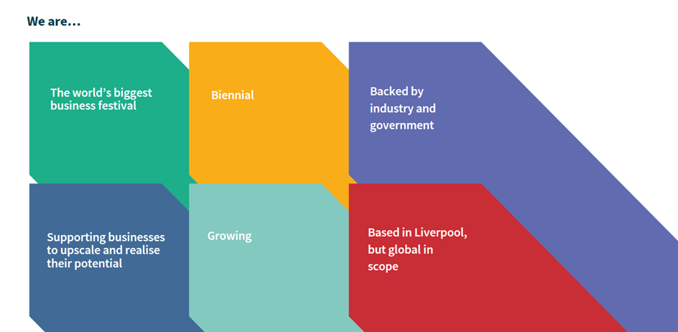







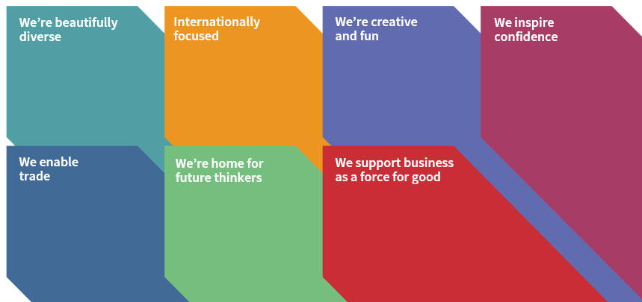





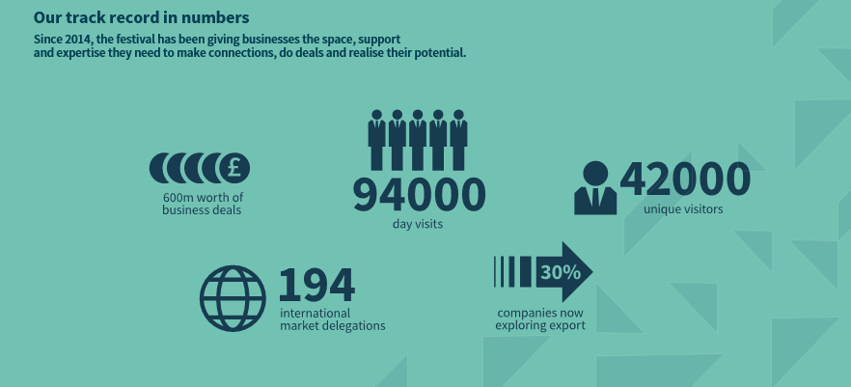

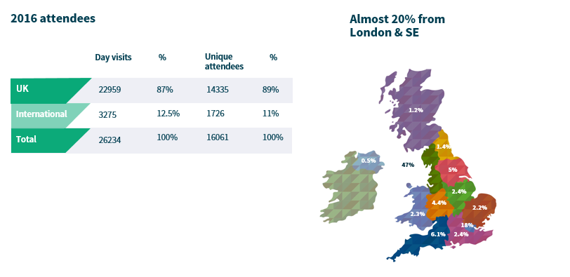

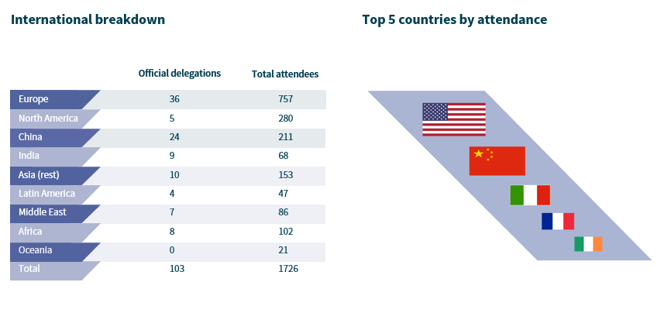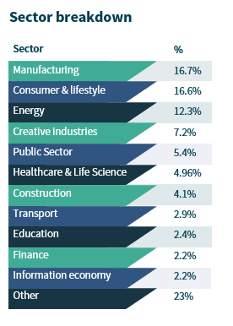







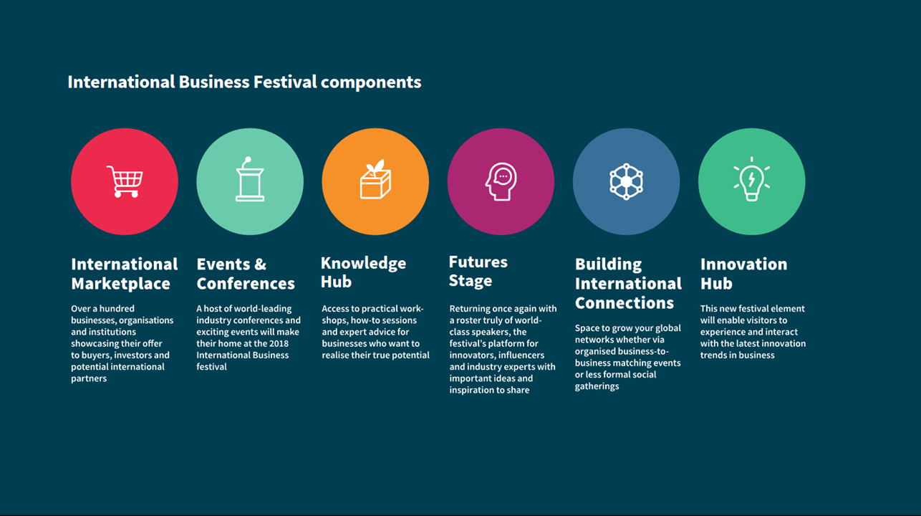

# Requirement Overview

Liverpool Vision is now seeking to procure the services of suitable organisations to deliver the build, operate and de-rig of a number of turnkey auditoria for the 2018 International Business Festival. The Festival requires an auditoria solution which provides:

Auditoria 1A- 500 minimum theatre style capacity

Auditoria 2A- 250 minimum theatre style capacity

Auditoria 2B- 250 minimum theatre style capacity

Auditoria 3A- 250 minimum theatre style capacity

Auditoria 3B- 250 minimum theatre style capacity

Please note: There is a requirement for either;

1. 2A + 2B to have the ability via a demountable, sound-proofed wall to combine, creating an additional 500 capacity space

OR

1. One of the assigned 250 capacity spaces (2A, 2B, 3A, 3B to be replaced with a bigger auditoria space that can accommodate a minimum of 400 theatre style capacity instead.

There are 3 requirements that must be met for those tendering to be considered:

1. An effective and proven soundproofing option for the auditoria structures, providing a minimum 25 db level internally.
2. An effective and practical AC option with the ability to control the temperature in each auditoria space independently.
3. Ability to meet restricted build and de-rig time limits of the project.

Liverpool Vision will employ the services of a **Delivery Management** agent, to oversee the project planning and delivery process. This will include developing a detailed project delivery plan in conjunction with the appointed supplier. This will include build, delivery and operational schedules; the review of all health and safety documents, adherence to the venue eGuide and event delivery plans.

Further specifications are available in section 4.   
  
The quotation must be inclusive of the building, the operating, the derigging, any installation requirements, any derigging requirements, labour costs, a demountable wall solution, the sound proofing of the auditoria, an integrated and controllable AC solution for each space and flooring, steps and any disabled access ramps required. Consideration should also be given to any optional feature that may be required, such as dressing the interior and exterior of the space as well as integration within the overall Festival design.

# Indicative Timetable

This timetable is indicative only and LV reserves the right to change it at its absolute discretion.

|  |  |
| --- | --- |
| Publication of ITT | Friday 13th October 2017 |
| Site visit | Tuesday 24th October 2017 |
| Opportunity to raise items for clarification ends | Friday 27th October by 1:00pm |
| LV response to clarification requests, posted on LV website, tenders section. | Monday 30th October 2017 |
| Return of completed ITT Response to LV | Monday 6th November 2017 by 2:00pm |
| Presentation / Interview with shortlisted tenderers (if applicable). To be confirmed following evaluation. | Wednesday 8th November 2017 |
| Indicative award (subject to final due diligence, contract and LV board approval) | Friday 10th November 2017 |
| Contract award notice and standstill period | Friday 10th November 2017 |
| Service Commencement | Immediate upon contract signature |

# Specification of services or goods required

Liverpool Vision is seeking a supplier to provide turnkey auditoria structures. A solution that incorporates the venue plans whilst retaining PAX allowance and mitigates sound travelling between auditoria as per site plans and approx dimensions shown below.

The quotation must be inclusive of the building, the operating, the derigging, any installation requirements, any derigging requirements, labour costs, a demountable wall solution, the sound proofing of the auditoria, an integrated and controllable AC solution for each space and flooring, steps and any disabled access ramps required. Consideration should also be given to any optional feature that may be required, such as dressing the interior and exterior of the space as well as integration within the overall Festival design.

|  |  |  |
| --- | --- | --- |
| **Auditorium** | Pax | Total Dimension (m2) approx. |
| **Auditorium 1A** | 500 | 500 |
| **Auditorium 2A** | 250 | 250 |
| **Auditorium 2B** | 250 | 250 |
| **Auditorium 3A** | 250 | 250 |
| **Auditorium 3B** | 250 | 250 |
| **ADDITIONAL REQUIREMENTS** |  |  |
| 1. **Auditorium 2A+2B (Combined with demountable Wall)** | 500 | 500 |
| 1. 250 capacity spaces (2A, 2B, 3A, 3B to be replaced with 400 capacity space | 400 | 400 |

All auditoriums for the Festival will be built at the Exhibition Centre Liverpool (ECL) in Hall A of the venue. We have completed the final version of the floorplan, so preference is for auditoria to remain within the units. The specifications for Hall A are as follows, as well as an image with the vehicle entry:

|  |  |  |  |  |  |  |  |
| --- | --- | --- | --- | --- | --- | --- | --- |
| **Hall A** | Dimensions (m) | Size (m2) | Height (m) | Vehicle Doors | Floor loading | Roof Loading | Power/water |
|  | 60.00 x 45.00 | 2,700 | 10.5 | 4.9m high x 7m wide | 2 tonnes per m2 | Max weight 5 Tonnes per 5M grid | From service duct |

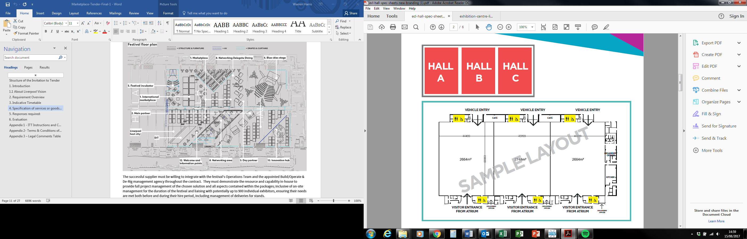

Consideration must be given to emergency access and back of house access with positioning of the structures. An allowance should be made for a minimum 3m corridor around the entrance walls.

Please see below a concept design of the floorplan. The auditoria’s will be located to the left of the floorplan, in the ‘Event Space’ section of the floorplan. Please note, that this not that this not the final floorplan and will be subject to change.

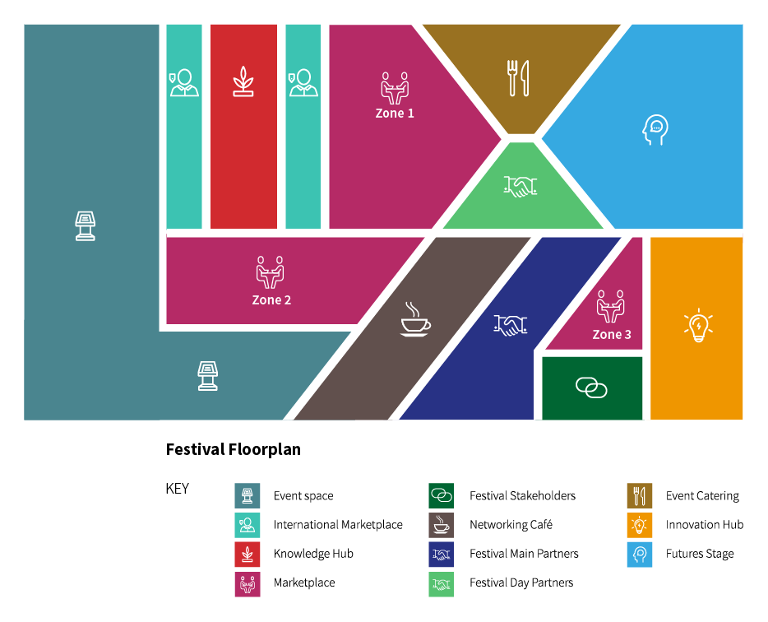

**Requirements**

To be considered for this tender for the auditorium supply, the company must be able to provide suitable solutions, as cost effective as possible for the following three items.

1. **Soundproofing**

The awarded company must provide soundproofing within each structure that is effective to a minimum of 25Db internally and achievable to build and derig in the strict allotted times. The solution should meet the following conditions:

* All structures require acoustic doors, proven reduction of minimum 25Db or higher (Ideally 40Db).
* All roofs and walls require proven acoustic absorption (insulation) and sound barrier system to achieve at least 25Db (Ideally 40Db).
* The removable internal wall requires proven acoustic absorption (insulation) and sound barrier system to achieve at least 25Db (Ideally 40Db).

To achieve the required sound reduction and quality required, we understand that there are several options available including wood metal and other structures. If you are able to provide more than one solution that conform to the above, then please give all optional costs.

All solutions suggested must be achievable within the build & derig time scales.

1. **AC Solution**

An AC solution is required to provide cool air into all the auditoria. The awarded company will be allowed to outsource this element of work to another to provide the solution. However, the awarded company for the tender will be responsible for bringing that company into the build of the auditoria, the operate, the derig and any responsibility if the company fails to provide an adequate solution or fails to deliver.

The awarded company, if outsourcing this part of the auditoria work, should include the cost of this company in there total costing.

There is a preference that the AC solution will give the ability to control the temperature of each space individually at an appropriate noise level.

1. **Build & Derig**

The Build & Derig timescales of the auditoria for the 2018 International Business Festival is very strict this year.

The build time for the entire Festival will begin on Friday the 8th June 2018 at 06:00am and must be completed by 06:00am on Tuesday the 12th June. This will include building with other teams in the same area such as an AV team, to complete the Festival build, ready for use.

Derig will begin in Hall A, as soon as events in the auditorium finish, which will be at 4:30pm, Thursday the 28th June. The derig of the entire Festival must be finished by Sunday the 1st July at 2:00am.

Any company that tenders for the auditoria build and derig, must be confident and provide evidence that they will be able to build and derig in tight deadlines with no exclusive access to spaces permitted for large periods of time.

A schedule of the build and derig times can be found in Appendix 4 of the tender.

1. **On-site staff**

There is a requirement for the awarded company to have a team on-site, throughout the festival, for the operating and the maintenance of the auditorium that have been provide for the festival. Accommodation for the onsite team throughout the Festival will be required and these costs should be included within your proposal. Assistance can be given to find suitable accommodation for the onsite team through the Liverpool Convention Beau at reduced rates if available.

Please refer to opening turnaround and maintenance times in Appendix 4.

1. **Rigging**

UK Rigging are the venue in-house rigging contractor; they must make the first connection, contact with the company should be made through The Arena and Convention Centre. For the remainder of your rigging works you can continue working with UK Rigging or use an external rigging supplier. For more rigging details, please see the following reference documents.



1. **The auditoria should also include**

The auditoria solution should conform to the following:

* All structures should be in a finished condition ie. Painted or wrapped where appropriate.
* All work must conform to venue regulation as outlined in the eGuide – AEV Guidance for Events in UK Venues and in the Venue section of this document on pg. **Error! Bookmark not defined.**.
* The solution must look and feel seamless, therefore no pillars are allowed internally.
* All structures must be maintained and refurbished should they become damaged at any time during the Festival.
* Any solution must be able to be a part of an integrated build and de-rig approach, working alongside other suppliers, the delivery agent & the client Liverpool Vision.
* The preference is for a light coloured interior.
* Solution should provide ability to contain an integrated AV solution to be agreed with the awarded company
* Consideration required for disabled access into the auditoria.

**Additional Information**

Tenderers should be aware of the following:

**Rules and Regulations**

Please find below some of the key rules and regulations outlined by the venue. All contractors are required to comply with the eGuide – AEV Guidance for Events in UK Venues.

  
Consideration required for disabled access into the auditoria.

**Disability Allowance**

All auditoria will have reasonable access provided for disabled visitors as required by the Disability Discrimination Act 1995. The basic structure will be accessible, but should you wish to add platforms or stands, these should be made accessible.

Platforms that exceed 38mm in height or a part platform that exceeds 20m² and 38mm in height, must ensure that it is accessible to disabled visitors and contain clear and specified access and constructed in such a way to conform to the following:

* bevelled with a ramp of no more than 5” (1.12 gradient)
* a minimum of 1,000mm wide
* fitted with a handrail on each side or other such division to avoid any trip hazard resulting in the change of floor level.

**Environmental Statement**

The appointed supplier shall ensure that its team and suppliers can remove all waste materials from the venue prior to departure. This includes the removal of production waste (inc. build/de-rig), structures, brochures, tape, paint etc. Absolutely all waste should be removed from site as there is no facility for disposal.

Any costs incurred by Liverpool Vision as a result of your event will be charged back to the appointed supplier.

**Exclusions of work from tender:**

* AV Equipment
* Cleaning
* Furniture
* Stage sets

This is not an exhaustive list.

**Maintenance**

All structures must be maintained and refurbished should they become damaged at any time during the Festival. Where reasonably possible maintenance will be undertaken during assigned maintenance times as set out in Appendix 4. The appointed supplier and its suppliers will be responsible for maintaining all items provided.

**Risk Assessment**

There is a legal requirement for you to produce an event specific risk assessment and method statement under the Management and Health and Safety at Work Regulations (MHSWR) to identify all ‘significant risk’. This should include build-up, event and de rig.

# Responses required:

Tenderers are invited to respond to the questions set out in this section, having regard for the evaluation criteria weightings set below:

|  |  |
| --- | --- |
|  | |
| Value For Money | 40% |
| Capability and Resource | 20% |
| Approach and Understanding of the Requirement | 20% |
| Flexibility / Innovativeness | 10% |
| Accreditations / Qualifications | 10% |
| Total | 100% |

For more information on evaluation of responses, please see Section 6 – Evaluation.

Please use the section reference numbering, as this will assist in the evaluation process.

All responses should be submitted in an unmarked sealed envelope, stating “**THE 2018 INTERNATIONAL BUSINESS FESTIVAL AUDITORIA**” and marked for the attention of: Zac Roberts, Procurement, Liverpool Vision, 10th Floor, The Capital, 39 Old Hall Street, Liverpool, L3 9PP.

Please provide 2printed responses, together with an electronic copy contained on a **USB / Memory Device**. This will ensure integrity of the process and allow fair, equal and transparent treatment of responses.

LV appreciate the environmental impact and request therefore that where practical duplex printing on environmentally friendly paper is utilised and that additional materials not directly related are **not** included.

Certain documentary requirements that are indicated by asymbol need only be submitted in electronic format.

If delivering by hand, please be advised that because of a barrier system in a shared building, you will need to ask reception in the Capital Building to phone Liverpool Vision (0151) 600 2900 that your submission has arrived for collection.

Envelopes must **not** indicate the identity of your organisation.

There is an opportunity to ask LV for further information to assist you in the preparation of your responses during the Items for Clarification period. If you have an Item for Clarification, please e-mail Zac Roberts (**zroberts@liverpoolvision.co.uk**) during the opportunity period. Please note that responses to these Items for Clarification from LV may be posted on the LV website rather than a response via e-mail. It is your responsibility to make regular checks of the LV website for updates on these.

Please do not contact any other members of Liverpool vision during the tender process.

*5.1.1 Lots*

Not applicable

*5.1.2 Executive Summary*

Please provide an Executive Summary of your response.

* + 1. *Evaluation Questions:*

Below, a list of evaluation questions is included within each of the evaluation criteria mentioned. We request that your submission specifically responds to these questions in order to give your organization the optimum chance to secure the highest score.

* + - 1. ***Value for Money***

1. Please provide a full breakdown of proposed costs to deliver the specification described, including but not limited to:
   * + - Bill of materials
       - Installation requirements (inc. scaffolding, fork lifts, cranes etc.)
       - Dismantling requirements
       - Transport requirement
       - Labour for build, installation, maintenance and de-rig
       - Project management
       - Waste removal
       - Maintenance

Ensure costs presented show the **total** cost for the option, inclusive of expenses and exclusive of VAT, with proposed payment profile.

1. Please provide a full breakdown of proposed costs for optional extras that can be provided and purchased for the auditorium.
   * + 1. ***Capability and Resource***
2. Please provide a detailed to scale floorplan in CAD and PDF format of at least 2 suggested combinations and clearly demonstrate how they fit within the Hall A boundaries alongside other components on the Festival floor.
3. Please provide a bill of materials, detailing all materials used in each part of the construction including
   * + - Walls (including demountable option)
       - Doors (Double & Single)
       - Ceiling or equivalent
       - Flooring
       - Any other requirements

1. Please provide imagery to demonstrate your solution in practice as well as the different elements. If imagery is unavailable, please provide design visuals.
2. Please provide a detailed project plan for the turnaround times for build of each element of the auditoria based on the schedule provided in Appendix 4.
3. Please provide a detailed project plan for the turnaround times for demounting/mounting of the wall in 2A+2B mid event if provided as an option
4. Please provide a detailed project plan for the turnaround times for derigging of each element of the auditoria based on the schedule provided in Appendix 4.
5. Please provide a full project plan demonstrating how your organisation will aim to provide a solution to the tender, throughout the Festival. Including approach taken to account management in advance of the build, suggested meetings with the Liverpool Vision and other suppliers that you would be willing to attend in Liverpool and your suggested reporting methods to keep Liverpool Vision updated on progress.
   * + 1. ***Approach and understanding of the requirement***
6. Please provide a detailed presentation that explains your understanding of the overall requirements along with visuals of the viable, deliverable and affordable solution you are proposing.
7. Please provide a clear and detailed demonstration, with case studies of previous work, of how you are able to provide an auditorium solution on a similar scale to the requirements we have stated above and on a similar time scale. Images and detailed explanations of contracted requirements needed for all case studies. A minimum of 3 case studies should be submitted.
   * + 1. ***Flexibility/Innovativeness***
8. Please describe how you would be able to provide an innovative solution in providing the requirements for the Festival, as well providing it in the scheduled build and derig times.
9. Please describe the innovative solution for the demountable wall to be provided for auditorium 2A and 2B if applicable.
10. Please describe how your company can be flexible in terms of building and derigging the auditoria within the time schedule, while working with other teams building other parts of the Festival e.g the AV supplier.
    * + 1. ***Accreditations/Qualifications***
11. Please provide details of any accreditations, qualifications or awards you have received.

*5.2 General company information required*

*The following information / requirements will not be scored, but are* ***mandatory;*** *ensuring that we know enough about the companies that we work with and that they are fit for purpose.* ***I****f not satisfied, then LV reserves the right at its absolute discretion not to award a contract irrespective of how the tenderer has scored using the evaluation criteria.*

Please provide a suitable response to the following:

|  |  |
| --- | --- |
| 5.2.1 | Full name of organisation (this should be the name of the organisation acting as prime contractor, where applicable). |
|  |  |
| 5.2.2 | Trading name of organisation (if different from above). |
|  |  |
| 5.2.3 | Date of formation |
|  |  |
| 5.2.4 | Registered number if a limited company (please supply a copy of the certificate of incorporation and any certificate of change of name) |
|  |  |
| 5.2.5 | Registered address of organisation **and** address of principal trading office |
|  |  |
| 5.2.6 | Main Phone number |
|  |  |
| 5.2.7 | Name and contact details in relation to tender preparation |
|  |  |
| 5.2.8 | Address and phone number of office from where business would be conducted in support of this contract, if different from the above |
|  |  |
| 5.2.9 | Full names of all directors / company secretary/ partners/associates or proprietor |
|  |  |
| 5.2.10 | Have any of the persons named in 5.2.9 above, been subject to bankruptcy proceedings or been involved in an organisation which has been subject to liquidation proceedings or had receivers appointed? If yes, please give details. |
|  |  |
| 5.2.11 | Have any of the persons named in 5.2.9 above, been convicted of any criminal offence, apart from minor traffic offence? If yes, please give details. |
|  |  |
| 5.2.12 | Do any of the persons named in 5.2.9 above, have relative(s) who are senior employees of the LV? If yes, please provide details. |
|  |  |
| 5.2.13 | Have any of the persons named in 5.2.9 above, ever been employed by the LV? If yes, please give details. |
|  |  |
| 5.2.14 | If your organisation is a member of a group of companies, give the name and address of the holding company |
|  |  |
| 5.2.15 | Please state the approximate number of employees in your organisation and companies acting in partnership (where relevant), who are specifically engaged in delivering similar services to those proposed by LV. |
|  |  |

*5.3 Financial Information*

|  |  |
| --- | --- |
| 5.3.1 | Please enclose  your organisation’s most recent audited accounts and annual reports. This should include: Balance Sheet, Profit and Loss Account, Full notes to the accounts, Director’s Report/Auditor’s Report. |
|  |  |
| 5.3.2 | If you have submitted accounts for a year ending more than 10 months ago, please confirm that the organisation described in the enclosed accounts is still trading. Also supply a statement of turnover since the last set of published accounts. |
|  |  |
| 5.3.3 | If your organisation’s accounts and annual reports are consolidated into those of your parent company or group, then for each of the last two years please provide for your organisation, your organisation’s turnover, profit before tax and net assets. |
|  |  |
| 5.3.4 | Are there any outstanding claims or litigation against your organisation with regard to systems and / or service delivery? If yes, please give details. |
|  |  |

*5.4 Professional Conduct*

|  |  |
| --- | --- |
| 5.4.1 | Has your Organisation or proposed partners or any employee within these organisations who would be working on this contract, committed a criminal offence relating to the conduct of your business or profession? If so, please provide details. |
|  |  |
| 5.4.2 | Is your Organisation or are your proposed partners currently involved with any legal proceedings (including Arbitration or any other form of alternative dispute resolution) with any other organisations including local authorities? If so, please provide details. |
|  |  |
| 5.4.3 | Are there any issues, current or likely, in relation to your Organisation or proposed partners that may give rise to any conflict of interest? If so, please provide details. |
|  |  |
| 5.4.4 | Please identify any potential conflicts of interest relating to this contract. |
|  |  |

*5.5 Insurance requirements*

The appointed supplier will be required to maintain appropriate levels of insurance in a number of areas and supply copies of relevant policies as  appropriate. Please complete the enclosed table

|  |  |  |  |  |
| --- | --- | --- | --- | --- |
| Area | Level of cover expected | Level of cover currently held | Level of cover to be provided | Further details |
| Public liability | £10m |  |  |  |
| Employer’s liability | £5m |  |  |  |
| Professional Indemnity | £1m |  |  |  |

Please note that the insurance cover detailed above needs to be in place before activities commence in pursuance of the services required and will not be considered as part of the costs under the contract between LV and the selected supplier.

*5.6 Health and Safety*

The appointed supplier will be required to ensure that all elements of your services are planned and implemented in accordance with best practice set out in the Health and Safety Executive (HSE) Event Safety Guide (the ’Purple Guide’) and other such guidance appropriate to your business, and to provide a specific detailed risk assessment of all Health and Safety issues associated with the service.

Please confirm your acceptance of this.

*5.7 Business Continuity*

The appointed supplier will be required to have in place suitable plan. Please provide  a copy of your organisation’s business continuity plan (“BCP”) and specifically state how this would be applicable to the service requirements of LV.

*5.8 Equal Opportunities*

LV expects all suppliers and contractors to operate within its Equal Opportunity Policy.



Please confirm your acceptance of this.

The appointed supplier will be required to have in place suitable plan and to provide  a copy of its organisation’s policy and specifically state how this would be applicable to the service requirements of LV.

# Evaluation

Tender Responses will be evaluated using the following criteria and weightings:

|  |  |
| --- | --- |
|  | |
| Value For Money | 40% |
| Capability and Resource | 20% |
| Approach and Understanding of the Requirement | 20% |
| Flexibility / Innovativeness | 10% |
| Accreditations / Qualifications | 10% |
|  |  |
| Total | 100% |

Responses, other than Price, will be scored as follows. Intermediate scoring, for example 3.7, is permissible: -

|  |  |  |
| --- | --- | --- |
| 0 | Poor | No response or partial response and poor evidence provided in support of it. Does not give confidence in the ability of the Tenderer to deliver the services. |
| 1 | Weak | Response is supported by a weak standard of evidence in several areas giving rise to concern about the ability of the Tenderer to deliver the services. |
| 2 | Satisfactory | Response is supported by a satisfactory standard of evidence in most areas but a few areas lacking detail/evidence giving rise to some concerns about the ability of the Tenderer to deliver the services. |
| 3 | Good | Response is comprehensive and supported by good standard of evidence. Gives confidence in the ability of the Tenderer to deliver the services. Meets the requirements. |
| 4 | Very good | Response is comprehensive and supported by a high standard of evidence. Gives a high level of confidence in the ability of the Tenderer to deliver the services. May exceed the requirements in some respects. |
| 5 | Excellent | Response is very comprehensive and supported by a very high standard of evidence. Gives a very high level of confidence the ability of the Tenderer to deliver the services. May exceed the requirements in most respects. |

Responses should reflect the services specified and will be evaluated against the response requirements set out in Section 5, on the basis of the above award criteria.

Liverpool Vision reserves the right to contact certain tenderers if clarification of their tender is required.

**Price will be evaluated using the following method:**

40% will be awarded to the lowest cost bid and the remaining Tenderers will be allocated scores based on their deviation from this figure.

For example, if the lowest cost is £40 and another cost is £48 then the lowest cost Tenderer gets 40% (full marks) for cost and the second placed Tenderer gets 33% and so on. (£40/£48 x 40% = 33%).

*The appointed supplier will be expected to have suitable financial stability to undertake these pieces of work and to have insurances and policies in place that are adequate to undertaking payment from public funds. If LV regards responses in section 5 to be unsatisfactory, then LV reserves the right at its absolute discretion not to award a contract irrespective of how the tenderer has scored using the evaluation criteria.*

# Appendix 1 - ITT Instructions and Conditions

Please note that by submitting a response to this ITT that you agree and comply with all parts of the ITT Instructions and Conditions section.

**1.1 General Instructions**

1.1.1 This document is made available on the condition that the information contained within it is used solely in connection with the competitive process for this ITT and for no other purposes.

1.1.2 Whilst reasonable care has been taken in preparing this document, the information within it does not purport to be comprehensive or to have been independently verified. LV accepts no liability or responsibility for the adequacy, accuracy or completeness of any information stated. No representation or warranty, express or implied, is given by LV or any of its representatives with respect to the information contained herein or upon which this ITT is based. Any liability for such matters is expressly disclaimed.

1.1.3 LV reserves the right, without prior notice, to change, modify, or withdraw the basis of its request and/or to reject all proposals and terminate negotiations at any time. In no circumstance will LV incur any liability in respect of time, effort or costs incurred in regard to either discussions, meetings or time spent in respect of reviewing and/or responding to this document or any subsequent material.

1.1.4 This document is not intended to provide the basis for any investment decision. The recipients of this document must make their own independent assessment of the requirements after making such investigations and taking such professional advice as it deems necessary.

1.1.5 The information in this document shall be kept confidential by the Tenderer and may not be copied, reproduced, distributed or passed to any other persons, at any time, without the prior written authorisation of LV. Ownership in any response to this ITT shall be vested in LV upon delivery of the same and such response shall only be returned at the sole discretion of LV and at the recipient’s cost.

1.1.6 This ITT is not a purchase order and does not constitute an offer capable of acceptance. This ITT does not commit LV or any official of it to any specific course of action. The issue of this ITT does not bind LV or any official of it to accept any proposal, in whole, or in part, whether it includes the lowest priced proposal, nor does it bind any officials of LV to provide any explanation or reason for its’ decision to accept or reject any proposal. Moreover, while it is the intention of LV to enter contract negotiations with the selected Tenderer, the fact that LV has given acceptance to a specific Tenderer does not bind it or any official of it in any manner to the Tenderer.

1.1.7 Without prejudice to any prior obligations of confidentiality you may have, no publicity relating to this ITT or to the acceptance by LV of any ITT response or to the letting of any future contract shall be released by you without the prior written approval of LV.

1.1.8 You shall be deemed to have examined before the submission of your tender response, all the provisions in this ITT as well as regulations and other information relevant to your tender response, and to have fully considered the risks, contingencies, and other circumstances, which could affect the tender response. You shall be responsible for obtaining all information by the making of reasonable and prudent inquiries and, by prior arrangement.

1.1.9 By submitting a Tender Response the Tenderer represents that it has read and understood the ITT. The Tenderer will consider the contents of any submitted tender response as an offer to contract.

1.1.10 Any attempt by Tenderers or their advisors to influence the contract award process in any way may result in the Tenderer being disqualified. Specifically, Tenderers shall not directly or indirectly, at any time:

(a)      Revise or amend the content of their Tender in accordance with any agreement or arrangement with any other person, other than in good faith with a person who is a proposed partner or supplier;

(b)      Enter into any agreement or arrangement with any other person as to the form or content of any other Tender, or offer to pay any sum of money or valuable consideration to any person to effect changes to the form or content of any other Tender;

(c)      Enter into any agreement or arrangement with any other person that has the effect of prohibiting or excluding that person from submitting a Tender;

(d)      Canvass LV or any employees or agents of LV in relation to this procurement; or

(e)      Attempt to obtain information from any of the employees or agents of LV or its advisors concerning another Tenderer or Tender; or

(f)       Offer, pay, promise to pay, or authorize the giving of any financial or other benefit to any person for the purpose of obtaining an improper advantage, or otherwise conduct themselves in a manner contrary to any anti-bribery or anti-money laundering legislation and/or regulations in the broadest sense (whether issued by the EU, the US, the UN or any other body) or any other such rule or legislation that may apply from time to time.

1.1.11 Tenderers are responsible for ensuring that no conflicts of interest exist between the Tenderer and its advisors, and LV and its advisors and Partners. LV reserves the right to disqualify any Tenderer that is guilty of any misrepresentation in relation to its Tender or the tender process.  Any Tenderer who fails to comply with the requirements of this clause may be disqualified from the procurement process at the discretion of LV.

1.1.12 Only information provided as a direct response to this ITT will be evaluated. Information and detail which forms part of general company literature or promotional brochures etc. will not form part of the evaluation process. Marketing material should not be included with your tender response. Supplementary documentation may be attached where you have been directed to do so. Such material must be clearly marked with the name of the organisation and the section to which it relates. All sections must be answered unless advised otherwise.

1.1.13 Please note that LV may require clarification of the answers provided or ask for additional information.

1.1.14 The response should be submitted by an individual of the organisation, company or partnership who has authority to answer on behalf of that organisation, company or partnership.

1.1.15 Should there be any obvious typographical errors or misunderstandings in the ITT documentation then clarification should be sought. However, if the response is found to misrepresent facts, the documents will be deemed void. In the case where the error or misrepresentation is not discovered until after the contract is awarded, we reserve the right to determine the contract and costs incurred by us as a result of the determination shall be recoverable from the Tenderer under the contract.

1.1.16 If applying on behalf of a consortium, please list the names and addresses of all other members of the consortium. Any contract will be entered into with the nominated lead organisation and all members of the consortium, who will in these circumstances each be required to execute said contract together with all ancillary documentation, evidencing their joint and several liability in respect of the obligations and liabilities of the contract. It will be for members of the consortium to resolve their respective duties and liabilities amongst each other. For administrative purposes, any associated documentation will be sent to the nominated lead organisation.

1.1.17 If sub-contractors are proposed to assist in the delivery of the service, please list the business names, registered offices, addresses and specific areas of service which they will deliver.

1.1.18 It is the responsibility of tenderers to ensure that their tender is delivered not later than the appointed time. LV does not undertake to consider tenders received after that time unless clear evidence of posting is available (i.e. a clear post mark and/or certificate of posting). It should be noted that mail is not delivered directly to the recipient but through a central post room. This may delay receipt of post, and allowances should be made.

1.1.19 Whilst LV is committed to selecting a supplier or suppliers, it reserves the right not to accept any proposals or award the contract.

1.1.20 LV does not bind itself to accept the lowest or any tender, and reserves the right to accept a portion of any tender, unless the tenderer expressly stipulates otherwise on his tender. The right is also reserved to award more than one contract.

**1.2 In responding to this ITT you specifically agree the following:**

1.2.1 Having examined all parts of the ITT that the supply of the Goods and/or Services to LV will be at the rates/prices as provided. All prices must be quoted on the basis indicated in the accompanying documents, except where the tenderer proposes alternative priced procedures, and should exclude VAT. Discounts for prompt payment should be stated. The basis of the price shall be inclusive of all costs and delivery to LV.

1.2.2 That any other terms or conditions or any general reservations which may be printed on any correspondence emanating from the tenderer in connection with this tender or with any contract resulting from this tender, shall not be applicable to the on-going relationship between LV and the selected supplier(s).

1.2.3 That any contract whatsoever that may result from this tender shall be subject to the laws of England and Wales as interpreted in an English Court.

1.2.4 The prices quoted and all other information supplied in this tender are valid and open to acceptance by LV for a period three calendar months from the tender return date specified in the ITT

1.2.5 The essence of competitive tendering is that LV shall receive bona fide competitive tenders from all companies tendering. In recognition of this principle, any response is declared to be a bona fide tender, intended to be competitive and that you have not fixed or adjusted the amount of the tender by or under or in accordance with any agreement or arrangement with any other person.

1.2.6 You declare that you have not done and undertake that you will not do any of the following acts: -

(a) communicate with a person, other than the person calling for this tender, the amount or approximate amount of the proposed tender.

(b) enter into any agreement or arrangement with any other person that he shall refrain from tendering or as to the amount of any tender to be submitted.

(c) offer to pay or give, or agree to pay or give, any sum of money or valuable consideration directly or indirectly to any person for doing or having done or causing or having caused to be done in relation to any other tender or proposed tender for the requirement any act or thing of the sort described above.

LV may, if requested to do so, disclose the name of any appointed supplier.

In this declaration the word "persons" includes any person and anybody or association, corporate or incorporate. The words "agreement or arrangement" include any such transaction, formal or informal, whether legally binding or not.

**1.3 Freedom of Information**

1.3.1 LV is subject to The Freedom of Information Act 2000 (“Act”) and The Environmental Information Regulations 2004 (“EIR”).

1.3.2 As part its duties under the Act or EIR, it may be required to disclose information concerning the procurement process or the contract to anyone who makes a request.

1.3.3 If the prospective Tenderer considers that any of the information provided in their response is commercially sensitive (meaning it could reasonably cause prejudice to the prospective Tenderer if disclosed to a third party) then it should be clearly marked as "Not for disclosure to third parties” together with valid reasons in support of the information as being exempt from disclosure under the Act and the EIR.

1.3.4 LV will endeavour to consult with the prospective Tenderer and have regard to comments and any objections before it releases any information to a third party under the Act or the EIR. However, LV shall be entitled to determine in its absolute discretion whether any information is exempt from the Act and/or the EIR, or is to be disclosed in response to a request of information. LV will make its decision on disclosure in accordance with the provisions of the Act or the EIR and will only withhold information if it is covered by an exemption from disclosure under the Act or the EIR.

# Appendix 2 – Terms & Conditions of Contract

This appendix contains the terms of LV’s standard Terms & Conditions for services.

By submitting a Response, the Tenderer is agreeing to be bound by the terms of this ITT and the agreements save as in relation to those areas of the agreements specifically highlighted in the response to Appendix 3. As such, if the terms of the agreements render proposals in the Tenderer’s Response unworkable, the Tenderer must submit full details of the unworkable/unacceptable provisions within the Agreement by completing the Legal Comments Table attached at Appendix 3.

Following receipt of this Response, LV will consider whether any amendment to the Agreement is required. Any amendments will be published through a Clarifications Log and will apply to all Tenderers. Where both the amendment and the original drafting are acceptable and workable to LV, LV will publish the amendment as an alternative to the original drafting. In this case, Tenderer’s should indicate if they prefer the amendment; otherwise the original drafting will apply. Any amendments which are proposed, but not approved by LV through this process, will not be acceptable and may be construed as a rejection of the terms of the Agreement leading to the disqualification of the tender.



# Appendix 3 – Legal Comments Table

|  |
| --- |
|  |
| |  |  |  | | --- | --- | --- | | **Clause/Paragraph /Schedule** | **Summary of Issue** | **Suggested Revisions** | |  |  |  | |  |  |  | |  |  |  | |  |  |  | |  |  |  | |  |  |  | |  |  |  | |  |  |  | |  |  |  | |

# Appendix 4- Build and Derig Schedule

***BUILD & SET UP:*** 8th June 2018 @ 06:00 – 12th June 2018 @ 07:59

***OPEN PERIOD:*** 12th June 2018 @ 08:00 – 28th June 2018 @ 18:00

***DE-RIG:*** 28th June 2018 @ 18:01 – 1st July 2018 @ 02:00

|  |  |
| --- | --- |
| **2018 INTERNATIONAL BUSINESS FESTIVAL FULL OPERATING HOURS** | |
| **DAY & DATE** | **ACCESS TIMES** |
| Friday 8th June | 06:00 - 24 Hour access commences for BUILD only |
| Saturday 9th June | 24 Hour access continues for BUILD only |
| Sunday 10th June | 24 Hour access continues for BUILD only |
| Monday 11th June | 24 Hour access continues for BUILD only |
| Tuesday 12th June | 06:00 – Access for BUILD ends  06:00 – 08:00 – Access for exhibitor and organiser set up  08:00 – ALL Venue open to delegates  18:30 – Halls close to delegates; atrium remain open for refreshments if required. Exhibitor and organiser turnaround commences in Halls.  19.00 - Atrium access close to delegates.  21.30 – Exhibitor and organiser turnaround ends.  22:00 – ALL venue shut down |
| Wednesday 13th June | 06:00 – 08:00 – Access for exhibitor and organiser set up  08:00 – ALL Venue open to delegates  18:30 – Halls close to delegates; atrium remain open for refreshments if required. Exhibitor and organiser turnaround commences in Halls.  19.00 - Atrium access close to delegates.  21.30 – Exhibitor and organiser turnaround ends.  22:00 – ALL venue shut down |
| Thursday 14th June | 06:00 – 08:00 – Access for exhibitor and organiser set up  08:00 – ALL Venue open to delegates  18:30 – Halls close to delegates; atrium remain open for refreshments if required. Exhibitor and organiser turnaround commences in Halls.  19.00 - Atrium access close to delegates.  21.30 – Exhibitor and organiser turnaround ends.  22:00 – ALL venue shut down |
| Friday 15th June | 10:00 – 16:00 – Limited access for operational maintenance and turnaround |
| Saturday 16th June | 10:00 – 16:00 – Limited access for operational maintenance and turnaround |
| Sunday 17th June | 10:00 – 16:00 – Limited access for operational maintenance and turnaround |
| Monday 18th June | 10:00 – 16:00 – Limited access for operational maintenance and turnaround |
| Tuesday 19th June | 06:00 – 08:00 – Access for exhibitor and organiser set up  08:00 – ALL Venue open to delegates  18:30 – Halls close to delegates, atrium remain open for refreshments if required. Exhibitor and organiser turnaround commences in Halls.  19.00 - Atrium access close to delegates.  21.30 – Exhibitor and organiser turnaround ends.  22:00 – ALL venue shut down |
| Wednesday 20th June | 06:00 – 08:00 – Access for exhibitor and organiser set up  08:00 – ALL Venue open to delegates  18:30 – Halls close to delegates, atrium remain open for refreshments if required. Exhibitor and organiser turnaround commences in Halls.  19.00 - Atrium access close to delegates.  21.30 – Exhibitor and organiser turnaround ends.  22:00 – ALL venue shut down |
| Thursday 21st June | 06:00 – 08:00 – Access for exhibitor and organiser set up  08:00 – ALL Venue open to delegates  18:30 – Halls close to delegates, atrium remain open for refreshments if required. Exhibitor and organiser turnaround commences in Halls.  19.00 - Atrium access close to delegates.  21.30 – Exhibitor and organiser turnaround ends.  22:00 – ALL venue shut down |
| Friday 22nd June | 10:00 – 16:00 – Limited access for operational maintenance and turnaround |
| Saturday 23rd June | 10:00 – 16:00 – Limited access for operational maintenance and turnaround |
| Sunday 24th June | 10:00 – 16:00 – Limited access for operational maintenance and turnaround |
| Monday 25th June | 10:00 – 16:00 – Limited access for operational maintenance and turnaround |
| Tuesday 26th June | 06:00 – 08:00 – Access for exhibitor and organiser set up  08:00 – ALL Venue open to delegates  18:30 – Halls close to delegates, atrium remain open for refreshments if required. Exhibitor and organiser turnaround commences in Halls.  19.00 - Atrium access close to delegates.  21.30 – Exhibitor and organiser turnaround ends.  22:00 – ALL venue shut down |
| Wednesday 27th June | 06:00 – 08:00 – Access for exhibitor and organiser set up  08:00 – ALL Venue open to delegates  18:30 – Halls close to delegates, atrium remain open for refreshments if required. Exhibitor and organiser turnaround commences in Halls.  19.00 - Atrium access close to delegates.  21.30 – Exhibitor and organiser turnaround ends.  22:00 – ALL venue shut down |
| Thursday 28th June | 06:00 – 08:00 – Access for exhibitor and organiser set up  08:00 – ALL Venue open to delegates  16:30 – All auditoria close to delegates. Interior Auditoria DE-RIG to commence.  18:00 – ALL venue close to delegates. 24 Hour access for DE-RIG to commence. |
| Friday 29th June | 24 Hour access continues for DE-RIG only |
| Saturday 30th June | 24 Hour access continues for DE-RIG only  ALL VENUE MUST BE VACATED BY MIDNIGHT FOR VENUE HANDOVER @ 02:00 |