SCHEDULE 2 – THE SERVICES

- Service Specifications

Service Specification No. | DRAFT ONLY
Service | Community Navigator Service
Commissioner Lead | Southampton City CCG
Provider Lead
Period | 2017/18
Date of Review | September 2018

1. Population Needs
  - National context
The Community Navigation service is aimed at achieving more efficient use of health and social care services, by enabling people to take better control of identifying and planning to meet their own needs and helping them to access the right support at the right time and is supported in the current policy context.

Community Navigators (CNs) enable and encourage people to improve their own wellbeing and independence through identifying and achieving their goals. They also support the person to re-connect with their community through accessing groups and activities in their local area.

Community Navigation is person-centred, utilising a whole person approach that considers the individual circumstances of a person's life and their broader health and wellbeing needs, not only the services they want to access or the condition(s) they have.

Current Government policy on health and care rests on two main principles:

- Everything should be done to prevent, postpone and minimise people’s need for formal care and support. The system should be built around promoting people’s independence and wellbeing.
- People should be in control of their own care. Growing emphasis on choice, personal budgets and direct payments, backed by clear, comparable information, will empower individuals. Local authorities will have a duty to shape the local market and work to integrate services.

In response to the NHS Five Year Forward View which calls for a new relationship between services and people in their communities, it is argued that place based approaches, drawing on the assets and resources of an area, are a key part of developing local solutions to improve health and wellbeing and reduce health inequalities.

“Just What the Doctor Ordered”: Social prescribing a guide for local authorities, developed by the Local Government Association provides strong support for this approach and details a number of case studies of national best practice.

In a jointly commissioned report, NHS England and Public Health England respond to this by outlining proven community approaches that can improve health and wellbeing. In drawing together a large body of research, the report concludes:

“There is a compelling case for a shift to more person and community centred ways of working in public health and healthcare.”
The report outlines a ‘family of approaches’ to achieve this shift:
- Strengthening communities “where approaches involve building on community capacities to take action together on health”
- Volunteer and peer roles “where approaches focus on enhancing individual’s capabilities to provide advice, information and support”
- Collaborations and partnerships “where approaches involve communities and local services working together at any stage of the planning cycle”
- Access to community resources “where approaches connect people to community resources, practical help, group activities and volunteering opportunities”

The Community Navigation service incorporates all four of these approaches via its model of social prescribing.

Community navigation and social prescribing have a significant role to play in addressing loneliness and health and social wellbeing:

Loneliness

Prevalence:
- Studies since the 1940s have shown that approximately 6 – 13% of people aged 65 and over feel lonely all or most of the time (so this hasn’t changed in over 50 years.
- The number of people who feel chronically lonely will increase as our population ages.
- There are a number of things that increase our vulnerability to loneliness. Loneliness can happen at any age but the risk factors are more likely to increase and converge, and our resilience to them reduces, as we age.
- National organisations such as the NSPCC, Ageing Without Children, Movember and CALM (Campaign Against Living Miserably) are all actively seeking to address loneliness in younger people.

Impact:
- Evidence presented identified the link between loneliness and physical and mental health. Evidence is also emerging of the cost to society caused by loneliness and the UK Parliament launched a Commission on Loneliness in January 2017.
- The cost of being chronically lonely to the public sector on average is around £12,000 per person, over 5 years, based on costs associated with GP and A&E visits (LSE study).
- The health service is a place where lonely people are frequently presenting. It has a significant impact on health and care systems.

Mental wellbeing

Research by the Mental Health Foundation found that 78% of GPs had prescribed an antidepressant
in the previous three years, despite believing that an alternative treatment might have been more appropriate. Of the GPs surveyed, 60% said they would prescribe antidepressants less frequently if other options were available to them. While both medication and psychological therapies have a role, social prescribing (Community Navigation) provides a further opportunity to respond effectively, and at an early stage, to symptoms of mental distress, as well as to initiate a more proactive approach to mental health promotion.

1.2 Local Context
Southampton has piloted Community Navigation during 2015-16 in two neighbourhoods within the City.

Locally, Community Navigation supports Southampton’s Better Care programme by enabling individuals to take greater control of their health and wellbeing and access resources in the communities in which they live.

Results from Mental Health Matters public consultation (Feb – May 2016) supported the proposal to develop Community Navigation to help individuals with a mental health problem to improve access to local community resources in order to help maintain their own health and wellbeing.

Community Navigation is also seen as being a key enabler in reducing loneliness in the City, and the City Council have made specific recommendations which include the roll out of Community Navigation in the report findings from the Scrutiny Inquiry into Loneliness in the Southampton City published in April 2017 (see appendix 1).

The CCG and City Council, with partner organisations and stakeholders have worked collaboratively to determine the scope and requirements to be delivered including: outcomes for service users, health and social care professionals and commissioners, target population, outline service descriptor to meet the needs of individuals and supporting professionals in promoting self-management.

Community Navigation is funded by the CCG and SCC. It is also now recognised that other services operating in the City perform similar functions, in particular housing related support services. It is the intention that these services will over the life of the contract be aligned and integrated where appropriate to provide a place based approach to delivery and community engagement.

1.3 Southampton City CCG demographics

The registered population of Southampton City CCG in 2014 was approximately 282,455, whilst there are 254,000 residents living in the boundary of Southampton City Council.

A higher proportion of older people in Southampton rely on input from social services than is the case nationally (5.2% compared with 3.8%).

Around 86,000 people in Southampton are estimated to be living with long-term health conditions
- 2,758 people registered with their GP are recorded as having a long-term and enduring mental illness
- 13,800 people registered with their GP are recorded as having depression (with a diagnosis since 2006)
Not everyone who has a mental health problem is registered with a GP or has a diagnosis so the true figure is likely to be significantly higher.
The over 65s population is set to increase by 11% between 2012 and 2019.

Loneliness in Southampton:

It has been estimated using national prevalence rates that:
- Within the population aged 16+ there are 29,552 people experiencing loneliness (14.6% of the population).
- Within the population aged 65+ there are 5,482 people experiencing loneliness (15.9% of the population). The map below produced by Age UK identifies neighbourhoods in the City where there are loneliness high risk factors, compared with the national average.

Groups at particular risk of isolation and loneliness include:
- Mothers of young children
- Children and young people who do not conform to local norms of appearance, language or behaviour
- Young people and adults who care for others
- Teenage mothers
- Lesbian, gay, bisexual and transgender people
- People in ethnic minority groups
- People with mild to moderate depression and anxiety disorders
- People with long-term conditions and disability (including people with long-term and enduring mental health problems)
- Young people Not in Employment, Education or Training (NEET)
- People who are unemployed
- Working-age men
- People who suffer from addiction
- Homeless people

2. Overview
2.1 Target Groups
We aim to commission an integrated generic offer for community navigation. Core funding will be focused on providing leadership, linking with other services in the city providing navigation type functions such as housing related support services. The generic offer will also support integrated working with health and social care professionals working in cluster teams and other specialist services.
Within this specification we are also commissioning specific targeted community navigation to:
- Adults with mental health needs
- People with dementia
- Older people needing housing related community navigation. This element will work closely with the existing older person housing related support service provided by Southampton City Council.
- People with a learning disability

See Section X for specific details of the above targeted support.
The service will prioritise support to the following people:
- People who are frequent attenders to primary care, social care and/or emergency and urgent care services (i.e. NHS 111, 999/Ambulance services, ED, Minor Injuries Unit, Out of Hours).
- People, who are not receiving intensive case management from a health or social care professional, but have an identified significant underlying unmet need.
- Risk stratified patients by the Multi-Disciplinary Team (involving primary care, community health services, social care, housing, voluntary sector). Initially focused on patients in top 2% to 5% at risk.
- To work with cluster teams, through engaging in cluster meetings, to identifying gaps and informing local community development, linking with local solutions groups

3. Scope – Aims and Objectives
3.1 Aims of the service

- To receive referrals from health, social care and housing services and support the individual to access community resources which provide opportunities to improve their health and wellbeing, whilst reducing their needs to access health and Local Authority statutory services.
- To empower people to take control/action for their own health and wellbeing. To build and maximise community opportunities, identifying gaps and building on what already is available in community, increasing the numbers of people accessing local community opportunities
- To increase the numbers of referrals made by health and social care professionals to local community provision, increasing the numbers of people signposted and connecting people to local community provision
- To work individuals are supported to make housing choices, supporting move on to more appropriate accommodation
- To work with households to implement life changes that will promote their continued tenancies or living arrangements
- To improve people’s general welfare
- To reduce loneliness and improve community connectiveness to contribute to overall improvements in health and wellbeing.
- To develop and implement a pathway for service users, GP’s and other health and social care professionals for referrals, to provide access to self-assessment resources, coaching and one to one assessment, in order to identify opportunities to explore their social support and wellbeing needs.
- To reduce pressure on health and social care services

Provision of this service will be free at the point of access for all service users. Opportunities accessed by individuals may incur a charge by the organiser.

3.1.3 Population covered

- The Community Navigation Service will provide services for any person registered with a GP in Southampton City CCG or resident of Southampton City Council boundary.
- SC CCG has a population of 236,900 with 268,200 people registered with GP practices in January 2013. There are 29 GP practices within Southampton City who have been grouped into 6 cluster areas and aligned with other community health services as well as with social care and housing.
- The Service will be organised in a way that supports the 6 cluster areas, (see the map below)
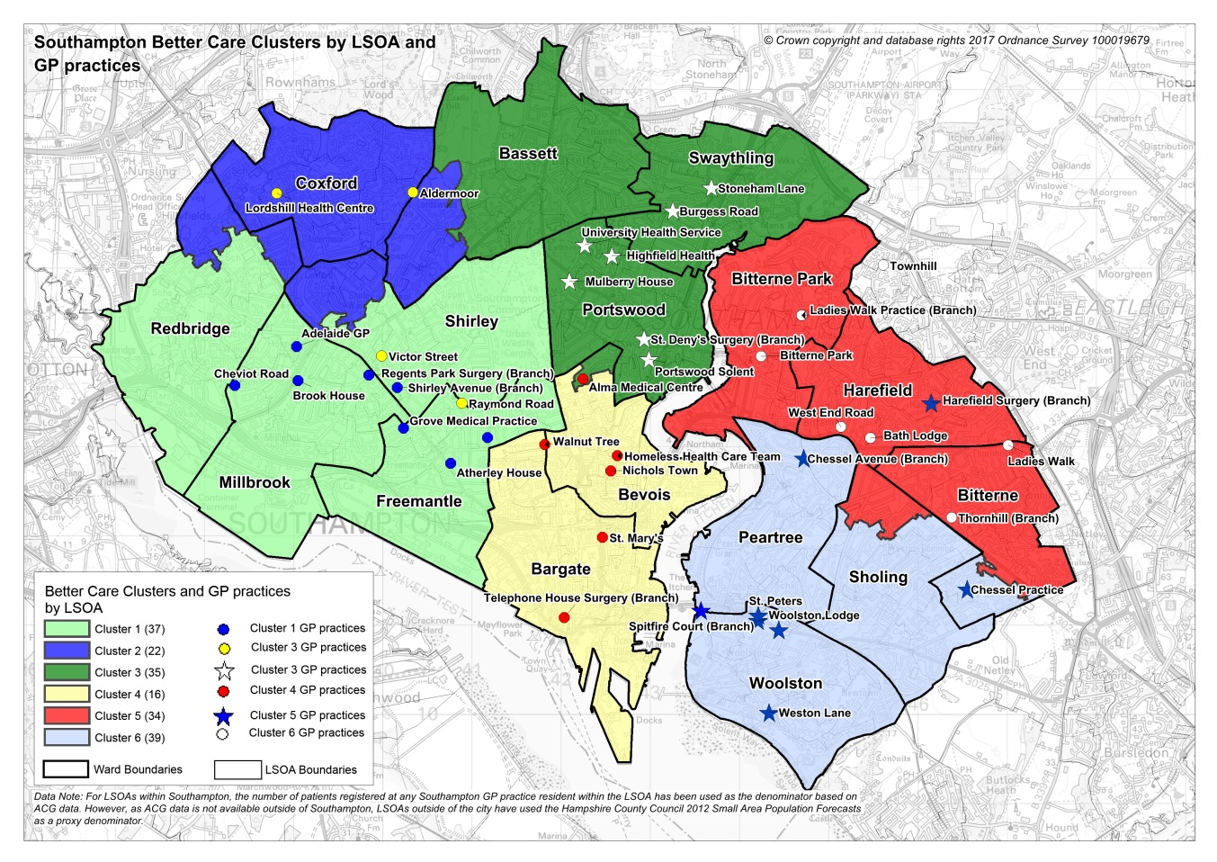

Demographic information per Cluster area
Demographic information per Cluster area | Cluster 1 | Cluster 2 | Cluster 3 | Cluster 4 | Cluster 5 | Cluster 6 | Total
HSCIC Raw List Sizes 01/01/2017 | 54,305 | 35,352 | 51,016 | 44,649 | 49,524 | 47,489 | 282,335
Weighted GSUM Population figures 01/01/2017 (1) | 53,927 | 37,020 | 45,097 | 45,762 | 51,829 | 48,700 | 282,335
QoF 2015-16 Dementia (2) | 238 | 246 | 182 | 238 | 439 | 284 | 1,627
QoF 2015-16 Depression (2) | 4,025 | 2,749 | 3,062 | 1,951 | 4,176 | 2,529 | 18,492
QoF 2015-16 Serious Mental Illness (2) | 638 | 329 | 404 | 706 | 507 | 456 | 3,040

(1) Weighting calculation is based on a number of demographic indicators, for example age, deprivation etc.
(2) Quality and Outcomes Framework (QOF) register data provides an indication of the level of Mental Health need, it will not include those individuals who may have an undiagnosed mental health need

3.2 Service Objectives

Service description
- To provide a single referral process for community navigation, linking with other related services such as Southampton Healthy Living Service, Advice and Information Services, Housing Related Support Services.
- To receive and make referrals from/to primary care and cluster teams.
- To adopt a partnership approach –challenging services to become more person centred.
- To make contact with service users, identify initial needs and signpost and/or provide further targeted support.
- To contribute to the prevention agenda – particularly preventing the need to access statutory services.
- To provide information about how to access community resources and directly link people to these activities/community resources e.g.
- Leisure (sport, interests)
- Employment
- Education
- Welfare rights
- Housing
- Friendship schemes
- Time banking schemes
- Volunteering to support others/co support
- To provide the point of contact to access other universal services
- To actively follow up all people referred to confirm individuals are taking action, discover if the identified solutions are working, identify if the person needs additional support to take action or other solutions.
- To inform the referring organisation of service user referrals made into the service from their organisation and provide feedback in relation to interventions made.
- To map community resources and local organisations encouraging people to up load information on the Southampton Information Directory (SID), maximising the mapping already undertaken by organisations across the City. (SID is hosted by the City Council and provides a platform for organisations to share their offer and assist people to identify resources in their community).
- To collate, analyse and report to Local Solutions Groups and Commissioners on issues raised in relation to service provision, e.g. challenges and trends, identifying gaps in required service provision across geographical and health and social needs categories.
- To offer the service in accessible locations and venues that are suitable to service users, taking into consideration the geographic, demographic, cultural and transport links of the population.
- To collect and maintain accurate records and data systems, ensuring high quality performance management information is available; this will include providing output and outcome data on a regular basis as specified by the commissioners. (as per point 6 page 17)
- To accompany or organise support for individual service users with low confidence levels to community groups.
- To consult and gain views from local people and service users in relation to the development, implementation and running of the service.
- To support Community Development services to identify through a process of coproduction gaps in community resources/assets required by the community and clinical teams (linking into the JSNA and Community asset map) to improve health and wellbeing.

Community activity provision
The service will seek to establish and maintain relationships with community groups and services, building relationships, linking people and networking.

The service will:
- Know their community and the key people
- Have a strategic view of cluster communities
- Support bottom up community development as appropriate
- Coordinated Community Navigation approaches across the city
- Collaborate and bridge the gap between services and community
- Link people with people – making and supporting the connection
- Be willing to listen and act on community development ideas as appropriate
- Take a facilitative approach - not controlling – facilitating, not doing
- Gather and disseminate information

The Service will play a lead role in coordinating the mapping of local community assets and resources. The service will have editorial responsibilities to review information uploaded to the Southampton Information Directory (SID). The Service will support groups to upload and keep up to date their information on SID. It is envisaged that community groups will be responsible for their own data, Community Navigators will have oversight, prompt people to review and train others to maximise and keep the data base up to date.

The commissioner acknowledges that there will be circumstances in which the individual needs of service users cannot be met due to a lack of capacity within the identified community and/or where there is a total gap in provision for a particular need.

Capacity issues in the community will be identified by the provider using their knowledge and working relationships with community organisations, particularly those operating in the voluntary community and faith sector.

The provider will be required to submit a monthly return to the commissioner, cluster teams and local solutions groups, detailing any identified lack of capacity and/or gap in provision. The provider will work with the commissioner to develop a reporting template for this purpose which will include: type of intervention and expected outcome; associated service user demand; details of community provider/organisation sign posted.

The commissioner will work with Local Solutions Groups to develop a community response to the identified gaps.

The provider will not be expected to facilitate or administer any unsolicited requests from any type of provider organisation or community group for funding.

Support Provided

The service will assess and support individuals based around 3 different levels of intervention. This includes being able to identify where the initial request masks a much wider range of complex issues.

Basic level

This level will support people who are able to plan their needs but unsure of how to find and access services and activities. They require basic level support and assistance including.
and provide including:
- Effective gathering of service user’s details needed to assess their advice needs and provide a service to them. .
- Basic identification and provision of information about the next steps needed to address the individual’s problem(s)/needs.
- Filtering inappropriate queries and signposting.
- Provision of options available to the service user.
- Assisting the service user where the initial assessment has already been carried out.

Support at this level will be short-term i.e. no more than 6 contacts but usually 2 appointments with the person.
Intermediary level

The service must be able to provide a small number of appointments to assess and support the individual’s needs, develop a plan with the individual and assist the person to take the first steps, providing advice directly or make appropriate referrals to other advisors or agencies, where more specialist advice or an alternative service is needed, as specified below:

- Provision of brief ( initial assistance (e.g. filling in forms, helping the service users draft letters, liaising with third parties to seek information on the service user’s behalf )
- Sign posting people to Advice and Information services
- Referrals where generalist advice is not able to meet the advice requirements or where another service is needed.
- Need support and assistance to find and access service.
Support at this level will be over a longer period of time, usually between 6 weeks and 6 months, although it should remain as short as possible to maintain an individual’s level of independence..

Advanced level

The service must be able to provide more detailed direct support and guidance, typically over a period of months including:

- Helping people who struggle to identify and plan how to meet their needs.
- Helping people who need support and motivation to improve their health and wellbeing
- Situations where multiple needs have been identified which require monitoring and support over a period of time or specialist service / intensive support is required to complete the support package.
- Helping to reduce risks to individuals (including to self and others, to tenancy and safeguarding) identified as significant if client’s current situation continues.
- Writing letters on the service user’s behalf, contacting third parties and providing support to deal with the service user’s issue.
- Taking action on behalf of a service user in order to address a problem, with the adviser taking some responsibility for action. This could involve consultation and guidance with specialists.
- Form completion, where involves more than one form.
- Dealing with several issues for the same service user.
- Undertaking searches (from a range of information resources) due to the nature of the issue/ need and communicating with the service user.
- Helping people understand individual options where ability is an issue and increases the length of time due to the level of support needed.
- Enhanced motivational support
- Detailed negotiation to resolve the issue or avoid an escalation of the issue.
- Preparatory work for specialists.

The provider will need to be aware of the interdependencies with the Advice and Information Services, Community Development discussions and the Behaviour Change Service.

Based on the evaluation of the pilot community navigation service the following issues are prevalent in the communities of Southampton:

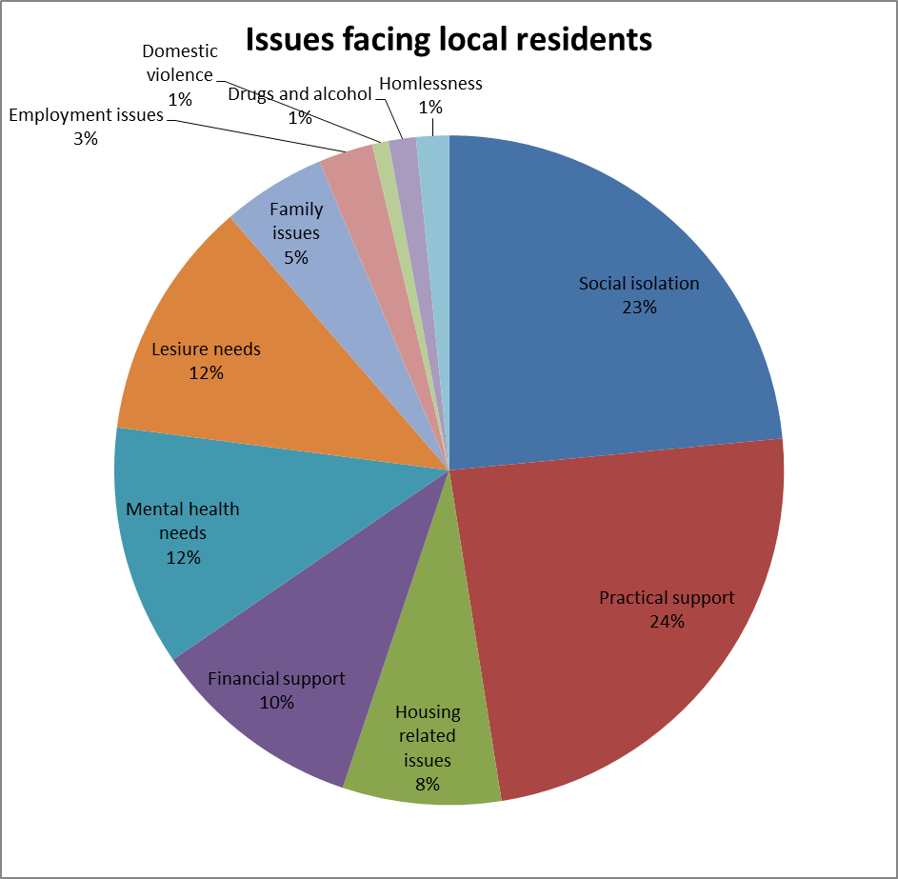

The Service will work with other community initiatives to support people who are struggling to access technology and support them to use their own and community IT resources.

Support plan
The provider will need to engage with those service users referred (for people with intermediary or advanced support needs only) to develop a person centre plan detailing the services received by the individual and the agreed outcomes. The person centred plan is to be developed with participation from the service user and a copy of the plan will be held by the service user.

Training, induction and ongoing workforce development

The service will use safe recruitment processes and ensure all staff and volunteers have appropriate levels of personal checks prior to employment or placement. Community Navigators should adopt a de-professionalised approach and deliver the service in a competent manner. Community Navigators should have suitable knowledge and experience in the following areas:

- Motivational interviewing
- Skilled in the use of the GENIE tool (see https://www.southampton.gov.uk/moderngov/documents/s31318/Using%20GENIE%20Presentation.pdf), being the trainer for other organisations in each cluster
- Problem solving
- Basic counselling skills/techniques/health coaching/mental health first aid
- Knowledge of primary care and the voluntary and community sector
- Making every contact count (MECC) principles
- Delivering general basic welfare advice and referring people with specific issues to the Advice and Information Services.

Individuals must feel that the sensitivity and nature of their condition is understood and an empathic approach should be taken to promoting dignity and respect, with a focus on empowering and encouraging people on all aspects of self-care as part of a value base.

Community Navigators must have the following core competencies and abilities:

- Excellent Communication skills
- Planning and goal setting with good organisational skills
- Proven track record in relationship building
- Have skills to assist with mediation/conflict resolution
- Strong networking and collaboration skills
- The ability to link with all communities (different faiths, geography, interests) making and maintaining relationships.
- The ability to build relationship with statutory services including the police to appropriately manage risks in communities
- Person Centred assessment skills
- Be able to promote responsible use of services
- Have the ability to confidently intervene
- Be part of community (live within ideally) they serve
- Have a range of skills to support people with access issues including: language, hearing & visual impaired.
- Be good at doing with, not doing to and be non-judgemental
- Good self awareness and not to be afraid to ask for help
- Ability to manage expectations (individual, professional and community group expectations).
- Be creative with solutions and not wedded to particular support models

Community Navigators will need a broad breadth of knowledge around individuals’ conditions and issues and seek expert advice from cluster team professionals as appropriate.

All staff must have a basic awareness and understanding of disability (NB. for the targeted areas of community navigation provision a more indepth awareness of learning disabilities, autism, dementia and mental ill-health will be required) and have the skills and abilities to work with service users with these conditions and be sufficiently skilled in risk assessment to refer to specialist providers as required.

The provider will be required to submit workforce information and evidence of workforce competence to commissioners upon request.

The Community Navigator Job Description must include reference to safeguarding competency levels and a “Think Family” approach; any concern regarding a child’s welfare will take paramount consideration during the visit. Safeguarding children and adult’s training must be provided at the appropriate level to all provider staff.

Community Navigators must be familiar with the provider’s Lone Worker Policy.

Marketing/Communication

The provider is responsible for marketing the services to GPs and other referrers, for example social care, housing, community nursing teams, psychological therapies (Southampton Steps to Wellbeing) and other stakeholders in the Southampton City boundary.

Service information should be available in the main languages spoken across Southampton. The provider is responsible for organising interpretation and translation services where required.

Through consultation with potential service users and stakeholders, the provider should propose a name for the service that resonates with service users.

The provider is required to produce a service information leaflet. The leaflet should include as a minimum: the name of the provider; the name of the service; a description of the service; information about the service including location and opening times; access and referral information; and contact information. An electronic version of the leaflet will also be required, and be available on Southampton Information Directory and NHS Southampton Directory of Service. The service information leaflet will require the approval of the commissioner before issuing.

Branding of the service and service leaflets will be agreed with the commissioner.

Referrals

Referrals can be self-referral or originate from either a GP or Health & Social Care professional or other worker providing support in a cluster.

It is expected that most referrals will be generated at a service user’s routine visit to a GP practice or social care service visit. The consulting GP or Health & Social Care professional will undertake the normal medical appointment/assessment but would also consider if the service user might benefit from addressing their social support needs. The service user’s consent to refer would be required.

The provider will need to develop robust referral processes and systems. However, the process must include the ability for referrers, during their initial contact with the service user, to make direct bookings with a Community Navigator, potentially via an on-line, web based booking system offering real-time appointment slots is required.

All referrals for intermediate and advance support must be supported by a referral form, developed by the provider and in consultation with practice managers and commissioners. Ideally, the referral form will be completed and uploaded electronically (secure NHS Mail/Pathway Information Portal (PIP)) although paper referrals will also be accepted. Faxed referrals are not permissible.

Following receipt of the referral form, Community Navigators will undertake an initial assessment of the service user’s needs.

Assessment

All referrals to the Community Navigation Service will be assessed in order to identify the individual needs of the service user. The assessment scope and process will be agreed with the commissioner but should be holistic covering social factors such as: long term conditions, emotional and physical wellbeing, housing, finance etc. (please note this is not an exhaustive list).

The assessment process must support people to:
- Identify their need for intervention
- Agree person centred goals
- Agree individual initiated follow-ups back to the service, if required
- Support the individual to access community resources they require

Following assessment, the service user will be contacted, by telephone wherever possible. During this first contact, the service user will either be provided with the requested information or offered an appointment with a Community Navigator if not already made; the service user may already have an appointment with a Community Navigator made by the referring GP or Health & Social Care professional.

Service users will be contacted within 2 calendar days of receipt of referral. Where a face- to-face assessment with a Community Navigator has been identified, the service user will be offered an assessment to take place within 5 calendar days of receipt of referral.

If the assessment process uncovers a more serious underlying mental health, physical health or social need the service will need to refer the service user to their GP or SCC Contact Centre. Any matter relating to a significant risk or safeguarding issue must be dealt with appropriately and under the overarching CCG Safeguarding Policy and the Care Act 2014.

The service will develop an outcomes tool to be agreed with commissioners.

Discharge planning

Once an individual has achieved their agreed goals or has an appropriate ongoing plan in place, they will be discharged from the service. If ongoing community care is required, the individual signposted or referred to their local Cluster Team.

Days/hours of operation

Community Navigator Service will be fully operational between Monday and Friday 09.00hrs to 18.00hrs and Saturday mornings 09.00hrs to 12.00hrs. There should be the flexibility in place to enable assessments and ‘handholding’ in the early evenings (Monday to Saturday), up to 20.00hrs, as appropriate, to promote accessibility.
The service will offer support to people via:
- Face to face
- Telephone/email/text
and be accessible via a single route for statutory services (at cluster level)

Population covered

The service is for adults aged 18 years and above, registered with an NHS Southampton City Clinical Commissioning Group GP or resident within the Southampton City Council boundary area (regardless of GP status).

The Service will be part of the integrated Cluster Teams and seek intelligence from community groups about vulnerable people living in communities (finding people proactively before services are aware) and feeding this into risk stratification processes so that individuals in need are targeted with early interventions and prevention services.

It will be important to focus efforts on vulnerable and traditionally marginalised and excluded groups and so the service will need to effectively meet the needs of target groups including:
- Primary health care users
- People with an illness or disability (including mental health) and their carers
- Families on a low income
- Older people (over 65 years)
- Black and minority ethnic people
- Victims of violence, including domestic violence
- People living in priority areas (wards with the highest levels of deprivation)
- Service personnel and ex service personnel
- People adversely affected by changes to the benefit system

The Service may help people who have funding through a direct payment to access community resources to enhance their lifestyle and use the resources they have effectively.

Any exclusion criteria and thresholds

The following exclusion criteria apply:

- Service users who are unsuitable for care and support under the conditions of this service specification
- Service users under the age of 18 years
- Service users who have not validly consented to the care and support offered
- Service users who display unreasonable behaviour unacceptable to the provider and its staff
- Service users who are acutely ill at the point of referral

The Service will not seek to filling gaps in formal health and social care services.

Interdependence with other services/providers
- Cluster Integrated Teams including primary care, community and mental health services, housing, police, fire services
- Integrated Community Independence and Discharge Teams
- Cluster and City wide voluntary groups
- Faith groups
- Behaviour Change Service
- Southampton Information Directory SCC IT Team
- Integrated Advice and Information Services (under development)

The provider will need to establish links with Local Solutions Groups, local Voluntary and Community sector organisations, faith groups and the provider of psychological therapies (Southampton Steps to Wellbeing, Dorset Healthcare University NHS Foundation Trust) covering the Southampton City area. The establishment of good working relationships with Southampton GP Federation, individual GP Practices, NHS Solent, NHS Southern Healthcare, and SCC provider adult health and social care services is also essential. The Service will need to establish strong links with the Southampton City Contact Centre and Single Point of Access.

In addition to the Generic Service detailed above, commissioners are also looking to commission the following additional targeted services :
A community navigation service for people with a diagnosis of, or with suspected dementia, this includes older adults and younger adults with an early onset dementia type illness
Southampton are working towards becoming a dementia friendly city where people with dementia will be treated with respect and feel included in our local communities. We want everyone to be able to find information and advice regarding memory problems and dementia quickly and easily, and to receive a diagnosis of dementia as early as possible. The aim is to have a community navigation service for people that have a formal organic mental health diagnosis, and people with a known mental health condition, but who have refused conformation of diagnosis. The aim is to deliver interventions for people with mild-moderate dementia who do not yet require specialist care.
The service provider will work in close collaboration with all providers in the dementia pathway, in particular with GPs, Southern Health NHS Foundation Trust (the specialist NHS dementia service provider), Solent NHS Trust (the specialist NHS admiral nursing service provider), Adult Social Care, University Hospital NHS Foundation Trust (the General Hospital), Carers in Southampton, Day Services and other third sector providers who are providing services to this population, Southampton Dementia Action Alliance (DAA), and emerging Dementia Friendly Communities in the city.
Promotion of dementia awareness and inclusion provides an opportunity for collaboration and partnership with other community services and interventions as part of local service delivery (for example housing, physical activity and leisure services, BME focussed services etc.) This will help to build community resilience and opportunities to live well with dementia.
The service will work with primary care to ensure maximum awareness of the service, to develop dementia aware General Practices (iSPACE initiative), the service will have the skill and capability to respond to the needs of the spectrum of people with dementia.
A community navigation service for working age adults who have mental ill health
Social inclusion of people with mental health problems is essential to achieving improved quality of life, which supports recovery and improved clinical outcomes. Community navigation supports improved access to psychological treatments, access to services and interventions addressing the wider determinants of mental health, and well as improving mental health and wellbeing. Community navigation should be available as part of prevention and early intervention within primary care, and also to support recovery from severe mental distress.
Results from Mental Health Matters public consultation supported the proposal to develop Community Navigation to help individuals with a mental health problem to improve access to local community resources in order to help maintain own health and wellbeing.
The service provider will work in close collaboration with all providers in the mental health pathways, in particular with GPs, Southern Health NHS Foundation Trust (the specialist NHS mental health service provider), Dorset Healthcare University Foundation Trust (the specialist NHS Improving Access to Psychological Therapies provider), Adult Social Care, University Hospital NHS Foundation Trust (the General Hospital), Carers in Southampton, Mental Health Anti-Stigma Steering Group, Mental Health Partnership Group, Day Services and other third sector providers who are providing services to this population.
The service will have the skill and capability to respond to the needs of the spectrum of people with mental health problems, ranging from mild-moderate depression and anxiety related disorders through to severe and enduring mental health problems.
A community navigation service for people with a learning disability
Social inclusion for individuals with a learning disability is essential to achieving improved quality of life, and improves both health and social care outcomes. Individuals with a learning disability suffer from health inequalities largely driven by social determinants. Community navigation supports improved access to meaningful activity including leisure and employment opportunities and supports the person to adopt healthy lifestyles. Individuals with a learning disability need additional support to access opportunities with providers needing to make reasonable adjustment to their offer. Community navigation should be available as part of prevention and early intervention within primary care, and other specialist learning disability services to support individuals.
The Learning Disability Partnership Board has been established to champion change locally to ensure that individuals and carers are supported. The Learning Disability Partnership Board is made up of learning disability self-advocates, carers and professionals working in partnership to improve the quality of life and outcomes for people living in the City. The Partnership Board has a powerful role to play in improving access and challenging the offer of services to ensure that the needs of people are recognised and accommodated. Community Navigation will need to work within this partnership framework.
The service provider will work in close collaboration with all providers supporting people with a learning disability service , in particular with GPs, Southern Health NHS Foundation Trust (the specialist NHS learning disability service provider), Adult Social Care, University Hospital NHS Foundation Trust (the General Hospital), Carers in Southampton, Mencap, Autism providers, Domiciliary Care Services (Supported Living Services), Housing related Support Services, Residential Care Services, Day Services and other third sector providers who are providing services to this population.
The community navigation service will have a role to play in supporting people on the journey to access paid employment. The service will need to work closely with specialist employment services and local businesses to facilitate the development and maintenance of individual support arrangements for people in work or training for work.
The service will have the skill and capability to respond to the needs of the spectrum of people with a learning disability including people who have a physical or behavioral support needs.
Community navigation service focused on people with housing related support needs to older people
Older people have historically received significant support via their accommodation (shelter housing etc.). We intend to extend this to all older people living in the City based on need and risks to individuals (including to self and others, to tenancy and safeguarding) identified as significant if client’s current situation continues. The support offered will typically involve Case holding /Key working, with the service providing an open caseload - longer term, or intensive support required. Multiple needs identified which require monitoring and support over a period of time or specialist service / intensive support is required to complete the support package.
The support will be targeted meaning it involves specialist areas or specialist services such as HRS floating support service, which address particular issues. This is not intended to replace general needs service dealing with all needs ranges.
The table below outlines to nature of the housing related support expected:
INFORMATION and SIGNPOSTING / COMMUNITY INVOLVEMENT
- Referring to another organization – passing on a case to another organization or involving another organization in support
- Support to access services – linking people with organizations and statutory services to access appropriate support (such as rehab teams, GPs)
- Accepting referrals
- Accessing the community – improving people’s knowledge about local activities and groups and supporting to attend
- Offer information on activities
- Accompanying / taking to appointments
- Emotional support – conversations, motivation, confidence building
- Empowering / Confidence building

SKILLS
- Online support and IT training
- Domestic support – would include cleaning, shopping or support to do these things
- Personal support – sourcing of personal care
- Help with medication

FINANCES
- Form filling
- Budgeting
- Financial wellbeing, including dealing with debt
- Benefit assistance / Maximising income

HOUSING NEEDS
- Organizing support – telecare
- Organizing adaptations / OT assessments
- Repairs and maintenance
- Joint working on issues – including other agencies to complete the support package
- Need to move on, support moving on
- Poor living conditions / decluttering
- Safeguarding acting on and referring to ASC – identifying causes for concern and notifying agencies appropriately. Could include 1 to 1 work on staying safe or drawing and delivering on action plans to increase safety
- Support maintaining property / Avoiding eviction

4. Applicable Service Standards
The service must:
- Take into account cultural, religious and gender sensitivities and provide male or female clinicians when requested.
- Ensure that services are delivered to meet the specific needs of people with disabilities or mental health problems so they receive equitable access to services
- Be led by service user views and opinions in developing integrated services that best suit user needs.
- Ensure staff are trained to appropriate level in terms of safeguarding adults and young people
- Facilitate links with social care and the voluntary sector to enable them to provide practical assistance for people who are homeless or need support to access healthcare services.
- Provide access to interpretation services to facilitate communication with ethnic minority groups as necessary.
- Make the service available in locations that are geographically convenient with good transport links based within local communities. Where people are unable to travel to appointments visits must be arranged.
- The service will need to develop a proportionate & risk based quality assurance framework
- Develop and operate an effective lone worker procedure
- The provider must ensure systems and processes are in place to ensure continuity of support and advice and information
- The provider must ensure that a senior officer is in place with managerial responsibility takes the lead for the day to day running of the service.

4.3.3 The provider must ensure that the following levels of supervision are provided to the community navigator team (paid staff and volunteers)
- Management supervision
- Personal supervision
- Safeguarding supervision (safeguarding issues to be referred to named officers with safeguarding corporate responsibilities).

5. Key Service Outcomes
The service will contribute to the following outcomes:
- Achievement of Person Centred Outcomes at an individual level (as measured through a systematic tool such as the outcomes star and Patient Activation Measure – to be agreed with the Commissioner)
- Reduction in loneliness
- Reduction in GP contacts for medically unexplained symptoms
- Reduction in avoidable ED attendances and use of other emergency and urgent services
- Reduction in avoidable use of social care services
- High levels of individual and professional satisfaction with the service provided as measured through service user, staff and referrer feedback mechanisms)
- Shorter length of stay in reablement and rehabilitation services
- Reduction in low level anti-social behaviour
- Increase in the actual number of activities/support being accessed (Age UK, Luncheon Clubs, etc)
- Increase in number of times SID is accessed.

The provider will develop an evaluation model with commissioners to evaluate performance against these outcomes, exploring how others areas and services have evaluated. This might include:
- Working with referrers and commissioners to track the health and social care service use of individuals referred pre and post intervention to ascertain what impact there has been achieved
- Comparisons with control groups not receiving community navigation
- Simple self assessment tools used with service users
- Seeking broad stakeholder feedback on the impact of the service (e.g. How has the service contributed to building capacity in the community.
- Sample of people using the service (level to be agreed with the commissioner) to be contacted and followed up at 3 and 6 months after discharge to evaluate outcomes, using agreed tool.

6. Management Information and Reporting Requirements
All data to be reported by Cluster area.
The provider will be required to collect and report monthly with the following service user data:
Progress against an outcomes tool
NHS Number
Demographic data – to include ethnicity: mental health/learning disability/age/gender
First Four digits of the service users postcode and registered GP
Health conditions of service user supported
Number of service users in receipt of welfare support
Number of service users who are not in paid employment

Performance indicator | Indicator | Threshold | Method of measurement | Frequency of monitoring
Outcomes | Person Centred Outcomes (outcomes star). Patient Activation Measure. Loneliness Score | % referred who score an improvement from baseline 6 weeks following discharge  Primarily focused on level 2 – 3 support levels | Data report | Monthly
Outcome | Reduction in GP contacts for medically unexplained symptoms | Reported by Cluster Teams | Data report | Monthly
Activity | Number of referrals into the service, by type and source of referral (eg self- referral) |  | Data report | Monthly
Activity | Number of service users receiving telephone consultations |  | Data report | Monthly
Activity | Number of service users receiving face to face consultations |  | Data report | Monthly
Activity | Number of service users receiving support broken down by:  - Service users receiving advanced level  - Service users receiving intermediate level  - Service users receiving basic level |  | Data report | Monthly
Activity | Number of 30 minutes sessions delivered |  | Data report | Monthly
Activity | Number of service users referred or signposted on to other services:  - NHS service (primary and secondary)  - Social Care  - Housing  - Employment support agencies  - Information, advice and guidance services (broken down by name)  - Others as appropriate |  | Data report | Monthly
Activity | Number of service users referred on to Voluntary and Community sector broken down by activities, care and support (including name of organisation) |  | Data report | Monthly
Activity | Overall numbers in service broken down by types of intervention, age and gender/ length of time in service |  | Data report | Monthly
Activity | Number of service user support plans developed |  | Data report | Monthly
Activity | Number of MDT sessions attended by Community Navigators; by GP practice location |  | Data report | Monthly
Activity | Number of referrals to Children's Safeguarding |  | Data report | Monthly
Activity | Number of referrals to Adult Safeguarding |  | Data report | Monthly
Activity | Number of exclusions from service and reason for exclusion/referrals declined and reason |  | Data report | Monthly
Activity | Number / type of complaints received |  | Data report | Monthly
Activity | Number/ type of compliments received
Activity | Reasons for service users not attending/ declining to attend |  | Data report | Monthly
Activity | Number of service users accompanied to a community activity or group |  | Data report | Monthly
Outcome | Patient and professional satisfaction (use of feedback –iPads), patient feedback | 100% reported.  Minimum 10% to be completed annually | Data report | Monthly
Activity | Total number of individuals on the caseload |  | Data report | Monthly
Patient Activity | Total number of individuals discharged from the service | 100% of all discharges to be reported |  | Monthly
Quality of life following support after 3/6 months | Questionnaire | 100% to be reported | Audit Report - Quality of life following treatment | Quarterly

Performance Indicator | Target | Reporting Frequency | Consequence of Breach
Service users to be contacted within 2 calendar days of receipt of referral | 95% | Monthly | <95% withholding of 1% of monthly contract value  <90% withholding of 2.5% of monthly contract value
Where a face to face assessment has been identified service users to be offered an assessment to take place within 5 calendar days of receipt of referral | 95% | Monthly | <95% withholding of 1% of monthly contract value  <90% withholding of 2.5% of monthly contract value
Establishment of comprehensive electronic database community resources/assets recorded on Southampton Information Directory | 6 months from commencement | N/A
Number of website hits on Southampton Information Directory |  | Monthly | Provided by SCC
Written reports submitted to Commissioners on Service provision, challenges and trends, identifying gaps in required service provision across cluster and health need categories | Submitted monthly | Monthly

