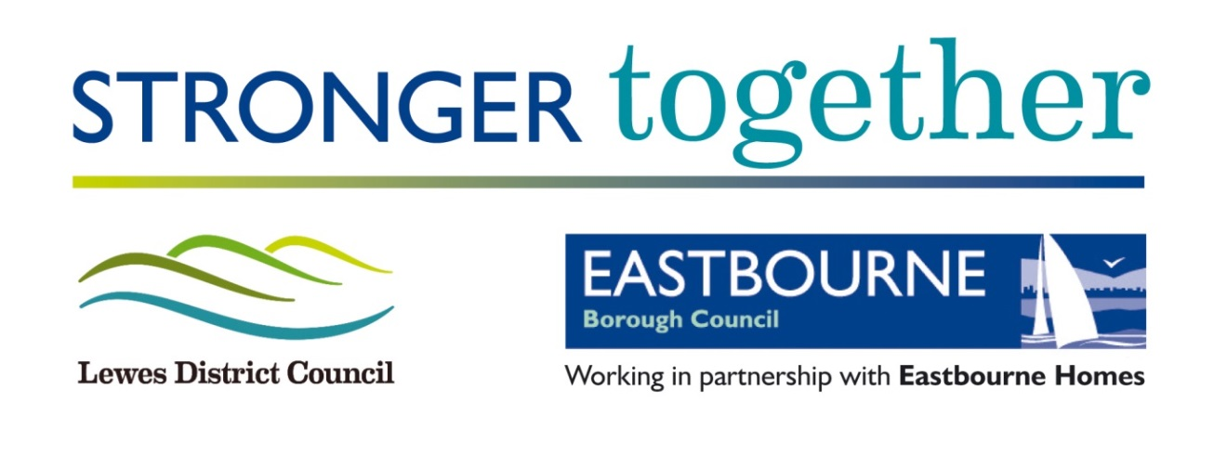

**NEWHAVEN ENTERPRISE CENTRE**

**OPERATOR SPECIFICATION**

**August 2019**

1. **Introduction**
   1. The Services to be provided within this part of the Specification embrace the management of the Newhaven Enterprise Centre (NEC) and perform the Services for the benefit of Lewes District Council (LDC).
   2. The objectives of the Service are to:
      1. NEC management.
      2. The maintenance, repair and renewal of the NEC.
      3. Market the NEC.
      4. Letting units within the NEC in accordance with the Management Agreement.
      5. Efficient and timely collection of all Rents, other licence fees, deposits and any additional costs payable by the Licensees within the NEC and prompt payment of the same into LDC’s Designated Account for the same.
      6. Employment and training of staff for the NEC.
      7. Prepare budgets for agreement with LDC.
      8. Ensuring that LDC’s obligations to Licensees in the Business Centre are properly complied with.
      9. Manage the provision and maintenance of the telecommunications and broadband services.
      10. Completion of Quarterly Output Monitoring Returns for each Quarter and deliver of the same to LDC within the period of four weeks after the Quarter end.
2. **The Enterprise Centre**
   1. The Newhaven Enterprise Centre is owned by Lewes District Council and opened in 2007 providing business incubator and managed workspace facilities for the local business community. The Centre was developed on a former employment site, utilising funding secured from the now defunct South East England Development Agency (SEEDA). Due to the success of the centre, the Council was successful in securing Coastal Communities funding in 2013/14 to expand the centre, with the extension opening in April 2016.
   2. The centre is located on Denton Island (see appendix 3) and provides furnished incubator units for start-ups, workshops, larger units aimed at businesses with 1 to 15 people, and flexible co-working space. The centre comprises of 48 offices, 12 workshops and has a range of modern business facilities including breakout areas, meeting rooms and its own dedicated car park (see appendix 4). The East Sussex College and Sussex Community Development Association occupy neighbouring properties on the Denton Island site and the operator would be expected to build collaborative relationships to support the Council’s continued focus on skills and employment in Newhaven.
   3. The Newhaven Enterprise Centre operates on three levels with a total lettable area of 19,111 sq ft (1775 sq m), comprising of 48 offices totalling 12,740 sq ft (1183 sq m) and 12 workshops totalling 6,371 sq ft (592 sq m).
   4. LDC will provide the successful operator with a list of all the occupiers within the Newhaven Enterprise Centre. The current SqM occupancy rate is 92% (May 2019) and has averaged approximately 87% since the extension was added in 2016 (see appendix 5).
3. **Strategic Context**
   1. The LDC Council Plan sets out the Council’s priorities and key projects. This includes a commitment to support businesses to grow and prosper, through advice, guidance and high quality employment premises as well as attracting inward investment. The Council Plan is also very clear that the Newhaven Enterprise Zone is a high, strategic priority for Lewes District Council aiming to deliver significant regeneration through increasing the supply and occupation of commercial floorspace that will generate new employment opportunities.
   2. The Newhaven Enterprise Zone is a collaboration between the South East Local Enterprise Partnership, Coast to Capital Local Enterprise Partnership and Lewes District Council. The designated Zone commenced in April 2017. Located between several key transport links and already home to a number of rapidly growing companies, Newhaven provides fantastic opportunities for businesses looking to thrive in this growing economy. Newhaven has substantial physical capacity for growth and is evolving to become a key harbour town on the South Coast. Its transport links offer strong opportunities for business growth and excellent employability prospects. Newhaven and the wider Lewes District Council area, is also part of the Greater Brighton City Region which is home to 695,000 people and almost 30,000 businesses. It is the home of prosperity, with an economy worth £23.1 billion and a large workforce. The town is home to a growing and diverse economy with an emerging specialism in innovative, high-value growth sectors including offshore wind and marine engineering. Alongside this emerging specialism, Newhaven is also home to a large number of creative industries and innovative manufacturers. With room for growth for expanding businesses and its connections to the wider economy, Newhaven is fast emerging as a key economic hub.
   3. Published in July 2018, the Newhaven Enterprise Zone Strategic Framework identifies three core priorities to ensure lasting and positive change; quality growth, inclusive growth and sustainable growth.
      1. **Priority 1**, Quality Growth: To promote cohesive development which will foster pride in Newhaven, recognising the town’s exceptional natural capital and also it’s working port and coastal connections.
      2. **Priority 2**, Inclusive Growth: To deliver local skills and support for businesses which will create a diverse and prosperous economy, ensuring Newhaven residents are shared benefactors of change.
      3. **Priority 3**, Sustainable Growth: To invest in housing and infrastructure which will attract inward investment, creating a lasting economic and social legacy for Newhaven.
   4. The Newhaven Enterprise Centre provides modern and essential flexible business spaces, which are valuable in supporting the ambitions of the Newhaven Enterprise Zone Strategic Framework.
4. **Outcomes**
   1. SqM occupancy target of 85% at agreed revenue target per month
   2. Meeting room hire revenue target of £1,000 per month
   3. Regular centre-focused and local economy networking events.
   4. Supported access to business mentoring opportunities.
   5. Understanding of the sectors represented by licensees, why they choose to leave, and where they move to.
   6. Annual customer satisfaction survey results
   7. Maintain a detailed inventory audit of each unit and communal spaces
   8. Any other reasonable outcomes as required by Lewes District Council.
5. **General Requirements**:
   1. Preparation of budgets for agreement with LDC;
   2. Employment and training of staff for the Business Centre;
   3. Marketing the Business Centre;
   4. Letting units within the Business Centre;
   5. Business Centre management including organisation of all items relating to Operating Costs as set out in Appendix 1 below;
   6. Efficient and timely collection of all Rents, other licence fees, deposits and any additional costs payable by the Licensees within the Business Centre for services provided at the Business Centre and prompt payment of the same into LDC’s Designated Account for the same;
   7. The maintenance, cleanliness and repair of the Business Centre;
   8. Ensuring that LDC’s obligations to Licensees in the Business Centre are properly complied with.
   9. The provision of the telecommunications services referred to in clause 5.4.
   10. Completion of any required reports for each Quarter and delivery of the same to LDC within the period of four weeks after the Quarter end.

Appendix 1: Operating Costs

**Service Provider sha****ll supply:**

Centre staff

**Payments made on behalf of Lewes District Council**

Business rates

Electricity gas and water

Property maintenance and security

Cleaning and waste disposal

Building insurance

Office equipment costs

IT maintenance

Telephone and broadband maintenance, line rental, call costs etc properly incurred by the Service Provider in the provision of the Services

Valuation fee

# Appendix 2: Services Specifications

|  |  |  |
| --- | --- | --- |
| **Service Specification** | **Monitoring Process** | **Measurement** |
| Financial Management and Service Charge Budgeting | Monthly report against annual agreed budgets for operating costs within 28 days of month end. | 1. Savings made on budget 2. Budgets achieved (Target) 3. Budgets exceeded without LDC approval |
| Income Levels / Occupancy Levels | Monthly reporting against annual forecasts provided by Contractor.   * Sqm2 occupancy target of 85%. * Meeting room hire revenue target of £1000 per month | LDC to monitor income levels against forecasts and in conjunction with Contractor adjust marketing and lettings strategies accordingly |
| Cleanliness/State of Repair/ | Manager reports on sub-contractor performance against service level agreements. | Quarterly report to LDC  Inventory Audit to be provided to LDC on an annual basis. |
| Efficient Centre Operation | Customer satisfaction surveys from occupiers (annual basis and on all exiting occupiers), also setting out where occupier is moving to for exiting occupiers. | Quarterly report to LDC on exit reviews and annual report on the general surveys. Target 75% satisfaction levels minimum – below this level, improvements will need to be agreed with LDC. |
| Health & Safety | Centre Manager monitor performance, with an independent annual audit. | 1. Zero Health & Safety incidents reported on site due to negligence of the FM provider. 2. Number of Health & Safety incidents reported on site due to negligence of the FM provider. |

# Appendix 3: Newhaven Enterprise Centre Site Location

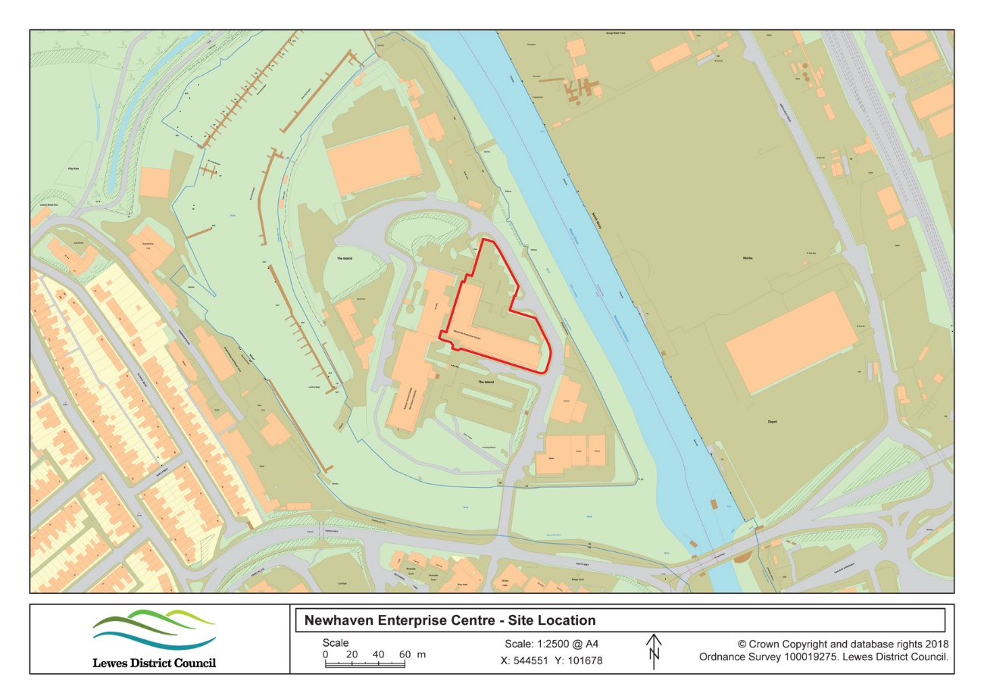

# 

# Appendix 4: Newhaven Enterprise Centre Site Plan

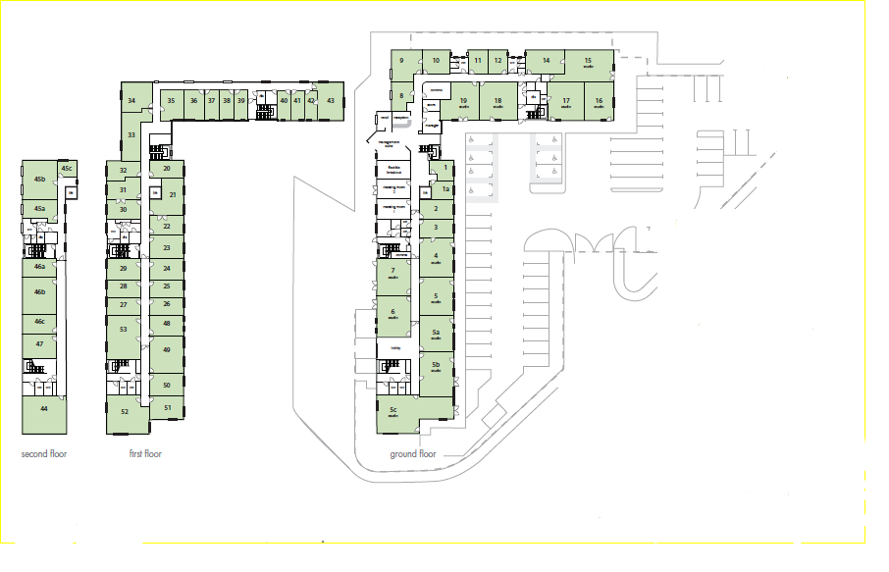

# Appendix 5: Occupancy Rates

|  |
| --- |
|  |

|  |  |
| --- | --- |
| **2016/17** | **Occupancy** |
| **Average** | **86%** |
|  |  |
| Apr-16 | 71.5% |
| May-16 | 81.7% |
| Jun-16 | 84.8% |
| Jul-16 | 86.3% |
| Aug-16 | 82.3% |
| Sep-16 | 83.9% |
| Oct-16 | 86.9% |
| Nov-16 | 88.0% |
| Dec-16 | 86.9% |
| Jan-17 | 90.9% |
| Feb-17 | 91.0% |
| Mar-17 | 92.4% |
|  |  |
| **2017/18** | **Occupancy** |
| **Average** | **93.1%** |
|  |  |
| Apr-17 | 90.9% |
| May-17 | 87.8% |
| Jun-17 | 89.1% |
| Jul-17 | 88.8% |
| Aug-17 | 88.8% |
| Sep-17 | 86.0% |
| Oct-17 | 91.9% |
| Nov-17 | 97.8% |
| Dec-17 | 100.0% |
| Jan-18 | 95.6% |
| Feb-18 | 100.0% |
| Mar-18 | 100.0% |
|  |  |
| **2018/19** | **Occupancy** |
| **Average** | |  | | --- | | **85%** | |
|  |  |
| Apr-18 | 99.2% |
| May-18 | 88.0% |
| Jun-18 | 86.7% |
| Jul-18 | 85.9% |
| Aug-18 | 86.9% |
| Sep-18 | 79.3% |
| Oct-18 | 78.3% |
| Nov-18 | 79.1% |
| Dec-18 | 77.3% |
| Jan-19 | 85.0% |
| Feb-19 | 86.2% |
| Mar-19 | 86.0% |