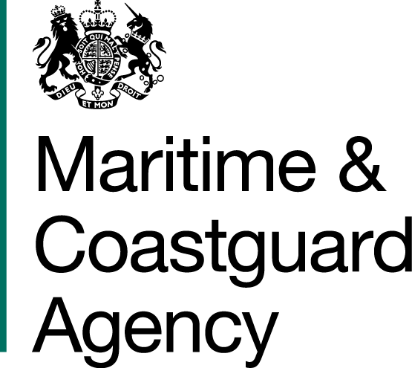 |  |  | Bay 3/21  Spring Place  105 Commercial Road  Southampton  SO15 1EG
 | To whom it may  Concern, |  | Tel:  E-mail: | +44 (0)20 381 72173  contracts@mcga.gov.uk
 |  |  | Your ref:  Our ref: |  | TCA 3/7/706
 |  |  | 31st January 2018

TENDER FOR Contract for the Storage, Maintenance and Deployment of the United Kingdom’s Counter Pollution Equipment Stockpile

Dear Sirs

We have received questions for the above-mentioned tender, and to ensure that all tenderers have access to the same information, we have copied the questions and our answers to you:

Question 1:
Reference: Instructions on Submission of Tenders: 12. A – F.
Please confirm whether the requirements relating to the provision of a Small Combination Skimmer System are relevant to this tender.

Response:
This is not relevant to the tender and has been removed from the document.

Question 2:
Is it down to the contracted OSRO to decide where equipment from the three existing stockpile locations is relocated? i.e. does all the equipment from Barnsley need to be stored in one location or can it be split/combined with that from Bristol and Dundee for example?

Response:
The requirement is for the first lorry load of equipment and the first response team to be able to reach any location on the coast of the UK mainland within 12 hours of leaving any one of the bases, if this can still be achieved after the split then it would, in theory, be acceptable. The MCA would need to consider how the split will be carried out however, in terms of what equipment will be stored at each of the two remaining bases. It is essential that the 12 hour response time can be met for all of our major categories of equipment to enable us to deal with pollution in any area and with oil of any type i.e. shoreline and offshore equipment, disk skimmers and brush skimmers. For example, if all of the at sea equipment was moved to a Scottish base and all of the shoreline equipment was kept in the South of England, then a 12 hour response time for a call out of shoreline equipment to Inverness would not be achievable. For certain pieces of very specialist equipment, where the MCA may only hold one item, such as our portable inert gas generator, an even split may not be possible. For these pieces of equipment the 12 hour response time will not necessarily be applicable, but we will still be looking to achieve the best estimated response time possible based on the optimum location of the equipment. A further consideration which will be factored into the evaluation is business continuity. Splitting the stockpile over three sites provides a good level of contingency should one site be lost, through fire for example, both in terms of equipment quantity and national coverage. For example, at present, if either the Bristol or Dundee stockpiles were destroyed, the Barnsley stockpile is well placed to reach both the South of England or Scotland. Equally, if the Barnsley stockpile was destroyed, the Bristol and Dundee stockpiles would enable us to continue to meet our 12 hour response timeframe for England and Wales and Scotland respectively. If a tenderer proposed to reduce the number of stockpile sites, they would need to explain how the business continuity risks would be mitigated.

Question 3:
Is unloading at the point of delivery the responsibility of the contracted OSRO?

Response:
Yes – even where local contractors/stevedores are used, the OSRO will be expected to oversee unloading operations. Where local contracted services, i.e. stevedores, the OSRO will organise (sometimes with the assistance of MCA Counter Pollution Logistics) and be the point of contact.

Question 4:
Is the equipment selection for a mobilisation based on the MCA’s request, or the contractor’s experience or combination of both? i.e. will the contracted OSRO be instructed what equipment to load and transport by the MCA?

Response:
Ultimately it will be the MCA’s decision as it will be the MCA’s equipment and an MCA response, but the contractor will be consulted for their professional view on what equipment would be most appropriate for a given scenario. The contractors advice will be considered in the MCA’s selection of equipment.

Question 5:
Insurance. Is the MCA Equipment to be insured by the MCA for storage, maintenance, deployment (spill or exercise/training) or by the Contracted OSRO? If the later please provide details of insurance value of equipment.

Response:

It is the responsibility of the storage contractor to insure the MCA equipment against fire, theft and third party consequences whilst in their care and the cost of this insurance cover must be included in the overall contract cost, but detailed separately for clarity. To permit the contractor to obtain quotations for this insurance a nominal value for the equipment to be stored is £5,000,000. The insurance of the equipment whilst in transit for use at an incident or training exercise is the responsibility of the haulier. The insurance of the equipment whilst on site, and during deployment, is the responsibility of the MCA.

These terms are in line with the Department for Transport General Conditions of Contract for Services:

https://www.gov.uk/government/uploads/system/uploads/attachment_data/file/657713/general-conditions-of-contract-for-services.pdf

Question 6:
Will it be a requirement for the successful OSRO to gain and maintain accreditation under both the existing UK Spill Contractor Accreditation Scheme for Module 5a (Tier 3: Large Ports) and the new UK National Standard for Marine Oil Spill Response Providers or would the new Standard supersede that of the UK Spill one?

Response:
The new UK National Standard is unlikely to be in force by the time the new contract is let. The successful OSRO will be required to be accredited under Module 5a of the UK Spill scheme or under ISAA’s Marine and Shoreline Modules.

Question 7:
Will incumbent OSRO’s lifting equipment and competent operators (i.e. appropriate forklifts and/or crane) at the existing sites be made available for loading of equipment on to arriving trucks as part of the relocation process? Will the associated costs be borne by the incumbent OSRO?

Response:
We would envision that there would be a short overlap between the two contracts to allow a staggered relocation of the equipment while maintaining a response capability. The incumbents lifting equipment and operators would be available during this time; this should be part of their exit strategy. The MCA will cover the cost of this work, but it will not be factored into the price scoring for the tender evaluations.

Question 8: During a response, will loaded trailers be required to be kept on standby along with a tractor unit or be unloaded onsite and trailers returned?

Response:
This depends entirely on the incident. In most cases the method of haulage would not remain with the equipment – it would be offloaded onto a response vessel or a forward staging area. However, there are conceivable scenarios where mobilised equipment may need to be relocated at short notice. For example, our modelling may anticipate oil coming ashore at a particular location, but we may not be completely certain. In this scenario we may forward deploy shoreline equipment to an area we expect to be impacted, but would be prepared to relocate it, probably only over a short distance, if a more up to date model or surveillance indicated an impact elsewhere. We would regard this as approach as prudent and technically reasonable and would therefore seek to recover the cost of keeping a haulier on location from the polluter.

Question 9:
Mobilisation times. Is the requirement to commence loading a 40’ flatbed trailer within 1hr of notification (during office hours) or to have equipment leaving the stockpile location within 1 hr of notification and then a 12hr transit time to site subject to road/weather conditions?

Previous Response:
The requirement is for the first lorry load of equipment to have left the stockpile within one hour of a call out (during normal office hours) and then an estimated 12 hour transit time (allowing for road/weather conditions) to a staging/forward deployment area on the UK mainland.

Response for the Previous question has been reviewed and amended to the following:

After further consideration the MCA has amended the requirement to one hour to commence loading the selected equipment. The Statement of User Requirement has now been amended to make this clearer, specifying a commencement of loading and departure from the stockpile within two hours of a call out during office hours and three hours outside of office hours and then an estimated 12 hour transit time (allowing for road/weather conditions) to a staging/forward deployment area on the UK mainland.

Question 10:
Reference: Statement of Requirement V4: 17.3 Logistics Support.

Response:
In the event of an overseas deployment, will the MCA provide details of equipment values for the preparation of commercial invoices/shipping documentation if not already provided as part of insurance details?

Response:
We can provide these details upon request

Yours sincerely,

Richard Skeats MCIPS
MCA Procurement Team

