Ministry of Justice
New Build Resettlement Prison at Wellingborough

Project Execution Plan

Document Control
Document ID | 000000-3680-MOJ-PET000-XX-CT-K-0014-G1600_PEP
Product Name | Project Execution Plan
Owner
Author
Functional Area | Client Representative
Acceptance Level | Partnering Team
Date Created/Updated | 23 January 2019
Date Approved
Change Request No | N/A
File Location
Security Classification | Official - Protect
Version Number | 3.0
Comments

Stakeholders
Name | RACI
MoJ | R
Mace | A
WTP | I
Kier | C

RACI, R = Responsible, A = Accountable, C = Consulted, I = Informed

Version Control
Revision | Changes  Made | Author | Approved by | Dates
1.0 | PPA 1 | JS | JB & RW
2.0 | PPA2 | JS | JB & RW
3.0 | CA | JS
3.1 | CA | AH | AH | 1.4.19

- Introduction 5
  - PETP Design and Construction Project Team Charter 5
  - Purpose of Document 7
  - Security 7
- Governance 8
  - Project Governance Structure 8
  - Gateway Management 9
    - Purpose & Scheduling of Control Points 9
    - Control Point Products & Review Criteria 9
    - Ownership & Review Process 10
    - Transition into New Control Point 10
- Project Success Criteria 13
  - Priority Themes 13
  - KPI’s & Incentivisation 14
- Design Development & Management 15
  - Overview 15
    - Design Review, Stakeholder Engagement & Acceptance 15
    - Contractor Design Management 17
    - Design Development Roles, Definitions & Terminology 18
      - Workflows Within CDE 18
      - PIM-CDE Process 19
      - AIM-CDE Process 19
      - WIP Exchange to AIM CDE & Client Review of Models 19
      - Interim Client Review & Stakeholder Engagement 20
      - Published Exchange 20
      - Stage Review and Sign off 20
    - Information & Technology System 20
    - Communication Tools & Recording 20
      - Manner 21
      - Recording 21
      - Signposting 22
        - Interested Parties Communications Plan 22
- Processes & Procedures 24
  - Objectives 24
  - Integrated Work Breakdown Structures 24
    - PETP Breakdown Structures 25
      - Location Breakdown Structure – ePIM 25
      - Project Breakdown Structure – BPRN 25
      - Cost Component Breakdown Structure – Level 1 25
      - Site Work Breakdown Structure – Building Volume 25
      - Constructor Code 26
      - Supplier Code 26
  - Baseline & Change Management 27
    - Change Management Process 27
    - Schedule & Interface Management 27
    - Schedule Management Process 27
    - Schedule Requirements 28
      - Schedule Buffer 28
      - Revising & Updating the Progressed Forecast schedule 29
5.3.5. Early Warning Process 29
  - Progress Monitoring & Reporting 29
    - Drumbeat Calendar 29
    - Client Rep Reporting 29
      - Weekly Update 29
      - Monthly Project Data Sheets (PDS) 30
      - Wellingborough Project Board (WPB) 30
    - Constructor Reporting 31
      - Weekly Project Performance Indicators (PPI) 31
      - Monthly Constructor Dashboard 31
5.5. Risk & Issue Management 32
- Commissioning & Hand-Over 33
  - Handover and Close Out Process 33
  - Completion Process and Timetable 34
    - T-12 Initial Take Over Meeting 34
    - T-8 Meeting 35
    - T-6 Meeting 35
    - T-4 Meeting (Final Take Over Meeting) 35
    - T-3, 2, 1 Meeting (Final Take Over Meeting – as required) 36
    - Completion and Take Over Day 36
- Commercial 37
  - Cost Control during Construction 37
    - Monthly Certificates 37
    - Final Account 38
  - Value Engineering and Management 38
  - Commercial Reporting 38
  - Cost Management & Controls 38
Appendices 40
Appendix A- Meeting Schedule 41
Appendix B – Meetings Terms of Reference 42
Appendix B- Reporting Calendar 43

Introduction

PETP Design and Construction Project Team Charter

The following section contains the PETP Design and Construction Project Team Chart that has been developed to capture the Ambitions, Objectives, Culture and Golden Rules for the delivery of Project. It is expected that this will underpin delivery and will be refined with the Constructors during the Pre- Construction Period.

Our Ambition
PETP Vision Statement: Prison Estate Transformation Programme: restructuring the prison estate to hold prisoners in the right conditions to help them change their lives.

The Prison Estate Transformation Programme (PETP) aims to deliver a modernised estate that will enable prisoner reform. To support this vision the programme will simplify the organisation of the estate to improve safety and access by offenders to appropriate services and deliver modern buildings that will create the physical conditions for Governors to achieve better educational, training and rehabilitation outcomes.

Our Objective
We commit to placing trust and working together at the heart of our working relationship. We know that with a strong sense of trust and teamwork, we can:

- Share in a common vision and agreed goals
- Improve the experience of working together
- Create new opportunities where none may have existed before
- Be bolder in our delivery, pushing harder for the right balance of efficiency and effectiveness in pursuit of new and better ways of working
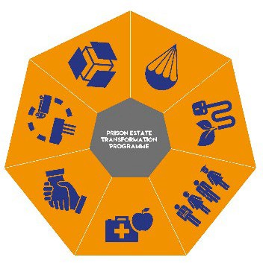
- These objectives have been distilled into seven priority themes to ensure a united, consistent, and collaborative approach is in place to address the main environmental, social, and economic aspects of PETP ensuring that the policy objectives of the MoJ and the wider government Construction 2025 agenda are met.

- Health & Safety and Wellbeing
- People & Skills
- Sustainability
- Government Soft Landings
- BIM & Digital Construction
- Collaboration
- Supply Chain Development

To achieve this, the establishing of a collaborative working environment is essential to ensure that these themes are implemented and achieve our objective, based on robust evidential information and data.

Our Culture - DRIVE
We want to build a working relationship that is based on a common set of behaviors, and we are prepared to challenge each other to demonstrate these behaviors throughout the relationship:

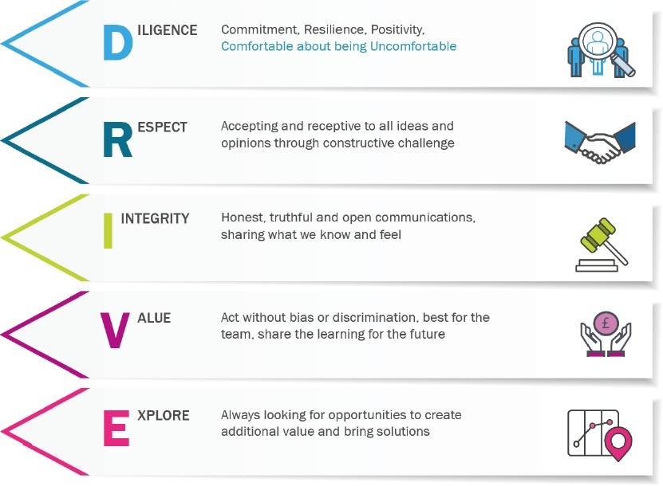
5 Golden Rules
The Partnering Team are driven to deliver the best in everything they do. The team will do this by ensuring that, at every challenge and at every key milestone, every decision is robust and remains true to the following principles:

- We will safely deliver new prison places, ready for operation, on time
- The design will support transformation
- The new prisons will provide a safe, secure and decent environment
- We will deliver best value for money both in the build and in the operation of our new prisons
- We will support the Government’s commitment to Smart Construction

Purpose of Document

The purpose of this Project Execution Plan is to define the principle and strategies that form the basis for management of the Project. Each level of Execution plan provides relevant guidance and direction without limiting scope for key partners and suppliers to the project to contribute.

This plan describes the overarching processes and procedures to be carried out by the respective members of the Partnering Team following the execution of the Commencement Agreement. This document is to be read in conjunction with the Constructor’s PEP, which will define in detail the construction processes and management tools.

The Execution Plan provide reference to key Package objectives and provide the structure for;

Delivery | Scope, Location, Constraints, Schedule, Phasing, Opportunities & Risks
Community | Stakeholders, Collaboration, Organisation Structures, Roles & Responsibilities
Process | Governance, Reporting, Performance Indicators, Gateways & Acceptances
Information | Brief, Existing Information, Conditions, Standards, Statutory Obligations etc.

Security

PETP will require an appropriate Security Minded Approach to proceed safely and to ensure project data & information is handled appropriately. An assessment of the vulnerabilities and threats has been undertaken, in the form of a Built Asset Security Management Plan, and the development of the measures to address local procedure for the Project and the Site Packages are defined in the Security Aspects Letter; underpinned by Ministry of Justice and Government policy.

The Security Aspects Letter and associated guidance can be found on xxxxxxxxxxxxxxxxxxxxxxxx

Governance

Project Governance Structure

The Prison Estate Transformation Programme (PETP) has overall responsibility for the successful delivery of the new prison at Wellingborough. The project shall be delivered by MoJ Estates on behalf of PETP with the interface between the two Client functions led by the MoJ Project Delivery Director. The two functions shall meet monthly at the Wellingborough Project Board.

[diagram redacted]

Figure 1 PETP Governance

At project level, the Partnering Team is structured as per Figure 2 Partnering Team below.

[diagram redacted]

Figure 2 Partnering Team

Figure 3 below indicated the problem-solving hierarchy which outlines the key members of the Project Partnering Agreement and the associated reporting lines. Direction to the Partnering Team will be as per the PPA structure but will be informed by the Wellingborough Project Board, as outlined in Figure 1 PETP Governance.

[diagram redacted]

Figure 3 Problem Solving Hierarchy

Gateway Management

    - Purpose & Scheduling of Control Points

The Control Points have been identified to control the development and delivery of work packages through the course of the project which in turn provides a health check to the Partnering Team. Figure 3 Control Point alignment with MoJ PCF 2 highlights the timing of the Control Points and alignment with RIBA & MoJ PCF 2.

Figure 4 Control Point alignment with MoJ PCF 2
MoJ PCF2 (SAA)
5a & 5b
6
7
Control Point
Pre-Construction
Construction
Design (RIBA)
2
3
4
5
6&7
PC
Control Point 5

    - Control Point Products & Review Criteria
Commercial
PPA AMP & FBC
CA

Each Control Point will be checked against the agreed deliverable headings known as ‘Products’ outlined within Table 1 Control Point 5 Deliverables below, with each product being assessed on a

‘STATUS’ basis. The ‘STATUS’ update will be an outcome, which outlines the agreed progress of the product, including further work which will need to be completed at the next Stage. Each product where applicable needs to be linked back to the RIBA Stage of works/ BSRIA BG6, which identifies the required detail of which the product is issued.

Table 1 Control Point 5 Deliverables outlines the ‘Products’ which are required at each Control Point, with further detail requiring to be agreed for the next Control Point within 4 weeks of successful completion of current Control Point. This table provides a high-level summary of the Products; a detailed breakdown of the Products will be presented at the first Control Point meeting.

On agreement of the detail of each ‘Product’ with all Project Partnering Parties, the Client Representative will produce a detailed tracker to ensure progress is being monitored on a bi-weekly basis.

    - Ownership & Review Process

The Control Point dates will be identified on the working Project Timetable, with completion of the Control Point being identified by a Project Panel Review. All Required ‘Products’ are to be uploaded to the agreed file location in advance of the date for commencement of the next stage, with those ‘Products’ requiring statements being issued to the Client rep for inclusion into the Draft, End of Control Point report. The Project Panel Review will then take place 2 weeks prior to commencement of next Control Point, allowing for any ‘Products’ requiring further attention to be updated prior to progression into next control point phase. During the review period leading up to the Panel, each panel member is expected to review each product in detail and collate comments which can be addressed on the panel review day.

It is accepted that some documents will be issued in draft 4 weeks prior to completion of control point, due to timings of the control points. In all cases statements/ documents need to be issued to reflect the current status of the deliverable.

The Review Panel will be formed of a nominated representative from the MoJ, Kier, WTP & Mace with an agreed neutral facilitator. Each panel member will be required to review all products prior to panel review date, to allow each ‘Product’ to be reviewed and the ‘STATUS’ being confirmed acceptable to move into the next stage.

    - Transition into New Control Point

To facilitate the successful transition into the next stage, the review panel must agree that all relevant or applicable information issued is of the required standard, and all relevant formally issued changes have been captured. An End of Control Point report shall be authored on behalf of the whole project team including the client for presenting to the review panel as a collaborative view of the status of the project. It is important to note that the report is not a progress update for the client. The report is to be authored by the Client Rep with input from the whole project team.

Draft End of Control Point Report and all associated appendices shall be issued to all members of the review panel in hard copy prior to the control point meeting.

Core Group are to be involved if the Project Panel are in dispute over a deliverable, with any concerns being formally issued to the Core Group for acceptance. Progression to the next Control Point deliverables are not to be started until formal notification of successful completion of control point is received, unless the Core Group confirm the ‘Product’ can be developed and completed in parallel with the next Control Point deliverables to avoid delays.

Table 1 Control Point 5 Deliverables

Domain | Control Point 5 (Hand-Over) | Control Point 5 Product Detail | Owner
1.0 Governance | 1.1 Control Point Summary Report | Summary report which is to be issued following Panel review meeting, which captures statements from all parties on relevant products. | Client Rep (Input from All)
 | 1.2 Lessons Learnt log | Issue of current lesson learnt log, which captures all lessons learnt to date. Client Rep to collate and issue. | Client Rep
2.0 Resource, Roles & Responsibilities | 2.1 Responsibility Matrix | Responsibility matrix for the defects liability period and escalation process. | Constructor
3.0 Design | 3.1 RIBA Stage 5 Deliverables | Completion of the RIBA Stage 5 technical deliverables checklist. This needs to be issued to Client Rep TA for review prior to Panel Review to ensure statement can be issued. | Constructor
 | 3.2 BIM Data Drop | As per the agreed BIM programme. Constructor to issue a statement of progress against contractual BIM requirements relative to project programme position. | Constructor
 | 3.3 Record Drawings | Constructor to issue all record drawings as per the contractual requirements. | Constructor
 | 3.4 BREEAM Certification | Constructor to issue formal BREEAM information to indicate completeness; certification to follow. Where certificates are not available due to formal issue dates, Contractor to issue formal confirmation that the required BREEAM rating has been achieved. | Constructor
 | 3.5 Testing and Commissioning  Certification | Constructor to provide all testing and commissioning certificates as required to verify the installation. All certs to be reviewed and verified by relevant individuals prior to control point review.  Where certificates are not available to be issued, confirmation of agreed commissioning process to be issued with associated dates identified. This is to be in line with MoJ handover process and any Digital Construction Deliverables required. | Constructor
4.0 Investigations, Surveys, Assessments, Statements & Reports | 4.1 Survey & Investigation Records | Constructor to issue a full pack of all survey information, with any certificates or comments as required for Client record. | Constructor
5.0 Standards | 5.1 Final derogation schedule | Constructor to provide final derogation schedule for Client records. Statement to be provided to clarify any changes. | Constructor
6.0 Risk, Threats and Opportunities | 6.1 Statement on key cost, time & quality risks including extent, causes & mitigation. | Client Rep to issue statement to summarise project risks and mitigation, as well as any residual risks which need to be incorporated within Client operational policy. | Client Rep
7.0 Scope | 7.1 As-Built Information | As-Built Information. | Constructor
8.0 Certificates & Acceptance s | 8.1 Discharging of outstanding pre-  occupation planning conditions | Where pre-occupation conditions have not yet been discharged due to timings of project in line control point, Client provide an updated of process to achieve. | Client
 | 8.2 Discharging of Building Control Conditions & inspections | Update on Building Control Officer’s review to be issued prior to issue of occupation certificate. | Constructor

9.0 Programme | N/A
10.0 QA
11.0 Commercial | 11.1 Final Account Prepared | Forecast final account to be issued for review. | Constructor
12.0 Supply chain / Procurement | 12.1 Supply Chain Close Out Reports / Final Accounts | Refer to 14.1 | Refer to 14.1
13.0 H&S | 13.1 Health & Safety File |  | Constructor
14.0 Government Soft Landings | 14.1 O&M Manual Issued |  | Constructor
 | 14.2 Post-Occupancy Evaluation | Confirmation of agreed date of post-occupancy evaluation, including any requirements to complete. | Constructor
15.0 Environmental | 15.1 Register of Environmental Residual risks & Mitigation/ Management |  | Constructor

Project Success Criteria

The project is measured against the success criteria of cost, time, quality, risk and benefits.

Cost
Delivery of the project in line with the AMP outlined in the Price Framework in Annexure D, Appendix C2 of the Commencement Agreement.

Time
Completion of the project as per the Project Timetable as outlined in Annexure A, Appendix G of the Commencement Agreement.

Quality
The integrity of PETP design intent should be preserved as far as possible through the Alternative Design, measured by Key Performance Indicators outlined in Annexure A, Appendix K of the Commencement Agreement.

Benefits
Ensuring the custodial estate is transformed and used to best effect
- Prisoners held in security conditions to proportionate to their risk
- Better use of technology to improve outcomes
- Prisoners held in more rehabilitative environments.

Building New Prisons
- Short term economic benefits to the local community in terms of the planning & construction projects (employment/supply chain)

Priority Themes

Collaboration
Although the Project will no longer be intending to achieve ISO44001, the Partnering Team will continue to drive the key themes:
- Effective collaboration will, over time, create an environment that engenders trust between organizations.
- This in turn will increase their ability to deliver joint efficiency improvements, challenge traditional working practices and explore new ways of working, enhance transparency and openness, strengthen their ability to challenge and innovate, understand and overlay each party’s governance and assurance processes

Health, Safety and Wellbeing
The Partnering Team will drive good practice and betterment in relation to Health, Safety and Wellbeing. The Constructor’s Detailed Project Proposals outline how the following key points shall be implemented for the delivery of the project:
- Compliance with all relevant legislation, standards, codes of practice, consents and licenses
- Integration of health, safety and wellbeing requirements and opportunities for excellence during design
- Prevention of accidents and ill-health and the promotion of well-being during the build and for users of the facilities
- Integration of good industry practice into health, safety and wellbeing performance in planning, design, construction and operation to achieve our vision
- Systematic identification, assessment, reduction through optioneering, and management of health and safety risks (and identification of health, safety and wellbeing opportunities); monitoring our performance against targets and publishing the results
- Creation and maintenance of a positive culture where staff, partners, and suppliers are actively involved in contributing to good health, safety (including fire) and wellbeing.

People and Skills

The Partnering Team shall drive social and economic benefits. The Constructor’s Community and Engagement Strategy incorporates the wider social economic values. The project KPIs referenced in section 3.2 outline how these shall be achieved.

Sustainability
The project shall achieve a minimum of BREEAM Excellent. The Constructor’s Detailed Project Proposals outline how the project shall achieve performance targets in relation to resource efficiencies. Section 3.2 outlines the KPIs to achieve these targets.

Government Soft Landings
The project shall be following the standard as set out in Annexure B, Appendix M2 of the Commencement Agreement.

BIM & Digital Construction
The aspirational Performance Targets set out below shall be monitored by the Technical Assessor.

The Programme Objectives are based on 5 keystones of the MoJ digital construction strategy 2017 - 2020:
- Implementing a Master data strategy
- Maintaining digital standards
- To enrich and strengthen BIM object library
- Education and compliance testing
- And increase client team confidence

To deliver these objectives, the following key activities are set as priorities:

- To put digital information at the heart of key decisions.
- To enable wider PETP team to deliver the vision of the PETP board.
- To ensure our systems are integrated and trusted to deliver the right information in the right format at the right place at the right time.
- BIM level 2 and development towards level 3 as an exemplar.

Supply Chain
The supply chain has been developed by seeking to maximise the benefits of early, transparent and collaborative supply chain engagement. The Constructor has adopted and will continue to utilise the key features of the Construction 2025 plan for collaborative procurement techniques:
- Enable early contractor and supply chain involvement
- Develop skills capacity and capability, apprenticeships
- Promote fair payment
- Deliver value for money – cost, time & quality

KPI’s & Incentivisation

Key Performance Indicators have been identified to ensure that the performance is measured against a set of agreed criteria, KPI’s defined in Annexure A of CA, document 00000-3680-MOJ-PET000-XX- CT-K-0016-G1600. Performance against each indicator will be monitored monthly, with all Partnering Team Members requiring to provide updates on the status of performance based on criteria.

Design Development & Management

Overview

The design for Wellingborough site will be managed by the Constructor and developed in line with the agreed brief, as set out in Annexure B of the Commencement Agreement. All models shall be developed in accordance with the MoJ Digital Construction Standards, BIM Execution Plan and any associated approved derogations. The working environment will require an ‘open book’ policy for design development during all RIBA Stages, which shall require an iterative and collaborative approach.

The Design Briefing Note included as part of Annexure B- Project Brief of the Commencement Agreement (CA) for the new build prison at Wellingborough, outlines the relationship between the Constructor’s Detailed Project Proposals (DPP), the Client’s briefing documents and the Technical Assessor’s (TA) design comments tracker is defined, whilst outlining all relevant standards which the design is to comply with. This include a hierarchy of the documentation forming the Detailed Project Proposals.

    - Design Review, Stakeholder Engagement & Acceptance

DPP to RIBA Stage 4

The information submitted as part of the DPP have been issued to MoJ CDE. This will be required to be placed in a ‘Virtual static container’ structure within the project CDE for it to be held for record during the project.

The Detailed Design Proposals outlined within the Commencement Agreement will be developed further to enable the completion of a full RIBA Stage 4 Design as per the timescales outlined in the Project Timetable. During this stage of design development acceptance will be required to ensure compliance to the Client Brief.

Fortnightly workshops will be scheduled in line with agreed timescales, with the Constructor identifying dates in a timely manner to allow for availability of stakeholders to be secured. It will be the Client’s responsibility for ensuring that all relevant stakeholders are present, with the Client Rep assisting the Client in developing an appropriate agenda, in line with design by the Constructor.

Acceptance will be sought through the issue of technical information from design teams in line with the RDD schedule. Contractor to ensure that adequate time is allowed for all parties to review design information as required.

RIBA Stage 4 Onwards
Following completion and acceptance of RIBA Stage 4, the fortnightly (or as otherwise agreed) meetings will continue throughout the project and be utilised to review technical queries, as well as provide the platform for stakeholder involvement as required. Meeting ToR’s included within Appendix A.

Acceptance Process

Design information will be issued to the MoJ Common Data Environment (CDE) throughout the project phases. As Kier develop the design information on the Design-and-Build basis, the Client will require assurance that the design being developed by Kier satisfies their requirements based upon the Project Brief contained within the DPP issue. Through sharing the design information to the CDE there is a visibility maintained throughout the design stages that allows this to be shared.

When design information has reached suitability/maturity for issue to the CDE for acceptance [RDD] or for information, it will be issued by Kier with the purpose of issue ascribed accordingly, and a transmission note will be produced to confirm what information is issued at that time. The following points should be noted:

- Not all information that is issued to the CDE is issued to the Client/TA for the purpose of their acceptance.

- The Client in reviewing the RDD information on the CDE are required to limit comments to identify non-compliance as per the contract.

- The Kier RDD schedule and Project Timetable outlines the agreed information to be issued to the CDE for acceptance and associated acceptance dates in accordance with clause 8.6 of the PPC2000 contract.

- The acceptance period is 5 working days to return comments. In exceptional circumstances, and by prior agreement by the Client Representative, timescales may be adjusted.

- Review at the design meetings will review upcoming design information to obviate where possible these instances.

- For the consultant construction-issue design information issued as RDD (S4N), the information issued for acceptance /comment will relate to specific design as noted within the RDD schedule which will be submitted according to the Project Timetable, with the client required to approve within a prescribed timescale and in compliance with the contract. Note – this also applies to samples and relevant mock-ups identified in the RDD and Design programme.

- Design information which is not issued for ‘acceptance’ to the MoJ CDE will be issued for ‘information’, giving the client visibility of the design prior to construction commencement. This process will give the client visibility of the design as it progresses, however as noted above, the RDD will define the information intended to be issued for formal acceptance.

The purpose of the RDD issue is to engage the Client team in design as noted which requires the Client to review for compliance with the brief (DPP).

Reasons for Client design (RDD) rejection:

-The design does not comply with the Client brief (intent of DPP design information)

-The design does not comply with statutory requirements/ Technical standards

Following rejection of design information by the client in the CDE acceptance process – there will be revision and resubmission of the design by Kier to follow – and a review and acceptance period for the Client from resubmission of 5 working days.

Should there be a further rejection of design information following resubmittal, the Kier & Client team should engage to review and resolve the issue using a problem-solving hierarchy.

For developed design provided by CDP specialist contractors, the information issued for acceptance will relate only to relevant design covering the systems/elements through design drawings & specifications or Technical Submissions (see RDD schedule).

All other design information provided to the client for information constitutes the client’s acceptance to progress with the design to construction commencement, in line with the constructor’s scope to develop the RIBA 3 DPP design.

S4 – Design issued to CDE reviewed and accepted by Constructor

As the design progresses with the inclusion of CDP (Contractor Design Portions), the specialist’s ‘shop drawings’ for fabrication will be developed where the level of detail necessary to fabricate is provided.

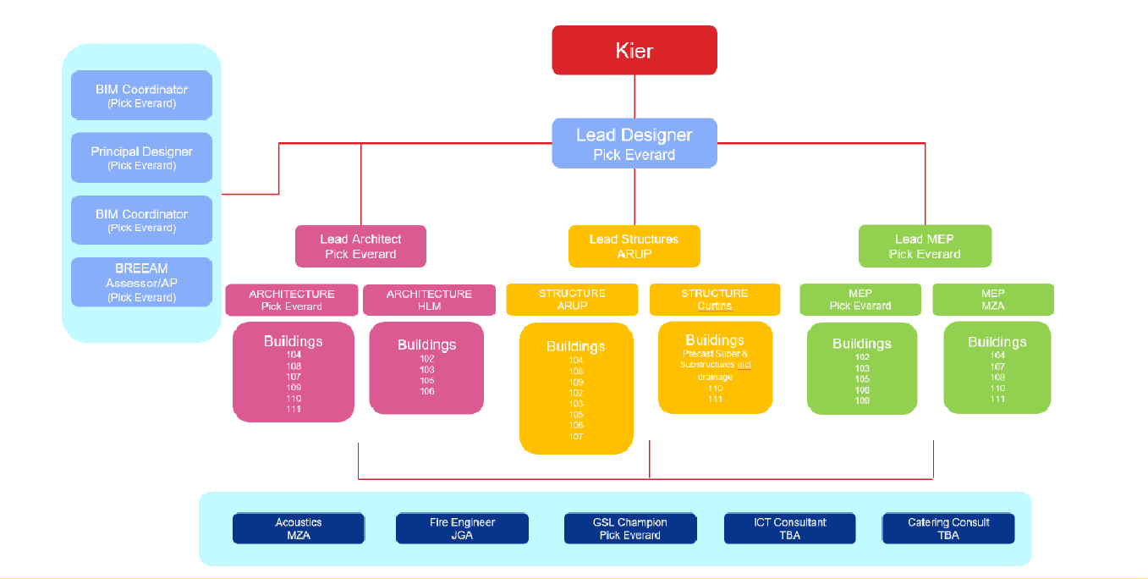These will be issued to Kier for review and acceptance and will not be issued to the CDE for Client acceptance, however relevant information will be issued to Client CDE for information.

Technical Submissions for specific plant items (as scheduled in the RDD) will be issued using the Kier technical submission template.

This will be limited to specific plant and equipment that has an operational aspect such as boilers, luminaires, Pump sets etc. The performance specification and technical suitability will be verified by Kier’s design team. The technical submissions will be submitted for Client review and acceptance as per timescales identified above for ‘Design Information’

    - Contractor Design Management

Figure 5 Constructor Design Management Structure*

*Bryden Wood have been appointed direct by the Client to fulfil BREEAM Assessor role. Table 2 Constructor Design Consultants
Discipline | Company | Lead Name | Appointed By
Lead Designer | Pick Everard |  | Kier
Architect | Pick Everard |  | Kier
Architect (ERH, CSH] | HLM |  | Pick Everard
Structural and civil | Arup |  | Kier
Structural and civil engineer [houseblocks and CASU] | Curtins |  | Kier
Building services engineer | Pick Everard |  | Kier

Building services engineer | MZA |  | Pick Everard
Site-specific landscape architect | Pick Everard |  | Kier
Acoustic consultant | MZA |  | Pick Everard
Fire engineer | Jeremy Gardner Associates |  | Pick Everard
Temporary works engineer | Kier Professional Services |  | Pick Everard
Cut and fill engineer | Kier Professional Services |  | Pick Everard

    - Design Development Roles, Definitions & Terminology

      - Workflows Within CDE

Workflow Phases through the MoJ AIM Live Enterprise incorporate information being developed from a Work In Progress [WIP] starting point through a review / commenting and acceptance process for use as the asset information for both construction and operation processes. Comments will be first discussed and recorded within the fortnightly design review workshops, with comments on Viewpoint being channeled to set review period windows [S4 and beyond].

MoJ Enterprise is broken down into two functional states of the CDE this being PIM-CDE and AIM CDE and following workflows applied to both states: -

PIM-CDE: - Project Information Model Common Data Environment – Workflows:
.
S3 – For Internal review and Comment S4 – For Stage Gate Acceptances.
S6 – For PIM-CDE Authorisation.

AIM-CDE: - Asset Information Model Common Data Environments – Workflows: S7 – For AIM-CDE Authorisation.
CR – Construction Record Documentation
Note – there is no S5 as this has been deleted within BS 1192:2007+A2:2016.

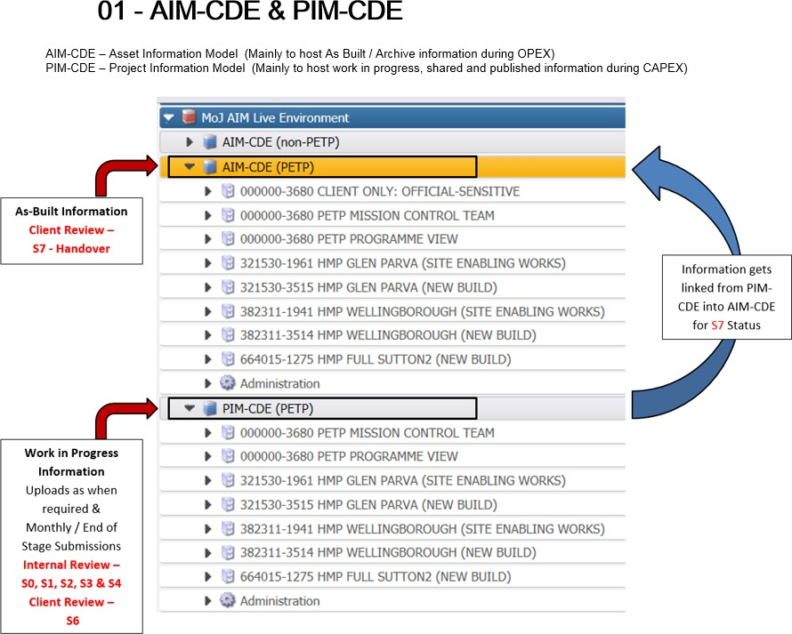

      - PIM-CDE Process

The PIM-CDE process involves information being uploaded and reviewed securely through the Design and Development workflow statuses S3 to S6 of each RIBA Stage, auditing and accepting information migrated to AIM-CDE for use by the supply chain partners and the client. Within the PIM CDE the following four parties are the main contributors and these are: -

        - Information Managers – perform initial QA
          - Kier on behalf of Design Team – Issuing Information, Reviewing and commenting on other production information.
          - Client Representative/Technical Advisors – Management and reporting on workflows, Reviewing and commenting on production information.
          - Constructor – Issuing, Reviewing, Commenting and Approving information.

Within the PIM CDE the project information model (PIM) is audited through the workflows defined above. The PIM consists of graphical data, non-graphical data and documents. Within graphical data the models have been shared in following four formats.
          - IFC [Industry Foundation Classes] (Federated & Un-federated)
          - Native Model (discipline specific) – 2D drawing sheets information is generated from the native models.
          - DWF Model
          - SMC – Federated

In accordance to the Project BIM Execution Plan.

      - AIM-CDE Process

Once project the information model has been accepted through the PIM-CDE workflows of S3 to S6 and is suitable for AIM authorization it is then transferred to the AIM-CDE to pass through the acceptance workflow process of S7. This would be the final stop for the information in readiness for use by either the contractor or client after handover.

      - WIP Exchange to AIM CDE & Client Review of Models

Kier will issue their Work in Progress models (federated and un-federated) on the PIM CDE and on a monthly cycle via the AIM CDE to the Client, in line with the BIM Execution plan. This is to facilitate the Client and their advisors to monitor the progressive development of models and associated structured data in addition to the opportunity for informal Client and Stakeholder engagement.

      - Interim Client Review & Stakeholder Engagement

All agreed stakeholder reviews will be supported by the WIP models (federated and un-federated) and additional documents (i.e. drawings, sketches, schedules etc.) as required to inform the workshop agenda. This continual partner and stakeholder engagement will provide the necessary opportunity for feedback and focus on design outcomes to facilitate a smooth gateway sign off and transition.

      - Published Exchange

Coordination and validated design output for use by the total project; information suitable for Stage Completion, Acceptance or Construction:

      - Stage Review and Sign off

At completion of work flow S4 and in line with Control Points all design deliverables shall be issued by the constructors and their design teams for Client review and acceptance (Workflow S6). The Stage Deliverables are defined in the schedule: 000000-3680-MAC-PET000-XX-SH-J-0001-G1600
    - Information & Technology System

During the project the following information and technology systems will be utilised;

      - PDMS
      - BIMCollab
      - Viewpoint
      - GoogleDrive

    - Communication Tools & Recording

Table 3 Communication Tools and Recording Tracker

Communication  Method | Output/  Document | Function
Viewpoint | Meeting Schedule & Minutes | Where appropriate meetings should be organised through the Client Rep.  Updated meeting schedule to be circulated monthly to all teams.
Email | Emails | An aspiration of the communication by the PETP is to minimise email traffic although it will of course be a key communication method. Furthermore, the Common Data Environment (using short code links) should be used for WIP where possible for as well as the location for formal  submission of documents. Formal communication of risk, change and EWN is acceptable via email.
Viewpoint | PEP, Design information, drawing  comments, review & acceptance s | Viewpoint has been chosen as the Client’s Common Data Environment. This will hold all Project and Asset Information.
Viewpoint | Contract Documents & Instructions | Viewpoint has been chosen as the Client’s Common Data Environment. This will hold all Project and Asset Information, where PDMS and Google Drive are not used.
Google Drive | Valuations | All valuations are to be saved on Google Drive.
Viewpoint | Requests for Information (RFI’s) | Requests for information shall be managed through the in-built functionality within the Viewpoint platform which

 |  |  |  | provides defined workflows and notifications. Response periods contract. | automated are defined | system in the
Google Drive |  |  | Trackers | EWN, Change Control, Opportunity & Risk Register all  kept on Google Drive for all to view, with Client Rep having editing rights only to maintain and manage.
PDMS  Drive | & | Google | Raising of Change Control, Risk and Opportunity | Partnering team member to populate the required information within the PDMS standard form and issue. Client Rep to address issued information and track as required on the tracker saved on Google Drive.
Google Drive |  |  | Control Point | Control Point Documents & tracker to be saved in the relevant file on Google Drive.
Google Drive |  |  | Raising of EWN | EWN to be populated within the standard template saved on GoogleDrive and emailed to all relevant parties for  review. Client rep to maintain a log of all EWN’s save on GoogleDrive.
Viewpoint |  |  | Reporting | All reports to be saved on Viewpoint with relevant  document naming, and circulated to required parties/ individuals.
      - Manner

Where necessary, for formal communication, reference should be made in the communication to the site by the BPRN number. This will be visible in the filename printed on the document being communicated, within the subject line of an email, thus reflecting the naming convention in the Client’s Common Data Environment.

Table 4 Exact from filename builder

Project Code (ePIMS-BPRN) | Project Description | Site name
000000-3680- | PETP Mission Control Team | PETP Mission Control Team
000000-3680- | PETP Programme View (Platform Design) | PETP Programme View
382311-3514- | HMP Wellingborough (New Build) | Wellingborough

      - Recording

To be read in conjunction with section 3.1.3.1. Viewpoint is the repository for the Project and Asset Information and can be uploaded with the following suitability codes in Table 5 below. Files will be uploaded with the necessary filename to and comply with the PETP filename builder: redacted

Table 5 Exact from filename builder

Suitability | Description
S0 | Initial status or WIP  Master document index of file identifiers uploaded into the extranet.
S1 | Suitable for Co-ordination  The file is available to be ‘shared’ and used by other disciplines as a background for their information.
S2 | Suitable for Information
S3 | Suitable for Review and Comment
S4 | Suitable for Stage Acceptance
S6 | Suitable for PIM Authorization (Information Exchanges 1-3)

S7

D1 D2 D3 D4
A1, A2, A3, An, etc.

B1, B2, B3, Bn, etc
Suitable for AIM Authorization
(Information Exchange 6) Suitable for Costing Suitable for Tender
Suitable for Contractor Design
Suitable for Manufacture/Procurement Accepted as stage complete
(C= Contractual/Complete)
Partially signed-off:
with minor comments from the Client. All
minor comments should be indicated by the insertion of a cloud and a statement of ‘in abeyance’ until the comment is resolved, then resubmitted for full authorization.
CR
As Construction Record
documentation, PDF, Models etc
      - Signposting

To maintain version control and limit the security vulnerability of email transmission, formal documents for collaborative review should be uploaded to Viewpoint with the correct filename. The short code link and filename can be the reference for emailed recipients.
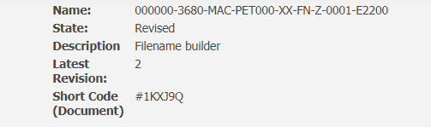

xxxxxxxxxxxxx

xxxxxxxxxxxxxx

      - Interested Parties Communications Plan

The Client Representative will be responsible for Communications and notification of the ‘Interested Parties’. The ‘Interested Parties’ Communication plan will be managed by the Client in conjunction with the Stakeholder Engagement process for Design Development; whereby selected Stakeholders will be engaged.

Table 6- Interested Parties

Interested Party | Roles & Responsibility | Involvement
The Controller | HMPPS appointed to interface between private operator and HMPPS. | Involvement as outlined in the Operational  Interface Document ‘382311-3514-MAC- WBC000-XX-RP-J-0001-B1100’.
Custodial Services Provider | Appointed Private Operator | Involvement as outlined in the Operational  Interface Document ‘382311-3514-MAC- WBC000-XX-RP-J-0001-B1100’.
Local Authority | Wellingborough Borough Council | Interface required to ensure all Planning Requirements are discharged.
NHS England and Healthcare Provider | Lead on the procurement & appointment of the NHS provider of the prison. | Involvement as outlined in the Operational Interface Document ‘382311-3514-MAC- WBC000-XX-RP-J-0001-B1100’. And

confirmation of the medical equipment due to be installed. All involvement to be managed through the Client Rep team as
required.
Education Provider | Education provider for the prison. Responsible for providing all educational requirements of the prison. | Involvement as outlined in the Operational Interface Document ‘382311-3514-MAC- WBC000-XX-RP-J-0001-B1100’. And  further involvement to be managed through the Client Rep team as required.
FM Provider | Organisation appointed by the Operator to managed & maintain the prison estate for the duration outlined in the contract agreed. | Involvement as outlined in the Operational Interface Document ‘382311-3514-MAC- WBC000-XX-RP-J-0001-B1100’.
Emergency Services | Local Constabulary, Fire Service and Health Trust | Construction Stage interface required to ensure all requirements are discharged.
Probation Service  Provider | NPS and Local CRC | Involvement managed by Client & Client  Representative.

Processes & Procedures

The Client and Client Representative promote the use of consistent project management and control methodologies for the successful delivery of the Project. Successful delivery depends on accurate and timely information to support informed and effective decision making.

At the forefront of project delivery is consistent and proven project control process, structure, and tools to disseminate and integrate timely, accurate program performance information. The project controls approach intended to be used is described below, with Appendix A identifying the required meetings to manage the processes and procedures.

Objectives

The primary objective of the controls processes is:

- Consistently gather and analyse data to monitor and manage the requirements of the Project providing management information to support effective decision making.

This will enable oversight by the Client representative for the delivery by the Partnering Team:

- Project Controls, Supporting Commercial Assurance with; Cashflow; Consistent Cost data; Commercial Reporting; Cost Management; transparency of information to create, supply and update the right management information; KPI’s; to communicate divergence; carry out trend analysis; providing an independent view and audit and assurance as required

- Schedule Management, Inc.; Change Management; Project planning and Scheduling assurance; Project Reporting; Risk, Issue & Opportunity Management;

- Risk & Change Management Inc.; Risk, Issue and Opportunity management throughout the project; mitigation strategies and reporting.

These controls and processes provide a disciplined approach to analysing project performance, communicating a common plan, and enabling overall project schedule flow. They also facilitate accurate variance analysis leading to root-cause problem identification for early and decisive corrective actions needed to deliver the Project on cost and on schedule.

Integrated Work Breakdown Structures

To support the integration of data and to speed reporting, work will be planned and managed using these WBS’s and associated numeric coding structures.

Each Breakdown Structure has been defined to represent the project scope of work. The Breakdown Structures organise the works using a ‘hierarchy of products’ structure such that the sum of the lower level child elements equates to the scope product of the parent. The WBS is subdivided breaking out the works into more granular work package levels of detail.

The Breakdown Structures identify all elements of the works and is the basis for organising and managing the works, people, and control systems. It is also providing the common structure for performance measurement reports and analysis. The Breakdown Structures provide the framework for defining the product-oriented family tree of deliverables, services, and other work tasks which organise, define, and represent the project work package elements required to provide the Works such that all authorised works required to provide the Works are represented in the once in the Breakdown Structures.

Development of the Breakdown Structures will include development of a corresponding Scope Dictionary. This Statement of Work will align the scope to the WBS such that each element is understood by all. The Scope Dictionary will define the scope of work in terms of objectives, requirements, and deliverable products including completion criteria. Once established, the project

WBS serves as the primary structure for organising the project and associated Project, budget, and performance reporting.

    - PETP Breakdown Structures

For completeness and context, all potential scope of the Project is shown (in italics). Only the structures required for Package delivery will be included in the individual Package Execution Plans

      - Location Breakdown Structure – ePIM

Location | ePIM
Wellingborough | 382311
      - Project Breakdown Structure – BPRN

Location | BPRN
Wellingborough Demolition | 3512
Wellingborough New Prison | 3514
      - Cost Component Breakdown Structure – Level 1

Description | Value
Profit | 001
Central Office Overheads | 002
Site Overheads | 003
Risk | 004
Fees from Specialist sub- consultants | 005
Pre-Construction Fees | 006
Regulatory fees | 007
Demolitions | 008
Substructures | 009
Superstructure Envelope | 010
Superstructure sub-division | 011
Internal Finishes | 012
Fittings | 013
Building Engineering Services | 014
External works | 015
Minor works | 016
      - Site Work Breakdown Structure – Building Volume

Description | WBS / Volume
Site Wide – Non Building | 000
Site Infrastructure | 101
Entrance Resource Hub | 102

Reception/ Central Services Building/ Healthcare | 103
Support & Admin Building | 104
Not in use | 105
Not in use | 106
Kitchen | 107
Workshops | 108
Energy Centre | 109
Care and Separation Unit (CASU) | 110
Houseblocks | 111
Houseblock - Mirrored | 112
Electrical Substations | 113
Waste management Unit | 114
Dog Kennels | 115

      - Constructor Code

Description | Value
Kier | 102
      - Supplier Code

Note. To be fully developed in line with the Procurement Strategy (TBC, example included)

Description | WBS / Volume
Structural Frame | 200
MEP Distribution | 201
Façade Systems | 202
Bathrooms | 203
Cell Furniture | 204
Roof | 205
Stairs and Core | 206
Acoustic Treatment | 207
Control Desk | 208
Architectural Metalwork | 209
Ceilings and Soffits | 210

Baseline & Change Management

Baseline Change Management will be undertaken to follow the Changes approved in line with the contract administration changes. The baseline will be taken as the DPP which have been agreed to be included as part of the Commencement Agreement within Annexure C.

    - Change Management Process

The Change process will be managed as per the change management workflow outlined in the contract. A meeting will be called as required, depending on the level and type of change raised. The Partnering Team shall review changes at the Partnering Team meeting with the final decision on a change request determined by the Client’s Project Sponsor, or as necessary the PETP Change Authority.

The change controls are to be populated using the PDMS system and issued for review by the Partnering team. The Client Representative will maintain the Change Control register saved on the Google Drive and share with the Partnering Team leads on a frequency as required. Change Controls will be monitored continuously by the Client Representative, with all parties having a contractual obligation of a 5-working day’s timescale to respond. Change instructions and compound instructions may have a different impact or issue to the design/construction that need to be analysed.

    - Schedule & Interface Management

To avoid confusion of terms schedule has been consistently used to differentiate between the Project and the time management definition of programme. Where PPC 2000 terms are required Project Timetable will be used.

    - Schedule Management Process

For the control of time the Constructor prepares a schedule, the full detail will be developed during the PPA following, where appropriate, the principles defined below.

Once this first schedule has been agreed with the Core Team becomes the Performance Measurement Baseline (PMB).

Key components of the Baseline schedule in respect of the works include:
      - The Project Work Breakdown Structure (WBS) and associated WBS Dictionary
      - An Integrated schedule incorporating all relevant specialist work schedules
      - KPI’s will be used for Project Performance Measurement for all activities showing the metrics that will be measured to demonstrate the progressed position
      - The schedule is produced in accordance with the below Requirements:
      - The schedule is to be an integrated design, procurement and construction schedule for the works.
      - The schedule will be developed, maintained and reported by the Constructor using Asta Power Project as their primary planning software tool. Asta Power Project which exports to .XER files that are compatible with Primavera P6 are to be provided to the Client Representative as per the quarterly forecast, or as required as result of resequencing the project timetable.
      - It will represent input from consultants, subcontractors and suppliers employed by the Constructor.
      - The schedule will be logic linked, with each activity having both predecessor and successor dependencies, critical paths, and total float will be identified.
      - Additional levels of coding will be agreed between the Client Representative and the Constructor to develop the detail the Constructor requires to manage the works
      - The schedule will be established to support the lowest level WBS elements of the works. These same activities in the schedule can then be summarised using the WBS hierarchy
      - All higher level schedules or reports are depicted by summarisation or filtered reporting of the schedule activities.

    - Schedule Requirements

The Constructor shows on each schedule which is submitted to the Client Representative

      - the start of off-site works date, start on site date, and Project Completion,
      - the date on which the constructor has planned Project Completion,
      - the order and timing of the operations which the Constructor plans to do in order to provide the works
      - durations for all activities relating to the works, including design, procurement, off site manufacture, subcontract activities, delivery dates, key milestones, construction, testing and commissioning, handover in sufficient detail to enable effective management of the works;
      - logical links so that all activities have a predecessor to the start of the activity and a successor to the finish of the activity (except for the first and last activities) to allow a critical path analysis to be undertaken to show the critical path and float periods;
      - a measure of progress defined for each activity to track the work done against the activity so that a % complete can be measured;
      - dates for site setup including logistical support services;
      - the dates for the ordering of Long Lead Items;
      - subcontract procurement and contract award dates;
      - the order and timing of the work of the Client as last agreed with them by the Constructor or, if not so agreed, as stated in the PEP,

      - provisions for:

        - float,
        - time buffers,
      - the dates when, in order to provide the Works in accordance with his schedule, the Constructor will need:

        - access to a part of the Site if later than its start on site date,
        - information or deliverables from the client,
        - design information requirements
        - acceptance periods
        - dates for submissions to statutory authorities including Planning Authorities
        - when information is required from interfacing works, e.g. demolition;
      - An outline phasing method statement of how the Constructor plans to do the carry out the work identifying; the sequence, phasing is provided at DPP. Any fundamental change to resequencing will be provided as required.

The detailed schedule will be submitted to the Client Representative as per the Asta Power Project file which can be exported as an XER file compatible with Primavera P6 version 8 and a PDF showing;

      - the activity ID
      - activity name
      - start date
      - original duration
      - remaining duration
      - finish date
      - physical % complete
      - total float

      - Schedule Buffer

Once the Project Timetable has been agreed a Forecast schedule will be prepared, based on the agreed baseline, by removing all the time buffers (minimum 20%) from the schedule. This Forecast schedule will be used as the day to day management tool for time across the project.

The use of schedule Buffer will be monitored on a monthly basis.

      - Revising & Updating the Progressed Forecast schedule

The initial forecast schedule shall be provided to the Client Representative upon Commencement Agreement in pdf and Asta formats.

The forecast schedule shall be revised and submitted to the Client Representative on a on a Quarterly basis or as required due to a resequencing of the Project Timetable.

    - Early Warning Process

The procedures to raise and manage early warning notices are to be in line with the PPC 2000 contract requirements.

The early warnings are to be populated using the PDMS system and issued for review by the Partnering team. The Client Representative will maintain the Early Warning log saved on the xxxxxx and share with the Partnering Team leads on a frequency as required.

The final issued documents are to be issued onto the Common Data Environment by the Client Rep as detailed below. The Early Warning Notice schedule will be maintained on Viewpoint at link: xxxxxxxxx

The naming convention by which Early Warning Notices, and their corresponding responses, are to be identified are as follows:

      - EWN’s are to be sequentially numbered – this will require organisations to monitor the most current EWN file number on the EWN log (and for the Mace Information Manager to track).

      - Therefore, file name structure will differ in Originator and Sequence only.
o E.g. 000000-3680-KMP-PET000-XX-MI-W-0001-F0300
      - The response will maintain the numerical EWN identification but will be responded to and referenced as such by the responding originator.
o E.g. 000000-3680-MAC-PET000-XX-MI-W-0001-F0300

Progress Monitoring & Reporting

The following section outlines the reporting requirements for the project including content & frequency of issue.

    - Drumbeat Calendar

The reporting drumbeat calendar will be created and distributed by the Client Representative to provide the partnering team with reporting deadlines and submission dates. These drumbeats will be updated and distributed 5 days before month end for month specific requirements. Appendix B includes general drumbeat reporting calendar.

    - Client Rep Reporting

      - Weekly Update

The Mace weekly update will be completed by Mace PMs and submitted by CoB Friday and reviewed at the Monday weekly meetings. It will provide a high-level report of PPI scores and look ahead of risks, issues, and required decisions.

      - Monthly Project Data Sheets (PDS)

The PDS is a MoJ template reports that feeds MoJ projects data base. The report measures progress against programme, actual spend, and forecasted cash flow for the financial year. The PDS report will be completed by WTP and Mace utilising the valuations provide by the consultants and constructors.

Report | Current Data Requirements
PDS | Cost  - Actual cost  - Forecast cost  - Baseline cost  Schedule  - Actual Dates  - Forecast Dates  - Baseline Dates

      - Wellingborough Project Board (WPB)

The WPB dashboard is a month end report that reports that captures the project progress for that month and is presented by sponsors for review at the Wellingborough Project Board. The dashboard is designed to provide the board with an overview of project’s cost, programme, risk/issues, and project KPIs.

This report is prepared by the Client Representative, with input from the Client, Cost Consultant and Constructor. The below list currently reflects the data provided on the WPB dashboard. These requirements are subject to review by MoJ.

Report | Current Data Requirements
Client | Cost: | Change:
Dashboard | Budget | Under Review
 | % Planned Spend | Closed Rejected
 | % Complete | Closed Instructed
 | % Actual Spend | Closed Approved
 | AFC (Anticipated Final Cost) | Total
 | Cost to Go | Derogations:
 | Current Baseline Budget | Derogations not required
 | AFC/CBB Variance | Derogations required
 | Authorised Spend | Total
 | PDS Cash Flow Graph | H&S:
 | Programme: | LTIFR
 | Milestone Forecast and Actual | AFR
 | Sustainability: | Days Since Last Reportable Incident
 | Site CO2 | AIR
 | Waste Diverted | ASR
 | Waste Landfill | Observations
 | % Timber FSC | PM Narrative:
 | % Material BES6001 | Project Summary
 | BREEAM Target | Critical Issues
 | Current Score (BREEAM) | Actions/Recovery Plan
 | BREEAM Update | Key Decisions Required
 | EWN – Open/Closed/Total | Opportunities
 |  | Key Goals for Next Period
 |  | Progress Against Last Periods Goals

    - Constructor Reporting

      - Project Performance Indicators (PPI)

In line with MoJ requirements the PPI report is completed by the Constructor on a fortnightly basis and is to be submitted by midday Friday. This is a fortnightly report focusing on the critical activities that are forecasted or have actually started and finished within the reporting cycle.

The fortnightly reporting will provide a snapshot of progress as the month progresses and allow for focused intervention in between the monthly reporting cycle.

The basis of the information provided for the PPI reporting will be taken from the Project Timetable’s Level 2 Critical Path.

      - Monthly Constructor Dashboard

The Constructor will be responsible for producing a monthly dashboard and populating the required information. A draft of the dashboard must be distributed to the Project Partnering Team before the Monthly Partnering Team Workshop is held. This draft will be review and an agreed final dashboard will be produced by the Constructor for final submission.

The below list currently reflects the data requirements for the constructor dashboard. These requirements are subject to change depending on the status of the project and MoJ/Mace requirements.

All reports to be saved on xxxxxxxxxxxxxxxxxxxxxxxxxxxxxxxxxxxxx

Report | Current Data Requirements
Constructor | Cost: | Contract Admin:
Dashboard | Budget | Change Description
 | % Planned Spend | Change Status
 | % Complete | Prog. Impact
 | % Actual Spend | Cost Impact
 | AFC (Anticipated Final Cost) | EWN:
 | Cost to Go | EWN Name
 | Current Baseline Budget | Date
 | AFC/CBB Variance | Impact
 | Authorised Spend | Status
 | PDS Cash Flow Graph | H&S:
 | Programme: | LTIFR
 | Milestone Forecast and Actual | AFR
 | Sustainability: | Days Since Last Reportable Incident
 | Site CO2 | AIR
 | Waste Diverted | ASR
 | Waste Landfill | Observations
 | % Timber FSC | PM Narrative:
 | % Material BES6001 | Project Summary
 | BREEAM Target | Critical Issues
 | Current Score (BREEAM) | Actions/Recovery Plan
 | BREEAM Update | Key Decisions Required
 | Quality: | Opportunities
 | Audits | Key Goals for Next Period
 | Benchmarks | Progress Against Last Periods Goals
 | ITP
 | Priority Theme updates
 | Commentary and RAG

Risk & Issue Management

Risk processes in line with PPC 2000 requirements will be developed in line with the following principles

The overall aim of Risk Management within the PETP is to manage any uncertainty that could impact the project from meeting its objectives and is to protect all parties by maximising opportunities and minimising threats.

Risk Management is an integral part of MOJ’s key processes; and is a core component for robust decision making.

Risk Management should be systematic, iterative and have continual improvement & enhancement, to ensure the achievement of MOJ and PETP objectives.

Risk management can be applied to many areas and levels, at any time, including to specific functions, projects and activities within the PETP and in a systematic, consistent manner to ensure that all threats and opportunities have been identified, analysed and evaluated and that the risk exposure is managed and monitored in accordance with the contract approach of eliminate, reduce, insure, share or apportion.

Additionally, Risk Management activities will be integrated with other Programme Management and Planning activities so that it becomes embedded as a normal and natural process within the PETP In order to deliver and maintain effective Risk Management within PETP, a number of principles need to be defined and followed. The objective is to ensure that it is ingrained in management and reporting processes and policies and that its values and culture reflect best risk management practice.

Moreover, a positive risk culture will be developed and maintained for the PETP and will be extended beyond MoJ’s staff and employees and include the programme’s key sub-contractors and stakeholders.

Risk processes in line with PPC 2000 requirements will be developed in line with these principles This will be carried out via:

    - Undertaking risk workshops and one-to-one risk reviews to; identify, describe and estimate risks and also analysing risks affecting the PETP programme;
    - Management of risks at the programme and project level, ensuring that all risks are recorded and that all parties are aware of ownership and mitigation strategies for risks identified;
    - Undertake the use of MoJ reporting templates and develop best practice templates for risk management as required;
    - Undertake risk management activities to manage programme and project risk escalation and aggregation; wider MoJ risks and risks to benefit achievement;
    - Support the development of action plans to eliminate, reduce, insure, share, apportion
    - Assure the risk management processes of the constructors
    - Hold regular risk management workshops; and
    - Provision of support, education and training to staff to build risk awareness at the programme level.

Post CA the top five risk’s and any new risks are to be reviewed at the monthly Partnering Team meeting. This meeting will be used to actively manage the risk allocation against the project.

Commissioning & Hand-Over

Full details on the Operator Interface Requirements is included in the document entitled 382311-3514- MAC-WBC000-XX-RP-J-0001-B1100, with this being the agreed set of principles for integration of the construction completion and take-over by the private Operator. On appointment of the Private Operator this document will be developed with the project team to ensure compliance with Government Soft Landings and MoJ/ PETP compliance.

Handover and Close Out Process

The Handover and completion process is to be used to transfer responsibility of the completed assets from the project teams to the Client.

Project Completion under PPC2000 is defined as follows “completion of the Project in accordance with the Partnering Documents necessary for the Client to use and occupy the Project to the agreed standards”

This procedure applies to project completion;

The handover procedure and deliverables shall be in line with the following documentation, identified within the contract;

- Estates Cluster handover documents checklist- Appendix 1- Included within Annexure B Appendix M of the Commencement Agreement.
- Employer’s Information Requirements (EIR’s) – Included within Appendix B- K1- Document- 000000-3680-MOJ-PET000-XX-SP-K-0005-G0200. No hard copies will be provided of this documentation, but will be provided in digital form only
- Asset Information Requirements. (AIR’s)- Included within Appendix B- K2- Document- 382311-3514-KMP-WBC000-XX-SH-W-6011-G0500
- Appendix B M2 GSL- Agreed Scope

The steps and deliverables outlined in this process are to be clearly understood by the Partnering Team, For completion and takeover of the asset to proceed, the following conditions must have satisfied:
- The asset should be completed in accordance with the contract.
- The Client, or their delegated authority should be ready to accept the maintenance and to undertake the protection of the asset.
At project completion, the Client Representative will coordinate the handover of the asset from the Constructor to MoJ Estates and HMPPS.

The Completion process sets out a regular series of meetings counting down the weeks to Completion whether it be sectional or project completion for all parties associated with completion to be involved in. Each meeting shall a specific purpose and agenda. The overall process is indicated below:

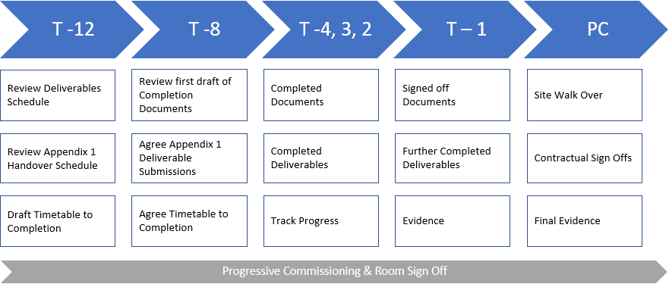

Figure 6 T-Minus Process

Although timescales are suggested, the Partnering Team must ensure there is sufficient time to produce and review the documentation required, and it may be necessary to commence this process well in advance of the timescales set out above.

Completion Process and Timetable

Each of the “T minus” meetings has a specific purpose and agenda as follows:

    - T-12 Initial Take Over Meeting

The ‘Initial Take Over Meeting’ is to identify and agree all assets associated Project Completion and take over requirements including the asset boundaries, date of take over, and take over documentation requirements. It is therefore setting out the roadmap to Completion and take over and every effort should be made to ensure the appropriate representatives are in attendance. The Client Representative and Constructor should prepare draft deliverables and a Completion programme in advance to be tabled at the meeting.
This meeting should occur approximately 12 weeks prior to the proposed asset take over (dependant on asset size and complexity) and is organised and chaired by the Client Representative.

The suggested attendees for the ‘Initial Take Over Meeting’ include:
- Client Representative, Mace
- Constructor, Kier
- Principal Designer, Pick Everard
- Senior Project Sponsor, MoJ Estates
- HMPPS
- Other stakeholders as appropriate i.e. MoJ’s appointed Operator

Outputs of the meeting should include an agreed Completion Documentation Schedule including timeline for delivery, action list for any outstanding items, and an agreed take over date.

Agenda items should include:

- Handover area/scope/extent agreed
- Completion Deliverables presented and reviewed
- Ongoing maintenance responsibilities for the asset agreed
- Takeover programme presented and reviewed
- Health and Safety File list and strategy agreed

- O&M Manuals list and strategy agreed
- Defects List/s reviewed and updated
- Operator training plan completed and implemented
- Any other project-specific deliverables reviewed (if applicable)
- Actions for next meeting agreed

In agreeing take over documentation the project should consider any contractual milestone requirements and any sign off requirements relevant to the asset take over.

The scope, and who will be carrying out, the review of any of the Completion documentation must also be agreed.

This minutes from the meeting shall be taken by the Client Representative and issued to form the agreement between parties on the requirements for asset take over.

    - T-8 Meeting

  - is the first opportunity for the team to review the progress of Completion of some of the documentation to be reported – for example, the Health and Safety file production should have commenced.

The meeting should be attended by key individuals from the Initial Take Over Meeting and is chaired by the Client Representative

Agenda items should include:
    - Review actions from previous meeting
    - Final as-built drawing list signed off
    - Other Completion deliverables lists updated,
    - Completion programme presented, progress reviewed
    - Ongoing maintenance responsibilities reviewed
    - Takeover programme confirmed, progress reviewed
    - H&S file progress reviewed
    - O&M Manuals progress reviewed
    - Defects List/s reviewed and updated, strategy to close out defects reviewed
    - Operator training plan reviewed, attendees agreed
    - Any other project-specific deliverables reviewed (if applicable)

    - T-6 Meeting

Follow up meetings should be scheduled as appropriate depending on the complexity and state of progress evident at the previous meetings. Agenda should be based on those items relevant from the T-8 meeting, and should include a review of progress against Completion deliverables. It may be necessary to hold these progress meetings weekly.

    - T-4 Meeting (Final Take Over Meeting)

The ‘Final Take Over Meeting’ is to occur 4 weeks prior to the proposed asset Completion and take over. This meeting is to review the status of the take over and ensure that the documentation and programme are on schedule for ‘Take Over Day’.

The attendees for this meeting should include those present at the Initial Take Over Meeting including the Client’s Operator.

Outputs of this meeting include a confirmed Completion and take over date, take over documentation reviewed and approved by the Project Manager and Employer, all action items complete from the Initial Take Over Meeting, agenda for Take Over Day agreed, asset defects list agreed (where appropriate).

This meeting is to be chaired by the Client’s Senior Project Sponsor and should be attended by all key representatives identified at the Initial Take Over meetings.

Agenda items should include:

- Takeover date and programme re-confirmed
- Defects List
- Commissioning and all test certification completed
- All Asset Take Over Deliverables Matrix items completed
- As-built/Record drawings complete and submitted
- H&S file complete
- O&M Manuals complete
- All Consents & Licenses in place
- All Planning Conditions discharged
- All relevant Statutory Acceptance s in place
- All additional take over documentation reviewed and accepted
- Asset Takeover Certificate drafted
- Asset Condition Survey complete
- Operator training completed
- Final Clean complete
- Project-specific deliverables completed (if applicable)

    - T-3, 2, 1 Meeting (Final Take Over Meeting – as required)

Where the T-4 meeting does not achieve all the sign offs listed, then the meeting should be re-run weekly to ensure all the Completion deliverables are available at Take Over.

There are multiple pieces of documentation to be signed and exchanged between the parties on Take Over Day, including possible third-party documents. These should be identified, completed and signed off throughout the process to limit the amount of acceptances on the final day.

    - Completion and Take Over Day

On the Completion and Take Over Day, a site visit of the asset area should occur and a formal review of all Completion documentation completed to allow the Client Representative to certify Completion. The asset and the documentation relating to the asset is then handed over to the Employer. The Asset Take Over Certificate is signed by the Client Representative, Constructor and Client to formalise the asset and documentation take over. All documentation is to be issued on Viewpoint.

All the sign off sheets, certificates and evidence should be collated into a single file for ease of reference. The Client Representative shall ensure that all signed forms and the backup documentation is correctly numbered and uploaded onto Viewpoint.

Agenda should include:

- Site Walk round
- Defects identified (if any)
- Any relevant site constraints identified and documented
- All handover and take over certificates signed and issued

- Completion Certificate
- Take over Certificate
- Acceptance of H&S File sign off
- All Asset take over documentation issued
- BIM model issued
- Documentation issued to stakeholders, as required
- Asset Take Over Certificate signed (Any special conditions documented)
Client Rep & Client
C
C
Constructor
Operator

ompletion records

ompletion records

NB. Permitted Post-Completion works are identified separately from the PEP

Commercial

Cost Control during Construction

    - Monthly Certificates

The Cost Consultant shall agree the value of the monthly certification with the Constructor and will recommend it for payment to the CR and the Client.

The Cost Consultant will maintain a record of all payments made to the Constructor and shall separately identify costs associated with variations to the original contract.

The following process must be followed for the issue of Constructor invoices:
      - Valuations shall be raised monthly and agreed with the Cost Consultant.

      - Valuation Certificates to be issued to the Client Representative by the Cost Consultant via email. Client Representative to sign Valuation Certificate and submit via email to the Constructor and the Senior Project Sponsor using the email address: MOJ_ED_Project.Delivery@justice.gsi.gov.uk

      - The email subject title must be in the form of: VALUATION: Name of Senior Project Sponsor / Establishment and name of project

      - Constructor to submit their invoice, together with a signed copy of the signed valuation certificate to the Shared Service Centre.

Constructor invoices must include the project BPRN and should be issued directly to: Shared Service Centre, PO Box 766, Phoenix House, Celtic Springs Business Park, Newport, Gwent.
Client Representative (via Cost Consultant) must ensure that the information updated for the Projects Database accurately reflects actual payments made.

    - Final Account

The final account will be prepared and administered in accordance with the relevant clauses within the contract, summarised as follows;

      - Client Representative confirms satisfaction that the Constructor has fulfilled his obligations under the contract in regard to the rectification of any defects;

      - Cost Consultant shall prepare and issue to the Client and the Constructor a Final Account for agreement between the Client and the Constructor;

      - Constructor or the Client (as the case may be) shall make an application for payment;

      - Payment to be made by the relevant party in accordance with the payment terms within the contract.

Value Engineering and Management

The Cost Consultant and the Constructor will jointly establish and lead the Value Engineering Process post AMP. NB. No time allowance is included within the Project Timetable for large scale Value Engineering that would require extensive re-design, procurement and change approvals.

The following procedural guidelines will form the basis of any value engineering exercise undertaken:

- All members of the Partnering Team will contribute to the development of value in the design and the Architect/Lead Designer will lead the technical and co-ordination issues of Value Engineering proposals.

- All Value Engineering suggestions that are agreed by the Team as offering cost benefit, improved quality or programme benefit will be recommended to the Client for review and acceptance prior to being instructed into the scheme via a CI.

- The Constructor and the Cost Consultant shall be responsible for coordinating the costing, and presenting any suggestions judged to be feasible and offering value to the Project.

- A Value Engineering Log, documenting and registering topics for value engineering review, identifying action requirements will be updated from time to time and distributed amongst the team, at regular meetings, by the Cost Consultant.

Commercial Reporting

The constructor will be responsible for providing commercial reporting at regular intervals throughout the construction phase of the project as detailed in section 4.4.3 of this Project Execution Plan.

Cost Management & Controls

The Agreed Maximum Price (AMP) and The Constructor’s Detailed Project Proposals (DPP) will form the basis of the post-contract cost management and control.

Variances from the AMP and DPP will be dealt with under the change management process detailed further within section 4.3.1 in this Project Execution Plan.

The Cost Consultant shall submit a cost report to the Client Representative on a monthly basis at least five Working Days prior to the submission of the monthly Project Detail Sheets. The report shall be clear and concise and cover the following topics:

- Summary of the estimate forecast Project Completion Cost compared with the approved budget
- Fixed price additions and/or inflation allowances
- Client approved changes
- Design changes
- Evaluation of instructions and potential changes.
- Cash flow forecast indicating anticipated monthly expenditure
- An estimate of any anticipated claims for extra payment from any Partnering Team member.

In between the above reporting times new issues that arise shall be reported by exception to the Client Representative.

Appendices

Appendix A- Meeting Schedule

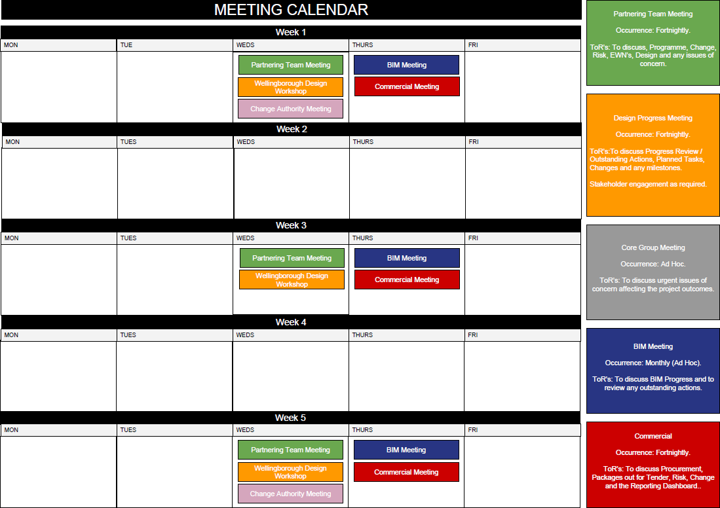

Appendix B – Meetings Terms of Reference

Wellingborough New Build Core Meetings Terms of Reference
Meeting | Occurrence | Outline ToRs | Attendees
Core Group Meeting | Ad Hoc | The Project Core Group meetings will cover the following:  - Key project decsions  - Discuss Change at a high level  - Coming up with solutions for any serious issues occuring on the project | MoJ - Project Sponsor Lead  Mace - Delivery Partner Account Lead WTP - Director  Kier - Project Director
Partnering Team Meeting | Fortnightly | Fortnightly review of issues arising across the project requiring the project team to plan an execution strategy. The meeting will cover the following:  - Programme / Works Update  - Change  - Risk  - EWN's  - Design  - Commercial | MoJ - Project Sponsor & Commercial  Mace - Programme Director / Delivery Lead WTP - Director  Kier - Project Director / Construction Lead
Commercial Meeting | Fortnightly (or as required) | Fortnightly meetings to review commercial and contract matters including:  - sub-contractor procurement progress  - Commercial Risks & Issues  - Technical Submittals  - change Control  - Cost/Commercial reporting | MoJ - Estates & Commercial Mace - Delivery Lead  WTP - Director  Kier - Commercial Lead
Design Progress Meeting (Site Specific) | Fortnightly (or as required) | Working level management meeting will cover the following:  - Changes  - RFI's  - Tech Subs (RDD Schedule)  - Design Issues  - BREEAM  - Stakeholder Input (As Req'd)  - Key Design Decisions | Mace - Design management Lead, Technical Coordination lead  , Project Manager  Kier - Design Managers, Technical Project Manager, Designers (as required)  MoJ - Project Sponsor
BIM Meeting | Monthly | Ensure the digital delivery outputs are in line with the PETP digital standards, to review the following:  - Cobie Data Drops  - IFC Files  - Progrss Against AIR & EIR | MoJ - BIM Lead  Mace - BIM Manager, Information Manager, Project Manager (Design)  Kier - BIM Coordinator, Associate Director
Other Mettings | As Required | Meetings to cover the Prioirty Themes, Interfaces, Stakeholder engagement etc. will be arranged as  and when required | As Required

Classification: OFFICIAL

Appendix C – Example Reporting Calendar

