Clarification to Invitation To Tender 480 dated 19 March 2020

- Question: Can you possibly clarify - is Ten: 480 just a replacement for the previous tender notice (Ten: 477)?

Answer: TEN 480 is a replacement for TEN477. Please download the new tender documents as there are a few details that have changed – TEN480 has, for example, an additional Enclosure.

- Question: Please could you let me know the following:

2a what is the weight of the model?
2b does it need to be enclosed in a box or is it already in a case?
2c do you have any images that you could send?
2d are there any height restrictions for the total stand height?

Answer: 2a No heavier than 100 kg
Answer: 2b It will not be in a case, and will come with a stand
Answer: 2c Below is an existing model, the model for FIA 2020 will not as big
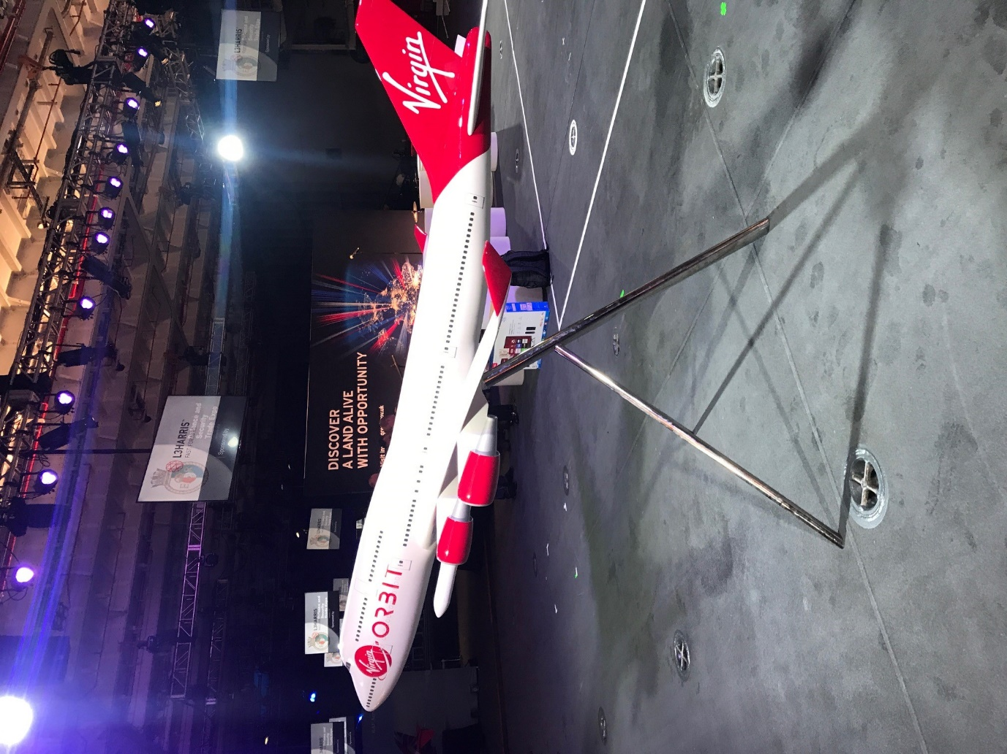
Answer 2d: From the Exhibitors Regulations (Enclosure FIA2020 Exhibitors Regulations):

Q. What is the maximum build height in the halls?
A. For self-build stands there is a working height of 4.0m.

Self-Build Stand Space: No structure, including graphics panels or lighting, may exceed a maximum height of 4m above ground level from the platform. Peripheral walling, if more than 1m high, must not occupy
more than two-thirds of any one side. Walling erected within 1m of the edge of the platform will be deemed peripheral walling

- Question:
3a. Can I confirm, in light of the coronavirus, whether this event is still likely to take place in July?
3b secondly if the deadline remains the 27th March for submissions (should the event have been postponed).

Answer: 3a If the FIA is rescheduled within 2020 the result of the Tender process will remain valid
Answer: 3b In accordance with answer 3a, the submission day remains the same.

- Question: Will you require wi-fi and, if so, should it be included in the budget for this contract?

Answer: 4 Yes. You should refer to FIA2020 Exhibitors Regulations and the organisers regarding coverage and provision. Please note that the organisers have approved suppliers for certain services/supplies

- Question: Please can you share some further information regarding the following points:

5a Venue Services: Will Cornwall Development Company book venue services directly with the event organiser (e.g. Electrical Power and WiFi)?
5b Cover Letter: Is there a word count / page / font size limit?
5c Stand Designs: Do you have any images of previous stand designs?
5d Corporate Identity: Does Cornwall Development Company / Aerospace Cornwall have specific corporate identity / brand guidelines?
5e Model Aircraft: Do you have images or specs of the model aircraft that will be displayed on the stand?
5f Audio Visual: Is there a requirement for the production of any content that will feature on audio visual displays?
5g Case Studies: Is there a limitation on page count / word count for case studies (It is understood that further information to support the case studies is limited to two sides of A4. Is there a limit on font size?
5h Budget: Is there a limitation on page count?

Answer 5a: Please see FIA2020 Exhibitors Regulations which details services and supplies to the self-build stands. Any further clarification should be sought from FIA. See also answer to 4.
Answer 5b: No
Answer 5c: No
Answer 5d: See Invitation To Tender 4.1.1; 4.1.2 and 4.1.3
Answer 5e: See answer 2 a-c and Invitation To Tender 4.1.1
Answer 5f: See Invitation To Tender 4.1.1
Answer 5g: No. However, the detail is to be within the 2 pages of A4
Answer 5h: No

- Question:

6a Would it be possible to clarify what stand package has been ordered and what is included with in it eg. Power, Floor, Internet, etc?
6b Is there a specification, including size and power requirements, for the Barrister Coffee machine that is going to be used?
6c Has a particular stand location been booked? If so is it possible to get the exact dimensions of the stand plot

Answer 6a: See FIA2020 Exhibitors Regulations; the stand is number 1202. Any further clarification should be obtained from FIA. See also previous answers
Answer 6b: This is yet to be procured. However, assume a standard barrister system using a standard domestic 240V 13 amp supply.
Answer 6c: See Annex 1 to Invitation To Tender 480.

