REDACTED
Attn: REDACTED
REDACTED
Date: 27th July 2020
Contract Reference: CCZZ20A49
Dear Sir/Madam,

Award of contract for the Provision of Research into Highly Renewable Electricity Systems

Following your bid / proposal for the provision of Research into Highly Renewable Electricity Systems to National Infrastructure Commission (The Contracting Authority) we are pleased to award this contract to you. The attached appendix provides detailed feedback on your submitted proposal.

This letter (Award Letter) and its Annexes set out the terms of the contract between National Infrastructure Commission as the Contracting Authority and Baringa Partners LLP as the Supplier for the provision of the services. Unless the context otherwise requires, capitalised expressions used in this Award Letter have the same meanings as in the terms and conditions of contract set out in Annex 1 to this Award Letter (the “Conditions”). In the event of any conflict between this Award Letter (and its Annexes) and the Conditions, this Award Letter (and its Annexes) shall prevail. Please do not attach any Supplier terms and conditions to this Award Letter as they will not be accepted by the Customer and may delay the conclusion of the Agreement.

- For the purposes of the Agreement, the Contracting Authority and the Supplier agree as follows:

  - The services shall be performed at the Supplier’s premises.

  - The charges for the Services shall be as set out in Annex 2. The total contract value shall be £67,600 exc VAT.
  - The specification of the Services to be supplied is as set out in Annex 3 and within the Supplier’s response at Annex 4. Where there is conflict Annex 3 shall take precedence.

  - Contracting Authority will ensure the reasonable cooperation of Contracting Authority’s staff and sub-contractors is provided and if not provided (or an agreed dependency / assumption is not met) then the Supplier will be excused from providing that part of the affected Services and not be liable as a result and shall be entitled to invoice for the properly performed elements of the affected Services.

  - The Term shall commence on 31st July 2020 (the “Start Date”) and the Expiry Date shall be 30th July 2021.

  - The address for notices of the Parties are:
Contracting Authority | Supplier
REDACTED | REDACTED
  - The following persons are Key Personnel for the purposes of the Agreement:
    - For the Supplier:

Name | Title/Role for the Supplier
Full list can be found at Annex 4 – Suppliers response of the Contract annexes
1.7.2 For the Contracting Authority:

Name | Title/Role for the Contracting Authority
REDACTED | REDACTED
REDACTED | REDACTED
- Payment
Payment can only be made following satisfactory delivery of pre-agreed certified products and deliverables.

Before payment can be considered, each invoice must include a detailed elemental breakdown of work completed and the associated costs.

All invoices must be sent, quoting a valid purchase order number (PO Number), to: REDACTED
Within 10 working days of receipt of your countersigned copy of this letter, the Contracting Authority will send you a unique PO Number. You must be in receipt of a valid PO Number before submitting an invoice.

To avoid delay in payment it is important that the invoice is compliant and that it includes a valid PO Number, item number (if applicable) and the details (name and telephone number) of your Contracting Authority contact (i.e. Contract Manager). Non-compliant invoices will be returned, which may lead to a delay in payment. If you have a query regarding an outstanding payment please contact REDACTED
- Liaison
For general liaison your contact will continue to be REDACTED,
Please confirm your acceptance of the award of this contract by signing and returning the enclosed copy of this letter to via the e-sourcing suite within 2 days from the date of this letter. No other form of acknowledgement will be accepted. Please remember to quote the Contract Reference number above in any future communications relating to this Contract.

Thank you for your cooperation.

Yours faithfully,
Signed for and on behalf of National Infrastructure Commission(“the Customer”)
Name: REDACTED

Job Title: REDACTED

Signature REDACTED

Date 4 August 2020

We accept the terms set out in this letter and its Annexes, including the Conditions.
Signed for and on behalf of Baringa Partners LLP (“the Supplier”)
Name: REDACTED
Job Title: REDACTED
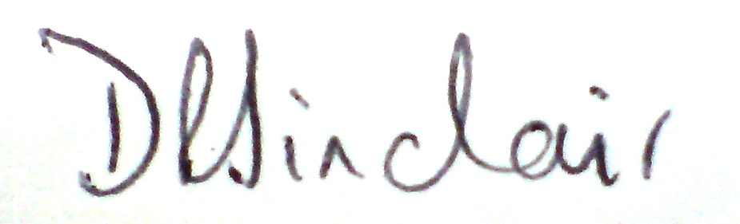
Signature: REDACTED
Date: 4th August 2020

