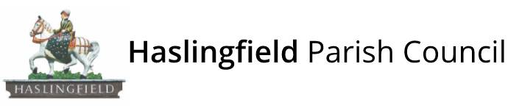

Haslingfield Skate Park - Phase 2 – Invitation to Tender

**Location:**

Haslingfield Skate Park

Porkers Lane, off High Street

Haslingfield

Cambridge

CB23 1JP

**Contact Details:**

Cllr. Ben Mavely

07732 076 830

[ben.mavely@haslingfieldparishcouncil.gov.uk](mailto:ben.mavely@haslingfieldparishcouncil.gov.uk)

**Brief History:**

Haslingfield Skate Park site consists of a skate park area, and a basketball court.

The site including the land is owned outright by Haslingfield Parish Council.

The site was originally built back in 2009 using wooden ramps. These ramps over time rotted away and in 2023 we successfully carried out renovation of the skate park to concrete ramps, what it is today.

**Current Requirement**

After the success of the renovation we’re now looking in to the second phase of works.

These works will comprise of **two elements**;

1. **Creating a new, second entrance to the area on from River Lane, to include new seating area.**
2. **Renovating and repurposing the Basketball court area to a MUGA**

**Element 1,** will involve creating a small foot bridge over the small river / stream, connecting the area to the footpath on river lane allowing people easy step free access the areas from river lane. This will open up the whole area making it feel much more open and inviting. (currently there is only one entrance). We’ll also be creating a seating area (currently just a gravelled area), again bringing a new lease of life into this section of the skate park. Shown in green below:

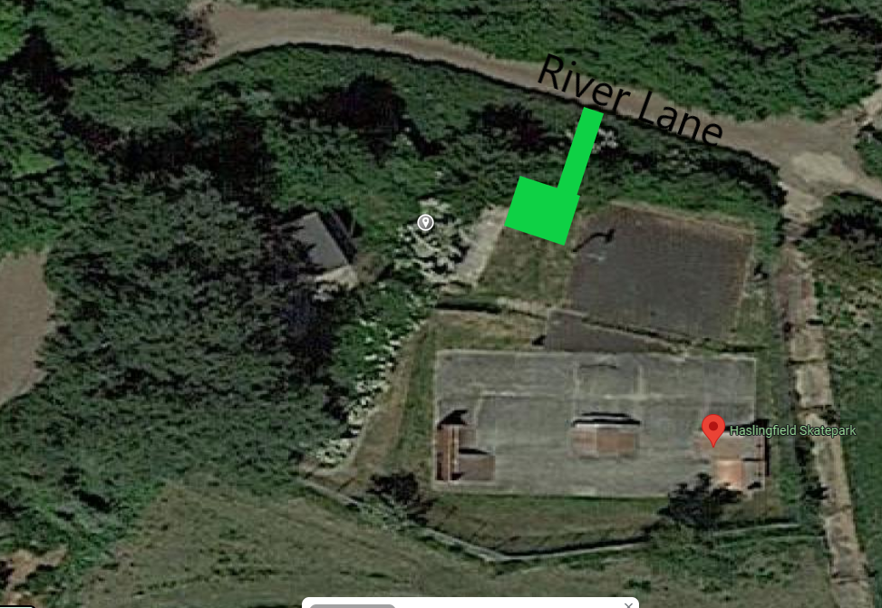

Below shows images view from River Lane looking into the Skate Park

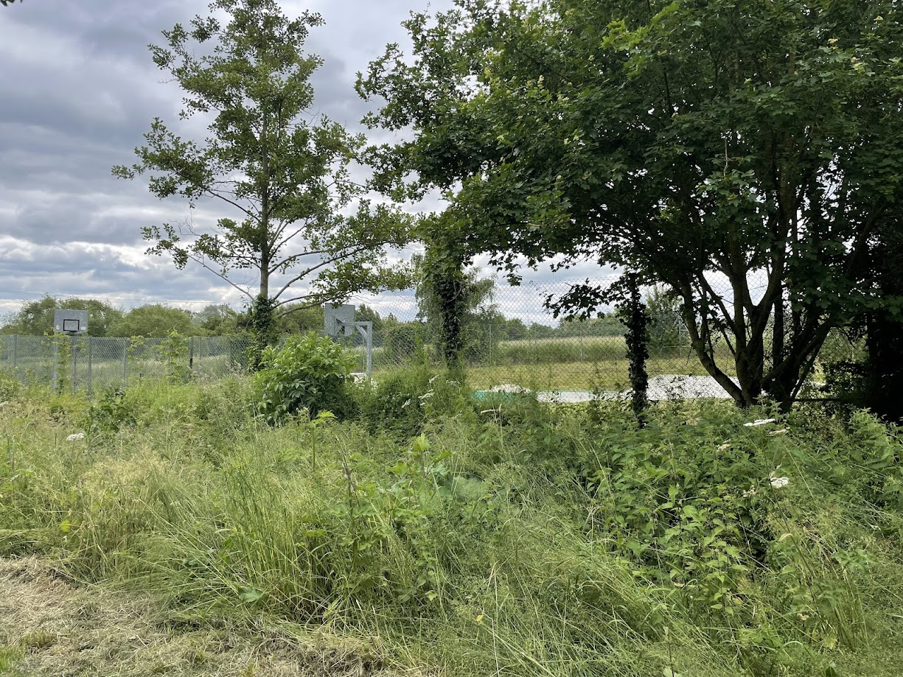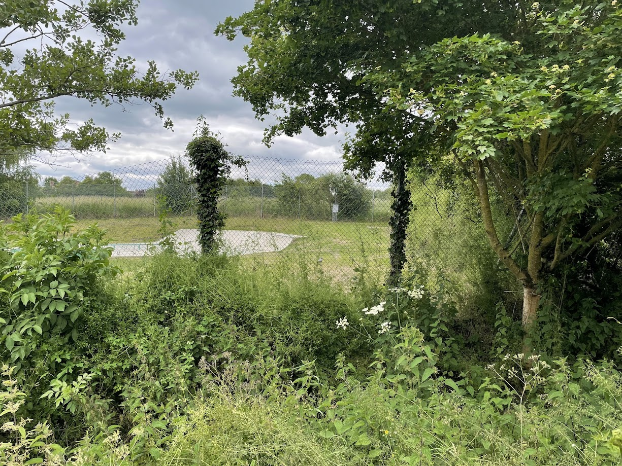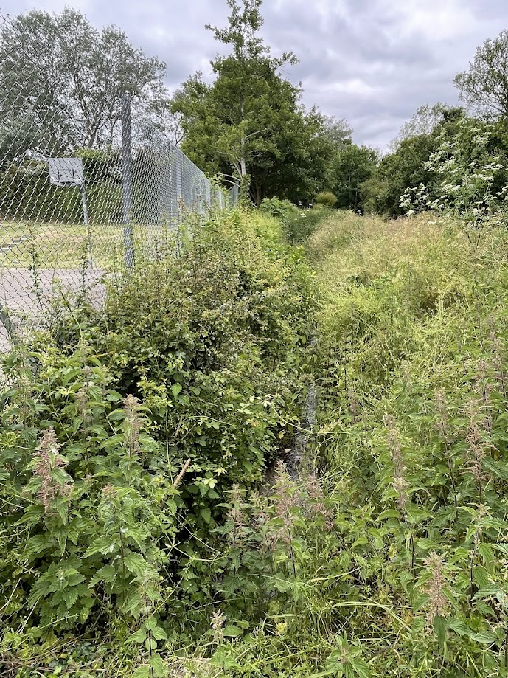

Below images shows view from inside the skate park looking out to River Lane, where new seating area will be

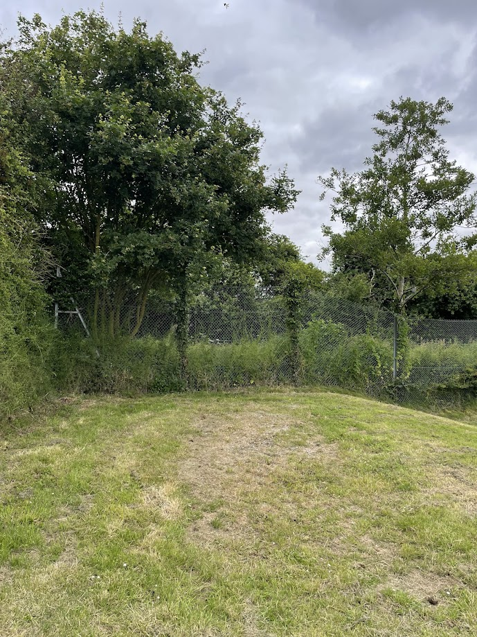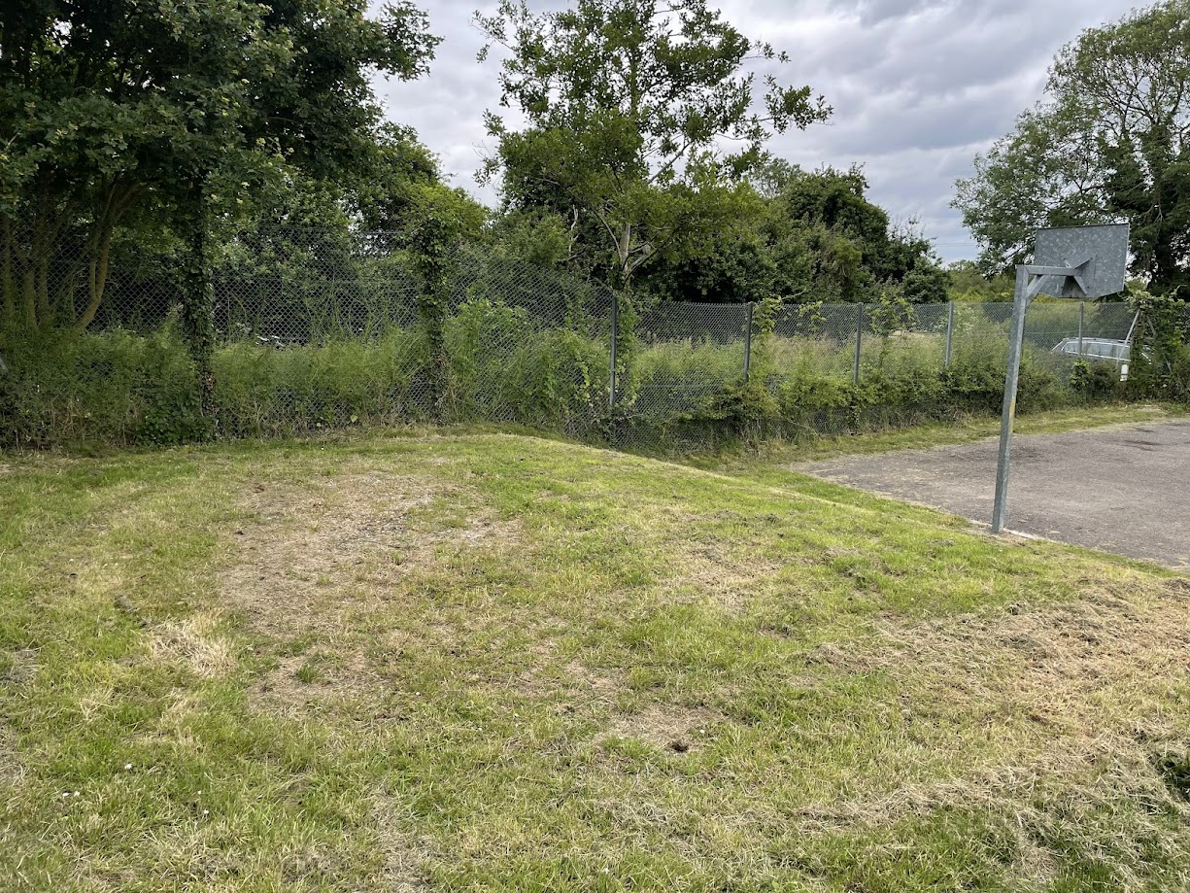

**Element 2** would be to renovate the existing Basketball court to incorporate a new Multi Use Games Area (MUGA)

Here we will be looking to remove the old rusted basketball nets and install a purpose built MUGA with new combined hoops and goals – the idea being this area can then be used for multiple sports like, Basketball, netball, football, hockey etc. something like shown below:

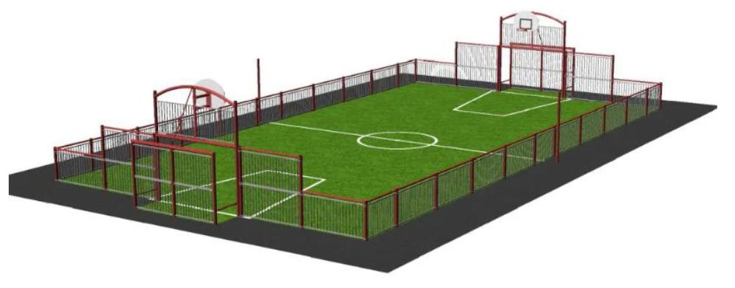

Below images show existing basketball court area

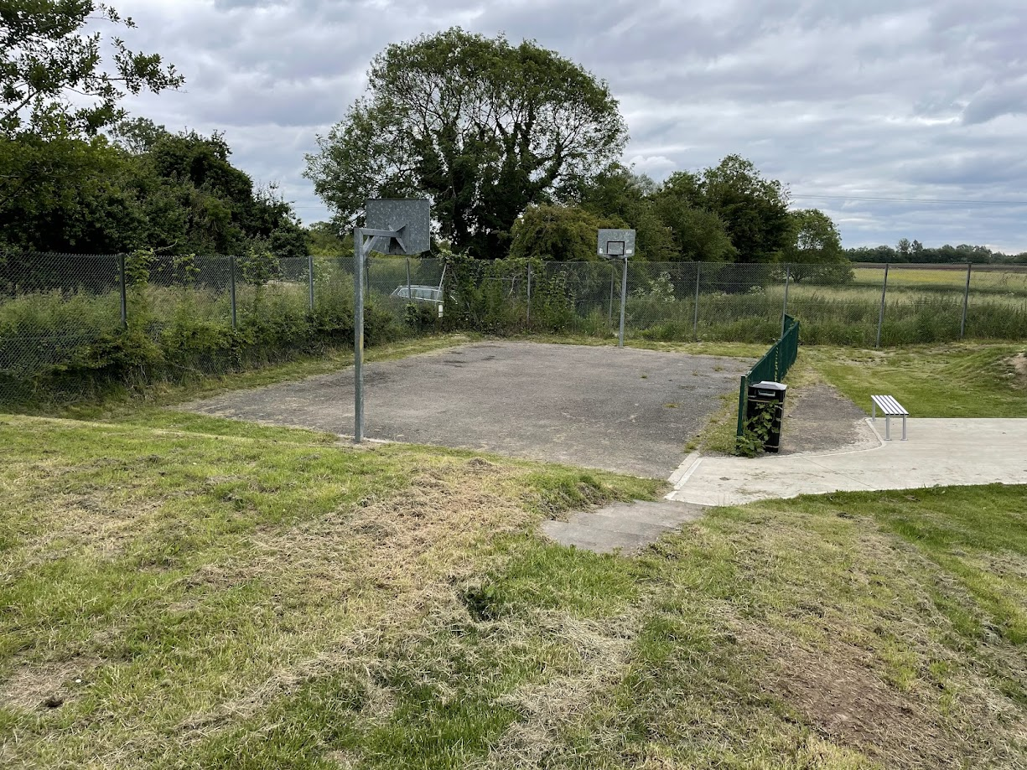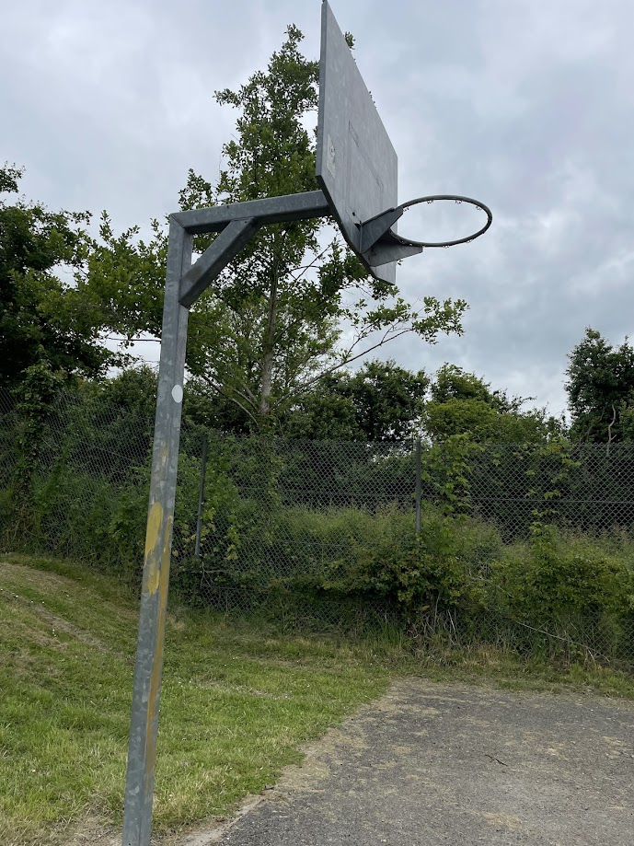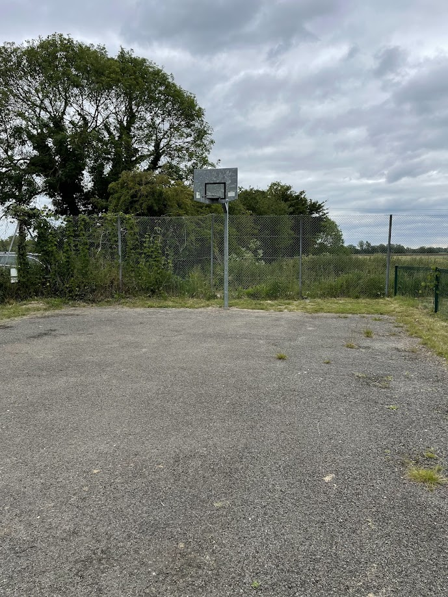

**Further Info**

We expect we will need planning permission for clearing the area on River Lane, and installing the footbridge.

We do have some funds to help put towards this project but will need the majority funded through some sort of Grant / Funding (We have already spoken to National Lottery who are keen to help out)

In order to move the project forward we expect we will need to have some initial consultation meetings on site, prepare some drawings for planning permission, and application for funding. We will be looking for help with all of these elements.

We hope these works will build on the success of the existing Skate Park and significantly boost numbers using the overall facility, providing a wonderful space for children (of all ages) to the village.