

**NHS SUPPLY CHAIN - FURTHER COMPETITION INVITATION TO TENDER (ITT)**

**Framework Title:** **Renal Replacement Therapies Services, Technologies, and Consumables (the “Framework Agreement”)**

**Framework Reference: 2019/S 205-499640**

Please ensure all highlighted colours are removed from this document before issuing it to suppliers.

1. INTRODUCTION

* 1. This Invitation to Tender (ITT) relates to a procurement to award a single supplier for the provision of Renal Replacement Therapies Services, Technologies, and Consumables.
  2. This procurement is being carried out as a further competition (**Further Competition**) under the **NHS Supply Chain Renal Replacement Therapies Services, Technologies and Consumables Framework Agreement.**
  3. The call off contract will be for an initial 5 year period with an option to extend for a maximum period of 24 months. The initial call off contract duration will be from April 2024 to March 2029.
  4. This ITT contains the information and instructions suppliers need to submit a tender in response to the customer’s further competition. Please read this document carefully as failure to follow these instructions may result in the rejection of your tender response.

1. NHS SUPPLY CHAIN 
   1. Akeso & Company are acting as an agent for Supply Chain Coordination Limited (SCCL), a company registered in England and Wales. Registered number: 10881715. Registered office: Skipton House, 80 London Road, London, SE1 6LH. Supply Chain Coordination Limited (SCCL) is the Management Function of the NHS Supply Chain.
   2. Applicants are deemed to fully understand the processes that NHS Supply Chain is required to follow under relevant European and UK legislation, particularly in relation to the Public Contracts Regulations 2015 (as amended) and subsequent amendments. Compliance with all relevant legislation is required both in the tender process and during the term of any resultant call off contract.
   3. NHS Supply Chain is acting on behalf of Doncaster and Bassetlaw Teaching Hospitals NHS Foundation Trust], for further details please refer to <https://www.dbth.nhs.uk/>
   4. For the avoidance of doubt all clarifications, evaluation, and award will be undertaken by Doncaster and Bassetlaw Teaching Hospitals NHS Foundation Trust.
2. CONDITIONS OF TENDER
   1. The contents of this ITT and of any other documentation made available to framework suppliers in respect of this procurement, are provided on the basis that they remain the property of Doncaster and Bassetlaw Teaching Hospitals NHS Foundation Trust and must be treated as confidential and only shared with the supplier’s professional advisers and other parties essential to preparing their tender response and for no other purpose.
   2. If any supplier is unable or unwilling to comply with the requirements outlined in the tender documentation, the supplier must destroy this ITT and all associated documents immediately and must not retain any electronic or paper copies.
   3. This ITT is made available in good faith. No warranty is given as to the accuracy or completeness of the information contained in it and any liability or any inaccuracy or incompleteness is therefore expressly disclaimed by Doncaster and Bassetlaw Teaching Hospitals NHS Foundation Trust and its advisers.
   4. No supplier will undertake any publicity activities with any part of the media, on their own or any other websites or social media platforms, in relation to this procurement without the prior written consent of Doncaster and Bassetlaw Teaching Hospitals NHS Foundation Trust, including agreement on the format and content of any publicity.
   5. Failure to comply with any deadlines, fully complete the documents, provide all the information required (or requested by NHS Supply Chain or the customer throughout the tender and/or evaluation process) or meet any of the ITT requirements may result in the supplier’s tender response not being considered by Doncaster and Bassetlaw Teaching Hospitals NHS Foundation Trust.
   6. The supplier must submit their tender response in English and submit it directly to Doncaster and Bassetlaw Teaching Hospitals NHS Foundation Trust

The Authority is using the Atamis portal to conduct the procurement process can be accessed at <https://health-family.force.com/s/Welcome>. All communications (including submission of tenders) must be carried out via the Atamis portal.

All enquires in connection with this document must be addressed through the Online Tender Portal (Atamis). If Bidders have any problems with the electronic tendering portal, they should contact the helpdesk on 029 2279 0052 or email: [support-health@atamis.co.uk](mailto:support-health@atamis.co.uk). Tenders will not be opened prior to the closing date.

* 1. Doncaster and Bassetlaw Teaching Hospitals NHS Foundation Trust reserves the right to cancel the tender process (or any part of it) at any point, make no award at all, award incrementally, change the basis of the tender process at any time, award individual lot(s), or procure the subject matter of the tender by alternative means if it appears that it can be more advantageously procured by alternative means.
  2. Doncaster and Bassetlaw Teaching Hospitals NHS Foundation Trust is not liable for any costs resulting from any of the circumstances outlined above, or for any other costs incurred by suppliers tendering for this call off contract.

1. TIMETABLE
   1. Suppliers should note that the dates listed in Appendix 4 DBTH Renal Dialysis Furrther comp MES v4 (introduction) are indicative only and Doncaster and Bassetlaw Teaching Hospitals NHS Foundation Trust reserves the right to vary this timetable at its absolute discretion.
   2. Suppliers will be informed of any changes via the Atamis tendering portal. Please ensure that your contact details are up to date with NHS Supply Chain to ensure that you receive clarification and tender updates.
2. COMMUNICATION
   1. Clarification questions relating to this further competition must be submitted using the Atamis tendering portal.
   2. Doncaster and Bassetlaw Teaching Hospitals NHS Foundation Trust reserves the right not to respond to any clarification requests received after the clarification deadline
   3. Doncaster and Bassetlaw Teaching Hospitals NHS Foundation Trust may need to communicate with suppliers for clarification or to request supporting information during the tender and/or evaluation process. Please note that all messages from Doncaster and Bassetlaw Teaching Hospitals NHS Foundation Trust to the supplier will be addressed via the Atamis tendering portal.
3. **ASSUMPTIONS ON PRICING, DISCOUNTS AND SAVINGS INITIATIVES**
   1. Suppliers are encouraged to offer discounted pricing and discount rates wherever possible.
   2. All pricing must:
      1. be in £ Sterling;
      2. exclude VAT;
      3. include import duties and full delivery costs via the Direct/E-Direct/Stock route of supply to any location in England, Scotland, Wales and Northern Ireland specified by NHS Supply Chain and/or the customer;
      4. include installation costs (excluding any interface) where applicable;
      5. include a warranty as detailed in Appendix
      6. include any related products or accessories (e.g. software, options and/or accessories) that are supplied ‘as standard’ with the device that enable the customer to operate the product immediately upon delivery. The term ‘as standard’ means, for example, where the product requires software in order to function correctly upon delivery of that item, and as software is supplied ‘as standard’ by your organisation for the relevant product, then the price that you submit as part of your tender response for that item must include the appropriate software;
      7. remain open for acceptance for 90 days; and
      8. be firm for the period of the call off contract, subject only to any variation provisions contained in the framework.
   3. The management fee is applicable per the parameters laid out in the Framework Agreement. Suppliers must ensure that all costs are included in the pricing or commercial schedule within their tender response.
   4. Pricing submitted will be benchmarked against existing Framework pricing. No pricing submitted should exceed the pricing set out in the Framework Agreement pricing schedule. Should any pricing submitted exceed the agreed Framework pricing, NHS Supply Chain reserves the right to request a re-bid from the Applicant as part of the clarification process, or reject the Applicant’s bid.
4. SUBMITTING A TENDER RESPONSE
   1. You are required to submit a tender response which fully complies with the instructions in this ITT and its appendices. You are strongly advised to read through all the documentation first to ensure that you understand how to submit a fully compliant tender response.
   2. You must answer all questions and submit your tender response via the Atamis tendering portal unless otherwise stated. Tenders submitted by any other means may not be accepted.
   3. It is your responsibility to:
      1. ensure that a fully compliant tender is submitted in response to this further competition; and
      2. ensure that the latest version of this ITT and its appendices are used.
   4. No additional attachments should be submitted with a tender response unless Doncaster and Bassetlaw Teaching Hospitals NHS Foundation Trust has specifically requested them.
   5. A fully compliant tender response must adhere to the following instructions:
      1. It must be submitted in the English (UK) language; and
      2. All questions must be answered accurately and as fully as possible, within any word/character/page limits specified.
   6. Questions should not be answered by cross referring to other answers or to other materials (e.g. annual company reports located on a website). Each question answered must be complete in its own right.
   7. Doncaster and Bassetlaw Teaching Hospitals NHS Foundation Trust may disregard any part of a response to a question which exceeds the specified word/character/page limit (i.e. the excess will be disregarded, not the whole response).
   8. All tenders responses must be received before the tender response closing date and time of this ITT. Tenders received after this deadline will be considered irregular and will be excluded from this further competition. Tenders not submitted via the Atamis tendering portal will not be accepted.
   9. You may withdraw from this further competition at any time by choosing not to submit a tender response.
5. CONTRACT AWARD PROCESS AND EVALUATION CRITERIA
   1. Doncaster and Bassetlaw Teaching Hospitals NHS Foundation Trust will conduct the evaluation based on the Most Economically Advantageous Tender (MEAT) in accordance with the marking scheme and methodology set out within this ITT.
   2. Doncaster and Bassetlaw Teaching Hospitals NHS Foundation Trust reserves the right to award this further competition to one supplier as set out in the marking scheme.
   3. STEP 1: COMPLIANCE TO THE SPECIFICATION
      1. Evidence of compliance to the specification must be provided as part of the supplier’s tender response.

By responding to this further competition, a supplier is confirming compliance to the specification

Tender responses must meet all ’Pass/Fail’ requirements set out in the specification (Appendix 4). Only suppliers whose tender responses meet these requirements, as specified in 8.4.2, will progress to the next stage.

* + 1. Doncaster and Bassetlaw Teaching Hospitals NHS Foundation Trust reserves the right to verify compliance to the specification.
    2. Doncaster and Bassetlaw Teaching Hospitals NHS Foundation Trust reserves the right to exclude a supplier from the further competition in the event that they are unable to verify (to the customer’s absolute satisfaction) that the goods/services meet the requirements of the specification.
  1. **STEP 2: EVALUATION OF NON-FINANCIAL INFORMATION**
     1. The nonfinancial evaluation is based on the criteria and weightings detailed below;

|  |  |
| --- | --- |
| **Non-Financial Evaluation Weighting** | **50%** |

* + 1. Doncaster and Bassetlaw Teaching Hospitals NHS Foundation Trust will use the following weightings to evaluate the non-financial elements of tender responses; Qualitative Requirements

|  |  |  |
| --- | --- | --- |
| Qualitative Requirements | General Requirements | 10.00% |
| Workforce | 10.00% |
| Performance | 5.00% |
| Corporate Social Responsibilty | 10.00% |
| Communication and engagement | 5.00% |
| Additional Services, Ie I&MT | 5.00% |
| Operational Service Delivery | 5.00% |

* + 1. Suppliers are required to answer a number of questions as set out in Appendix 4 DBTH Renal Dialysis Draft Further Comp MES v3.
    2. Doncaster and Bassetlaw Teaching Hospitals NHS Foundation Trust will use the following marking scheme to evaluate the questions;

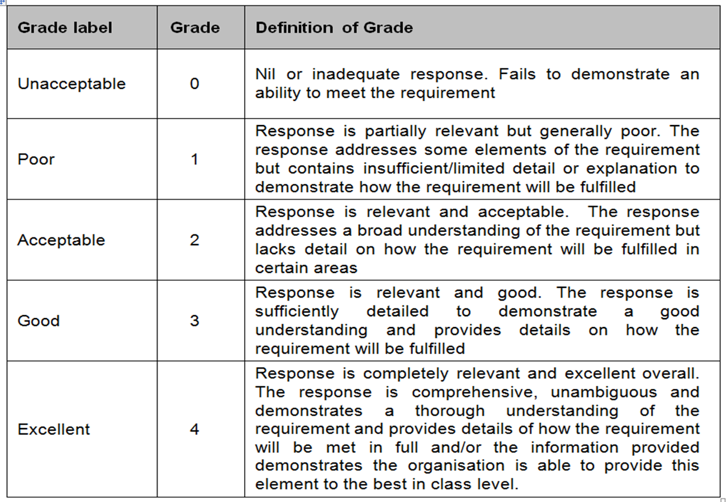

**STEP 3: FINANCIAL EVALUATION**

* + 1. The financial evaluation is based on the total cost of the call off contract using the following weighting;

|  |  |
| --- | --- |
| **Financial Evaluation Weighting** | **50 %** |

* + 1. The pricing submitted by the supplier in the pricing or commercial schedule (Appendix 5) and titled Total Contract Price for 5 Years will be evaluated as follows;



* 1. **STEP 4: FINAL EVALUATION** 
     1. Once the financial and non-financial evaluations have been carried out, the two sets of scores will be combined and rounded up or down to two decimal places.
     2. The supplier with the highest score (i.e. the Most Economically Advantageous Tender) will be awarded the call off contract.

1. **CONTRACT AWARD**
   1. Once Doncaster and Bassetlaw Teaching Hospitals NHS Foundation Trust has reached a decision in respect of the contract award, they will notify all suppliers who submitted a tender in response to this further competition of that decision and provide a voluntary standstill period before awarding the call off contract(s).
   2. Contract award is subject to the customer’s formal approval process. Until all necessary validation and compliance checks are completed and all necessary approvals are obtained (and any voluntary standstill period is successfully completed), no call off contract(s) will be entered into.
2. THE CONTRACT
   1. This further competition will result in the award of the call off contract(s) to the successful supplier(s), unless Doncaster and Bassetlaw Teaching Hospitals NHS Foundation Trust exercises their right to cancel or vary the procurement.
   2. This call off contract is being offered under the NHS Supply Chain call off contract terms and conditions.
   3. Suppliers may propose any amendments to the call off contract terms and conditions, however these will be subject to the agreement of Doncaster and Bassetlaw Teaching Hospitals NHS Foundation Trust
   4. Where clarification is sought during the clarification period on any points of ambiguity, new terms being introduced, or apparent error, Doncaster and Bassetlaw Teaching Hospitals NHS Foundation Trust may at their sole discretion make required amendments.
3. **CONFIDENTIALITY**
   1. Doncaster and Bassetlaw Teaching Hospitals NHS Foundation Trust is subject to the Freedom of Information Act 2000 (“Act”), the Environmental Information Regulations 2004 (“EIR”) and the Public Contracts Regulations 2015 (as amended) (“PCR 2015”). As part of the duties under the Act, the EIR, and/or the PCR 2015, Doncaster and Bassetlaw Teaching Hospitals NHS Foundation Trust may be required to publish and/or disclose information in relation to this procurement.
   2. If a supplier reasonably considers that any of the information provided in its tender response should not be published and/or disclosed to third parties (either because it is exempt from disclosure under the Act and/or EIR and/or should be withheld from disclosure under the PCR 2015 and/or should be treated as confidential at common law), then the information should be clearly marked as "Not for disclosure to third parties" (the “Designated Information”). Valid reasons in support of the Designated Information being exempt from publication and/or disclosure under the Act and/or the EIR and/or being withheld by Doncaster and Bassetlaw Teaching Hospitals NHS Foundation Trust from disclosure under the PCR 2015 and/or at common law (as the case may be) must also be provided.
   3. Designated Information must be limited to information which is genuinely exempt from publication and/or disclosure under the Act and/or the EIR and/or should be withheld under the PCR 2015 and/or should be treated as confidential at common law (as the case may be). Doncaster and Bassetlaw Teaching Hospitals NHS Foundation Trust will not accept blanket designations of documents. Doncaster and Bassetlaw Teaching Hospitals NHS Foundation Trust will have regard to any designation made by an Applicant in accordance with paragraph 11.2. However Doncaster and Bassetlaw Teaching Hospitals NHS Foundation Trust shall be entitled in its absolute discretion to publish and/or disclose any Designated Information (or any part or summary of such Designated Information) where it has a bona fide belief that notwithstanding such designation, and/or reasons why the Designated Information is believed to be exempt from publication and/or disclosure under the Act and/or the EIR and/or being withheld by Doncaster and Bassetlaw Teaching Hospitals NHS Foundation Trust from disclosure under the PCR 2015 and/or at common law (as the case may be), Doncaster and Bassetlaw Teaching Hospitals NHS Foundation Trust is obliged to publish and/or disclose such Designated Information (or any part or a summary of such Designated Information) to comply with its legal obligations. For the avoidance of doubt, Doncaster and Bassetlaw Teaching Hospitals NHS Foundation Trust shall be entitled to publish and/or disclose any information (i) which is not Designated Information pursuant to paragraph 11.2; and (ii) where valid reasons have not been provided to support the contention that the relevant information is exempt from publication and/or disclosure pursuant to paragraph 11.2

Doncaster and Bassetlaw Teaching Hospitals NHS Foundation Trust will not be held liable for any loss or prejudice howsoever caused by publication and/or disclosure of any information (or any part or summary of such information) (i) where such information has not been clearly marked “Not for disclosure to third parties” in accordance with paragraph 11.2; and/or (ii) where valid reasons have not been provided to support the contention that the relevant information is exempt from publication and/or disclosure pursuant to paragraph 11.2; and/or (iii) pursuant to paragraph 11.3 Doncaster and Bassetlaw Teaching Hospitals NHS Foundation Trust has a bona fide belief that Doncaster and Bassetlaw Teaching Hospitals NHS Foundation Trust is obliged to publish and/or disclose such information (or any part or a summary of such information) to comply with its legal obligations.

1. **LIST OF APPENDICES**

|  |  |  |  |
| --- | --- | --- | --- |
| **Appendix No.** | **Title** | **Contents** | **Action** |
| Appendix 1 | Form of offer | Letter detailing the form of offer | A signed copy must be returned as part of the tender response |
| Appendix 2 | Tupe Template | Bassettlaw and MMH Template | Resource |
| Appendix 3 | Specification for Satellite Haemodialysis Services in Doncaster and Bassetlaw | Document detailing the customer’s requirements which must be provided by the supplier(s) if awarded a call off contract(s) in response to this further competition | For reference; this will be used as the basis for awarding the call off contract |
| Appendix 4 | Further Comp MES | Non-financial questions Qualitative and Pass/Fail | All required questions must be completed and returned |
| Appendix 5 | Pricing or commercial schedule | Pricing or commercial schedule | Must be completed and returned |
| Appendix 6 | PAQ | Pre-Acquisition Questionnaire | Must be filled in for all devices and equipment |
| Appendix 7 | Equipment List Inventory | List of equipment | Must be filled in for all devices and equipment |
| Appendix 8 | Call off Terms and conditions | Call off Terms and Conditions for the supply goods and provision of service | To be completed at award |