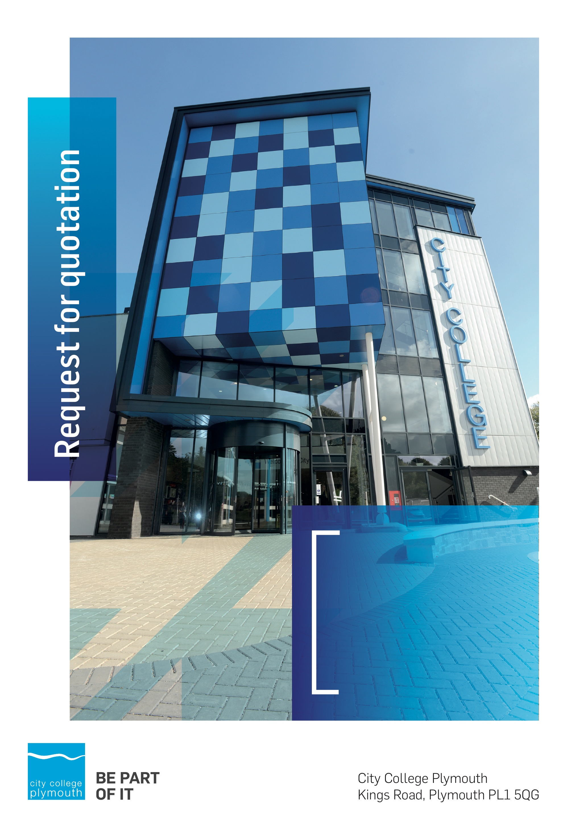

Request for Quotation
RFQ125
Safeguarding Works
Issued 12/12/19

Table of Contents
Table of Contents 2
Confidentiality Statement 4
Open Procedure 4
Submission Details 4
Submission Deadlines 4
Submission Delivery Address 5
Submission Questions and Clarifications 5
Electronic Submissions 5
Introduction and Executive Summary 6
Business Overview & Background 6
Our Vision … is where our future lies 6
Our Mission … is what we focus on each and every day 6
Background 7
Detailed Requirement 7
Work Timescales 9
Security 9
Specific conditions applicable to this quotation 10
Working Requirements 10
Electricity At Work Act 1989 10
IEE regulations 10
Health & Safety 10
Noise Control 11
Certification and Forms of Completion 11
Environmental 11
Redundant Services and Equipment 11
Provision of Materials, Plant and Equipment 11
Construction (Design and Management) Regulations 2015 12
Conduct of Work 12
Delivery of Plant and Materials 12
Tender Timescales 13
Written submission 13
Pricing 14
Terms and Conditions 14
Validity 14
Selection Criteria 14
Award Price 14
Scoring 15
Assessment of Quotations 15
Freedom of Information Act 2000 15
general data protection Regulation (GDPR) 2018 16
Agreement Conditions Acceptance and Declaration 16
Supporting Documentation 16

Confidentiality Statement
This document, and any attachments thereto, regardless of form or medium, is intended only for use by the addressee(s) and may contain legally privileged and/or confidential, copyrighted, trademarked, patented or otherwise restricted information viewable by the intended recipient only. If you are not the intended recipient of this document (or the person responsible for delivering this document to the intended recipient), you are hereby notified that any dissemination, distribution, printing or copying of this document, and any attachment thereto, is strictly prohibited and violation of this condition may infringe upon copyright, trademark, patent, or other laws protecting proprietary and, or, intellectual property. In no event shall this document be delivered to anyone other than the intended recipient or original sender and violation may be considered a breach of law fully punishable by various domestic and international courts. If you have received this document in error, please respond to the originator of this message or email him/her at the address below and permanently delete and/or shred the original and any copies and any electronic form this document, and any attachments thereto and do not disseminate further.
Thank you for your consideration, City College Plymouth.
Where no notice is given, all information contained herein is Copyright 2019 City College Plymouth.

Open Procedure
The College fully adheres to the requirements of the Public Contracts Regulations 2015, including for opportunities which are under threshold amounts.
Any Contractor who directly or indirectly canvasses any Member or Officer of the Institution, or advisor concerning the award of the contract for the provision of the services, or who directly or indirectly obtains or attempts to obtain information from any such member or Officer concerning any Tender or proposed Tender for the service will be disqualified from having his/her Tender considered.

Submission Details

Submission Deadlines
All submissions for responding to this Request for Quote must be submitted via email as stated below, no later than:
Thursday 16th January 2020
12:00 Noon
Any submissions received after this date will not be considered.

Submission Delivery Address
All submissions should be submitted electronically as below.

Submission Questions and Clarifications
You may contact the following person if you have any questions or require clarification on any topics covered in this Request for Quotation, by Friday 10th January
Adam Baker
Procurement Assistant
City College Plymouth
Phone: 01752 305313
Email: tenders@cityplym.ac.uk
All correspondence during the Tender should be channeled via the Procurement team using the above details only. Bidders found to have gained an unfair advantage shall be disqualified from the current opportunity and future opportunities with the College for a minimum of three (3) years.

Electronic Submissions
Electronic submissions in response to this Request for Quotation must meet the following criteria:
Sent via email to: tenders@cityplym.ac.uk quoting reference RFQ125
Document standards:
- Text must be in Microsoft Word format;
- Price tables must be in Microsoft Excel format (using pricing schedule in Appendix A);
- Supportive evidence may additionally be submitted in PDF format;
- Images, Designs, and other supporting evidence may be in either JPEG or PDF format
- Completed Appendix C Suitability Assessment & Selection Questionnaire (Including Mandatory & Discretionary Exclusions) Parts 1, 2 and 3. - Please note this suitability assessment will not be viewed unless you are shortlisted for the presentation stage. Failure at this stage may prevent the contract from being awarded.
- Signed Agreement Acceptance and Declaration Appendix D

Please note that the College is able to accept submissions sent in a compressed or “.zip” file format, so long as the files contained meet the standards described above.
WARRANTY:
By submitting your tender bid, you are warrantying to the College that you have not breached our canvassing or soliciting clause.

If any successful tenderer awarded a contract is found to have provided an inaccurate warranty, then the College reserves the right to terminate the awarded contract with immediate effect and re-tender the contract from which the successful tenderer will be excluded from re-bidding and shall be disqualified from any future opportunities for a period of four years.

Introduction and Executive Summary
City College Plymouth is looking to carry out various works related to safeguarding, to include new barriers and fencing.
As the anticipated value of the advertised works exceeds £25,000, we will advertise the opportunities on the government portal ‘Contracts Finder in accordance with the Public Contracts Regulations 2015.
All prospective contractors will be required to complete the suitability assessment questionnaire (Appendix C).

Business Overview & Background
The College currently operates on two main sites within the city, serving 12,897 students and employing 622 staff. The College operates year round, with opening times from 0800-2100 on some days.

Our Vision … is where our future lies
We are a College with a national reputation for promoting enterprise, employability and science, technology, engineering and mathematics (STEM).

Our Mission … is what we focus on each and every day
To be the South West’s leading provider of innovative, technical, professional education and training by supporting partnerships for growth, raising aspirations and fostering wealth creation

Background
City College Plymouth is one of the largest providers of innovative, technical and professional, education in the South West with a national reputation for promoting enterprise, employability and science, technology, engineering and mathematics (STEM). The College plays a central role in the educational, cultural and economic life of the region and works with strategic partners to facilitate growth, raise aspirations and foster wealth creation.
The College was awarded the Teaching Excellence Framework Gold award for its university-level provision and its most recent Ofsted inspection confirmed that the College continues to be ‘Good’ with outstanding features. The College was rated first in the South West and second nationally for student satisfaction in the latest FE Choices student satisfaction survey.
City College supports the region’s employers with their award-winning Apprenticeship provision, as well as providing a range of courses and bespoke training programmes which enable employees to upskill or retrain to better support their business’ requirements. Their successful partnership working with the local business community resulted in a 99.5% satisfaction rate in the Government’s national ‘FE Choices employer satisfaction survey 2016 to 2017’ - placing them first in the country for general further education colleges.
City College Plymouth offers a wide range of academic and vocational courses in a variety of subjects. The total number of students supported by the College is 12,533 - which comprises of: 3,569 full-time students, including 765 higher education students and 179 non EU students; 8,964 part-time students; and 1,599 apprentices.

Detailed Requirement
The anticipated cost of the works is £25,000 split into lots as per the detail below;
Lot 1: Nursery Entrance Works (£6000)
- To provide new electronically locked entrance gates – gates to cover a width of 3240mm with two equal leaves
- The right hand leaf is to be electronically locked and to be released by either entering a code number or calling through to reception on a GSM intercom to be installed by yourselves
- The gate is to be able to be released remotely and to close automatically once entered
- The area between the inner and outer gates is to be covered with a steel frame and polycarbonate roof above to provide a dry vestibule for persons entering the nursery.
Lot 2: Nursery Fencing (£4000)
- Remove old wooden fencing and two access gates to the right hand side of the building, approximately 26m above stone wall (approximately 46m in total to install)
- Replace with new closed board fencing and gates at 2.1m high and 800mm high above side wall
- The new rails installed with fencing are to be visible on the internal side of the fence and not the outside as they are at present to improve safety
- The 2.1m fencing posts are to be concreated into the ground and the posts above the wall are to be chemically anchored to the wall with galvanised threaded bar
- All new fencing is to have a 150mm gravel board at the base with pales starting from this height
- All existing fencing to be removed and disposed of by yourselves
Lot 3: Main reception area (£11,000)
- To Install 11 in number stainless steel anti ram fixed bollards to the area immediately outside the main college entrance (one to be installed by the far end of the walkway). Bollards to meet following spec;
  - Height above ground: 1000mm
  - Overall length: 1500mm
  - Diameter/Profile: 114mm
  - Weight ~ 32kg
  - Installation method: Root Fixed in concrete foundation
- The bollards are to follow the curved line of the brick paviours pattern
- Contractor to be responsible for whole installation process and to provide chapter 8 safety fencing for the works
- To supply and install an Armco barrier to deter vehicle access to the area along the boundary of the walkway and the parking spaces
- To install a high visibility safety end at the end of the Armco barrier
Lot 4: External Walkway (£2000)
- To replace existing gate and install additional fencing to the side of the gate
- The overall height of the gate including header panel to be 3.2m (2.4m high gate)
- The gate is to be manual in operation and is to be secured by a sliding lockable bar and padlock
- To install an additional fence panel to run back between the existing boundary wall and the parallel building.
- To remove and dispose of the existing gate and associated posts

Lot 5: Stonehouse Creek access (£2000/£4000)
Option1
- Install approximately 10m of 2.0m high v-mesh fencing to the area at the far end of the bridge.
- To install a manual pedestrian gate with sliding lockable bar to the pathway within this section of fencing.
- The gate is to be manual in operation and to be secured by a sliding lockable bar and padlock
- No thoroughfare signage to be added to fencing (exact wording/design to be confirmed)
Option 2
- To install approximately 40m of 2m high v-mesh fencing to the area at the top of the steps that lead to the Stonehouse Creek exit
- To install a semi-automated pedestrian gate with electronic locking to the pathway with above section of pathway. The gate is to be connected to the colleges existing swipe card system by others
- Gate to be only openable by authorised persons
- No thoroughfare signage to be erected at far end of pathway (exact wording/design to be confirmed)

We would like to invite any prospective bidder to an Open Site Visit on Tuesday 17th December at 1000 hours. At the open site day, you can view the site and the prospective jobs and ask questions to the Health and Safety Manager, David Wright.
Prospective contractors can bid for one or as many opportunities as they wish but we would expect to receive assurances that they can complete the jobs within the given timeframes. Please note any contractor who cannot meet the require timeframes will be discounted from bidding.

Work Timescales
The work is planned to be carried out the week commencing 17th February. This is a school holiday so should minimise disruption.

Security

The College requires that all contractors, prior to undertaking work on the College site, will have been subject to a (DBS) English Disclosure Barring and Services check. This requirement may be suspended where works are undertaken during the college holiday breaks or outside of the main school week, providing the College is satisfied any risk to students who may be on site for revision or taster sessions is adequately managed.
All staff on site will be required to comply with health and safety requirements at all times and to wear appropriate identification.
All staff will be required to sign in and sign out when on College premises.

Specific conditions applicable to this quotation

Working Requirements

Electricity At Work Act 1989
The contractor is to comply with the Act at all times. If LIVE WORKING cannot be avoided, the contractor is to inform the Estates Engineer of the reasons and the proposed action to be taken, to implement a safe system of working.

IEE regulations
Electrical work must be carried out by an electrical contractor on the roll of the National Inspection Council for Electrical Installation Contracting, or other approved certification body e.g. NAPIT, ECA etc, and conform to the requirements of current IEE Regulations (BS7671) and the local electricity supply company

Health & Safety
The contractor is responsible for carrying out a detailed risk assessment of the work to be done. This must be issued to the premises manager at least two weeks before work commences, along with method statements, which explain how the work is to be carried out, and the safety controls to be employed.
In addition to the Electricity at Work Act 1989, all work must be carried out in a safe manner, and in accordance with all relevant Health & Safety Regulations, without risk of harm to the people carrying out the work, students and staff of the college, and members of the public.
The College operates a Signing In/Out, and a permit to work system which must be strictly adhered to.
The contractor is responsible for arranging all safe access to work areas (e.g. scaffolding) and for maintaining safe working conditions (e.g. edge protection, temporary lighting) within the work area.

Noise Control
The Contractor shall comply with The Noise at Work Regulations 1989. He must take all reasonable steps to control and curtail the level of noise whilst carrying out the works.

Certification and Forms of Completion
The Contractor is to prepare all forms of completion as prescribed in the relevant section of the current IEE regulation.
- The NICEIC or NAPIT forms are preferred.
- The forms are to be presented in a clean condition.

Environmental
All work must be carried out with a responsible attitude to environmental concerns. All waste arising from the work is the responsibility of the contractor, and must be handled and disposed of in accordance with the current waste and all relevant environmental legislation.

Redundant Services and Equipment
All redundant services arising from the work must be completely removed back to the distribution board. Where this is difficult, impractical or potentially costly, this must be discussed with the Estates Engineer before commencing.
Redundant equipment arising from the works (e.g. light fittings), may if requested, be retained by the college for future use. If this is not the case, the contractor must arrange for disposal from site. Redundant metal materials can be disposed of in the college’s scrap metal skip only by agreement with the Estates Engineer or the Sustainability Officer. In the case of light fittings, lamps, diffusers and electronics must be removed before the metal casing is placed in the skip.

Provision of Materials, Plant and Equipment

- Unless otherwise specified, the contractor must supply all materials, plant, tools and equipment required, to effectively complete the works detailed in this specification.

- For all equipment, fittings and accessories, where a manufacturer is not specified, good quality units compliant with the relevant British Standards and EN Standards must be used.

- Any deviation from the specified fitting’s, must be agreed with the Estates Engineer.

Construction (Design and Management) Regulations 2015
The Contractor must comply with the requirements of the CDM Regulations and notify the other parties to the contract immediately it becomes aware that they are or likely to be in breach of these Regulations.
All building and maintenance work now falls under CDM Regulations.
All building and maintenance work will now require a Construction Health & Safety Plan, even if it is not notifiable. The level of detail and planning required will be proportionate to the scale and complexity of the project.
All projects involving more than one Contractor must have a Health & Safety File.
Projects will be notifiable to the HSE where:-
- The work will last longer than 30 working days AND involve more than 20 workers on site simultaneously.
OR
- The work exceeds 500 person days.

The Contractor must notify the Contract Administrator in writing, with their quotation or tender, if they foresee the above criteria for notification being exceeded during the works. The Contractor must also notify the Contract Administrator if they foresee that additional contractors are required to complete the work.

Conduct of Work
The Contractor is to arrange their work as to avoid interference with routine use of occupied premises and must co-operate with persons occupying or using the premises whilst he is working.
The Contractor shall protect and keep free from damage the buildings, fences, walls, roads, paths kerbs and all other parts of the work location.
The Contractor shall remove or cover up and protect all furniture, fittings and the like if in a position affected by the works and replace or remove protection as relevant and upon completion make good any loss or damage.
The Contractor shall supply all requisite watching, lighting and barriers during the progress of the work.

Delivery of Plant and Materials
The contractor is responsible for the supply, delivery and off-loading of all plant, materials and equipment into final positions. The contractor must liaise with site services staff to identify suitable storage areas, although these cannot be guaranteed.

Tender Timescales
These are timescales for the selection process-
Action | Date
Tender Issued | 12/12/2019
Site Visit | 17/12/2019
Deadline for queries | 10/01/2020
Tender Response Date | 16/01/2020
Tender Award Date | 24/01/2019
Work To be carried out | W/C 17/02/19

Written submission
You are required to submit a brief written document that outlines how you will meet our requirements and how you intend to work with the college, with particular regard to the following:
- Contract management, including a named contact and how you would manage the works.
- Experience of similar works carried out in an operation environment, preferably in an educational establishment.
- Details of any subcontractors you would use on the above works
- Demonstrate competence and relevant registrations/professional memberships in the trades you are quoting for.
- Supply chain and any environment impact.
You should also confirm your understanding of our DBS requirements and that you will be able to comply.
You are also required to complete a suitability and assessment questionnaire, attached at Appendix C. This document is not used during the selection process, but will be viewed if you are the shortlisted contractor.
Your document will be scored in accordance with the table on page 15.

Pricing
Bidders should provide their pricing for each of the opportunities in Appendix A
There should be no additional cost incurred.

Terms and Conditions
The College’s normal business terms are 1-2 months from the date of invoice. Payment will become due subject to the above upon the College’s full acceptance of the goods/services. This Request for Quotation and any resulting purchase order will be subject to the College’s General Terms and Conditions of Purchase of Goods/Services – see Appendix B.

Validity
Bidder’s offers should be open and valid for acceptance for a period of no less than ninety [90] days from the date of submission.

Selection Criteria
The successful supplier will have provided the Most Economically Advantageous Tender (MEAT) to the college. It should be noted that the bidder with the lowest submitted prices will not necessarily be down-selected. All bidders will be notified via email of the results of the outcome no later than ninety [90] days form the date of submission. The date of contract award will be provided within that email.
The marking criteria are described in the table below:

Category | Weighting
Price | 80%
Contract Management and previous experience | 10%
Relevant qualifications and use of sub-contractors | 5%
Supply chain and environmental impact | 5%

Please see table overleaf for more details on the scoring method.

Award Price
Lowest quote price divided by quote price multiplied by 100.

Scoring
Assessment | Score | Interpretation
Excellent | 4 | Comprehensive response supported by examples  Description fully supported by details that demonstrate the applicant’s ability to provide the required services.
Good | 3 | Broad response supported by relevant examples.  Description well supported by details that demonstrate the applicant’s ability to provide the required services.
Satisfactory | 2 | Reasonable response supported by some evidence.  Description adequately supported by details that demonstrate the applicant’s ability to provide the required services.
Poor | 1 | Limited response not well supported by evidence.  Description inadequately supported by details that demonstrate the applicant’s ability to provide the required services.
Unacceptable | 0 | No response or insufficient information provided.

Assessment of Quotations
Bidders must ensure that their quotation fully addresses all information requested within this RFQ document. Bidders must ensure that any quotation fully meets the specification required. The College reserves the right to discount any quotation which does not fully meet the specification.
The College reserves the right to seek clarification with bidders upon receipt of quotations.

Freedom of Information Act 2000
Under the Freedom of Information Act 2000 the College cannot guarantee that information provided by bidders during the course of this RFQ procedure or any resulting contract will be held a confidential. The College will not routinely release information to interested parties unless required to do so in order to meet our statutory obligations.

general data protection Regulation (GDPR) 2018
All bidders must comply with the General Data Protection Regulation (GDPR) 2018 in respect of using and processing personal information. Bidders must have in place technical and organisational safeguards to protect personal data from unauthorised use, disclosure or loss.
The College reserves the right to request a copy of your privacy statement if you are the successful bidder.

Agreement Conditions Acceptance and Declaration
Bidders are required to sign and return the attached Agreement Conditions Acceptance and Declaration, Appendix D.

Supporting Documentation
Appendix A Pricing Schedule.
Appendix B Standard Terms and Conditions for the Purchase of Goods and Services.
Appendix C Suitability Assessment & Selection Questionnaire (Including Mandatory & Discretionary Exclusions) Parts 1, 2 and 3.
Appendix D Agreement Conditions Acceptance and Declaration.

