Map A- Location of Works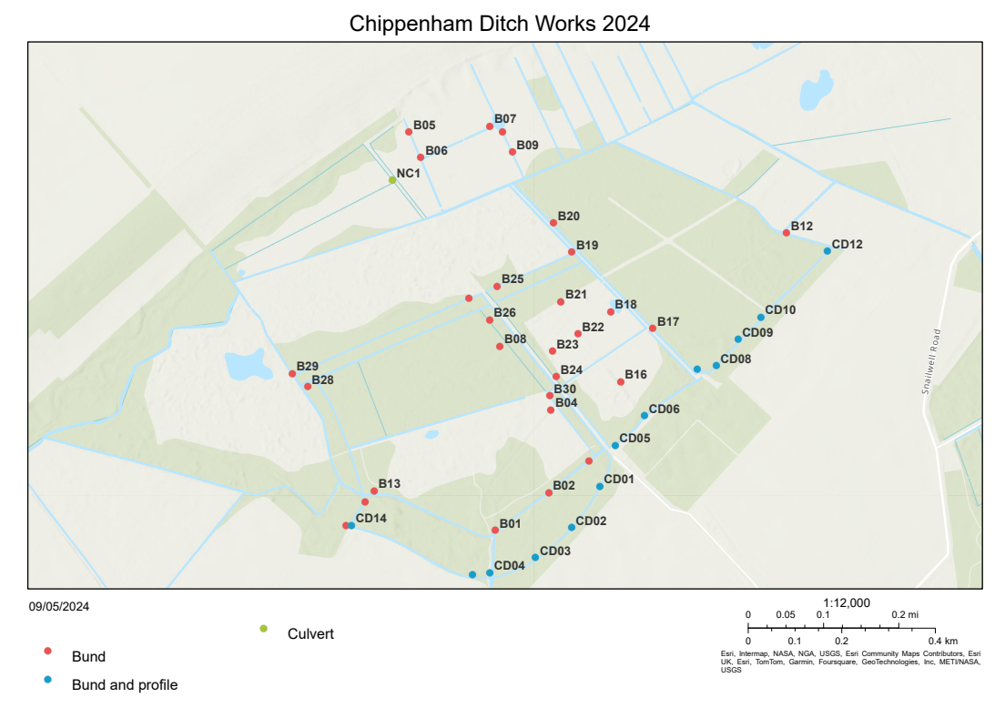

Table 2 – Table of Works

Ref | Work | Access | Preparation | Notes | ditch width | ditch depth
B01 | Bund | easy |  | Partially built. Needs reinstalling | 4 | 2
B02 | Bund | hard | remove trees and fence |  | 3.5 | 1.5
B03 | Bund | hard | remove trees and fence |  | 5 | 1.5
B04 | Bund | easy |  |  | 3 | 1.25
B05 | Bund | easy | remove fence |  | 4 | 1
B06 | Bund | easy | remove fence |  | 6 | 1
B07 | Bund | easy |  | Near pond | 6 | 1
B08 | Bund | easy |  | Possible foot drain needs blocking | 6 | 0.75
B09 | Bund | easy |  |  | 3 | 3
B10 | Bund | easy |  |  | 4 | 2.5
B12 | Bund | hard | remove trees and fence | Access from outside fen challenging terrain | 6 | 3
B13 | Bund | medium | remove trees and fence | Access issues within woodland | 5 | 1.5
B14 | Bund | medium | remove trees | Existing bund needs proper install | 3 | 1.5
B15 | Bund | easy | remove trees |  | 3 | 1
B16 | Bund | easy |  |  | 3 | 1
B17 | Bund | easy |  |  | 7 | 3
B18 | Bund | easy |  |  | 4 | 1
B19 | Bund | easy |  |  | 6 | 2.5
B20 | Bund | easy |  |  | 7 | 2.5
B21 | Bund | medium |  |  | 6 | 2
B22 | Bund | easy |  |  | 3 | 1
B23 | Bund | easy |  |  | 4 | 0.5
B24 | Bund | easy |  |  | 3 | 1.5
B25 | Bund | easy | remove trees |  | 4 | 2
B26 | Bund | medium | remove trees and fence | Pick route through the trees | 4 | 1.5
B27 | Bund | medium | remove trees | Access? | 6 | 1.5
B28 | Bund | medium | remove trees | Bund near deer seat | 6 | 1.5
B29 | Bund | easy |  | Collar or sluice | 6 | 3
B30 | Bund | easy |  |  | 4 | 2
CD01 | Bund and profile | easy |  | Catch dyke- pull in soil | 3 | 1.75
CD02 | Bund and profile | easy |  | Catch dyke- pull in soil | 3 | 1.5
CD03 | Bund and profile | easy |  | Catch dyke- pull in soil | 4 | 1.75
CD04 | Bund and profile | medium | remove trees | Catch dyke- pull in soil | 4 | 1.25
CD05 | Bund and profile | easy | remove trees | Catch dyke- pull in soil | 3 | 1.5
CD06 | Bund and profile | medium |  | Catch dyke- pull in soil | 4 | 1.5
CD07 | Bund and profile | medium | remove trees | Catch dyke- pull in soil | 4 | 2
CD08 | Bund and profile | medium | remove trees | Catch dyke- pull in soil | 4 | 1.5
CD09 | Bund and profile | medium | remove trees | Catch dyke- pull in soil | 6 | 2
CD10 | Bund and profile | medium | remove trees | Catch dyke- pull in soil | 6 | 2
CD12 | Bund and profile | medium | remove trees | Catch dyke- pull in soil | 4 | 1
CD13 | Bund and profile | easy | remove trees and fence | Catch dyke- pull in soil | 4 | 1
CD14 | Bund and profile | easy | remove trees | Catch dyke- pull in soil | 3 | 1
NC1 | Create Culvert | easy | remove trees | Create culvert under track | 10 | 1.5

Diagram 1- Proposed design of bunds
