Refurbish the Library Quad Garden

Date: Nov 2017 Ver: 01

Introduction:
The National Institute for Biological Standards and Control (NIBSC) is a multi-disciplinary scientific establishment whose purpose is to safeguard and enhance public health by standardising and controlling biological substances used in medicines. One of its key roles is the production of reference materials, which are used to ensure the high quality of biological medicines such as vaccines and blood products. The Institute is a designated World Health Organisation (WHO) laboratory for the production of International Standards and its scientists provide advice to a wide range of National and International bodies on product safety and efficacy. The NIBSC is funded in the main by the British Government and as such is obliged to comply with its Standing Financial Instructions (SFI’s) to ensure that quotations are obtained in a fair and effective manner ensuring optimum quality and cost. The SFI’s require that projects of this nature are subjected to a tendering process with an Invitation to Tender (ITT) posted on Bravo Solutions e Tendering Portal https://phe.bravosolution.co.uk/web/login.shtml with the aim to obtain a minimum of three contractors tenders. During the tender process every effort will be made to ensure impartiality and those contractors not appointed on this occasion will be given a further chance to tender for similar projects in the future.

Overview:
The Library Quad Garden is situated in the centre of the site (see Figure 1) which was landscaped in 2007 (see Figure 2). However, it is now showing signs of deterioration. The main features were the use of wooden sleepers to hold back made-up terraced ground of various heights. These sleepers have now rotted and several have fallen over.

There is also a pond on the top area that has a stream flowing south to a waterfall which flows into a lower pond. The system is in need of attention to resolve a leak and stop the waterfall falling onto the retention wall (currently sleepers).

The Rose Seating Area to the west of the garden has a similar issue with the sleepers in that they have perished, which also need to be addressed. There is a woodchip path that leads from the Rose Seating Area to north east of the garden which has a sleeper bridge over the stream. This pathway and bridge also need attention.

The landscape is generally in good condition and is maintained by the Institute gardener. However there is a need to undertake some tidying-up of the landscape, along with the remedial work by a contractor to return it to a manageable standard in order that the gardener can continue the day to day maintenance.

Proposal:
The sleepers forming the retention walls are to be removed and replaced by decorative grey stonework in keeping with the Rose Seating Area central wall and the lower walls. The stone work is to be built on solid foundations and any of the retained earth that spills out during the works is to be replaced behind the wall. Within the Rose Seating Area there are to be sturdy seats formed in the wall, similar to those made by the current wooden sleepers.

The wood-chip path from the Rose Seating Area is to be replaced by spaced wood-effect concrete sleepers forming a path similar to the secluded path at the top of the Quad Garden (see image of wood-effect concrete sleeper paved path, with spaces to be filled with woodchip. A new non-slip bridge is to be installed over the stream from the Upper Pond to the Waterfall. The concrete sleeper path is to continue the other side of the bridge to the paved steps. Along the existing wood-chip path are lights on small bollards which are/were fixed to small wooden sleepers that have long since perished, some of which have fallen over. A suitable design to permanently fix/reinstate the lights is to be offered to the project manager and the Institute gardener, with steel wired armour cabling agreed before implementation. Any new lights that maybe required is to be of LED type. Throughout the Quad Garden is an irrigation/sprinkler system which is to be replaced as part of the works, to the satisfaction of the Institute’s gardener. There is also a watering system requiring replacement new hosing and attachments.

The Upper Pond is to have a new pond 1.5m wide to the side of the pond, to cater for the water filter and UV/Infrared steriliser which are to be repositioned for easy maintenance access, by agreement with the Institute gardener. The Upper Pond is to be reinforced and enlarged to 3m wide to accommodate an increased volume of water. To the side of the new pond are to be several decorative slabs to form a small path (similar to the spaced wood-effect concrete sleepers), to facilitate easier access for maintenance to service the components within the pond. Around the edges of both ponds are to be solid-set decorative stones to mask the pond-liners.

The stream currently has a leak which is to be investigated and remedial works undertaken to permanently resolve the problem. The stream is to be widened to 0.9m (3 ft) and reinforced to prevent movement fatigue and any potential for puncturing the stream-liner. The edges of the stream are to have decorative stones solid-set along the length. The current waterfall is to be replaced with a more decorative rock waterfall similar to the image below (the new main waterfall design should include large rocks).

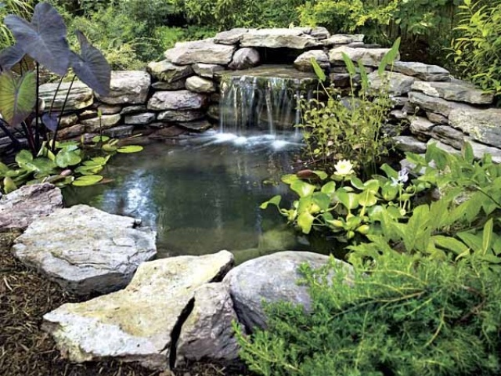

The contractor is to provide design options for the project manager to agree.

The Lower Pond is to be investigated and remedial works to be agreed with the project manager. Larger stones around the edge of the pond are to be re-sited and fixed in place. The existing pump and UV are to be reused in the new scheme, but a separate price to replace the pump setup is to form part of the cost return.

The stone chippings on the beds either side of the Lower Pond are to be enhanced to provide a full cover and the plastic liner underneath is to be investigated to ensure that it is integral and replaced where there is any shortfall. The Ground Level Lower Pond Walls which are currently wooden sleepers (see image titled Ground Level Lower Pond Walls, should be replaced in keeping with the decorative grey stonework walls (shown within the same image), at a similar height to the existing wooden sleepers (approximately 200 mm or 8” high).

A general clean up and tidying of the area is to be allowed within the work of the contractor under the guidance of the project manager and the Institute gardener. The contractor is to allow 1 x gardener staff 1 week to allow for pruning/cutting back, a responsible labourour or gardeners mate to carryout some tidying up, and also to pressure power wash designated areas identified in the walk round. If you are successful in your bid, you will be asked to provide horticultural certification or City and Guilds in gardening or landscaping. Please do not use building contractors or unqualified people. All work must take due care and attention of the existing plant and shrubs whilst working in the garden areas.

During the site visit you will be shown an area of paving which has become unsafe for use. The location is between the link wing and our manufacturing department. Paving flags form steps up to a high level grass area. I would like a price to repair/replace and level out existing steps, along with forming new steps nearer to the bottom where they slope to ground level. I also want a price to widen the steps to twice the existing flag. Level out the top paving flags as these have become uneven. A hand rail down the entire length of the steps and re-make the soldier course between the flags and the link building. A small retainer to be formed between the path and the bank to prevent overgrowth on to the steps.

Please note that due to fragile drains in this area no heavy mechanical machinery can be used. Your method statement will need to explain how you are going to tackle the heavier tasks.

Our sustainable development manager would like an alternative cost to install recycled plastic lumber sleepers where we are proposing to site the new path way. This will be explained during the site visit.

Site Access
The logistical flow of lorries and large vehicles must be managed to prevent heavy vehicle congestion on site. All works that may have indirect or direct impact on staff welfare must be carried out of hours:

Mon- Fri 06:00 to 8:30
17:15 to 20:00
Sat & Sun With the permission of the project manager and site security

Access to the site will be via the main access to NIBSC, which is shared with the client’s employees, and visitors. All vehicles will be stopped at the security cabin and all drivers will be required to comply with the client’s security arrangements.

After 7pm no work can take place unless security and the project manager have agreed to this.

Waste removal and recycling
All waste materials are the responsibility of the contractor. All waste associated with the project will be disposed of in an environmentally acceptable way and in compliance with the Duty of Care under the Environmental Protection Act 1990. If a contractor brings his own skip onto site they should provide details and waste licenses/permits of the waste carrier and site where the waste will be disposed of.

A contractor’s skip can be located in the local area with agreement of the project manager but must be maintained so no rubbish is left around it, or be blown around by the wind.

Site Survey
All tenderers will be expected to carry out full site survey to verify actual site dimensions, prior to further design work and the subsequent construction phase. This is mandatory for all contractors tendering as non-compliance will result in tender disqualification. The contractor is to allow for any site setup that may be required under the CDM regulations.
Prior to commencement of the works as verification of condition
- Before starting work, survey structure. Record and take photographs of damaged or defective areas.
- Items to be recorded: Location, extent and magnitude of cracks, spalling, indications of movement, previous repairs, modifications and other irregularities of the fabric.
The contractor is to give notice for any works that may cause vibration. One of the electron microscopes we have is very sensitive to vibration.

Welfare facilities
The site has toilets, power and water which will be provided to contractors with the Employer's permission. The site also has a staff restaurant that the Contractors’ staff may use subject to persons being properly dressed (no bare torsos or shorts) and in clean and tidy clothing. We have first aiders on site but we expect each main contractor to supply a first aider as part of their team.

Confidentiality
Contractors are expected to keep any information about the work of the Institute or staff details totally confidential at all times. The contractor is requested to sign a Confidentiality Agreement as attached and return with the Tender.

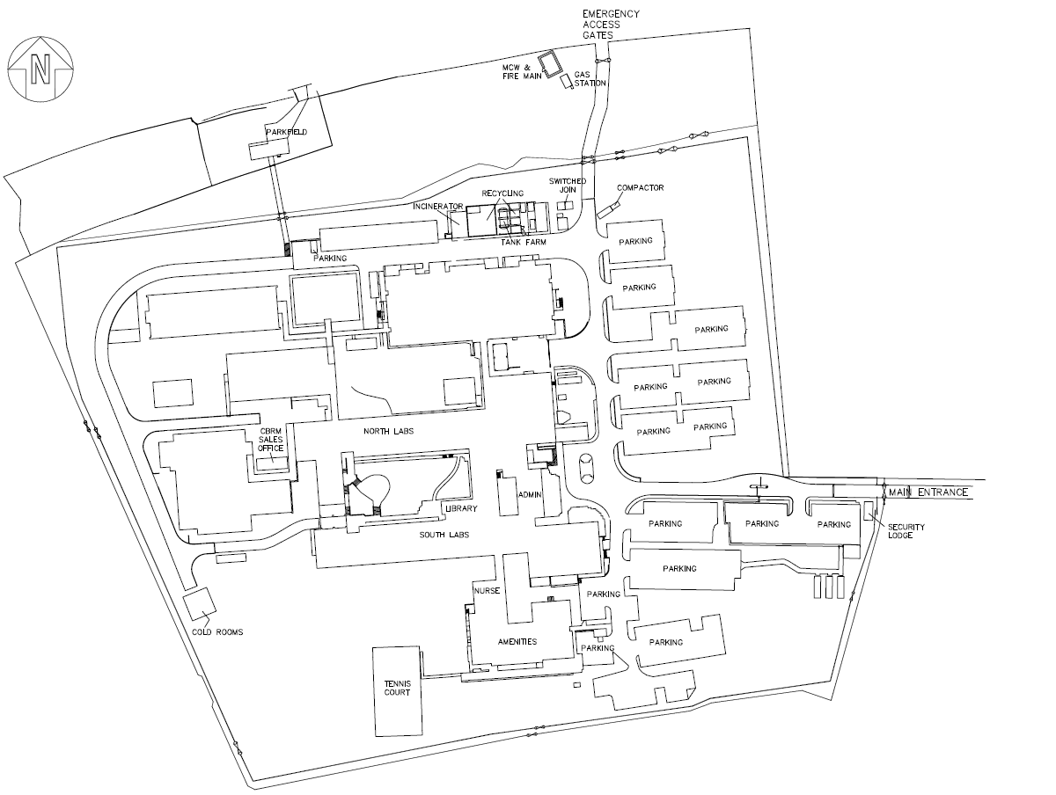
Figure 1
Library Quad Garden
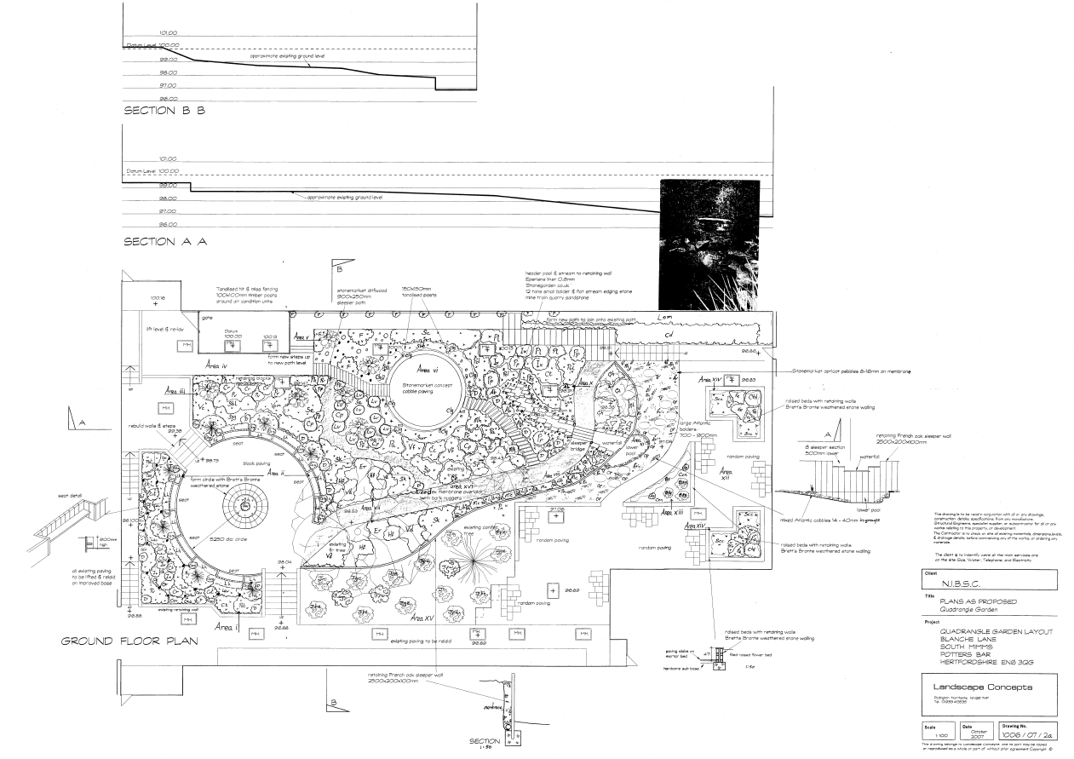
Ground Level Lower Pond Wall
Waterfall
Rose seating area walls
Upper Pond
Lower Pond
Concrete Sleeper Bridge over stream
Sleeper retaining wall
Woodchip path
Figure 2

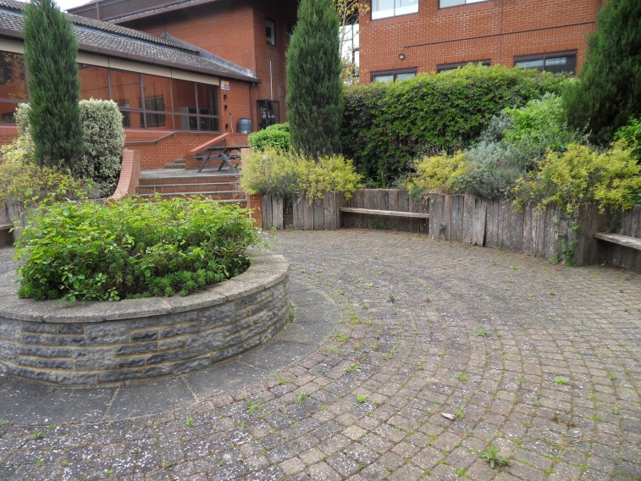
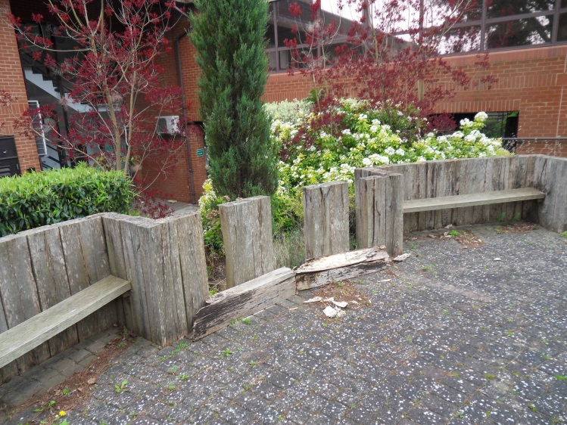
Rose Seating Area
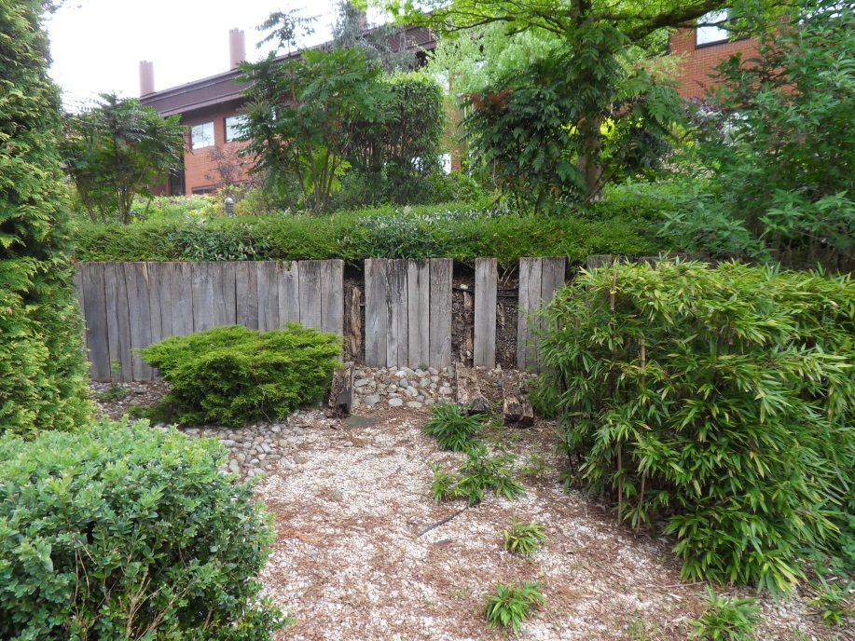
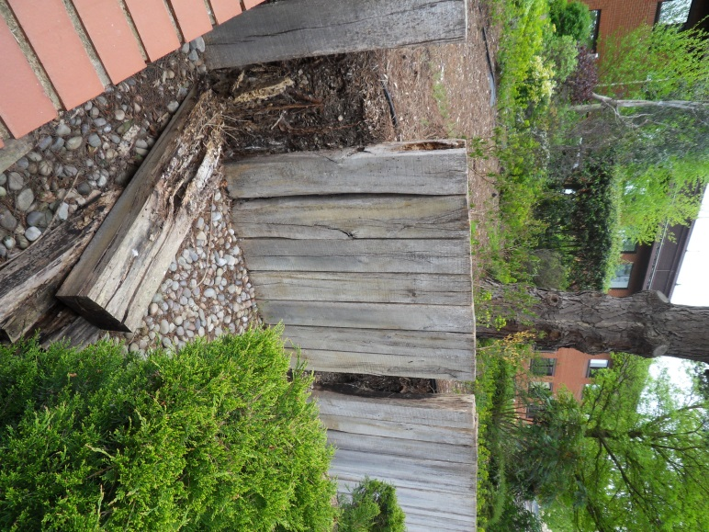
Sleeper Retaining Wall
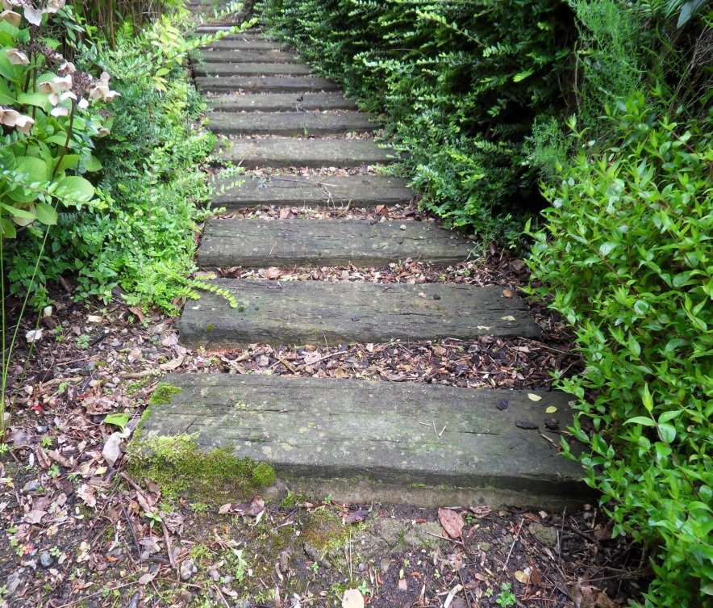
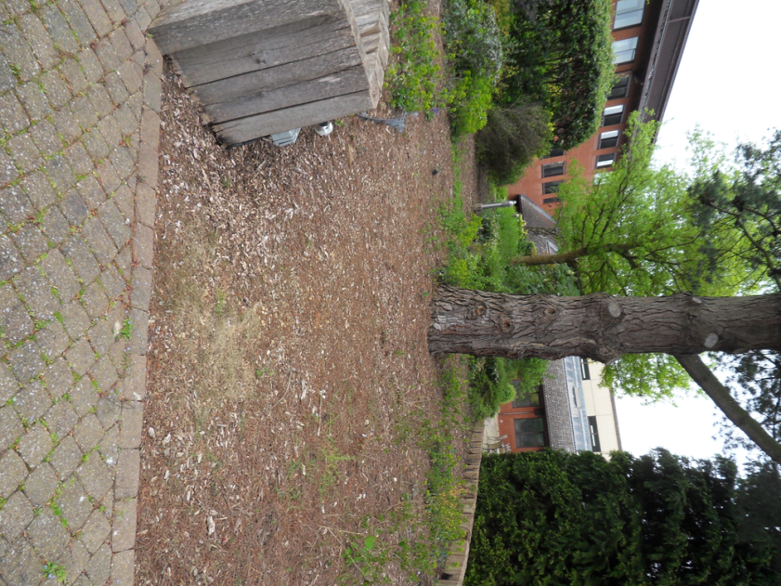
Woodchip path from Rose Seating Area to Upper Pond
Start of watering system (requires new replacement hosing and attachments)
Wood-effect concrete sleeper paved path
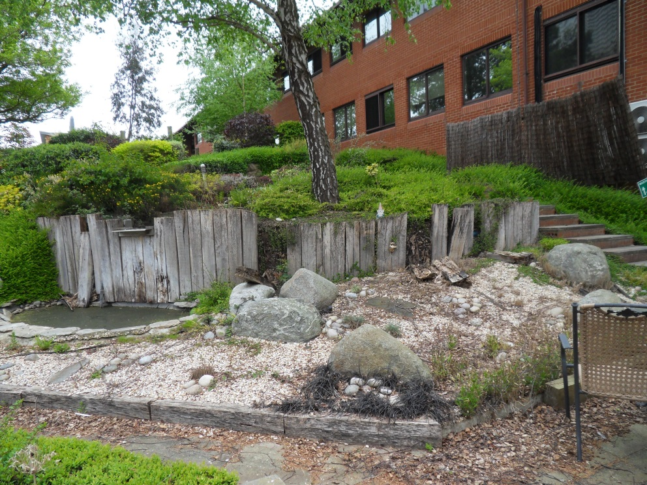
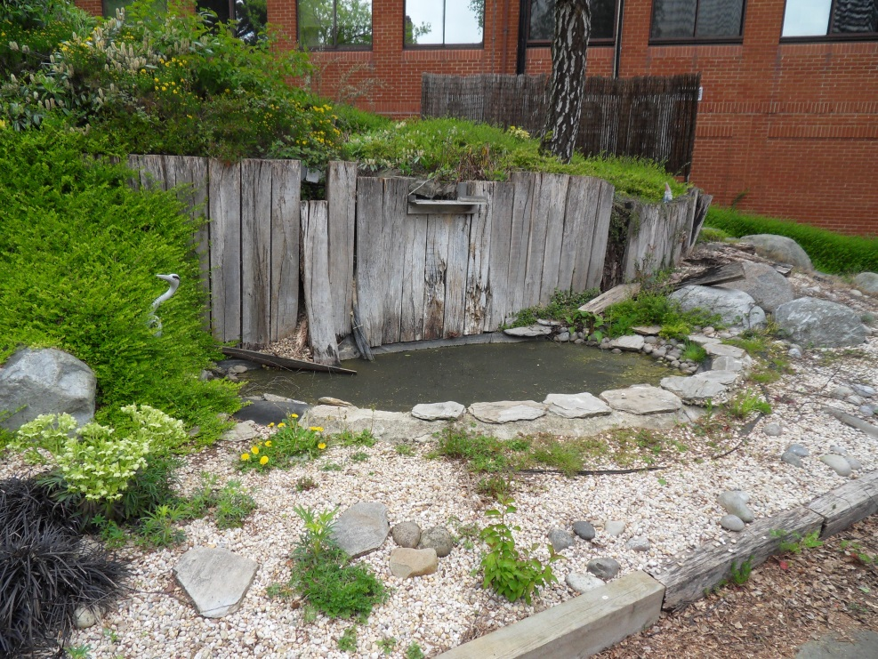
Lower Pond
Sleeper Retaining Wall
Waterfall

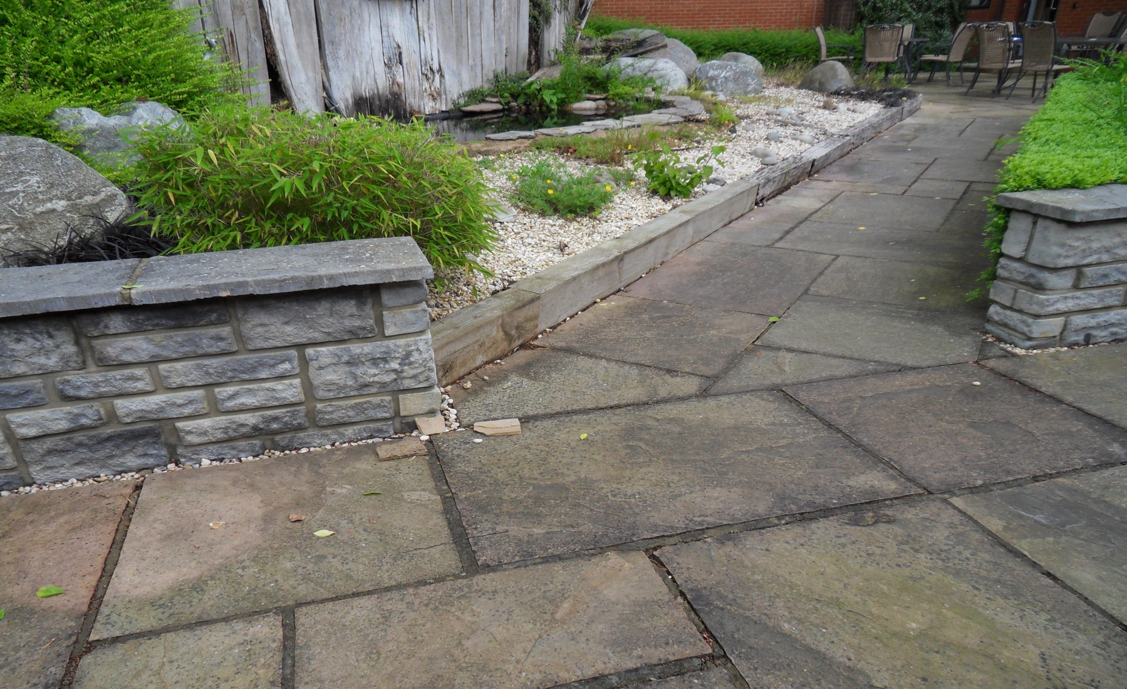
Decorative grey stonework
Ground Level Lower Pond Walls
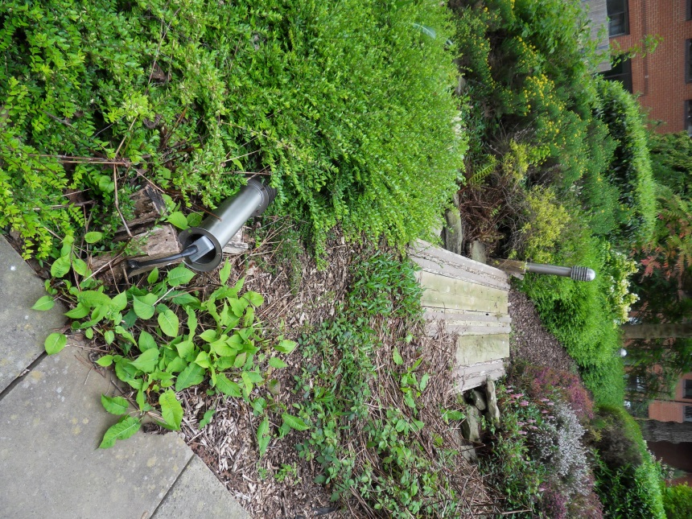
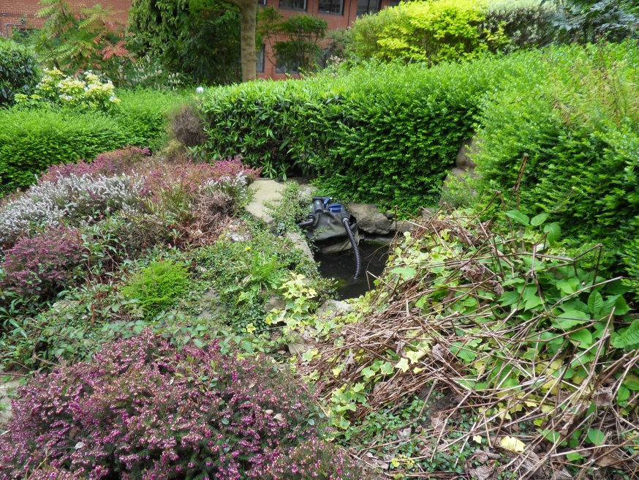
Path Lighting and Perished Bollard
Upper Pond & Filter with UV Lighting
Wood-chip path from Rose Seating Area & Sleeper Bridge
Stream to Waterfall
Lower Pond

