**GREAT CORNARD PARISH COUNCIL**

**Invitation to Tender**

**Tender Specifications:** **Great Cornard – Allotment Car Park Resurfacing**

**Introduction**

The Parish Council owns Great Cornard Allotments which provide just under 100 plots to local residents. The Allotments are currently served by an unmade parking area which is difficult for disabled visitors and all other users, including vehicles, to negotiate safely. As the Allotments are adjacent to the Country Park, the parking area is well used and because of it’s narrow width, vehicles sometimes have to turn numerous times in order to get in and out of spaces which can churn up the surface and create pot holes. The Parish Council has recently refurbished the sports pavilion and external toilets at Blackhouse Lane, which are in close proximity to the Allotments, and resurfacing the Allotment car park will further enhance the local area and facilities for residents, whilst creating a safer surface for all users of the Allotments and Country Park.

The Parish Council is looking to create a safe, tarmacked parking area with marked out bays and allocated accessible spaces and install a designated walkway for pedestrians’ safety. The area at the entrance gate to the Country Park is a pinch point for users so it is also intended to create a hoggin path to allow safe access. A French drain will also be installed to assist with drainage.

**The Site and Access**

The Great Cornard Allotments are located on Blackhouse Lane, close to the junction with Wells Hall Road. Blackhouse Lane is a single lane road with residential dwellings and farm buildings running the length of the road. Access is from either Wells Hall Road or Bures Road (B158), although Contractors may need to make use of the car park facilities at the Country Park.

The map below shows the car park and vehicle access point from Blackhouse Lane, running adjacent to the Allotment Gardens.

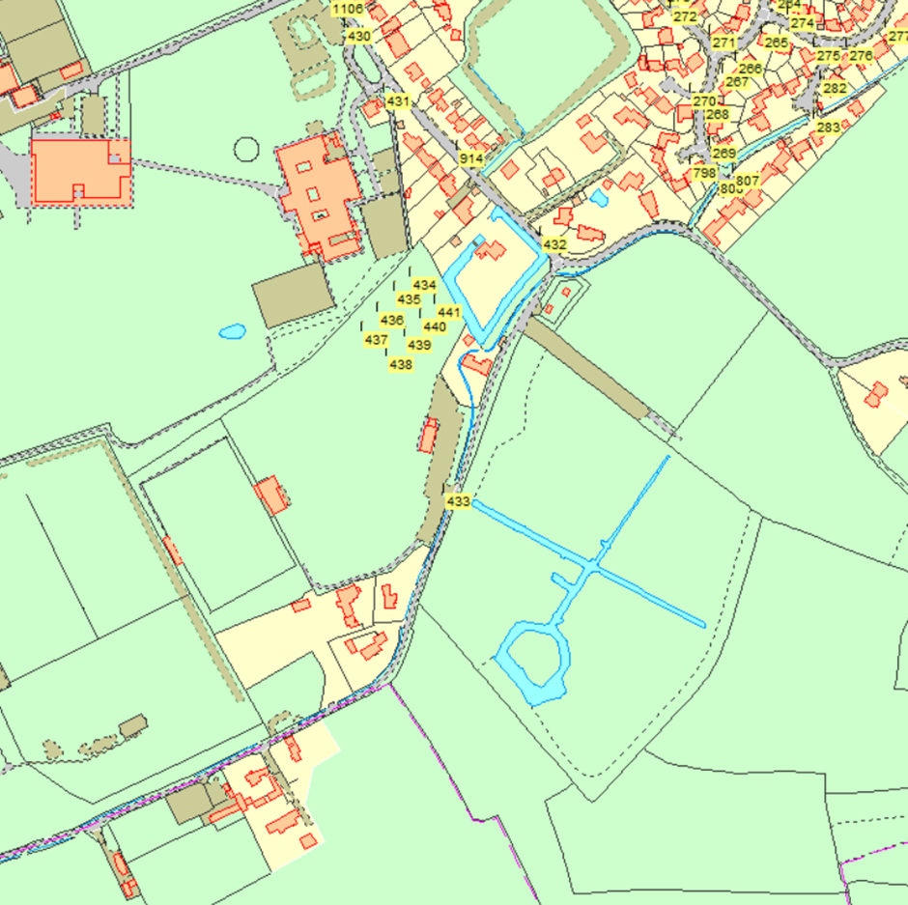

**Location Address: The Allotment Car Park, Blackhouse Lane, Great Cornard, Sudbury, Suffolk, CO10 0NL**

**TENDER TIMETABLE**

|  |  |
| --- | --- |
| **ACTION** | **TIMETABLE** |
| Tender publication | 23rd August 2022 |
| Deadline for Tender Returns | 7th September 2022 |
| Contract offer subject to outcome of grant submission to Principle Authority | 16th September 2022 |
| Commence installation on site | To be discussed with the successful Tenderer |

**Procurement Process**

All bids will be considered in conjunction with the Parish Council’s Standing Orders, Financial Regulations and Procurement Policy. Each bid will be marked against the Council’s Assessment Criteria which accompanies the Invitation to Tender.

Unsuccessful bidders will be notified as soon as possible and provided with feedback on their submission, after the successful bidder has been awarded the contract.

Details of the successful bid, including the contract value, will be shared on the Contracts Finder website once the contract has been awarded.

**Pricing**

All prices should be shown in line with the Tender Specification.

All pricing should be exclusive of VAT and valid for a period of at least **3 months** from the due date for the response.

Prices will be fixed and firm for the duration of the contract.

**Contract Conditions**

The successful contractor will enter a contract by way of tender/quote issued to Great Cornard Parish Council.

The contractor is responsible for complying with any British or European Standards that are relevant to the project. If there is evidence that the work does not conform to the required standard, and as a result the materials or workmanship are substandard or require replacement or repair, this will be completed at the cost of the contractor. The Contractor must follow the Design and Management Regulations 2015, and will have the skills, knowledge and experience necessary to fulfil the role that they are appointed to undertake, in a manner that secures the health and safety of any person affected by the project.

The successful contractor must provide evidence of Public Liability Insurance of no less than £5 million, and Employers Liability Insurance, to the Parish Council within the tender response.

Confirmation of work hours, storage of materials, access, location of skips etc. a final programme of works and risk assessment/method statements will need to be finalised and provided to the Parish Council before works begin on site.

The area will be closed to allow for these works to be completed but during installation the contractor will need to keep access points clear of equipment and provide suitable HERAS fencing and safety notices around the construction site.

On completion of the project, any areas that have been damaged during the installation such as fences and gates must be returned to the original condition at the contractor’s expense.

**Award Criteria and Evaluation Criteria**

Any contract(s) awarded because of this procurement will be awarded based on the offer that is most advantageous to the Parish Council.

All tenderers shall provide information which demonstrates their understanding of, and ability to meet, the specification. Unclear tenders may be discounted in evaluation. The Parish Council reserves to right to seek clarification.

**Tender Assessment Criteria**

|  |  |
| --- | --- |
| **Category** | **Weighting** |
| Value/ Quantity for Money | 70% |
| Materials | 15% |
| Warranties and References | 5% |
| Experience and Previous Work Examples | 5% |
| Health and Safety and Sustainability | 5% |
| **Total** | **100%** |

**GREAT CORNARD PARISH COUNCIL**

**TENDER SPECIFICATION**

**INCLUDING DRAINAGE SOLUTION FOR THE**

**GREAT CORNARD ALLOTMENT CAR PARK**

**Car Park Preparation**

Remove the existing hard standing and vegetation from both sides of the car park to achieve maximum width of 10m (approximate length 118m). All appropriate waste certificates must be supplied.

**Car Park (area approximately 1180sqm)**

Install 150 x 50 flat top, concrete set, kerb edges to the perimeter of the car park (approximately 10 x 118 m)

Excavate a 118m long trench for the installation of a French Drain/land drain next to the car park boundary and kerb edge. Remove waste from site

Install a geotextile membrane and 100mm perforated pipe to the excavated trench and surround in 20mm of stone

Grade level and compact the sub-base

Lay tarmac planings where necessary, adjusting levels to assist with taking water to the French Drain

Lay 60mm of AC20 Open Binder to the prepared area

Surface the base course with 40mm Stone Mastic Asphalt 10 Surface

Install individual designated parking bays with thermoplastic white lines including two disabled bays (The parking bays should be of sufficient size to accommodate modern motor vehicles)

Install a pedestrian walkway along the entire length of the car park with thermoplastic white lines

**Hoggin Footpath (area approximately 4.5m x 25m)**

Excavate for the installation of flat top kerb edges to the border. Remove waste from site

Install flat top, concrete set, kerb edges to the border

Excavate grass area to a depth of 200mm within the area 4.5m x 25m and remove from site

Lay 150mm of Type 1 crushed concrete to the excavated area

Lay 50mm of Hoggin to the prepared sub-base

**Tenderers are invited to submit costings for the above.**

A site visit will be necessary in order to fully appreciate the site specific conditions and works required. Tenderers are welcome to visit the site at any time.

**Materials**

The Parish council is looking for longevity and minimal maintenance with low, or ideally no cost in the future.

Contractors shall clearly identify the construction material for each element and provide an outline of the life expectance of each material.

Post installation inspection – please allow for an independent written inspection report following completion of the works and any noted defects/risks will need to attended to and resolved immediately.

**Warranty**

Outline clearly what is covered in the warranty, and the length of warranty for each material type. Please ensure items with no warranty are also outlined.

**Installation**

Provide a robust statement for the installation. This should include how you will ensure that the installation will always be compliant with health and safety regulations to ensure the public and workforce safety throughout the term of the project.

**Sustainability**

The tenderer must supply information about methods used to reduce environmental footprint in all aspects of the production, supply, transportation and installation of equipment.

The tenderer must also supply details of how the site waste will be disposed of, whether landfill or recycled. All appropriate waste certificates must be supplied.

**Health and Safety**

The successful company will be required to submit all relevant Methodologies and Risk Assessments before any work commences.

All relevant liability insurance certificates must be provided before any work commences.

**References**

Please provide details of at least one similar project that you have successfully carried out for local authority or private sector clients. For each project please give:

1. Name and address of the project
2. Name, address, telephone number and email address of the client officer or principle contact
3. Description of the Scope of Services
4. Approximate value of the contract

**Format for Response**

Tenders are to be submitted in writing in a sealed envelope addressed to the Council Manager at the address shown below. Tenders may be sent electronically and will be kept in a secured folder.

**Contact Details**

Any questions relating to the tender, or to a arrange a site visit, should be directed to

Mrs Nadine Tamlyn, The Council Manager on 01787 373212 or email.

[councilmanager@greatcornardpc.co.uk](mailto:councilmanager@greatcornardpc.co.uk).

The Council Manager

Great Cornard Parish Council

The Stevenson Centre

Great Cornard

Sudbury

Suffolk

CO10 0WD