**Ideas for possible Haverhill Town Centre Lighting Attraction**

Lighting up trees


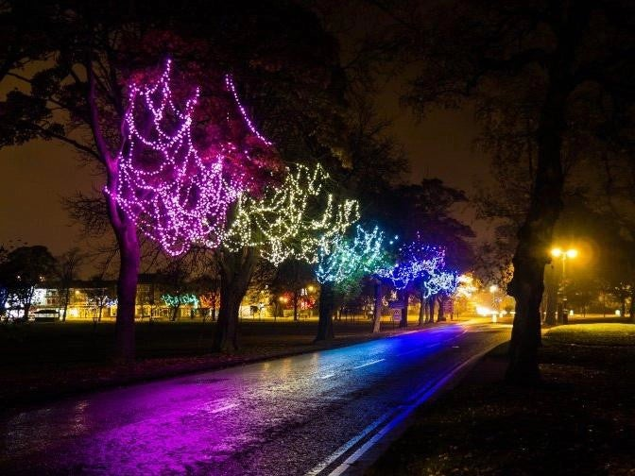

**Images from previous years lighting schemes**

Christmas Tree 2020 Merry Christmas from Haverhill

Haverhill Arts Centre Light Curtains