**ANNEX 1**

**Map 1 – Berry Hill**

a. Recreation/play area both side of fence Crowash b. Amenity grass land at Kells Meend

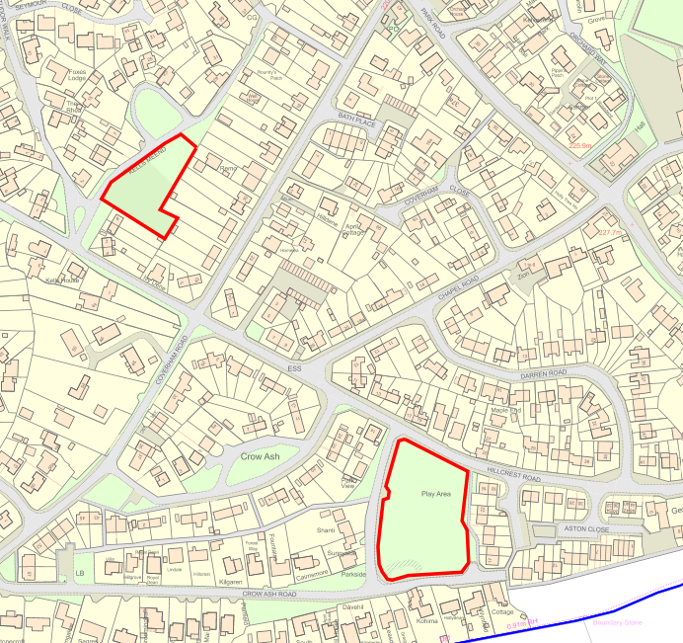

**b**

**a**

**2. BREAM**

Highbury Road verges, Cenotaph & verge outside school fence, High Street

**c**

**b**

**St James Church**

**3. Edge End**

a. Recreation Ground

**4. Parkend**

a. St Pauls closed churchyard

**5. Sling**

a. Play Park off March Way b. Footpath Marsh Way to Parkend Walk c. Bus stop Clements End Road, Sling

d. Scarr Bandstand, off B4228 (Four cuts per annum – April to October)

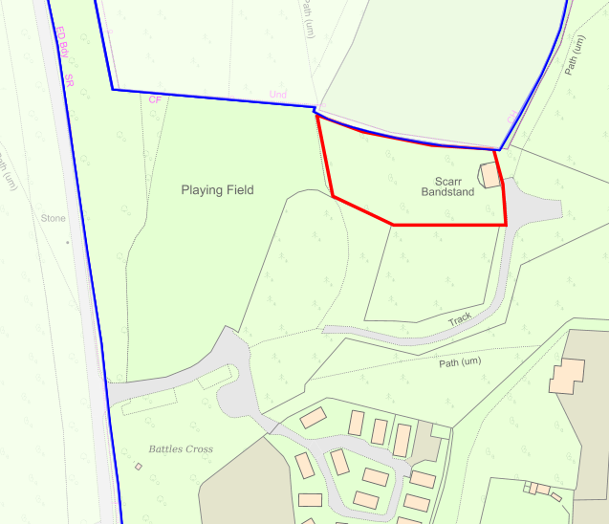

**Map 7 – Whitecroft**

a. Parkhill noticeboard area b.

**b**

**a**