Newborough and Borough Fen Parish Council
Clerk: Irene Healiss
5 Blenheim Road, Ramsey, PE261AL
07388584591
clerk@newboroughandboroughfen-pc.gov.uk
Tendering for Fernie Close Project -Supporting Statement
Newborough and Borough Fen Parish Council are in the process of renovating its playing field in Fernie Close, Newborough, Cambridgeshire. Newborough is a medium sized Village with a population of 1475 residents, together with Borough Fen. Following a period of consultation, the young people from the village have prioritised the equipment listed below. We invite you to tender a quotation for the supply and installation of the equipment listed in the brief.
Your tender should include: -
- The items of equipment described and shown below or equipment you supply to the same specifications.
- The price of Individual pieces of equipment.
- Installation cost
- Time frame from starting installation to completion
- Lead time from tender acceptance to project commencement
- Safety and security of the site during works
- Cost of installing “Grass Form” or similar ground cover over a suitable area around individual or grouped equipment
- Details of warranty for each piece or collection of supplied equipment
- Details of service schedules or requirements to validate warranty including relevant terms and conditions of warranty for all or individual pieces of equipment
- Life expectancy of the equipment in all categories
- Evidence of at least three other installations that have been done within 20-mile radius that can be inspected and testimonies sought.
In addition, you are required to supply: -
- Evidence of VAT registration
- Copy of third-party insurance liability
- Copy of risk assessment of prospective works
- Copy of risk assessment regarding equipment use
- Copy of COSHH assessment for the prospective works
- Waste Management Licence
All tender applicants are invited to view the prospective location of the works to carry out a survey. Please contact the Clerk by email as listed below. There is sufficient access to the field for plant and machinery. However, personal viewing is recommended.
Any further clarification of the required works can be obtained by contacting the Clerk in the first instance.
All tenders are required to be submitted to the Parish Clerk by Friday 4th September 2020 at the address below. Tenders are to be posted in sealed envelopes (not emailed please) in order to comply with the Parish Council financial regulations. The tenders will be opened and then discussed at the arranged Parish Council Meeting on Monday 7th September 2020 commencing at 7.15pm.
If guidance is required, a copy of Parish Council Financial Regulations are available at:-https://newboroughandboroughfenpc.org.uk/
The lead manager for the project is Mrs Irene Healiss (Parish Clerk)
Address:-
5 Blenheim Road, Ramsey PE261AL
Email: clerk@newboroughandboroughfen-pc.gov.uk
Mob: 07388584591
Access to the site
The playing field has access from a road. The village is on the edge of the fens and therefore is subject to land movement. It is essential that, should you wish to tender for the project, you make an appointment to survey the field before submission to ensure accuracy and appropriate installation procedures are employed and access is suitable for your plant and machinery. For information, the playing field is 1.95 acres in size.
Equipment
It is recognised that it may not be possible for individual companies to supply all the equipment range. Should this be the case please quote for what you can supply and install.
The product ranges offered by varying companies also may differ in style and size. It is requested that each item of equipment quoted for carries an adequate description, catalogue number and image.
The equipment listing in this information document will be in five categories.
- Play equipment
- Exercise equipment
- Recreation
- Seating
- Shelters

(All images are for guidance only – please see below)
Should you require further information please do not hesitate to contact the Clerk of the Council.
The tenders will be judged upon the “value for money” criteria and not acceptance of the cheapest. Considered criteria will be: -
- Cost of supply and installation of the play equipment
- Ongoing maintenance costs
- Length of warranty and warranty conditions
- Understanding of the nature of Fen geographical characteristics for installation and long-term utilisation
- Service requirements
- Installation schedules
- Lead in times
- Testimonies
- Equipment proposed in the tender matches closely to the items listed below.

Disabled access
The Disability Discrimination Act requires reasonable provision for those with disabilities. This means that not only should gates be suitable for wheelchairs but also that these should be able to get to the play area unhindered (ie hard standing paths etc)
The Disability Discrimination Act has made it illegal to treat disabled persons less favourably since December 1996. The Act came into full force from October 2004and has been largely supplemented by the Equality Act 2010.
The Equality Act requires reasonable provision to be made for equal opportunities for disabled people except where it affects the safety of others. The Act also applies to places where children play (play areas, games area etc). It is illegal to treat disabled persons any less favourably than non-disabled persons. With this in mind, please confirm that equipment items 1,2 and 3 are considered as suitable for dual use.
Play Equipment
- Basket swing with a two-seat flat swing extension and a steel frame.
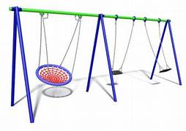
- Surf Rider.
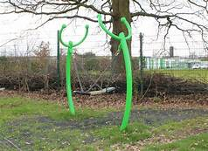

- Rocking Swing with a steel frame.
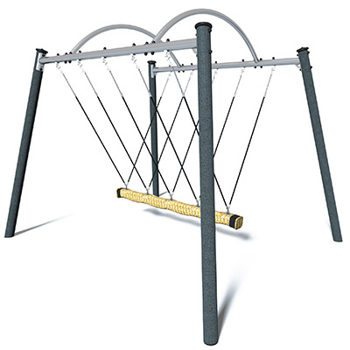
Exercise Equipment
- Crazy bars/Monkey bars, steel construction.
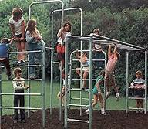
- Climbing Wall with net, steel construction.
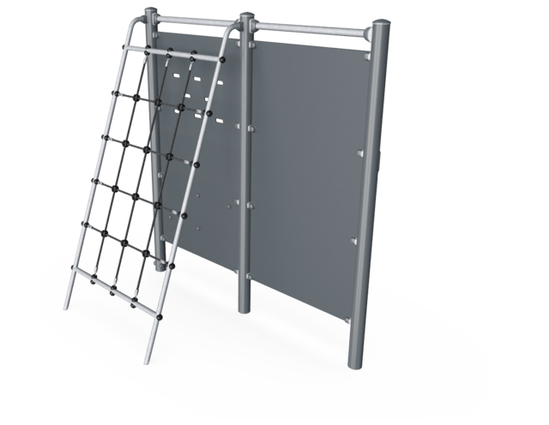
- Free Runner, steel construction. Please quote for a single and double version.
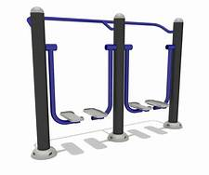
Recreational
- 3 x Steel (steel and composite) construction picnic tables. Suitable for wheelchair use.
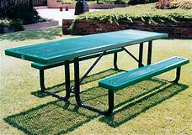

Seating
- 4 x Steel (steel/composite) construction park type benches with backs.
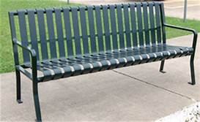

Youth Shelters
- Steel and composite youth shelter, with two to three sides filled in but an open front. Must have seating incorporated. Optional tabletops. Suitable for up to 10 youths.
