**STRATTON ST MARGARET PARISH COUNCIL**

Please contact callam.greenwood@strattonstmargaret.gov.uk to arrange a site visit or ask any questions

**Add additional equipment to complement existing at Stephens Roads**

**Location:**

Stephens Road Play Park

Stephens Road

Swindon

SN34DN

**Budget:** Up to but not exceeding £70,000 (excl VAT)

**Usage:**

Play park/ recreational ground.

Dog park

**Site size:**

237.44 m

(779.00 ft)

**Obstructions:**

Fence on west side of park separating play park from dog park

Heavily wooded/ fenced area on the south border separating park from river

Fence on the east side of park separating play park from Oxford Road

Top area of site is sloped, area surrounding existing equipment is flat

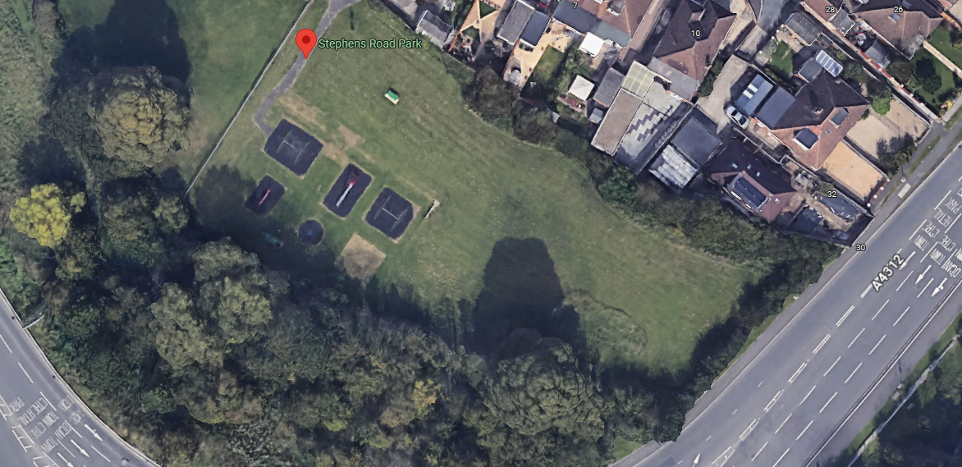

View of Stephens Road park

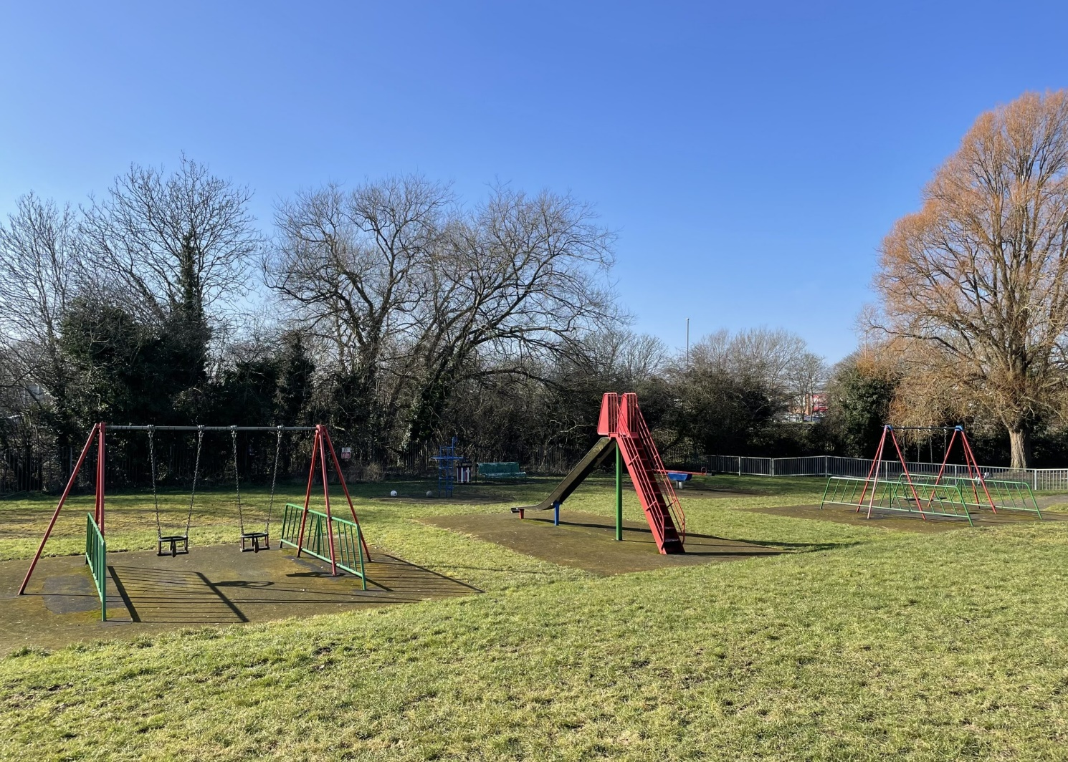

Existing play park equipment

**Existing equipment:**

* Slide
* Dual toddler swing
* Dual Junior swing
* Small climbing tower
* Seesaw

**Age range for new equipment:**

* Toddler area
* Junior area