Condition report of two 19th century account books RAIL 860/1 and RAIL 860/2

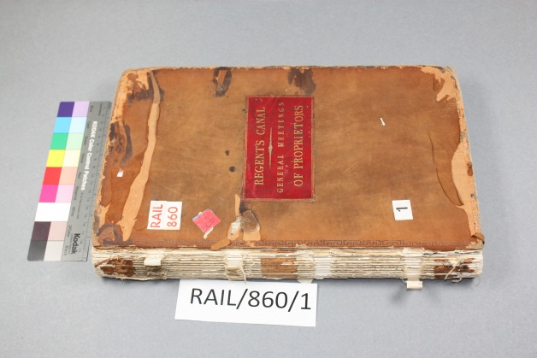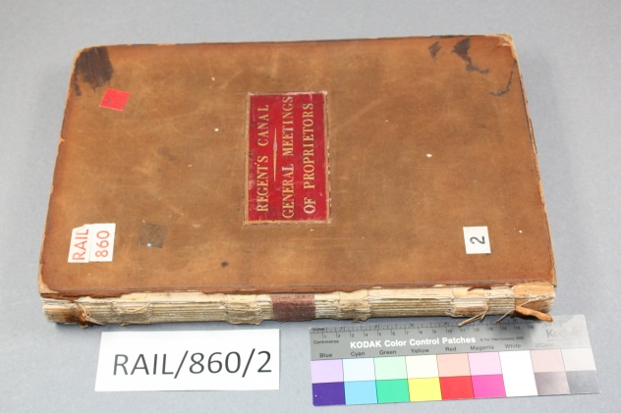

Reference: RAIL 860/1 and RAIL 860/2
Format: Tight-back/Account book
Dimensions: (text block):368(H) x 235(W) x22(D) mm
Dimensions: (boards): 375(H) x 238(W) x30(D) mm
Date examined: 01/03/2014

Description of the series: Records of the pre-nationalisation railway companies, pre-nationalisation canal and related companies, the London Passenger Transport Board, and successors. Minutes of the Regents canal company 1812-1930.
There are 88 volumes in this series.

Treatment objective: This is a condition report for two volumes in the RAIL 860 series, RAIL 860/1 and RAIL 860/2. Their current condition allows them to be produced normally in the reading room; however, it is felt that their physical stability is compromised by continued access without conservation treatment. The main aim of the treatment is to stabilise both bindings while preserving as many of the original structural and decorative features as possible i.e. reattach original boards and reinforce sewing and supports.

General description of RAIL860/1 and RAIL860/2
Binding: Both volumes are account books bound in the tight-back style. Their covering material is tanned reversed calf leather with blind-tooling on the outer edge on the front and back boards of both volumes, but they differ in style. The front covers have a red leather label bearing the title "Regent's Canal general meetings of proprietors".

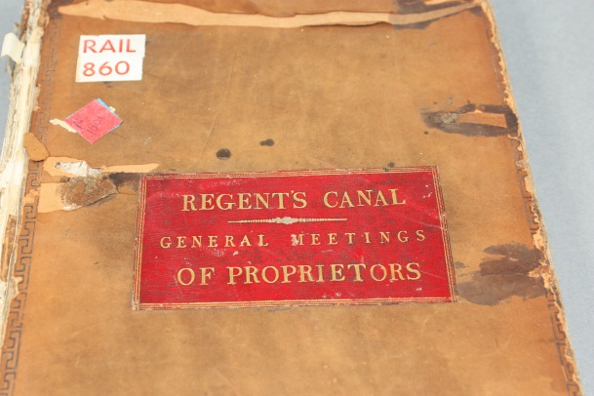

Text block description: The primary support is machine made laid paper of medium weight, off-white colour and rough surface. Each page has a watermark of a crowned shield with Fleur de Lys, bearing the letters TW underneath. The text block is made up of ten sections (5 folios) sewn all along with thick unwaxed linen thread (5 cord) on four vellum sewing supports.
The edges of the text block are cut and regular. Both volumes have blue marbled paper endleaves with a blue cloth joint on front and back covers. ". Inside the front covers of both volumes is a binder's ticket (Rowsell stationer No.31 Cheapside, London).

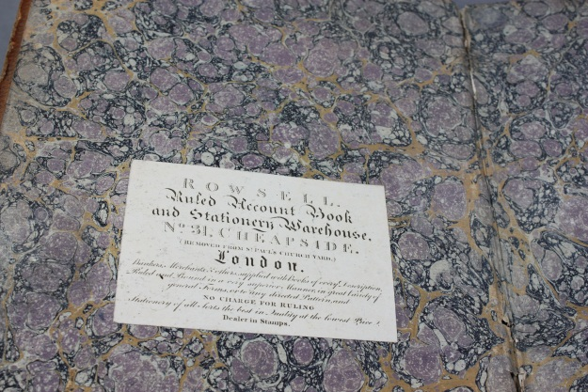

Cover attachment: Four vellum sewing supports pasted between the split cover boards.

Condition Report RAIL 860/1
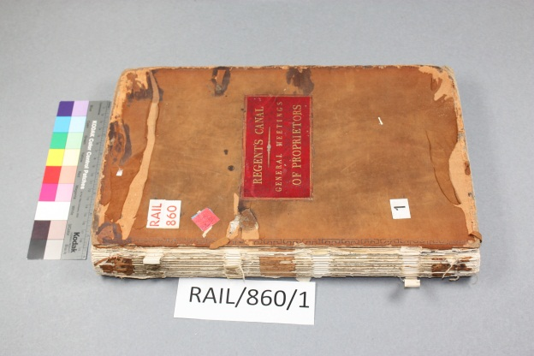

Covers/Binding: The front board is detached from the text block due to the split vellum sewing supports. The back board is partially detached (three split supports and one intact). Both boards are intact but delaminating at the corners, possibly due to impact damage. The covering leather is stained, torn and abraded in places. The spine leather is missing, apart from fragments where the leather was turned in. The blind tooling finishing on the outer edges of the boards is intact apart from where there are areas of loss in the leather.
╦╦╦╦ Detail of finishing

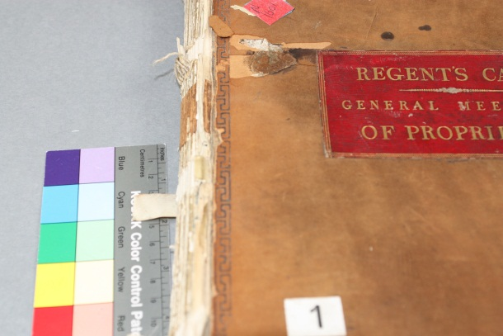

Sewing: The ten sections of five folios are sewn all along onto four vellum supports with thick unwaxed linen thread of 5 cord thickness.
The sewing supports are intact apart from three split and one remaining support attached to the split cover boards. The sewing is broken at the first section.
Text block: The paper support is in good condition apart from minor surface dirt mainly around the outer edges of each page. The text block has suffered some impact damage mainly head and tail of the spine area, possibly due to the missing covering leather. The spine is rounded and has a layer of animal glue. There is reversed leather head and tail showing the turn-ins and one brown leather clothing. The joint has split between the
endleaves and the first and last sections. The sewing is split throughout mainly from the two lower supports and the kettle stitch.

Condition report RAIL 860/2
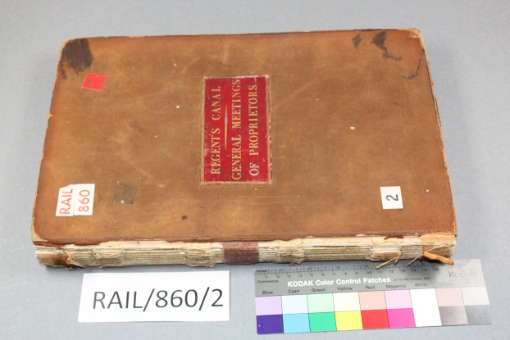

Covers/Binding: The boards remain intact. Both boards are intact but delaminating at the corners, possibly due to impact damage. The covering leather is stained, torn and abraded in places. The spine leather is missing, apart from fragments where the leather was
turned-in. The blind tooling finishing on the outer edges of the boards is intact apart from where there are areas of loss in the leather.
ǁ Detail of finishing
Sewing: The ten sections of five folios are sewn all along onto four vellum supports with thick unwaxed linen thread (5 cord). The sewing supports are intact apart from two split and two remain attached to the split cover boards. The sewing is broken at first two sections. The sewing is also split mainly from the endleaves to five sections down on the tail end sewing support and the kettle stitch.
Text block: The paper support is in good condition apart from minor surface dirt mainly around the outer edges of each page. The text block has suffered some impact damage mainly to the spine corners, possibly due to the missing covering leather. The joint has split between the end leaves and the first and last sections. The spine is flat and has a layer of animal glue. There is reversed leather head and tail showing the turn-ins and one brown cloth clothing.

Proposed treatment
The treatment will be both practical and preventative with the aim of improving the stability and increasing the accessibility of both volumes. All materials used are of archival quality and treatments are completely reversible.

Documentation: Photographs will be taken at three stages of the treatment, before, during and after treatment. Each of the volumes condition, treatment and materials used will be recorded in the departmental documentation database for future reference.

Treatment:
- The first stage of the treatment requires the mechanical dry cleaning of the text block mainly around the outer edge of each page with a smoke sponge and soft Japanese brush, removing the surface dirt.
- The original sewing and supports can be reinforced where split, using archival cotton tape fed behind the original vellum supports. The sewing will be around the original sewing supports holding the new tape in place. These reinforced sewing supports can be pasted to the boards using 20% shoufu wheat starch paste. All along stitches with 16/5 linen thread will imitate the original sewing and the original linen thread will remain insitu.
- The joint between the end leaves and the first and last sections requires a strip of Japanese paper to repair and attach to the text block. The adhesive will be 20% shoufu wheat starch paste.
- The original leather will be consolidated with 3% Klucel G /propan-2-ol. Consolidation will strengthen the leather in the weakened areas. Consolidate on the verso to prevent staining. Only one layer may be required.
- Line the spine with Japanese paper (Minogami Usukushi 23gsm) and 20% shoufu wheat starch paste.
- Pare the leather on the reversed side (the inner side of the skin facing outward).
- Dye if required, with sellaset dyes from the Leather conservation centre.
- Lift the original leather on the spine edge on front and back boards of both volumes. Sand the boards to help reduce the bulk when adding the new leather.
- Paste the new leather with 20% shoufu wheat starch paste and attach to the boards. Re-paste the original leather to the new leather and boards.
- An alternative repair of the spine is using toned Japanese papers layered to imitate the leather.
- Repair the delaminating corners with Japanese papers and shoufu wheat starch paste. Cover missing areas with toned Japanese paper.
- Each volume can be enclosed in a four-flap enclosure and returned to the box with the remaining three volumes.

Suggested materials
Smoke sponges (x2)
5 cord unwaxed linen thread
Archival cotton tape
Japanese papers ( x2 sheets)
Grey archival cover paper (x2 sheets)
Shoufu wheat starch paste (100gm)
Klucel G (x3gm)
Propan-2-ol (x 200ml)
Leather (x half a skin)

Planned resources
- 2 smoke sponges PEL smoke sponge /code 961-1002 @ £1.95 per sponge. £1.95 x 2= £3.90
- Japanese papers- Minogami Usukuchi No.3 25gsm K36 PAJAPK0036 CxD Paper Nao (£9.32 x 100) 2 sheets = 18p
- Klucel G – Conservation Resources Ltd – 1Kg @ £81.60 existing supply in department should be adequate as only small areas of the original leather requires consolidation.
- Propane-2-ol 99.5% 2.5 litre bottles. Laboratory reagent grade Fisher Chemical P/7490/17 (£23.88 x1) existing supply in department should be adequate as only small areas of the original leather require consolidation.
Shoufu wheat starch paste 500gm – Conservation by design £10.50 per bag - 100gm £2.10
- At least 1 sheet per volume of grey archival cover paper if 4-flap enclosure is required. Grey archival cover paper CxD PAAKNG0350 (£2.46 per sheet X2 £4.92)
- Grade 2 calf leather Hewitt and sons £162 (£192.40 Inc VAT) - existing supply in department should be adequate as only small amount required to replace the spine piece (half a skin = £96.20).
Cost of materials: Total £107.30

Health and safety risks
- Due to the surface dirt, mechanical cleaning can be carried out in the fume cabinet. Masks and gloves can be used if necessary. These can be found in the dry laboratory within collection care.
- A COSH form exists for both Klucel G and Propane-2-ol. They are not considered hazardous but application should be carried out in a fume cabinet if dissolved in a solvent.
Klucel G (adhesive or consolidant) has a hazard rating 1 and a risk rating A-3.
Propan-2-ol (Use as a solvent e.g. adhesive, consolidant) has a hazard rating 2 and a risk rating A-6.

Time estimates RAIL 860/1
Procedure | Time (day) | Time (hours) | Cost
Mechanical dry cleaning | 1 | 5.5
Re-inforce sewing | 1 | 5.5
Re-attach original boards | 0.5 | 3
Pare and dye leather | 0.5 | 3
New spine piece | 0.5 | 3
Repair to cover | 2 | 11
Total | 5.5 days | 31hrs x 16.5ph | £511.50

Time estimates RAIL 860/2
Procedure | Time (day) | Time (hours) | Cost for work
Mechanical dry cleaning | 1 | 5.5
Re-inforce sewing | 1 | 5.5
Re-attach original boards | 0.5 | 3
Pare and dye leather | 0.5 | 3
New spine piece | 0.5 | 3
Repair to cover | 2 | 11
Total | 5.5 days | 31hrs x 16.5ph | £511.50

Cost for treatment of two volumes =£1023
Cost of materials = £107.30
Total = £1130.30

