|  |
| --- |
| Name of Applicant: |

This document must be completed and returned in the published format. Failure to comply with this instruction may result in your submission being rejected.

# **General Information**

## Procurement Procedure

The Town Council is inviting companies to submit responses to its Invitation to Tender for the re-tarmac of a path at Flood Meadows, Alton GU34 1HE commencing at the entrance from Tanhouse Lane.

The current tarmac path is approximately 156m x 1.2m and new kerb edgings are also required along the entire length approx.

There are two “junctions” which also require tarmac where the path turns onto a gravel walkway; there is currently no tarmac in these areas, just a coarse gravel surface.

Responses to the Invitation to Tender are requested as per the following, and pricing must include edgings installed to both sides and a finish that is flush to the newly laid path. All surplus materials are to be removed from site.

Tenderers are asked to note the following points:

1. A site visit is required to ensure that tenderers take their own accurate measurements
2. Some photographs are attached at the end of this document but it should be noted that these are for illustrative purposes only and should not be viewed in any way as the basis upon which you should submit your response.
3. The easiest access point would be at the end of Tanhouse Lane (GU34 1HR) and there is a small car park at the end of the lane which will lead you straight into Flood Meadows.
4. We can arrange for a site meeting if you wish.
5. At first junction with riverside path there are a number of tree-roots visible and a short length of piping (broken one end) which looks obsolete
6. At second junction, on the main footpath is a large manhole cover which protrudes above the level of the path.
7. At both junctions there is a coarse surface laid by a previous contractor, which needs to be integrated smoothly with the new surface on the main footpath.

## Procurement Timetable

The Authority proposes the following timetable for the award of the Contract:

|  |  |
| --- | --- |
| **Procurement Stage** | **Dates** |
| Publication of advertisement | 1st February 2023 |
| Clarification questions to be submitted by | 20th February 2023 |
| Clarification responses to be issued by | 28th February 2023 |
| Bid Deadline | 10th March 2023 |
| Evaluation | 13th March 2023 |
| Intention to award | 22nd March 2023 |
| Contract start | To be agreed |

The Council reserves the right to change the above timetable and Applicants will be notified accordingly if there is a change.

## Council Representatives

|  |  |
| --- | --- |
| **Authorised Representative contact details:** | **Procurement Representative contact details:** |
| Leah Coney -Town Clerk  Town Hall, Market Square, Alton, Hampshire  GU34 1HD  [townclerk@alton.gov.uk](mailto:townclerk@alton.gov.uk)  01420 83986 | Pat Harris - Finance and Administration Manager  Town Hall, Market Square, Alton, Hampshire  GU34 1HD  [admin@alton.gov.uk](mailto:admin@alton.gov.uk)  01420 83986 |

## Contract Period

The path works must be completed by the end of summer 2023

## Insurance Levels

### Employer’s Liability Insurance

The Council’s minimum requirement for Employer’s Liability Insurance is £10 million

### Professional Indemnity Insurance

The Council’s minimum requirement for Professional Indemnity Insurance is £2 million.

### Public Liability Insurance

The Council’s minimum requirement for Public Liability Insurance is £10 million

# Selection Questionnaire

## 2.Background Information

The Town Council is looking to provide, an aesthetically pleasing, accessible tarmac path with a smooth finish, suitable for all users including those with pushchairs and wheelchairs. Respondents should be working to the specification contained with the Hampshire County Council Footpath Standards (included separately with this document)

**Added Value**

The Applicant will be expected to suggest any added value that their offer might be able to bring to the Council. Applicants are expected to build any such offers into their submissions regardless of whether specific questions are asked along these lines or not.

Applicants’ attention is drawn to the fact that the Council has declared a climate emergency and is therefore keen to ensure the supply chain reduced carbon emissions wherever possible and where such savings can be made, they are evidenced. e.g locally sourced construction materials, recycling of waste matter generated etc..

|  |
| --- |
| Selection Questionnaire |

**Notes for completion**

1. “Council” means the public sector contracting body, that is seeking to invite suitable suppliers to participate in this procurement process.

2. “You”/ “Your” or “Supplier” means the body completing these questions **i.e. the legal entity seeking to be invited to the next stage of the process and responsible for the information provided.** The ‘Supplier’ is intended to cover any economic operator as defined by the Public Contract Regulations 2015 and could be a registered company; charitable organisation; Voluntary Community and Social Enterprise (VCSE); Special Purpose Vehicle; or other form of entity.

3. This Selection Questionnaire has been designed to assess the suitability of a Supplier to deliver the Authority’s contract requirement(s). If you are successful at this stage of the procurement process, you will be selected for the subsequent award stage of the process.

4. Please ensure that all questions are completed in full, and in the format requested. Failure to do so may result in your submission being disqualified. If the question does not apply to you, please state clearly ‘N/A’.

5. Should you need to provide additional Appendices in response to the questions, these should be numbered clearly and listed as part of your declaration. A template for providing additional information is provided at the end of this document.

6. Please return a completed version of this document in accordance with the Submission requirements.

**Verification of Information Provided**

7. Whilst reserving the right to request information at any time throughout the procurement process, the Council may enable the Supplier to self-certify that there are no mandatory/ discretionary grounds for excluding their organisation. When requesting evidence that the supplier can meet the specified requirements (such as the questions in section 7 of this Selection Questionnaire relating to Technical and Professional Ability) the Council may only obtain such evidence after the final tender evaluation decision i.e. from the winning Supplier only.

**Sub-contracting arrangements**

8.The contractor shall not without the Council’s written consent sub-contract the whole or any parts of the works. Such consent shall not be unreasonably delayed or withheld but the contractor shall remain wholly responsible for carrying out and completing the works in all respects. Any sub-contractor’s employment under a sub-contract shall terminate immediately upon the termination for any reason of the contractor’s employment under this contract. The Council will never be liable for any payment which should properly have been paid from the contractor to the sub-contractor

**Variations**

9. Any inconsistency in or between the contract documents, locations plans and schedules of work shall be corrected and any such correction which results in addition, omission or other change shall be treated as a variation.

The Town Council may, without invalidating this contract, issue instructions requiring addition to, or omission from, or other change in the schedule of works or the order or period in which the works are to be carried out. The Council and the contractor shall endeavour to agree a price prior to the contractor carrying out the instruction. Failing any agreement to do so, any instruction issued shall be valued by the Town Council on a fair and reasonable basis using any relevant prices in the priced schedule of works and the valuation shall include any direct loss and/or expense incurred by the contractor due to the regular progress of the works being affected by compliance with the instruction.

If following receipt of an instruction from the Council, the contractor does not comply, the Council may employ and pay another person to execute any work whatsoever which may be necessary to give effect to that instruction. The contractor shall be liable for all additional costs incurred by the Council in connection with such employment and an appropriate deduction shall be made from the contract sum.

**Confidentiality**

10. When providing details of contracts in answering section 6 of this Selection Questionnaire (Technical and Professional Ability), the Supplier agrees to waive any contractual or other confidentiality rights and obligations associated with these contracts.

11. The Council reserves the right to contact the named customer contact in section 6 regarding the contracts included in section 6. The named customer contact does not owe the Council any duty of care or have any legal liability, except for any deceitful or maliciously false statements of fact.

12. The Council confirms that it will keep confidential and will not disclose to any third parties any information obtained from a named customer contact, other than to the Cabinet Office and/or contracting authorities defined by the Public Contract Regulations.

|  |  |  |  |
| --- | --- | --- | --- |
| 1. **Supplier Information** | | | |
| **1.1 Supplier Details** | | **Answer** | |
| Full name of the Supplier completing the Selection Questionnaire | |  | |
| Registered company address | |  | |
| Registered company number | |  | |
| Date of Incorporation | |  | |
| Registered VAT number | |  | |
| Name of parent company (if applicable) | |  | |
| Please mark ‘X’ in the relevant box to indicate your trading status | | 1. a public limited company |  |
| 1. a limited company |  |
| 1. a limited liability partnership |  |
| 1. other partnership |  |
| 1. sole trader |  |
| 1. other (please specify) |  |
| **1.2 Contact Details** | | | |
| Supplier contact details for enquiries about this Selection Questionnaire | | | |
| Name | |  | |
| Postal address | |  | |
| Country | |  | |
| Phone | |  | |
| Mobile | |  | |
| E-mail | |  | |
| 1. **Professional Ability** | | | |
| **Relevant experience and contract examples** | | | |
| Please provide details of any contracts awarded for your business and trading history. Please note we reserve the right to contact anyone listed to discuss their experience using your company. | | | |
| **Declaration** | | | |
| I declare that to the best of my knowledge the answers submitted to these questions are correct. I understand that the information will be used in the selection process to assess my organisation’s suitability to be invited to participate further in this procurement, and I am signing on behalf  Of (**Insert name of supplier**).  I understand that the Council may reject my submission if there is a failure to answer all relevant questions fully or if I provide false/misleading information. I have provided a full list of any Appendices used to provide additional information in response to questions.  I also declare that there is no conflict of interest in relation to the Authority’s requirement. | | | |
| **SELECTION QUESTIONNAIRE COMPLETED BY** | | | |
| Name |  | | |
| Role in organisation |  | | |
| Date |  | | |
|  |  | | |

|  |
| --- |
| Award |

## Award Criteria

The following criteria and weightings will be applied in the evaluation of the questions asked of Applicants within this section 4 Award.

|  |  |
| --- | --- |
| **Evaluation Criteria Breakdown** | **Means of Evaluation** |
| Price | 65% |
| Experience working with local authorities | 15% |
| Demonstration of sustainable practices ( eg supply chain, recycling, re-use of spoil materials) | 20% |

## Scoring Guidelines

The questions asked of Applicants within this section 4 Award shall be scored using the marking system described within this section. Applicants should refer to the Council’s minimum requirements to ensure that they meet or exceed the minimum requirements wherever possible.

Applicants should be aware that the responses provided to the questions will be evaluated in such a way that the highest scores will be awarded to Applicants who show innovation, creativity, further relevant details and information that could potentially enhance the Applicant’s proposal. It should be noted that to achieve the highest scores available the Applicant must not only meet but exceed the Council’s minimum requirements, where these are stated.

All scored question shall be evaluated in accordance with the guidelines below:

|  |  |  |  |
| --- | --- | --- | --- |
| **Score 0** | No response | No response |  |
| **Score 1** | Extremely Weak | Very poor proposal/response; does not cover the associated requirements, major deficiencies in thinking or detail, significant detail missing, unrealistic or impossible to implement and manage | **Weak** |
| **Score 2** | Very Weak | Poor proposal/response, only partially covers the requirements, deficiencies in thinking or detail apparent, difficult to implement and manage |
| **Score 3** | Weak | Mediocre proposal/response, moderate coverage of the requirements, minor deficiencies either in thinking or detail, problematic to implement and manage |
| **Score 4** | Fair - Below Average | Proposal/response partially satisfies the requirements, with small deficiencies apparent, needs some work to fully understand it | **Fair - Good** |
| **Score 5** | Fair - Average | Satisfactory proposal/response, would work to deliver all of the Council's requirements to the minimum level |
| **Score 6** | Fair - Above Average | Satisfactory proposal/response, would work to deliver the majority of the Council's requirements to the minimum level with some evidence of where the Applicant could exceed the minimum requirements |
| **Score 7** | Good | Good proposal/response that convinces the Council of its suitability, response slightly exceeds the minimum requirements with a reasonable level of detail |
| **Score 8** | Strong | Robust proposal/response, exceeds minimum requirements, including a level of detail or evidence of original thinking which adds value to the bid and provides a great deal of detail | **Strong - Excellent** |
| **Score 9** | Very Strong | Proposal/response well in excess of expectations, with a comprehensive level of detail given including a full description of techniques and measurements employed |
| **Score 10** | Outstanding/ Excellent | Fully thought through proposal/response, which is innovative and provides the reader with confidence of the suitability of the approach to be adopted due to the complete level of detail provided |
|  |  |  |  |
|  |  |  |  |

# **Project Costs**

## Project Costings

Applicants are required to give their bid price on the table below **and provide all supporting documentation required to substantiate or in support of your price**

|  |  |  |  |
| --- | --- | --- | --- |
| **Item Number** | **Description** |  | **Price (£)** |
| **1** |  |  |  |
| **2** |  |  |  |
| **3** |  |  |  |
|  |  |  |  |
|  | **Total of the prices (excluding VAT)** |  |  |
|  | | | |

# **Certificates**

## Conditions of Tender

|  |  |  |
| --- | --- | --- |
| **ALTON TOWN COUNCIL**  **CONDITIONS OF TENDER** | | |
| **Reference number and Title of Contract:** Shall be as per the Reference Number and Title of Contract as detailed on page one (1) of this Volume Two (2) Applicant’s Offer | | |
| 1. | Tenders are invited for the supply of the goods or services specified or described in the invitation. Tenders with conditions of contract duly completed should be marked with the title of the Contract and returned electronically to: **townclerk@alton.gov.uk**. Tenders must be returned no later than the specified time and date. Tenders received after the time stated or not properly completed will be disregarded. Facsimile copies will not be accepted. | |
| 2. | The Contract shall be subject to the specified terms and Conditions of Contract. Offers by Applicants made subject to additional or alternative conditions may not be considered and may be rejected on the grounds of such conditions alone. No alteration must be made to the printed conditions or schedules. Any Tenders bearing such alterations will not be considered. | |
| 3. | The Council does not bind itself to accept the lowest or any Tender, and reserves the right to accept a Tender either in whole or in part, for such item or items specified in the Invitation to Tender, and for such place or places of delivery as it thinks fit, each item and establishment being for this purpose considered as Tendered for separately. | |
| 4. | **To ALTON TOWN COUNCIL**  I/We the undersigned DO HEREBY UNDERTAKE on the acceptance by the Council of my/our Tender either in whole or in part, to supply (*or perform the services*), on such terms and conditions and in accordance with such specifications *(if any)*, as are contained or incorporated in the Invitation to Tender. I/We agree and declare that the acceptance of this Tender by letter on behalf of the Council, whether for the whole or part of the items included therein, will constitute a Contract for the supply of such items, I/We agree to enter into a further agreement for the due performance of the Contract, and I/We declare that I am/We are acting as the Delegated Authority for the purposes of signing off this Tender, and therefore, the Contract. | |
| Signed: | | Date: |
| Name *(in block capitals)*: | | |
| In the capacity of: *(State official position, i.e. Director, Manager, etc.)* | | |

## Certificate of Confidentiality

|  |  |
| --- | --- |
| **CERTIFICATE OF CONFIDENTIALITY** | |
| I/we hereby agree with the Authority that I/we shall not at any time divulge or allow to be divulged to any person any information, confidential or otherwise, relating to information passed to me regarding this project.  It is appreciated by the parties that in the event of negotiations in respect of the proposed Contract being entered into between the Authority and my organisation that it may be necessary to share information with colleagues within my organisation. In this event this confidentiality clause may be waived to allow such information sharing to take place but not further or otherwise. | |
| Signed*: | Date: |
| Name *(in block capitals)*: | |
| In the capacity of: *(State official position, i.e. Director, Manager, etc.)* | |
| *\*(It must be clearly shown whether the Applicant is a limited company, statutory corporation, partnership or single individual, trading under his own or another name, and also if the signatory is not the actual Applicant, the capacity in which he/she signs or is employed).* | |

## Commercially Sensitive Information

I declare that I wish the following information to be designated as Commercially Sensitive.

|  |
| --- |
|  |

The reason(s) it is considered that this information should be exempt under Freedom of Information Act 2000 is:

|  |
| --- |
|  |

## Conflict of Interest

|  |  |
| --- | --- |
| **CERTIFICATE OF CONFLICT OF INTEREST** | |
| I/we hereby notify the Authority that I/we consider the following declaration to be a conflict of interest (Applicant to insert details of the conflict of interest): | |
| I/we hereby understand that in accordance with Article 24 of the Public Contract Regulations 2015 that the Authority is obliged to take appropriate measures to effectively prevent, identify and remedy conflicts of interest arising in the conduct of procurement procedures so as to avoid any distortion of competition and to ensure equal treatment of all economic operators. | |
| Signed*: | Date: |
| Name *(in block capitals)*: | |
| In the capacity of: *(State official position, i.e. Director, Manager, etc.)* | |
| *\*(It must be clearly shown whether the Applicant is a limited company, statutory corporation, partnership or single individual, trading under his own or another name, and also if the signatory is not the actual Applicant, the capacity in which he/she signs or is employed).* | |

**Appendix 1 – Photographs**

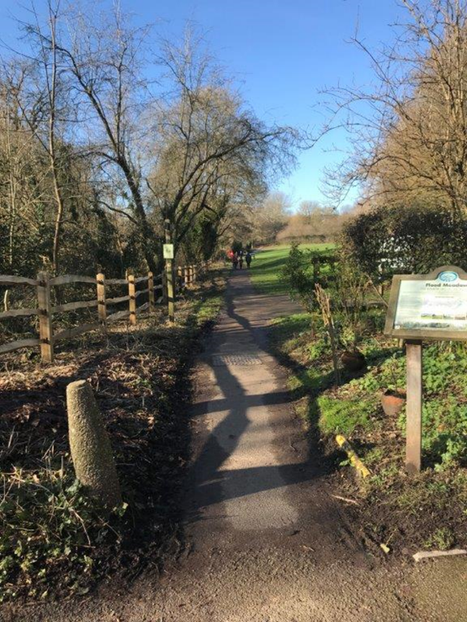

Entrance from Tanhouse Lane Looking back to Tanhouse Lane from the other end of the path

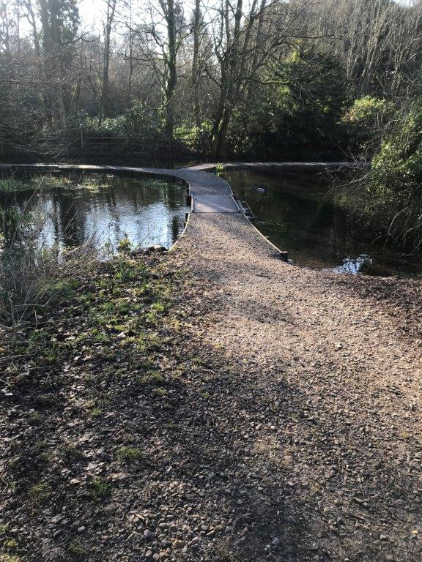

“Junction 1” “Junction 2”