Community Dermatology Service
Memorandum of Information (MOI)

NHS Brent
Clinical Commissioning Group (CCG)

Contents

1.0 Purpose 3
2.0 Definition 3
3.0 Strategic and Local Context 4
4.0 The Commissioning Organisation 7
5.0 Integrated Dermatology Procurement 9
6.0 Contractual Form 11
7.0 Governance and Administration 11

Purpose

1.1 The purpose of this Memorandum of Information (MOI) is to provide potential Bidders with an overview of the Community Dermatology Service procurement, which is being undertaken by NHS Brent Clinical Commissioning Group (CCG) on behalf of Brent CCG, NHS Harrow CCG and NHS Ealing CCG.
1.2 The MOI is a preliminary background explanation for the procurement of the Service. It is not intended to form the basis of any decision on the terms upon which the CCG will enter in to any contractual relationship.

2.0 Definition

2.1 The CCG wishes to commission a Community Dermatology Service for the paediatric and adult population of Brent, Harrow and Ealing. The proposed service should be a multidisciplinary consultant led community dermatology service (CDS) for the people registered with GPs in the three CCGs. The successful provider will be expected to manage all the cases which do not require a hospital facility to manage them and cannot be managed in primary care.
2.2 The scope of the service builds on the elements currently provided by both the acute providers and (where these currently exist) the community providers and covers:
a) A one stop consultant-led community dermatology service. Consultant-led for this service means that a consultant is available to provide advice, guidance, and professional support in a timely fashion to all staff as needed.
b) The service will treat all ages but for children under the age of 16 any surgical procedures must be referred to secondary care
c) Assessment, investigation and treatment of cancer patients within National and NWL cancer network guidance.
d) Will undertake minor surgery and skin biopsy in the community. The service must integrate with primary care minor surgery DES and refer to this where it is available.
e) The service will be expected to provide a clinical triage to assess the referral and how best to treat the patient.
f) Assessment, investigation and treatment of all patients with skin diseases, except patch testing, phototherapy, anti TNF therapy and complex cases. The assumption is that all the patch test, phototherapy, Anti TNF and complex cases will be referred to secondary care
g) Education of practices through providing both materials to support GPs and regular education sessions.
h) Supporting patients around management of skin disease through the provision of information resources. Provide information and support about self-care, prevention of skin disease and on-going management of long term skin conditions to healthcare professionals and patients.

3.0 Strategic and Local Context

3.1 National Drivers for Change
3.1.2 Dermatology is defined as the branch of medicine dealing with the skin and skin diseases.

Skin disease affects one third of the population at any one time and it accounts for 15% of all consultations in General Practice. The commonest skin diseases continue to increase in frequency and there are more referrals to secondary care Dermatology by GPs than to all of the other medical specialities combined. This is despite the fact that the majority of patients have mild problems that can be easily self-managed.

Unlike most medical specialities, which usually cite around 50 diseases, dermatology recognises more than 1,000 conditions affecting skin, hair and/or nails. Accurate diagnosis is fundamental to successful management. Chronic skin disease may have a substantial impact on work, social interaction and healthy living; skin disease is one of the commonest reasons for injury and disablement benefit and spells of certified incapacity to work in the UK. There is also a subset of skin cancers where mortality can be high and early diagnosis is vital.

Inpatient treatment of skin disease has reduced dramatically with only a small number of the most severe conditions now requiring hospital admission in addition to disorders such as psoriasis and eczema, which has failed to respond to day care /outpatient treatment.

The long term nature of many skin diseases means that a significant number of patients will have engagement with the dermatology service for many years, possibly even lifelong. Developments in technologies such as phototherapy have resulted in people requiring frequent visits over prolonged periods of time. This means that care needs to be easily accessible to patients.

The Department of Health, the British Association of Dermatologists and the National Collaborating Centre for Cancer have recognised that too many patients are attending hospital based services, for the provision of care that could be managed in a community setting. Initiatives elsewhere in the country demonstrate improved convenience and satisfaction for patients as well as reductions in DNA rates. Studies from some centres suggest up to 50% of patients referred to Dermatology departments could in fact been seen and treated by a GPwSI.
The key drivers for the development of this service are to provide a local, more accessible and cost effective service for patients, as set out in documents such as:
• ‘Our Health, Our Care, Our Say; A New Direction for Community Services’
• ‘Improving Outcomes for People with Skin Tumours including Melanoma’
• ‘Model of Integrated Service Delivery in Dermatology’

3.2 Local Drivers for change
3.2.1 The CCGs involved in this procurement are responsible for the health of all people registered with Brent, Harrow and Ealing general practices, even if they live outside of the borders of these boroughs.

This service redesign fits with the Out of Hospital strategy and Shaping a Healthier Future agenda.
Brent
- Total GP registered population (2015/16): 369,074
- Population of children under 18 (2015/16): 22.9%
- Number of GP practices: 61
- Practices are organised into three localities
Harrow
- Total GP registered population (2015/16): 260,000
- Population of children under 18 (2015/16): 22%
- Number of GP practices: 33

Ealing
- Total GP registered population 435,741:
- Population of children under 18 (2015/16): 23%
- Number of GP practices: 76
- Practices are organised into seven networks
- The secondary care spend for Dermatology is 2016/17: £2,248,468

Disease prevalence: There is no North West London or borough specific prevalence data for skin conditions, but in general the ten commonest diagnostic groups of patients are identified who require more than one follow up are: Eczema, Psoriasis, Basal Cell Carcinoma (BCC), Squamous Cell Carcinoma (SCC), Acne, Solar Keratosis, Naevi, Melanoma, Leg ulcers and Lichen Sclerosis.

The Community Dermatology Service will form part of an integrated Dermatology Service across primary and secondary care. This will entail working closely with GPs, GPwSIs undertaking minor surgery, Acute Specialist Service Departments (Level 4) and Specialist Skin Cancer services. In addition, the service will need to develop links with the local skin multidisciplinary team and cancer network’s skin cancer tumour working groups. The Service will also need to develop links with other secondary care specialities such as Plastic Surgery.

We have undertaken extensive reviews of our current community provision with clinicians both within the service and referring to it that highlighted the following elements that could be improved:
- Clinical governance and consultant input are critical to ensure the quality of the service
- Waiting times could be improved
- A wider range of conditions and treatments could be seen in the community
- General practice would value advice and support with some patients.

In addition we have engaged with patients who have used the service or would be eligible for the service. Their feedback can be summarized as:
- Accessibility needs to be considered, especially clinic locations and times. This is particularly relevant in light of the wider age range of patients who may be using the service
- Self-care and self-management support and information are important
- Having the appropriate equipment and expertise at each location

In light of the above and following consultation with GPs and patients, there is support for a Community Dermatology Service to deliver the following benefits:
- Improved Access
Too many patients are currently seen unnecessarily in acute settings as their condition does not warrant attendance at an acute hospital site. The CCG therefore wishes to commission services which are equitable, accessible and delivered from suitable premises to provide modern dermatology care.
- Improving quality, safety and clinical effectiveness

In some areas there is a lack of clinical oversight and governance which has eroded trust in the service. A new model with a different approach to consultant input and improved communication with GPs around the competencies of the service and recommendations for ongoing care will improve this.

4.0 The Commissioning Organisation

4.1 Brent is an outer London borough in north-west London. The number of patients registered with Brent GPs is 369,074. Brent has 62 member practices which are all aligned to one of five locality based groups. Each locality has a Clinical Director. 18 practices have a registered list of fewer than 3,000 patients and 5 practices have a registered list of greater than 10,000 patients.

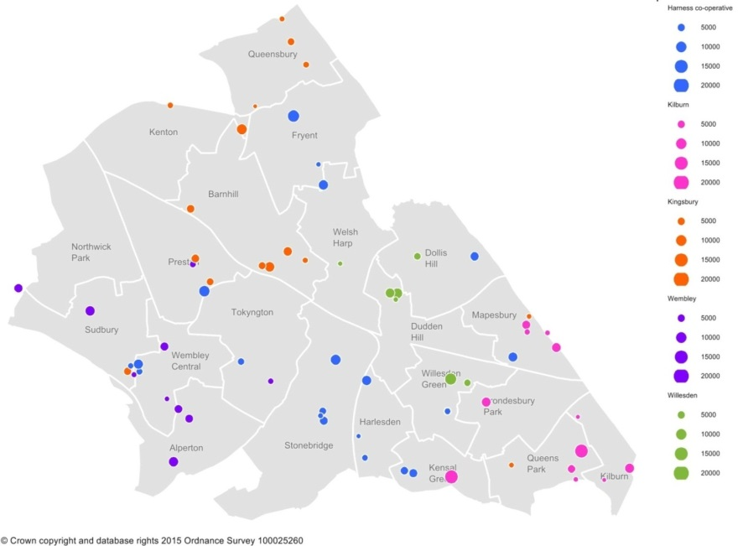

Brent borough has a population of 328,8001 (residents) and a population density of 75.2 people per hectare. The population has grown significantly since 2001 and is predicted to continue to grow. Brent has a young population with 35.1% aged between 20 and 39. The under 18 population makes up 22.9% of the population, the 16-64 (working age population) makes up 68.2% of the population and the 65 and over population makes up 11% of the population.
Brent is ethnically diverse: 66.4% of the population is Black, Asian or other minority ethnicity (BAME). This has increased since 2011, when BAME groups made up 63.7% of the population. The Indian ethnic group currently make up the highest proportion of BAME (19% of the population), followed by Other Asian (12%). The White group make up 33%. There are many different languages spoken in Brent. English is the main language for 62.8% of the population. Gujarati is the main language for 7.9% of the population and Polish is the main language for 3.4% of the population. In one in five households, nobody speaks English as their main language.
4.7 It should be noted that important information about the Brent population, including the needs and challenges of the area can be found in the relevant Joint Strategic Needs Assessment (JSNA) and Health and Wellbeing Profile. An Equality Analysis has also been undertaken as part of this community dermatology procurement to examine the extent to which the procurement may benefit different members of the community, and where appropriate, prompt the consideration of adjustments to ensure that all equality groups benefit equally from what is being analysed.
4.8 Potential Bidders are encouraged to review the JSNA and Health Profile at https://www.brent.gov.uk/jsna.
NHS Harrow Clinical Commissioning Group (CCG) is the GP-led organisation responsible for planning and commissioning health services needed by the approximately 260,000 people registered with GPs in Harrow.

Harrow CCG consists of 33 GP practices in the borough which is grouped into six peer groups who report to the Governing Body that consists of GPs, a hospital doctor, nurse and lay members. The CCG’s vision is to work in partnership to ensure local residents receive high quality, timely, sustainable, needs-led and cost effective care within the financial budgets available.

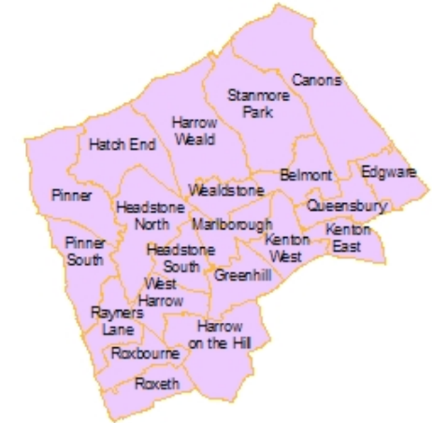

Harrow is one of the most culturally diverse areas of London with more than 50% of its population comprising of Black, Asian and Minority Ethnic communities who speak more than 80 languages. The borough also has a growing aging population and life expectancy has increased annually for the past 14 years with the average age for men and women reaching 82.4 years and 85.9 years, respectively. The CCG considers and values the diversity of its population to ensure healthcare services are appropriate and meet the diverse needs of Harrow patients.

Harrow faces social and economic challenges along with healthcare challenges that include higher-than-average rates of diabetes, dementia and heart disease. A comprehensive picture of Harrow’s health and wellbeing status is captured in the Joint Strategic Needs Assessment (JSNA) and Health and Wellbeing Profile which are available on the local authority website at: www.harrow.gov.uk

Ealing

Ealing is London’s third largest borough and very diverse with a steady rise projected for BAME group at 52%. It is estimated that by 2020, there will be a 19.5% increase in the number of over 65 years of age and a 48% rise in the number people over 85.

Between 2001 and 2015, Ealing’s population of 0-15 year olds increased by 23.1% (from 59,700 to 73,500). In the same time period, the number of 0-15 year olds increased by 21.8% across London and by 5.1% across England. From 2001-2015, the working age population (16-64) in Ealing rose by 7.7% (to 229,100), which is lower than the increase seen in London (22.3%) and England (10.3%). Nationally the number of older people (aged 65+) rose by 24.4% between 2001 and 2015. During the same period, the number of older people rose in Ealing by 16.4%.

Currently, Ealing CCG does not have a community dermatology service. All GP referrals are triaged via a referral management service and only appropriate referrals which cannot be managed in primary care are transferred into secondary care.

5.0 Community Dermatology Procurement

5.1 The following captures the objectives of the service under consideration. The details are under consultation.
To improve access by:
- Ensuring that the majority of patients are seen and treated in community settings and in an environment most appropriate to their needs.
- Only referring to the acute hospital those cases which cannot be safely managed in community settings and ensure as soon as the condition has stabilised that ongoing care is managed in a community setting.
- Being responsive to the individual, including those with special needs, e.g. learning disabilities or visual impairment as well as other specific requirements such as language.
- Ensuring a child-friendly environment and flexible appointment system to meet the needs of patients and carers, including patients who are in full-time employment.
To improve quality and efficiency by:

- Providing joined up, clinically effective patient care and pathways across the whole health community. This includes developing a strong interface with primary care.
- Facilitating the development of innovative delivery models through the co-location with other appropriate services.
- Introducing new approaches to increase service efficiencies such as telephone follow-ups, texting and flexible appointment times and generally optimising the use of technology.
- Delivering a service which has the ability to flex its resource base to meet capacity.
- Making appropriate referrals into specialist providers.
- Providing advice, information and support to primary care colleagues and a plan of treatment for the referring clinicians; the aim is to diagnose and refer back to the GP with a detailed management plan, and follow up only as appropriate.
- Developing and implementing clear referral criteria to significantly improve the quality of referrals. This will include returning referrals to practices where clinically appropriate, without seeing the patient.
- Working closely with both GPs and GPSIs undertaking minor surgery, the specialist skin cancer services and all other secondary care specialties, in particular Plastic Surgery, Rheumatology and Diabetes.

To provide assessment, diagnostics and treatment by:
- Providing assessment, investigation and treatment of patients suffering with skin disease. Ensure access to a full diagnostic service including phlebotomy, biopsy and swab taking and reporting of results.
- Adopting and ensuring compliance with appropriate clinical protocols for common conditions and ensure these are followed consistently .
- Providing as much care as possible from a one stop shop model of care.
- Introducing new and transformational ways of providing care e.g. use of telemedicine and other developments.
To contribute to patient education and self-management by:
- Proactively promoting patient self-care and self-management as a guiding principle within the service.
- Educating patients with long term skin conditions so that they understand the causes, trigger factors and lifestyle choices available to them.
- Empowering patients to manage their condition independently, knowing when to seek further help, thus reducing their need for specialist care.
- Developing relevant patient support groups led by specialist nurses.
- Running patient education courses regarding the different skin conditions or signpost patients to courses run by the third sector or other organisations.
- Making a range of patient information available to help patients better understand and manage their conditions and in different media, e.g. websites, leaflets or help lines.

5.2 2015/16 activity for the CCGs in both acute and community is as follows:

6.0 Contractual Form

6.1 The contract length is anticipated to be 3 years, with the option to extend for a further 2 years.
6.2 We are considering a block contract with marginal rates to be agreed
6.3 Standard NHS business rules regarding tariff inflator/deflator will apply to the agreed tariffs in year 2 and beyond.
6.5 The dermatology model of care relies upon the integration of services, therefore a potential bidder can be a stand-alone organisation or an alliance of organisations.

7.0 Governance and Administration

7.1 Consultation - Both GPs and patients have been consulted with to assist inform the CCG’s commissioning intentions for dermatology. The CCG will continue this engagement throughout the duration of the procurement. Any requirement for formal public consultation will be carried out by CCG under the Health and Social Care Act 2001 (now contained in the NHS Act 2006). However there will be a requirement on the provider to maintain an agreed level of engagement with GPs, other key stakeholders and relevant patient interest groups throughout the mobilisation period and throughout the duration of the contract.

7.2 Disclaimer -The information contained in this MOI is presented in good faith and does not purport to be comprehensive or to have been independently verified. Neither the CCG, nor any of its advisers accept any responsibility or liability in relation to its accuracy or completeness or any other information which has been, or which is subsequently, made available to any potential Bidder, Provider, Bidder Member, Clinical Services Supplier, financiers or any of their advisers, orally or in writing or in whatever media.

Interested parties and their advisers must therefore take their own steps to verify the accuracy of any information that they consider relevant. They must not, and are not entitled to, rely on any statement or representation made by the Commissioner or any of its advisers.

7.3 This MOI is intended only as a preliminary background explanation of CCG’s activities and plans and is not intended to form the basis of any decision on whether to enter into any contractual relationship.

7.4 Nothing in this MOI is, nor shall be relied upon as, a promise or representation as to any decision by NHS Brent, Ealing or Harrow CCGs in relation to this Procurement. No person has been authorised by the Commissioner or their advisers or consultants to give any information or make any representation not contained in this MOI and, if given or made, any such information or representation shall not be relied upon as having been so authorised.

7.5 Nothing in this MOI or any other pre-contractual documentation shall constitute the basis of an express or implied contract that may be concluded in relation to the Procurement, nor shall such documentation/information be used in construing any such contract. Each bidder must rely on the terms and conditions contained in any contract when, and if, finally executed, subject to such limitations and restrictions that may be specified in such contract. No such contract will contain any representation or warranty in respect of the MOI or other pre-contract documentation.

7.6 In this section, references to this MOI include all information contained in it and any other information (whether written, oral or in machine-readable form) or opinions made available by or on behalf of the Commissioner, or any of their advisers or consultants in connection with this MOI or any other pre-contract documentation.

Royal College of GPs, morbidity statistics. From General Practice: Fourth National study 1991-92,London, HMSO,(1995)
Guidance for Commissioning Dermatology Services. www.bad.org.uk
British Medical Journal, Evaluation of General Practitioner with Special interest in Dermatology: randomised controlled trial BMJ, 2005, 331:1441-1446, 17thDecember.
Our Health, Our Care, Our Say; A New Direction for Community Services, DH (2006)
Improving Outcomes for People with Skin Tumours including Melanoma, The Manual, NICE (2006)
Model of Integrated Service Delivery in Dermatology, Skin Care Campaign (2007)

