**Meadowcroft Pavilion Tender**

**Introduction:**

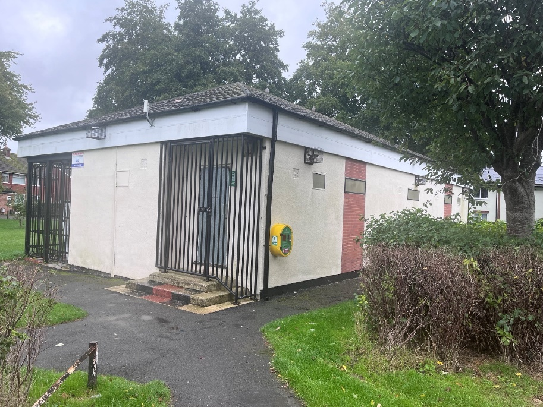Stratton St Margaret Parish Council are excited to go out for tender for the Pavilion at Meadowcroft Community Centre, Addison Crescent, Swindon, SN2 7JX. Meadowcroft Pavilion is currently made up of 2 changing room areas with communal showers, 1 referee changing room, A small kitchen type area, 3 toilets and 4 urinals. There are currently 2 large steps to enter into the building. Access can be granted from each side of the pavilion. The main idea of this project is to change the main area of the pavilion into a larger community space with separate changing areas with toilet and showers.

Planning permission has been applied for and awaiting approval and we now looking for contractor to complete the works.

**Existing floor plans**:



**Proposal:**



**Key points:**

* Knock through changing rooms and storage room to create 1 larger room.
* Installation of a disabled toilet.
* Decorate all rooms, walls, floors, ceilings and bathrooms.
* New access ramp to community room removing bars.
* Enlarge windows.
* Solar installations
  + With optimizers due to shading from nearby trees
  + Batteries (around 8 to 10Kwh)
* Reinstate fire exit and remove black protection bars from east side of building.
* Construction of a new a new storage cupboard to store tables and chairs.
* Shutter style door to protect entrance on the disability ramp.
* Sensory pod
  + Our preference Sensory Pod [attached](https://murraysmedical.co.uk/wp-content/uploads/2024/09/The-Sensory-Pod-Flyer-UK-Aug24.pdf). With steps, screen and wrapped in custom branding including delivery and installation was £8,500.
* New changing area with link through door.
* Two new shower cubicles and toilets for football side of the building.
* Kitchen window changed to a service hatch to serve food if required on football.
* Installation of a fire alarm and correct fire extinguishers. Currently no fire alarm installed in current building.
* To work with our current CCTV provider and install CCTV is the main room and entrance. (OSE <https://www.osesecurity.co.uk/>)
* New kitchen area
  + Sink
  + Sockets for microwave, kettle, water boiler, panni press, air fryer and a couple spare.
  + Dishwasher

**Asbestos Report**



**Structural survey**



Items 4.6 & Items 4.7, These two items within the report highlight what is required structurally to support the roof when the internal walls are removed to create the new internal layout – refer to the plan after Item 4.7

Both walls aid the stability of the building and they span a quite significant span therefore, it is very likely both will require to be moment frames to maintain the stability of the building

This item basically concludes that if items 4.6 & 4.7 noted above are done to structural engineers’ requirements then the roof is more than capable of having solar panels.

Please include a sum of £1,500 for the structural engineer to provide the calculations for the steel support beams.

**Budget:**

Up to the value of £150,000

**Completion:**

Stratton St Margaret Parish Council would like this finished and in use by November 2025.

**Site visits:**

If you require a site visit please contact Chris Matthews, Deputy Clerk at Meadowcroft Community Centre, Addison Crescent, Swindon or on 01793 823761 or email [Chris.matthews@strattonstmargaret.gov.uk](mailto:Chris.matthews@strattonstmargaret.gov.uk).

**Accessible times:**

Monday to Friday 8.30 til 4pm.

**Submissions:**

All competitive quotations and tenders need to be submitted to the Deputy Clerk (Chris Matthews) for the Council:

[Chris.matthews@strattonstmargaret.gov.uk](mailto:Chris.matthews@strattonstmargaret.gov.uk)

Stratton St Margaret Parish Council

Meadowcroft Community Centre

Addison Crescent

Swindon

SN2 7JX