Forest Research
Alice Holt Lodge
Farnham
Surrey
GU10 4LH

nicolas.porter@forestresearch.gov.uk

Urban Forest Scientist
Nicolas Porter
16th April 2024
To: Supplier

INVITATION TO TENDER FOR “i-Tree Eco Plot Survey – i-Tree Eco Portsmouth”
REF NO: CR2023/24/092

You are invited to submit a tender for a contract to conduct an i-Tree Eco Plot Survey (‘i-Tree Eco Portsmouth’) for Forest Research (‘FR’). The brief for the work is detailed below.

Please send your completed tender and any enquires about this invitation to:
nicolas.porter@ForestResearch.gov.uk

Your tender must be received by 5 pm on Tuesday 7th May 2024.

Tender submissions will be evaluated in accordance with the Evaluation Matrix (to follow).

Please note the following conditions:
- Any contract concluded as a result of this invitation shall be governed by English Law and Forest Research’s Standard Terms and Conditions of Contract will apply. Your terms will not apply.
- The completed tender and all accompanying documents are to be in English.
- All prices must be in GBP and exclusive of VAT.
- FR reserves the right to cancel or withdraw from the process at any stage.
- FR does not undertake to accept the lowest priced quotation, or part, or all of any quotation.
- All information supplied to you by FR in the course of this tender exercise must be treated in confidence and not disclosed to third parties.
- All details of your tender, including prices and rates, must be valid for acceptance for a period of 90 days from the date of tender submission.
- Once a contract has been awarded, any additional costs incurred which are not reflected in the tender will not be accepted for payment.
- Offering an inducement of any kind in relation to obtaining this or any other contract with FR or the Forestry Commission will disqualify your tender from being considered and may constitute a criminal offence.

Yours faithfully
Nicolas Porter

(by email)

Invitation to Tender for ‘i-Tree Eco Plot Survey – Portsmouth’

Reference: CR2023/24/092

Specification of Requirements
Brief
Forest Research in partnership with Portsmouth City Council is undertaking a survey of the trees in Portsmouth to find out how the diversity of trees provides benefits to the community.

Tenders are invited to conduct field surveying of up to 200 of the i-Tree Eco sample plots across the study area.

The Location
The study area is the whole of the City of Portsmouth, including Paulsgrove, Cosham, Drayton, Hilsea, Anchorage Park, Baffins, Somers Town, Southsea and Eastney. The full extent of the study location and the provisional survey plot locations are presented in the attached Maps (Appendix 1).

Health and Safety
Method statements and risk assessments must be provided in advance of any works taking place. Section 3.3 of the ITT must be completed.

Specification
The objectives of this work are to:
- survey each pre-designated i-Tree Eco plot in full accordance with the i-Tree Eco v6 methodology (EcoV6.FieldManual.2021.10.06.pdf (itreetools.org), including a ‘life expectancy’ estimate for each tree present (to enable a CAVAT valuation; LE brackets to be advised) and four additional metrics to be specified during a training session provided by FR in May 2024 (provisionally online).
- submit the survey data via the i-Tree Eco Mobile Data Collector (the project file will be pre-produced by FR and a URL provided).
- at least two attempts must be made to access a plot, on different days and at different times of the days, prior to moving onto the designated back-up plot.
- at least one photograph is required per plot, named with the plot number. Some of these will be used within the final report and so content quality is important. Guidance on producing an acceptable quality photograph will be provided to the winning contractor (and is available beforehand upon request).

Outputs
- The information collected should be submitted via the i-Tree Eco Application.
- Any complementary paper-copy field survey-forms or sketch maps completed during survey should be submitted to FR, either as the originals or as high-quality e-copies.
- Plot photographs, in digital .jpeg or .png or similar format shared via an online repository (to be agreed with FR).
- Outputs to be supplied to FR by close of play of each day of fieldwork for Data; and within two weeks of completing field work for field forms and photos.

Note: In their tender submissions, tenderers must identify any areas where they will not be able to comply with the above requirements. If your Tender does not meet these requirements we reserve the right to reject it.

Notes for Completion and Conditions

Timetable

FR would like all work completed and invoiced by Tuesday 16th July 2024, whilst ensuring sufficient time for FR review of the submitted ‘outputs’. Preference is given to submissions able to accommodate the proposed timeframe:

Task | Proposed completion date
ITT issued | 16th April 2024
Tenders received | By: 5 p.m., Tuesday 7th May 2024
Issue Award Notification | By: COP Friday 10th May 2024
Survey completion | All plots: By Sunday 14th July 2024
Outputs to FR | Data: By close of play of each day of fieldwork  Field forms and photos: within two weeks of completing field work.

The contract will include the possibility for reasonable extension due to unforeseen circumstances arising, for example extreme weather.

The appointed supplier is expected to make all reasonable efforts to survey all plots with trees prior to leaf-fall.

Whilst we do not intend to depart from the timetable above, we reserve the right to do so.

Site Visits

If a supplier requires to undertake a site visit for tendering purposes they should arrange this through the named contact in Section 2.2.

Enquiries
Please send all enquiries by email to nicolas.porter@ForestResearch.gov.uk

If we consider any question or request for clarification you submit is relevant to all interested parties, we will share both the query/question and the response with all prospective bidders (by publishing a Q&A list on Contracts Finder), although your identity will remain confidential.

Responses and supporting documents
Responses must be completed in full and in the format requested, all appendices must be clearly labelled. FR will only evaluate on information provided, working history with FR cannot be considered unless outlined in your tender submission. Please do not send promotional or general information; this will not be evaluated.

Return arrangements
Please return your completed tender submission by email to nicolas.porter@ForestResearch.gov.uk

We must receive your completed tender before the closing date and time shown in the Timetable at section 2.1. We reserve the right to not consider any tenders received after the deadline.

Title your covering email ‘Tender for i-Tree Eco Plot Survey – i-Tree Eco Portsmouth’.

Clarification
During our evaluation process, we may need to seek clarification on aspects of your tender return. If required we will contact you using the details you have provided. Clarification may require you to submit, supplement, clarify or complete the relevant information or documentation within an appropriate time limit. The purpose of any such clarification is to provide us with the information we require to evaluate your submission; it will not be an opportunity for you to improve or substantially change the information you have already submitted.

Sub-contracting arrangements
Where the supplier proposes to use one or more sub-contractors to deliver some or all of the requirements, details should be provided. This includes members of the supply chain, the percentage of work being delivered by each sub-contractor and the key deliverables each sub-contractor will be responsible for.

FR recognises that arrangements in relation to sub-contracting may be subject to future change, and may not be finalised until a later date. However, tenderers should be aware that where information provided to FR indicates that sub-contractors are to play a significant role in delivering key requirements, any changes to those sub-contracting arrangements may affect the ability of the Supplier to proceed with the procurement process or to provide the supplies and/or services required. Suppliers should therefore notify FR immediately of any change in the proposed sub-contractor arrangements. FR reserves the right to deselect the Supplier prior to any award, based on an assessment of the updated information.

Consortia arrangements
Please contact FR (see section 2.2) before submitting a tender if you intend to bid as a consortium.

Confidentiality
When providing details of contracts in answering section 3.4 of this ITT (Technical and Professional Ability), the Supplier agrees to waive any contractual or other confidentiality rights and obligations associated with these contracts.

FR reserves the right to contact the named customer contact in section 3.4 regarding the contracts included in section 3.4. The named customer contact does not owe FR any duty of care or have any legal liability, except for any deceitful or maliciously false statements of fact.

FR confirms that it will keep confidential and will not disclose to any third parties any information obtained from a named customer contact, other than to the Cabinet Office and/or contracting authorities defined by the Public Contracts Regulations.

The Supplier must treat all information supplied to it by FR in confidence and must not disclose it to third parties other than to obtain sureties or quotations for submitting its response.

As part of the tendering process, the Supplier must identify any parts of its tender submission which it designates as confidential and would not want published; such information may include technical or trade secrets or other confidential information. FR will then assess this information (along with the rest of the contract) when considering which contractual information should or should not be published or released on request.

Additional tender information
All costs associated with taking part in this process remain your responsibility and we will not return any part of your completed tender to you.

Pass/Fail questions
Some questions in this ITT are fundamental requirements of the proposed contract; these are marked on a ‘pass/fail’ basis and if you do not answer these sections appropriately, we may reject your submission in full and cease to evaluate any more questions.

Weighted questions
Some sections of this ITT include questions that are weighted. The weightings applied to each question ensure the relative importance of each is reflected in the overall scores applied.

Award & Feedback
Once we have carried out the evaluation and identified the successful tenderer(s), we will write to all tenderers by email of our award decision. We will give all bidders the opportunity of feedback. Please request feedback via email as soon as possible if required.

Right to cancel or vary the process
We reserve the right to cancel or withdraw from the tender process at any stage.

Inducements
Offering an inducement of any kind in relation to obtaining this or any other contract with us will disqualify you from being considered and may constitute a criminal offence.

Disclaimer
While the information in this ITT and supporting documents has been prepared in good faith by us, it may not be comprehensive nor has it been independently verified.

Neither FR, nor their advisors, nor their respective directors, officers, members, partners, employees, other staff or agents:
- makes any representation or warranty (express or implied) as to the accuracy, reasonableness or completeness of this ITT; or
- accepts any responsibility for the information contained in the ITT or for the fairness, accuracy or completeness of that information nor shall any of them be liable for any loss or damage (other than in respect of fraudulent misrepresentation) arising as a result of relying on such information or any subsequent communication.

Your tender response
In order to submit a tender for this requirement you must complete and return the below sections in compliance with Section 2 above. All sections must be completed and returned.

Supplier Information

Supplier details |  | Answer
Supplier Name & Address
Registered company number
Registered charity number

Registered VAT number
Name of immediate parent company
Name of ultimate parent company
Please indicate your trading status |  | Choose an item.
Please indicate whether any of the classifications apply |  | Choose an item.
Contact details
Supplier contact details for enquiries about this ITT/Tender Response
Name
Postal address
Phone
Mobile
E-mail

Selection Criteria

Insurance
Please self-certify whether you already have, or can commit to obtain, prior to the commencement of the contract or framework, the levels of insurance cover indicated below. | YES / NO
Employer’s (Compulsory) Liability Insurance = £5million
Note: It is a legal requirement that all companies hold Employer’s (Compulsory) Liability Insurance of £5 million as a minimum. Please note this requirement is not applicable to Sole Traders.
Public Liability Insurance = £5 million
Professional Indemnity Insurance = £500k

Health and Safety

This section allows us to assess your competency for health and safety. We have provided some guidance to help you understand the requirements for each area. You may also find it useful to refer to the Health and Safety Executive (HSE) website for some guidance before completing this section. You can find this here: http://www.hse.gov.uk/.

3.3.1 | - Does your organisation have a written health and safety policy? AND  - If yes, please provide details of when it was last reviewed and updated
Answer:

3.3.2 | FR requires confirmation that this contract or framework will be carried out by personnel (individuals, staff or sub-contractors) with the pre-requisite Health and Safety certifications / qualifications. Bidders are required to complete the table below with reference to their delivery team for this contract or framework.
Certification / Qualification |  |  | Number of personnel with certification / qualification | Qualification Provider | Frequency of Update training
First Aid at work or Emergency First Aid at Work (+ F)*
Add or delete as appropriate
3.3.3 |  | If the appropriate personnel who will deliver the contract or framework do not currently hold any or all of the above qualifications or certifications, explain any plans (including dates) you have in place to secure the necessary certifications/qualifications in advance of contract or framework commencement.  Please state ‘not applicable’ in the box below where this does not apply.
Answer:

* Please see our First aid policy | Forestry England for further details. Note: if your current certification does not cover these aspects, you will be required to undertake the necessary training prior to commencing any work.

3.3.4 | Briefly describe your selection process for sub-contractors. The selection process should include assessment and review of sub-contractors’ approach to risk assessment; competence and qualifications; and accident/near miss reporting & recording.  If you intend to carry out all work using your own direct employees, you need only provide a short statement to this effect.
Answer:

3.3.5 | Briefly describe your process for ensuring personnel are competent and up to date on general and site specific health and safety requirements. This should include your plans for supervision and monitoring. Provide evidence of examples to support your response.
Answer:

3.3.6 | Provide an example of a site specific risk assessment you have applied in a previous contract which demonstrates that the risks identified have been controlled.  OR  Where an example from a previous contract cannot be produced, please explain how you would risk assess a job; please support this response with a generic or hypothetical risk assessment relevant to the subject of the contract/framework.
Answer:

3.3.7 | In relation to your risk assessment process, describe how you monitor to ensure the controls remain in place for the duration of the work. Where available, supply any relevant evidence to support your response such as completed checklists or other similar evidence.
Answer:

3.3.8 | Explain your approach to Lone Working; and where this is carried out provide details of your process, methods and frequency of checking for contracts of this nature.
Answer:

3.3.9 | Briefly explain how your organisation obtains competent health and safety advice (either within the organisation or externally). Please show us you have the following or equivalent: Internal health and safety personnel, consultants, appointed person in the organisation responsible for health and safety.
Answer:

3.3.10 | - Describe your accident / near miss reporting system including any actions taken post incident to prevent recurrence;  - Support your response with one example where this is available;  - Describe your understanding of the requirements under the Reporting of Injuries, Diseases and Dangerous Occurrences Regulations 2013 (RIDDOR).
Answer:

References
Relevant experience and contract examples
Please provide details of up to three contracts, in any combination from either the public or private sector, that are relevant to our requirement. These contracts should have been performed during the past four years. The named contact provided should be able to provide written evidence to confirm the accuracy of the information provided below.
 | Contract 1 | Contract 2 | Contract 3
Name of customer organisation
Point of contact in customer organisation

Position in the organisation

E-mail address
Contract start date

Contract completion date

Approximate Contract Value

Award Criteria

Requirement Specific Questions
No. | Question | Weight %
3.5.1 | Please describe how you will meet the requirements of this contract (with reference to Section 1 ‘Specification of Requirements’ above) and provide a proposed method statement.  Provide information on your previous experience in i-Tree Eco and/or equivalent field work.  Your response should also include health and safety and site specific considerations, and details of any equipment you intend to use and its suitability for this contract. | 30
Response:

3.5.2 | Please outline your proposed programme for this contract, demonstrating that you can meet the surveying, analysis and reporting timetable, and state your proposed completion date. This must include key milestones and details of how you will keep on budget and to time. | 10
Response:

Pricing Schedule

 | Weight %
Please provide a fixed price, lump sum quotation, together with a supporting breakdown showing the main cost components/main elements of the work | 60

Terms and Conditions
Any contract arising from this ITT will be subject to FR’s Conditions of Contract for the Supply of Services (Non Operations)

The successful Tenderer’s usual terms and conditions are not, and will not, become terms and conditions of any contract or framework agreement that we may award as a result of this ITT.

a) | Do you accept the FR’s Terms and Conditions of Contract as detailed above? (delete the option that doesn’t apply) | Yes / No
b) | If no, please provide details of any specific areas that you have an issue with. Please note that failure to agree to our Terms and Conditions of Contract may invalidate your tender submission.

Declaration
I declare that to the best of my knowledge the answers submitted to these questions are correct. I understand that the information will be used in the selection and evaluation process to assess my organisation’s suitability to participate in this procurement, and to determine which supplier(s) provide the most economically advantageous tender in accordance with the criteria set out in this ITT. I am signing on behalf of

………………………………………………………………… (insert name of supplier).

I understand that FR may reject my submission if there is a failure to answer all relevant questions fully or if I provide false/misleading information.

I understand FR may assess the past performance of a Supplier (through a Certificate of Performance provided by a Customer or other means of evidence). FR may take into account any failure to discharge obligations under the previous principal relevant contracts of the Supplier completing this ITT. FR may also assess whether specified minimum standards for reliability for such contracts are met.

I understand that I must disclose if my organisation (or any member of your proposed consortium, if applicable), Directors or partner or any other person who has powers of representation, decision or control has been convicted of any criminal offences.

In addition, FR may re-assess reliability based on past performance at key stages in the procurement process (i.e. Supplier selection, tender evaluation, contract award stage etc.). Suppliers may also be asked to update the evidence they provide in this section to reflect more recent performance on new or existing contracts (or to confirm that nothing has changed).

The essence of selective tendering is that FR will receive bona fide competitive tenders from all those tendering. In recognition of this principle, I certify that this is a bona fide tender, intended to be competitive, and that ‘we’ (I or any other person acting for on behalf of my organisation) have not fixed or adjusted the amount of the tender by or under or in accordance with any agreement or arrangement with any other person. I also certify that we have not done and we undertake that we will not do so at any time before the hour and date specified for the return of this tender any of the following acts:
- communicate to a person other than the person calling for those tenders the amount or approximate amount of the proposed tender, except where the disclosure, in confidence, of the approximate amount of the tender was necessary to obtain premium insurance quotations required for preparing the tender;
- enter any agreement with any other person whereby they will refrain from tendering or as to the amount of any tender to be submitted;
- offer or pay or give or agree to pay any sum of money or valuable consideration directly or indirectly to any person for doing or having done or causing or having caused to be done in relation to any other tender or proposed tender for this work any act or thing of the sort described above.

In this certificate, the word “’person” includes any individual, partnership, association, or body either corporate or unincorporated; and “’any agreement or arrangement” includes any such transaction, formal or informal, and whether legally binding or not.

I also declare that there is no conflict of interest in relation to FR’s requirement.

ITT COMPLETED BY

Name:

Role in Organisation:

Date:

Signature:

Appendix 1

Location Map

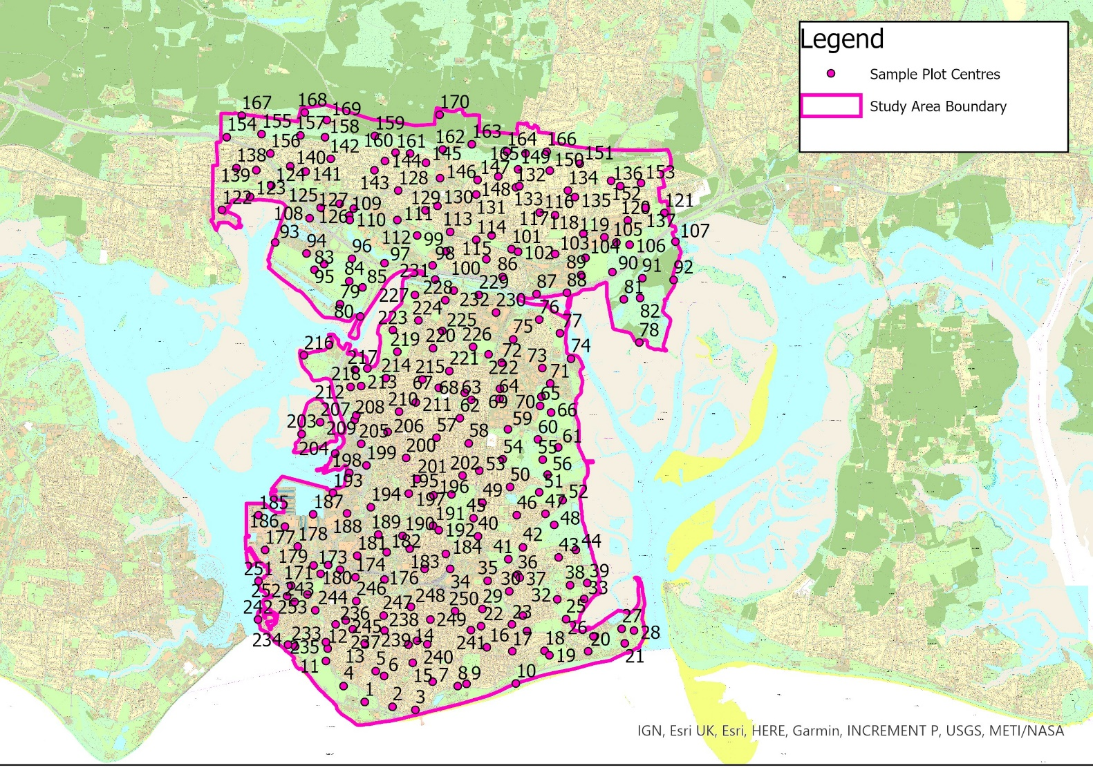

The Evaluation Matrix will be added to the Contracts Finder notice on Friday 19 Aoril

