LIVERPOOL VISION LIMITED

INVITATION TO TENDER

For
City Dressing
2017-2019

(A procurement for event services under the
Public Contracts Regulations 2015
Light Touch Regime).

Contents
Requirement Overview 4
Structure of the Invitation to Tender 6
1. ITT Instructions. 6
2. Intention to bid 6
3. Requirements 6
4. General company information 6
5. Additional Information 6
1. ITT Instructions 7
1.1 General Instructions 7
1.2 Freedom of Information 9
1.3 Responding to the ITT 10
1.4 Indicative Timetable 12
1.5 Evaluation 12
2. Intention to bid 13
3. Requirements 14
General Requirements 14
Temporary Requirements for Culture Liverpool and Other Events 16
3.1 Responses 17
Table 1 Charges 18
3.2 Insurance requirements 21
3.3 Health and Safety 21
3.4 Business Continuity 21
3.5 Key Performance Indicators and Service Level Agreements 21
3.6 Quality 22
3.7 Conflicts of interest 22
3.8 Customer References 22
3.9 CSR 22
4. General company information 23
4.1 Organisation information 23
4.2 Financial Information 24
4.3 Equal Opportunities 24
4.4 Professional Conduct 26
4.5 Social Aspects (including diversity, disability and CSR) 26
4.6 Environment 26
5. Additional Information 27
Appendix 1 – Terms & Conditions 28
Appendix 2 – Legal Comments Table 29
Appendix 3 – Location, sizes and styles of the current estate 30

Requirement Overview
This Invitation to Tender sets out City Dressing requirements for Liverpool Vision Limited (LV) commencing on 1st February 2017. The initial term of any resultant framework contract(s) will be for a two-year period with the option for LV to extend for an additional period of up to two years, subject always to termination by Liverpool Vision by serving no less than 30 days written notice.
The requirements are split into 4 main areas:-
- Liverpool Vision campaigns - Liverpool Vision has on average 130 banner installs and 220 flag installs per year, with approx. 8 gateway/welcome installations, depending on activities to promote.
- Culture Liverpool campaigns - Over and above general LV requirements, we also manage Liverpool City Council’s requirements for servicing Culture Liverpool events and on an average year this can be approx. 100 banners and 75 flags.
- ACC Liverpool Destination Welcome - LV also manage the Destination Welcome activities on behalf of The ACC Liverpool Group which, includes an estate of 21 flag poles. 8 of these poles are used for standard events, whilst other events utilise between 8 and all 21 poles.
- Temporary installations – Major events taking place during 2017-18 requiring a flexible approach to growing and shrinking the overall size of the estate.
Note: any volumes quoted in this ITT are indicative only and it is expected that these will change to suite demands of events over the term.
Tenderers are invited in section 5 to elaborate on any alternative innovative solutions, as well as temporary installs, but these must be distinct from your main response to the requirements described here which outlines the current estate.
The Client
The client is Liverpool Vision Limited (company registration number 06580889) working on behalf of the Mayor of Liverpool.
Who Are We?
Working closely with private sector businesses in the city, Liverpool Vision is the Mayor of Liverpool’s economic development company incorporating:
- Marketing Liverpool (ML), incorporating Liverpool Convention Bureau (LCB)
- Invest Liverpool (IL)
- Special projects, such as the International Festival for Business 2018 (IFB2018).

What Is Our Purpose?
Liverpool Vision’s purpose is to enhance the brand of Liverpool, attracting investment and creating jobs to ensure a more prosperous future for the city.

How Do We Do This?
Through raising the profile of our offer we will generate interest from investors and visitors that will both help attract new investment and encourage existing businesses to grow. We will, together with private and public sector partners maximise opportunities by participating in major events such as MIPIM, International Festival for Business (in 2014, 2016, 2018 and 2020) and Visitor Economy exhibitions. By working in partnership with commercial partners in the private sector we will communicate positive messages about the city to local, national and international audiences.

What Are Our Values?
Liverpool Vision’s is committed to the highest standards of ethical conduct and integrity in its business activities and to providing a high-quality service to all its customers and partners. Liverpool Vision believes that all its workers should be treated with dignity and respect and everyone is encouraged and supported to be the best they can be. We believe in taking responsibility, being creative and innovative and working together as a team for the benefit of the city.
You can find out more at www.liverpoolvision.co.uk and www.itsliverpool.com

Structure of the Invitation to Tender

This Invitation to Tender (‘ITT’) is divided into a number of specific sections:

1. ITT Instructions.

These instructions should be followed to ensure that your response covers all areas and is in the correct format and structure. By submitting a response to the ITT you are declaring that you comply with all the relevant sections and stipulations.

2. Intention to bid

This section, if applicable, provides details of how you should respond to LV if you intend to submit a bid.

3. Requirements

This section provides the details of LV’s specific requirements and you should ensure that all relevant responses are provided in your submission.

4. General company information

This section requests certain general company information from you and all sections should be responded to.

5. Additional Information

This section provides you with an opportunity to submit additional information in support of your submission.

Appendix 1- Terms and Conditions
Appendix 2 – Legal comments table

1. ITT Instructions

Please note that by submitting a response to this ITT that you agree and comply with all parts of the ITT Instructions section.

1.1 General Instructions

1.1.1 This document is made available on the condition that the information contained within it is used solely in connection with the competitive process for this ITT and for no other purposes.

1.1.2 Whilst reasonable care has been taken in preparing this document, the information within it does not purport to be comprehensive or to have been independently verified. LV accepts no liability or responsibility for the adequacy, accuracy or completeness of any information stated. No representation or warranty, express or implied, is given by LV or any of its representatives with respect to the information contained herein or upon which this ITT is based. Any liability for such matters is expressly disclaimed.

1.1.3 LV reserves the right, without prior notice, to change, modify, or withdraw the basis of its request and/or to reject all proposals and terminate negotiations at any time. In no circumstance will LV incur any liability in respect of time, effort or costs incurred in regard to either discussions, meetings or time spent in respect of reviewing and/or responding to this document or any subsequent material.

1.1.4 This document is not intended to provide the basis for any investment decision. The recipients of this document must make their own independent assessment of the requirements after making such investigations and taking such professional advice as it deems necessary.

1.1.5 The information in this document shall be kept confidential by the Tenderer and may not be copied, reproduced, distributed or passed to any other persons, at any time, without the prior written authorisation of LV. Ownership in any response to this ITT shall be vested in LV upon delivery of the same and such response shall only be returned at the sole discretion of LV and at the recipient’s cost.

1.1.6 This ITT is not a purchase order and does not constitute an offer capable of acceptance. This ITT does not commit LV or any official of it to any specific course of action. The issue of this ITT does not bind LV or any official of it to accept any proposal, in whole, or in part, whether it includes the lowest priced proposal, nor does it bind any officials of LV to provide any explanation or reason for its’ decision to accept or reject any proposal. Moreover, while it is the intention of LV to enter contract negotiations with the selected Tenderer, the fact that LV has given acceptance to a specific Tenderer does not bind it or any official of it in any manner to the Tenderer.

1.1.7 Without prejudice to any prior obligations of confidentiality you may have, no publicity relating to this ITT or to the acceptance by LV of any ITT response or to the letting of any future contract shall be released by you without the prior written approval of LV.

1.1.8 You shall be deemed to have examined before the submission of your tender response, all the provisions in this ITT as well as regulations and other information relevant to your tender response, and to have fully considered the risks, contingencies, and other circumstances, which could affect the tender response. You shall be responsible for obtaining all information by the making of reasonable and prudent inquiries and, by prior arrangement.

1.1.9 By submitting a Tender Response the Tenderer represents that it has read and understood the ITT. The Tenderer will consider the contents of any submitted tender response as an offer to contract.

1.1.10 Any attempt by Tenderers or their advisors to influence the contract award process in any way may result in the Tenderer being disqualified. Specifically, Tenderers shall not directly or indirectly, at any time:

(a) Revise or amend the content of their Tender in accordance with any agreement or arrangement with any other person, other than in good faith with a person who is a proposed partner or supplier;
(b) Enter into any agreement or arrangement with any other person as to the form or content of any other Tender, or offer to pay any sum of money or valuable consideration to any person to effect changes to the form or content of any other Tender;
(c) Enter into any agreement or arrangement with any other person that has the effect of prohibiting or excluding that person from submitting a Tender;
(d) Canvass LV or any employees or agents of LV in relation to this procurement; or
(e) Attempt to obtain information from any of the employees or agents of LV or its advisors concerning another Tenderer or Tender; or
(f) Offer, pay, promise to pay, or authorize the giving of any financial or other benefit to any person for the purpose of obtaining an improper advantage, or otherwise conduct themselves in a manner contrary to any anti-bribery or anti-money laundering legislation and/or regulations in the broadest sense (whether issued by the EU, the US, the UN or any other body) or any other such rule or legislation that may apply from time to time.

1.1.11 Tenderers are responsible for ensuring that no conflicts of interest exist between the Tenderer and its advisors, and LV and its advisors and Partners. LV reserves the right to disqualify any Tenderer that is guilty of any misrepresentation in relation to its Tender or the tender process. Any Tenderer who fails to comply with the requirements of this clause may be disqualified from the procurement process at the discretion of LV.

1.1.12 Only information provided as a direct response to this ITT will be evaluated. Information and detail which forms part of general company literature or promotional brochures etc. will not form part of the evaluation process. Marketing material should not be included with your tender response. Supplementary documentation may be attached where you have been directed to do so. Such material must be clearly marked with the name of the organisation and the section to which it relates. All sections must be answered unless advised otherwise.

1.1.13 Please note that we may require clarification of the answers provided or ask for additional information.

1.1.14 The response should be submitted by an individual of the organisation, company or partnership who has authority to answer on behalf of that organisation, company or partnership.

1.1.15 Should there be any obvious typographical errors or misunderstandings in the ITT documentation then clarification should be sought. However, if the response is found to misrepresent facts, the documents will be deemed void. In the case where the error or misrepresentation is not discovered until after the contract is awarded, we reserve the right to determine the contract and costs incurred by us as a result of the determination shall be recoverable from the Tenderer under the contract.

1.1.16 If applying on behalf of a consortium, please list the names and addresses of all other members of the consortium. Any contract will be entered into with the nominated lead organisation and all members of the consortium, who will in these circumstances each be required to execute said contract together with all ancillary documentation, evidencing their joint and several liability in respect of the obligations and liabilities of the contract. It will be for members of the consortium to resolve their respective duties and liabilities amongst each other. For administrative purposes, any associated documentation will be sent to the nominated lead organisation.

1.1.17 If sub-contractors are proposed to assist in the delivery of the service, please list the business names, registered offices, addresses and specific areas of service which they will deliver.

1.1.18 It is the responsibility of tenderers to ensure that their tender is delivered not later than the appointed time. LV does not undertake to consider tenders received after that time unless clear evidence of posting is available (i.e. a clear post mark and/or certificate of posting). It should be noted that mail is not delivered directly to the recipient but through a central post room. This may delay receipt of post, and allowances should be made.

1.1.19 Whilst LV is committed to selecting a supplier or suppliers, it reserves the right not to accept any proposals or award the contract.

1.1.20 LV does not bind itself to accept the lowest or any tender, and reserves the right to accept a portion of any tender, unless the tenderer expressly stipulates otherwise on his tender. The right is also reserved to award more than one contract.

1.1.21 Where a framework contract is intended, LV reserves the right to appoint one or more suppliers to such framework and to run various subsequent mini competitions in the award of specific pieces of work, pursuant to the contract.

1.2 Freedom of Information

1.2.1 LV is subject to The Freedom of Information Act 2000 (“Act”) and The Environmental Information Regulations 2004 (“EIR”).

1.2.2 As part of its duties under the Act or EIR, it may be required to disclose information concerning the procurement process or the contract to anyone who makes a request.

1.2.3 If the prospective Tenderer considers that any of the information provided in their response is commercially sensitive (meaning it could reasonably cause prejudice to the prospective Tenderer if disclosed to a third party) then it should be clearly marked as "Not for disclosure to third parties” together with valid reasons in support of the information as being exempt from disclosure under the Act and the EIR.

1.2.4 LV will endeavour to consult with the prospective Tenderer and have regard to comments and any objections before it releases any information to a third party under the Act or the EIR. However, LV shall be entitled to determine in its absolute discretion whether any information is exempt from the Act and/or the EIR, or is to be disclosed in response to a request of information. LV will make its decision on disclosure in accordance with the provisions of the Act or the EIR and will only withhold information if it is covered by an exemption from disclosure under the Act or the EIR.

1.3 Responding to the ITT

1.3.1 All responses should be sent in a sealed envelope marked “ITT Response for City Dressing” to Connor Reilly, Procurement Assistant, Liverpool Vision, 10th Floor, The Capital, Old Hall Street, Liverpool L3 9PP.

Please provide 2 printed Responses, together with an electronic copy contained on a memory device.

We appreciate the environmental impact and request therefore that where practical duplex printing on environmentally friendly paper is utilised and that additional materials not directly related are not included.

If delivering by hand, please be advised that because of a barrier system in a shared building, you will need to ask reception in the Capital Building to phone Liverpool Vision (0151) 600 2900 that your submission has arrived for collection.

Envelopes must not indicate the identity of your organisation.

1.3.2 In responding to this ITT you specifically agree the following:

1.3.2.1 Having examined all parts of the ITT that the supply of the Goods and/or Services to LV will be at the rates/prices as provided. All prices must be quoted on the basis indicated in the accompanying documents, except where the tenderer proposes alternative priced procedures, and should exclude VAT. Discounts for prompt payment should be stated. The basis of the price shall be inclusive of all costs and delivery to LV.

1.3.2.2 That any other terms or conditions or any general reservations which may be printed on any correspondence emanating from the tenderer in connection with this tender or with any contract resulting from this tender, shall not be applicable to the on-going relationship between LV and the selected supplier(s).

1.3.2.3 That any contract whatsoever that may result from this tender shall be subject to the laws of England and Wales as interpreted in an English Court.

1.3.2.4 The prices quoted and all other information supplied in this tender are valid and open to acceptance by LV for a period three calendar months from the tender return date specified in the ITT

1.3.2.5 The essence of competitive tendering is that LV shall receive bona fide competitive tenders from all companies tendering. In recognition of this principle, any response is declared to be a bona fide tender, intended to be competitive and that you have not fixed or adjusted the amount of the tender by or under or in accordance with any agreement or arrangement with any other person.

1.3.2.6 You declare that you have not done and undertake that you will not do any of the following acts: -
(a) communicate with a person, other than the person calling for this tender, the amount or approximate amount of the proposed tender.

(b) enter into any agreement or arrangement with any other person that he shall refrain from tendering or as to the amount of any tender to be submitted.

(c) offer to pay or give, or agree to pay or give, any sum of money or valuable consideration directly or indirectly to any person for doing or having done or causing or having caused to be done in relation to any other tender or proposed tender for the requirement any act or thing of the sort described above.1.3.2.7 When LV requests services from the successful tenderer, and the tenderer is able to provide such services, the parties will enter into a separate contract for the supply of services in accordance with the provisions of the framework agreement (“Call Off Contract”) and in each case incorporating the conditions of contract contained in schedule 3 (Call Off Terms and Conditions) including any specific information required and set out in the Request for Services contained in schedule 4.

In this declaration the word "persons" includes any person and anybody or association, corporate or incorporate. The words "agreement or arrangement" include any such transaction, formal or informal, whether legally binding or not.

1.4 Indicative Timetable

This timetable is indicative only and LV reserves the right to change it at its absolute discretion.
Activity | Date Due | Time Due
Issue of ITT | 2nd November 2016
Opportunity to raise items for clarification ends | 14th November 2016
LV respond to clarification questions | 16th November 2016
Return of completed response to ITT | 30th November 2016 - 3:00pm
Presentation / Meeting with LV (if required) | 8th December 2016
Provisional award subject to contract and final due diligence | 9th December 2016
Contract date(s) | 1st February 2017 until 31st January 2019, with an option to extend by up to a further two years.
There is an opportunity to ask LV for further information to assist you in the preparation of your responses during the Items for Clarification period. If you have an Item for Clarification please e-mail Connor Reilly, Procurement Assistant (creilly@liverpoolvision.co.uk) during the opportunity period. Please note that responses to these Items for Clarification from LV may be posted on the LV website rather than a response via e-mail. It is your responsibility to make regular checks of the LV website for updates on these.

1.5 Evaluation
The evaluation criteria will be as follows:
Approach 30%
Experience 30%
Value for Money 40%

A. Approach (30%):

Knowledge and grasp of strategic context
Understanding and interpretation of requirements
Flexible approach
Quality of rationale for approach
Focus of the organisation on services required
Relationship management
Methodology and approach used to meet requirements
Sustainability
Ability to operate within project structure and governance arrangements
Project plan and ongoing project management
Proposed materials/visuals

B. Experience (30%):

Appropriate skills of the Tenderer and of the staff allocated to this contract
Previous experience of the Tenderer and of the team allocated to the contract
Track record of achievement
Appropriate qualifications of the team allocated to the contract
References
Case studies

C. Value for Money (40%):

Pricing: base prices and volume discounts
Financial integrity of the Tenderer
Value for Money / Total Cost
Relevant and appropriate insurances
Ability to respond to service requests promptly and efficiently
Proposals for Added value
Quality of products and materials
Innovative approach to proving cost effective solutions

Successful tenderers will also be expected to have suitable financial stability to undertake these pieces of work and to have insurances and policies in place that are adequate to undertaking payment from public funds (as detailed in the general organisation requirements in Section 3.5 and Section 4 of this ITT). These requirements are mandatory and, if not satisfied, then LV reserves the right at its absolute discretion not to award a contract irrespective of how the firm has scored using the evaluation criteria.

Submissions which do not fully address the instructions within this brief will not be considered.
Interviews may be held after submissions to assist in the selection and recommendation to the Audit Committee of the preferred firm.

2. Intention to bid

Not used.

3. Requirements

General Requirements
LV is looking for a supplier or suppliers of City Dressing Services to provide such services on a call off basis under the mechanism of a Framework Agreement, with each call off being subject to LV’s standard Terms & Conditions (as contained in Appendix A). LV is intending to enter into a Framework Agreement with one or more suppliers, for a contract period of two years, with an option to extend for a further period of up to two years. Suppliers who are successful in gaining a place on the Framework are not guaranteed any level of work from LV.

Please note all figures are subject to change at the sole discretion of LV and no responsibility is taken for their accuracy at the time of the contract award.

See appendix 3 for location, sizes and styles of the current estate.

All artwork necessary for the fulfilment of the service requirements will be provided by LV apart from Liverpool Convention Bureau (LCB) flags, which will utilise a template that the successful company will be required to produce artwork for, to feature the name of conference for each event. Sample below.
Liverpool Vision’s main estate currently consists of 94 flag poles, 20 roadside signs and various banner sites across the city that welcome people to Liverpool and spread the good news about events in the city.
The city dressing opportunities have a number of objectives;
- To dress and showcase the city as a welcoming and international city of culture to conference delegates, organisers, sponsors and existing business and a destination for visitors and investors.
- To promote events awareness and to attract visitors to Liverpool.
- To welcome commercially, third party or independently organised events into the city.
- To highlight Liverpool’s success in bidding for and attracting high profile events.

Events and projects are promoted via our City Dressing estate throughout the year. For guidance only on average per year the service delivers approximately: -
- 20 installations at ACC Liverpool of between 8 and 21 existing poles.
- 295 flag installs
- 230 banner installs
- 8 gateway changes
- Additional requirements during International Festival for Business activity have included previously 120 banners and 120 flags (including supply/install/de-rig of approx. 90 temporary poles) and approx. 6 gateway/welcome signs.
Flag quantities include the regular installation of filler flags during downtime to ensure the estate remains animated and flag poles not left empty. With regard to this, cost effective options are sought in responses.
In June 2018 Liverpool will again host the International Festival for Business, following on from the success of IFB2014 and IFB2016. During this year specifically it is anticipated that the existing estate, particularly of flag poles, will need to be increased to meet the demands of sponsors who will receive an allocation of city dressing within their sponsorship package.
2018 will also be the 10th anniversary of Liverpool’s year as European Capital of Culture which may increase city dressing activities further during this year.
The successful company will need to have capacity and capability to bring in extra infrastructure including hardware, staffing etc to deliver this.
We also on occasions utilise partner estates for our campaigns that can include any or all of the production/install/de-rig requirements for flags and banners.
Liverpool Convention Bureau
- LCB manage the Destination Welcome programme which includes flag poles located at ACC Liverpool/Exhibition Centre Liverpool.
- For the Destination Welcome programme there are approximately 20 separate conference events during 2016-17 requiring 8 flags on each occasion. The schedule is issued annually in April. This programme is currently managed by Marketing Liverpool on behalf of ACC Liverpool Group.
- In total at this site there are 21 flagpoles and occasionally all poles are utilised for certain events and when not in use house flags will need to be installed by the Service Provider on unused poles.
- These flagpoles are in a prominent position around ACC Liverpool Group venues; these poles are approx. 6 m in height. The flags can be installed on foot at the base of the pole (no ladder/cherry-picker is required).
Notes:
- In terms of project management, we require the prime supplier to maintain contractual responsibility and to lead on all elements of the process, from artwork through to install and de-rig, to ensure campaigns are activated simultaneously, where necessary.
- Depending on campaign requirements, sometimes install/de-rig can be back to back with another event and any cost saving opportunities should be highlighted.
- During downtime with flag poles when no campaign is being promoted, these are filled with generic flags to ensure no poles left empty. This equates to approx. 94 per year.
- We would be interested in new industry initiatives for city dressing promotion and fully costed proposals should be presented with your submission.
- The successful tenderer will be responsible for the maintenance and auditing of all services to be provided under this contract and fully costed proposals should be outlined in the submission.
- The services will be procured on a call off basis as requirements arise and costs agreed based on the agreed rates, with any volume discounts highlighted to represent the scale of the project or installation.
- In relation to these services, please note there may be a requirement for road traffic management for certain activities. Your proposal should indicate where this is likely and associated costs for any permits/licences clearly shown in your submission.
- All cost should be inclusive of any project management costs associated in delivering this framework which should also cover for project management of any sub-contractors you wish to employ in order to deliver this contract.
- Cost analysis to include breakdown per unit, plus cost savings for volume discounts. Such costs should include provision for hire and purchase of proposed elements where applicable.

Temporary Requirements for Culture Liverpool and Other Events
This will entail temporary installation of say 40 flags (or other city dressing solution). The installation will be from April 2017 and keep in situ to include the period throughout 2018 as part of 10th anniversary celebrations for European Capital of Culture. There would be various changeovers in campaigns during this period and potentially pockets of downtime. Liverpool Vision is therefore seeking innovative cost effective solutions whereby we could either keep the estate animated throughout or remove to store during certain times.

The Culture Liverpool temporary requirements would include sites on the Strand and key arterial routes including Speke Boulevard and around the airport area.
There may also be total takeover campaigns for certain key events whereby flags/banners/other cost effective solutions are activated for 2-3 days at a time in a specific location.
Note: these temporary requirements are subject to change, but reflect current thinking at the time of this ITT.

3.1 Responses

Firms wishing to tender for this work should include the following information in their response, in addition to the information requested in sections 4 and 5. Please relate to specific section numbers in your response for ease of reference: -
3.1.1 Outline of all services provided by your organisation.
3.1.2 Details of relevant experience, with particular reference to the Public Sector.
3.1.3 Details of capacity and resource.
3.1.4 If sub-contractors are proposed to assist in the delivery of the service, or if you are applying on behalf of a consortium, please list the business names, registered offices, addresses and specific areas of service which they will deliver.
3.1.5 Confirmation that you (or specifically nominated sub-contractors, for whom you take full responsibility for) can provide all of the services required or if not, which elements you wish to be considered for.

LV will only enter into a contract with the prime service organisation and all and full responsibility for the management of and any act whatsoever undertaken by any sub-contractors or other organisations working with the successful supplier will be taken by the successful supplier. Please confirm your acceptance of this.

3.1.6 Geographical structure, including details of nearest office to LV and location where printing would occur.
3.1.7 Any relevant awards, accreditations, memberships and associations.
3.1.8 Health and Safety documents including risk assessments and method statements relevant to the tasks undertaken in delivering this project See 3.3
3.1.9 Describe how the account would be managed and any added value aspects of your service, including provision of timely service levels.
3.1.10 Examples of data / management information that would be provided to allow LV to manage the programme effectively.
3.1.11 Two small case studies (of max 1000 words) showing how you have performed these services for other projects/contracts of a comparable scale and relevance in the past two years.

3.1.12 Details of how individual projects would be managed, ie. your project management capabilities.
3.1.13 Details of materials proposed. In particular, LV is keen to explore more robust materials that will not show signs of deterioration within a short space of time.
3.1.14 Costing structure including costs for auditing and maintenance. Please complete Table 1 below.
Costings should include options for both hire and purchase of hardware including any costs savings associated with both options e.g. possible savings on maintenance costs with hire scheme. We are also interested in separate proposals and costings for new and innovative city dressing products which may replace or enhance the existing estate that provide value for money and cost savings particularly around maintenance and downtime periods.
In addition to the costings for the general requirements, please also provide as an annex, costings for temporary requirements, and show separately any other innovative and cost effective solutions to deliver the same messages.

Table 1 Charges

Utilising existing hardware |  | Signs (Gateway and Welcome). |  | Signs (Gateway and Welcome). |  | Flags |  | Banners
 |  | Single Sided |  | Double Sided
 |  | £ per side |  | £ per side |  | £ per flag |  | £ per banner
1. Preparation activities for the following:
2. Production activities
3. Installation activities
4. De-rigging activities
5. Storage activities
6. Disposal activities
7. Cleaning & maintenance activities
8. Regular audits (please state frequency)
9. Road traffic management (indicate where and when necessary)
10. Artwork (please indicate when this is included in job e.g. Destination Welcome or if separate cost)
12. Details of audit (activity and frequency)
13. Details of servicing / maintenance (activity and frequency)
14. Any other costs not included above e.g. replacement hardware
Welcome and Gateway signs | Location |  | Dimensions |  | Cost options for recommended applications | Complete breakdown of unit cost for supply/install/de-rig of sign at this location including any TM associations | Any other costs associated with delivery |  |  | Total inclusive unit cost for sign at location indicated
Welcome Sign | Breck Rd/Larch Lea |  | 4500mm x 3000mm
Welcome Sign | Erskine St |  | 4500mm x 3000mm
Welcome Sign | Everton Valley |  | 4500mm x 3000mm
Welcome Sign | Gt Howard St/Paisley Street |  | 4500mm x 3000mm
Welcome Sign | Kirkdale Road |  | 4500mm x 3000mm
Welcome Sign | Lambeth Rd/Stanley Rd |  | 4500mm x 3000mm
Welcome Sign | Leeds St/Vauxhall Rd |  | 4500mm x 3000mm
Welcome Sign | Scotland Rd Inward |  | 4500mm x 3000mm
Welcome Sign | Scotland Rd Outward |  | 4500mm x 3000mm
Welcome Sign | Commercial Rd/Pansy St |  | 4510mm x 3000mm
Welcome Sign | Commercial Rd/Stanley Rd |  | 4500mm x 3000mm
Gateway Sign | M62 |  | 4050mm x 3050mm
Gateway Sign | Speke Boulevard |  | 2500mm x 1700mm
Gateway Sign | E Lancs Rd |  | 3000mm x 2000mm
Gateway Sign | Derby Rd |  | 2320mm x 1840mm
Gateway Sign | LJL Airport |  | 3050mm x 2000mm
Gateway Sign | East Prescot Rd |  | 2500mm x 2000mm
Gateway Sign | Royal Hospital |  | 3000mm x 2000mm
Gateway Sign | Aintree |  | 3000mm x 2000mm
Gateway Sign | Birkenhead Tunnel |  | 2100mm x 1840mm

Temporary installations
Proposed methodology and charges, including hardware and services, for the provision of temporary flags and banners.

Volume Discounts
Please indicate any potential savings for multiple installs.

Timescales / Lead-times
Installation Time (Operation)
Product | Qty | Activity | Labour Need | Time
Flags
Banners
Gateway/Welcome signs

Lead Time (Print)
Product | Material | Time
Flags
Banners
Gateway/Welcome signs

3.2 Insurance requirements

The appointed provider will be required to maintain appropriate levels of insurance in a number of areas. Please complete the enclosed table and supply copies of relevant policies as appropriate:

Area | Level of cover expected | Level of cover currently held | Level of cover to be provided | Further details
Public liability | £10m
Employer’s liability | £5m
Professional Indemnity | £1m

Please note that the insurance cover detailed above needs to be in place before activities commence in pursuance of the services required and will not be considered as part of the costs under the contract between LV and the selected firm.

3.3 Health and Safety

The appointed firm will be required to ensure that all elements of its services are planned and implemented in accordance with best practice set out in the Health and Safety Executive (HSE) Event Safety Guide (the ’Purple Guide’) and other such guidance appropriate to its business, and to provide a specific detailed risk assessment and method statement for each type of installation proposed covering all of Health and Safety issues associated with the service.

Please confirm your acceptance of this.

3.4 Business Continuity

Please provide an electronic copy of your organisation’s business continuity plan (“BCP”) and specifically state how this would be applicable to the service requirements of LV.

3.5 Key Performance Indicators and Service Level Agreements

Please provide your proposed Key Performance Indicators (KPIs) and Service Level Agreements (SLA) to monitor and support the proposed service.

Your proposed KPIs and SLAs should be clearly defined and objectively measurable and should set out:
- The part of the Services they are measuring;
- The way in which the quality of the relevant part of the Services will be measured; and
- The measurement period
.
It is important that the KPIs and SLAs you propose are, as far as possible, as simple and clear as the circumstances allow and would thus easily slot into Agreement attached at Appendix 1 of this ITT. Please note that, where required, we may wish to include a service credit regime and/or specific rights of termination in this Agreement.

3.6 Quality

Please provide details of how you manage quality and whether you hold any relevant quality certification or industry specific accreditations.

3.7 Conflicts of interest

Identify any potential conflicts of interest relating to this contract.

3.8 Customer References

Please provide 3 relevant customer corporate references within the last three years on a comparable scale and relevance. No more than ½ a page. Provide contact details for LV to speak to the referees at an appropriate time.

3.9 CSR

3.9.1 Please show what approach you have taken to ensure sustainability through the active involvement in Environmental activities on a project of comparable scale and relevance and how you envisage this will be done if selected.

3.9.2 Please provide details of any environmental accreditation.

3.9.3 Please provide details of your internal environmental policies and how your organisation deals with its own environmental responsibilities.

3.9.4 Please provide your Company’s CSR Statement

3.9.5 LV strive to promote and support businesses in its region, having regard for the Public Services (Social Value) Act 2012. Please provide any evidence of how your services would address this requirement.

4. General company information

Please provide a suitable response to the following requirements:

4.1 Organisation information

4.1.1 | Full name of organisation (this should be the name of the organisation acting as prime contractor, where applicable).
4.1.2 | Trading name of organisation (if different from above).
4.1.3 | Date of formation
4.1.4 | Registered number if a limited company (please supply a copy of the certificate of incorporation and any certificate of change of name)
4.1.5 | Registered address of organisation and address of principal trading office, if different
4.1.6 | Prime contact details (name, position, address, phone and email)
4.1.7 | Full names of all directors/company secretary/ partners/associates or proprietor
4.1.8 | Have any of the persons named in 4.1.7 above, been subject to bankruptcy proceedings or been involved in an organisation which has been subject to liquidation proceedings or had receivers appointed? If yes, please give details.
4.1.9 | Have any of the persons named in 4.1.7 above, been convicted of any criminal offence, apart from minor traffic offence? If yes, please give details.
4.1.10 | Do any of the persons named in 4.1.7 above, have relative(s) who are senior employees of the LV? If yes, please provide details.
4.1.11 | Have any of the persons named in 4.1.7 above, ever been employed by the LV? If yes, please give details.
4.1.12 | If your organisation is a member of a group of companies, give the name and address of the holding company
4.1.13 | Please state the approximate number of employees in your organisation and companies acting in partnership (where relevant), who are specifically engaged in delivering similar services to those proposed by LV.

4.2 Financial Information

4.2.1 | Please state the full name and contact details of the person in your organisation who will be responsible for financial matters relating to this contract.
4.2.2 | Please provide an electronic copy of your organisation’s most recent audited accounts and annual report. This should include: Balance Sheet, Profit and Loss Account, Full notes to the accounts, Director’s Report/Auditor’s Report.
4.2.3 | If you have submitted accounts for a year ending more than 10 months ago, please confirm that the organisation described in the enclosed accounts is still trading. Also supply a statement of turnover since the last set of published accounts.
4.2.4 | If your organisation’s accounts and annual reports are consolidated into those of your parent company or group, then for each of the last two years please provide for your organisation, your organisation’s turnover, profit before tax and net assets.
4.2.5 | Are there any outstanding claims or litigation against your organisation with regard to systems and / or service delivery? If yes, please give details.
4.2.6 | Please supply your VAT registration number if applicable.

4.3 Equal Opportunities

LV expects all suppliers and providers to operate within its Equal Opportunity Policy.

All organisations should attempt to answer each of the following questions. Organisations from outside the UK should substitute where relevant, the appropriate legislation / Codes of Practice etc. which are applicable within their domestic jurisdiction.

4.3.1 | Is it your policy as an employer to comply with your statutory obligations under the Equality Act 2010 and, accordingly, your practice not to treat one group of people less favourably than others in matters of:  - Employment  - Service delivery  *Please enclose a copy of your Equal Opportunities Policy
4.3.2 | In the last three years, has any finding of unlawful discrimination been made against your Organisation by any court of law or industrial tribunal?
4.3.3 | In the last three years has your Organisation been the subject of formal investigation on grounds of alleged unlawful discrimination by The Commission for Equality and Human Rights or any other commission?
4.3.4 | If the answer to 4.3.2 is or 4.3.3 is yes what steps did you take in consequence of that finding?
4.3.5 | Is your policy set out :-
4.3.5.1 | In instructions to those concerned with recruitment, training and promotion?
4.3.5.2 | In documents available to employees, recognised trade unions or other representative groups of employees?
4.3.5.3 | In recruitment advertisements or other literature?
4.3.6 | Please provide evidence of how your Equal Opportunities Policy is incorporated into the working practices of your organisation, and how they benefit employees and service users.  Evidence might include but is not limited to:-  - workforce monitoring  - training plans  - staff forums  - management development programme  - consultation with employees and service users or clients  - trade union involvement  - fair recruitment and selection process  - how vacancies are advertised  *Please enclose copies of any relevant documents

4.4 Professional Conduct

4.4.1 | Has your Organisation or proposed partners or any employee within these organisations who would be working on this contract, committed a criminal offence relating to the conduct of your business or profession? If so please provide details.
4.4.2 | Is your Organisation or are your proposed partners currently involved with any legal proceedings (including Arbitration or any other form of alternative dispute resolution) with any other organisations including local authorities? If so please provide details.
4.4.3 | Are there any issues, current or likely, in relation to your Organisation or proposed partners that may give rise to any conflict of interest? If so please provide details.

4.5 Social Aspects (including diversity, disability and CSR)
4.5.1 | Please show what approach you have taken to ensure sustainability through the active involvement in Corporate Social Responsibility on a project of comparable scale and relevance.
4.5.2 | Please provide your Company’s CSR Statement or equivalent.

4.6 Environment
4.6.1 | Are you accredited to ISO 14001?
4.6.3 | Please provide your Company’s environmental Statement or policy or equivalent.

5. Additional Information

Tenderers are invited to provide any additional information in support of their offer. This may include references to any section previously covered, or further information which may be of interest to LV, such as awards, memberships, accreditations or, importantly, different or innovative ways of providing the service and achieving LVs objectives.
It would be helpful to include references to current arrangements, expanding on any possible developments, including the impact on your company and ultimately LV.

Appendix 1 – Terms & Conditions
This appendix contains the terms of LV’s standard Terms & Conditions for services under a framework agreement.

By submitting a tender response, the Tenderer is agreeing to be bound by the terms of this ITT and the agreements save as in relation to those areas of the agreements specifically highlighted in the response to Appendix 2. As such, if the terms of the agreements render proposals in the Tenderer’s tender unworkable, the Tenderer must submit full details of the unworkable/unacceptable provisions within the Agreement by completing the Legal Comments Table attached at Appendix 2.

Following receipt of this response, LV will consider whether any amendment to the Agreement is required. Any amendments will be published through a Clarifications Log and will apply to all Tenderers. Where both the amendment and the original drafting are acceptable and workable to LV, LV will publish the amendment as an alternative to the original drafting. In this case, Tenderer’s should indicate if they prefer the amendment; otherwise the original drafting will apply. Any amendments which are proposed, but not approved by LV through this process, will not be acceptable and may be construed as a rejection of the terms of the Agreement leading to the disqualification of the tender.

Appendix 2 – Legal Comments Table
Clause/Paragraph /Schedule | Summary of Issue | Suggested Revisions

Appendix 3 – Location, sizes and styles of the current estate

Banners
Various Liverpool locations

Welcome signage - North Liverpool (double sided unless stated otherwise) | size
Great Howard St / Paisley St (Leeds St river end), (single-sided) | 4500 x 3000mm
Commercial Road / Pansy Street | 4500 x 3000mm
Everton Valley (on left going up Valley) | 4500 x 3000mm
Kirkdale Road (bottom of Everton Valley by the Pitz) | 4500 x 3000mm
Lambeth Road / Stanley Road | 4500 x 3000mm
Breck Road / Larch Lea | 4500 x 3000mm
Leeds Street / Vauxhall Road | 4500 x 3000mm
Erskine Street / Shaw Street | 4500 x 3000mm
Scotland Road (outbound) | 4500 x 3000mm
Scotland Road (inbound) | 4500 x 3000mm
Commercial Road / Stanley Road, (single-sided) | 4500 x 3000mm

Gateway Signs | size
M62 | 4050 x 1000mm
Speke Boulevard | 2440 x 600mm
East Lancashire Road | 3000 x 600mm
Warbreck Moor | 2300 x 600mm
Derby Road | 2300 x 600mm
Birkenhead Tunnel | 2100 x 600mm
East Prescot Road | 3000 x 600mm
Liverpool John Lennon | 2440 x 600mm
Hall Lane | 2300 x 600mm

Flag Poles
94 x flag poles available for Cultural partners (48 city centre, 38 arterial routes plus 8 on Scotland Road usually reserved for general city messaging e.g. #itsliverpool)
- 3 x Church St
- 6 x Clayton Sq
- 5 x Dawson St
- 6 x Derby Sq
- 4 x Islington
- 8 x Pier Head
- 8 x The Strand
- 4 x Whitechapel
- 4 x Williamson Sq
- 32 x Edge Lane
- 6 x Speke Rd
- 8 x Scotland Road
Welcome North Liverpool

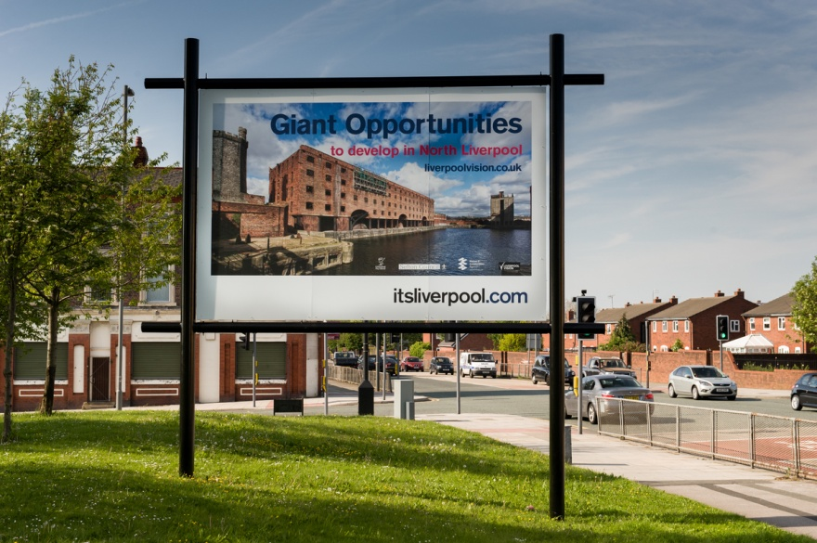

Gateway examples
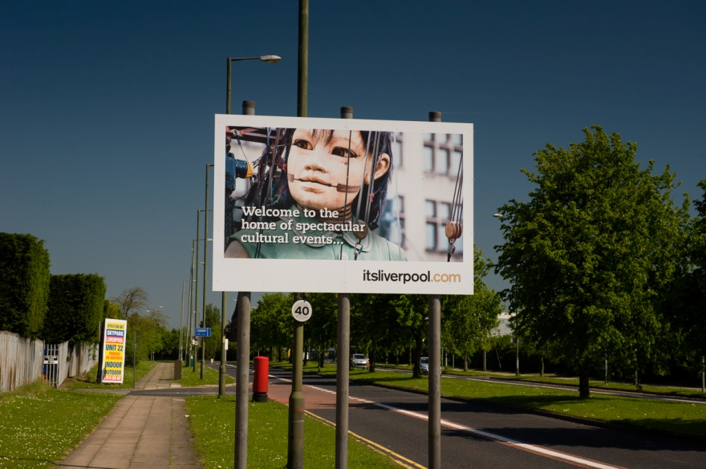

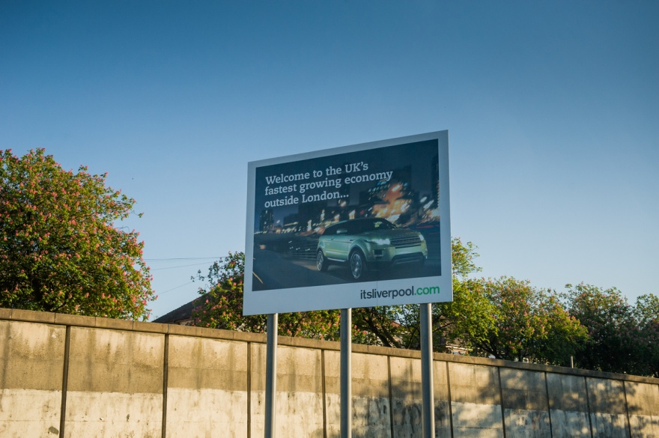

Flag examples

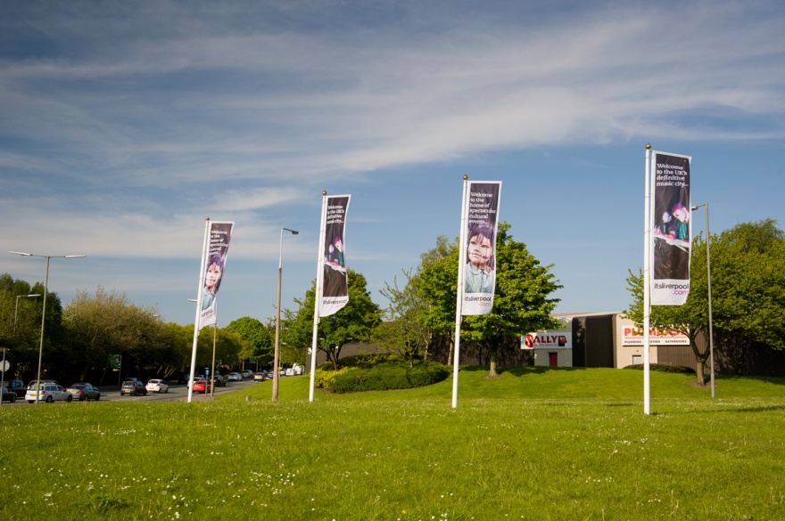

Sites of Gateway and Welcome Signs

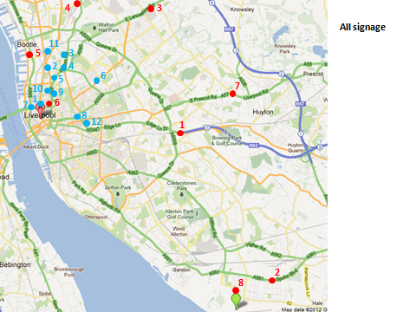

Liverpool Convention Bureau Flags at ACC

22 flagpoles are in a prominent position on Kings Dock; they are approx. 6 m in height.

