**Improvements to existing children’s play area in Pinehurst**

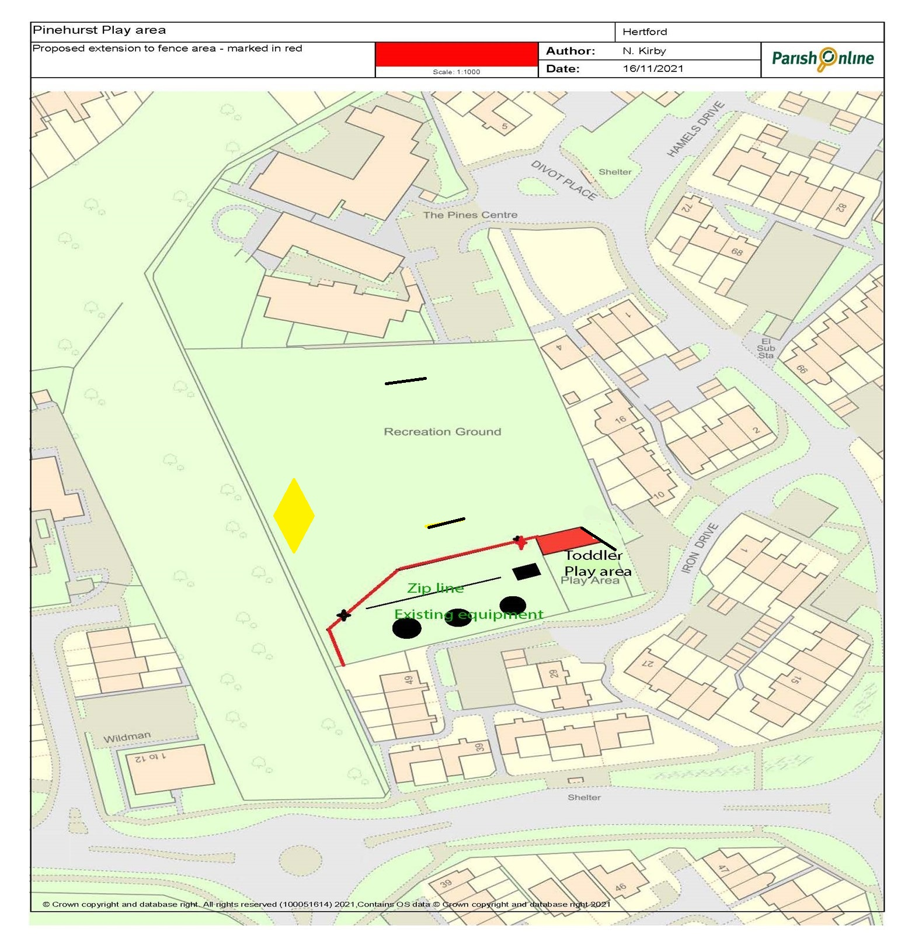

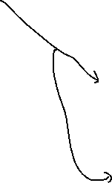

Existing Goal Posts

Proposed new self closing gates A, B, C

C

B

A

Existing basketball hoop/ goal

Please quote for:

1. Supply and install extension to fence area of Toddler play area as shaded red on the plan. Approximately 5m x 16m. Wooden fence to match existing.

**Notes:**

* **One laurel shrub to be removed and the corner of existing fenced area to be moved to allow for wider view into play area**
* **Existing fence and gate between toddler / junior area to be left and extended to sperate the two areas**
* **New self closing gates to be installed at points A, B & C**

1. Supply and install additional inclusive equipment to equipment and inclusive picnic bench and additional litter bin

Suggested examples provided below (but alternative suggestions are welcomed):

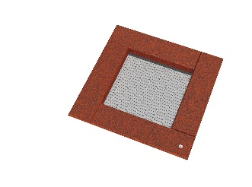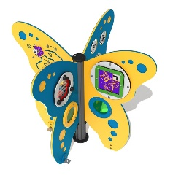

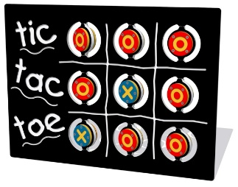

Sunken trampoline (either small 1.25m x 1.25m or large 2.25m x 1.75m)

Butterfly activity Station

Tic Tac Toe activity game on posts

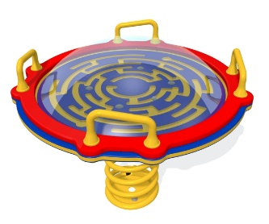

1 X Recycled picnic bench

Spring Maze

1. Football / basketball multi-unit - Supply and install new mesh and three vertical support, mesh to be clamped to new support and external framework using rebound sports clamps.
2. Supply and install basketball hoop
3. Provide a quote for replacing some swing seats with ones suitable for older children (13+) (Make Space for Girls [www.makespaceforgirls.co.uk/](http://www.makespaceforgirls.co.uk/) notes that if provided teenage girls will use swings for exercise / socialising)
4. Refurbish or replace existing two goal posts (if refurbished, works to include rubbing down and painting with suitable paint to protect from rust)
5. Supply and install some additional social face to face seating – as referenced in the Make Space for Girls report (this could be natural log style)
6. Supply and install Another basketball/netball goal with lines so a game can be played

Pinehurst Play Area – Additional detail of proposed improvements

Main entrance

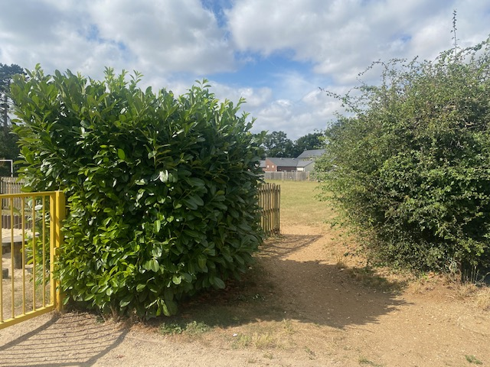Removal of Laural shrub and cutting back hedge to improve views in / out of open space

Remove corner off fencing so wider access

Extension to the existing fencing



To make the toddler playground bigger and also enclose the junior play area including the aerial runway

Red line shows approximate location of new fence line



This will make the whole are dog free (5m x 16m)

In area as shown in photo and per the plan in Appendix 2

Football wall improvements (shaded yellow on plan)

Supply and install new mesh and three vertical support, mesh to be clamped to new support and external framework using rebound sports clamps.

Basketball Hoop

Add new heavy duty chain, potentially look to include for other ball games

Add another Basket ball post / hoop and suitable surface so game can be played

Additional social seating area in the shade

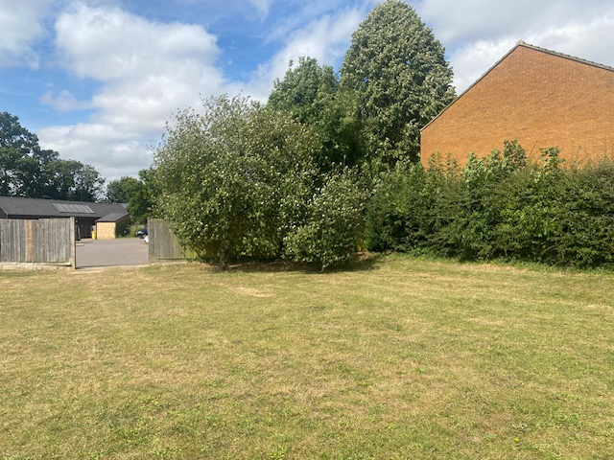

Potential of an informal sitting area under the shade of a tree



The branches can be lifted to enable some informal wooden seating to be installed

Paint / Replace goal two posts