PETER WESTON C.Eng.M.I.Struct.E. 7 SWANGLEY’S LANE KNEBWORTH HERTS SG36A
STRUCTURAL ENGINEERING CONSULTANT Tel. 01438 815488 Fax: 01438 815488

E N G I N E E R I N G R E P O R T

C O N D I T I O N O F B U I L D I N G S T R U C T U R E

B U I L D I N G 1 0 4

A T

I W M D U X F O R D

J A N U A R Y 2 0 1 6 2767

GENERAL

This building is sited on the north side of the A505 and was constructed as a storage building to house large / bulky equipment. The date of construction is unknown but the original drawing was re-traced in 1943 which may be very close to the actual construction date.

It is a rectangular building with a tiled roof. The roof is formed by a pair of duo-pitched slopes with a central valley and hipped ends. There are multiple sliding full height steel clad doors on both the south and north elevations. The west and east elevations are brickwork cavity walls with part glazing and personnel doors. There is continuous brick parapet and projecting concrete canopy around the whole building.

The building is approximately 47m long by 18m wide. The internal height is 4.6m to the underside of the steel trusses.

The structure of the building is classed as composite. i.e. multiple materials are used in the construction of the building.

The main frame of the building is structural steel work encased in concrete in some locations .

The roof trusses are fabricated from steel angle iron with gusseted main connections. The trusses span approximately 8.5metres and are at 3.75metre centres.

There is a continuous ring beam at eaves height comprising universal beams encased in concrete with nominal wrapping reinforcement.

The beams are doubled to span the main openings of (about 11.5 metres between stanchions) on the south and north sides of the building although the ring beam on the east and west flank walls may be single beams.

Smaller steel joists sections are cantilevered from the ring beam to provide reinforcement to the concrete canopy and to brackets supporting the head rail of the sliding doors.
The cantilevered canopy has nominal steel reinforcement between the joists sections and this are the areas which have required the patch repairs to be carried out.

There is a single steel beam, on the line of the central valley, supporting the two spans of steel roof trusses.

The stanchions to the north and south elevations and those supporting the valley beam comprise of paired steel channels also encased in concrete.

The east and west walls are constructed of 220mm thick brick inner leaf, a cavity and then a
further 110mm thick outer brick leaf. There are four high level windows and a personnel door on both walls.

There are 200 x 100 timber purlins spanning between the steel trusses. There is a 225 x 63 timber ridge member. 25mm thick continuous timber boarding spans between the purlins and carries the felt and battens for the interlocking concrete tiles.

There is a modern concrete blockwork partition wall dividing the building in two plus a further ‘caged’ secure area.

There is a 125mm thick concrete floor to the building that is level with the external concrete aprons. The slab is probably unreinforced and is believed to be based upon 150mm of hardcore. The slab is in good condition where visible.
The slab incorporates a continuous gridded channel, to cope with driven rainwater, set just inside of the rolling doors. There are further chases in the floor that have been filled in with concrete.

The valley and box gutters discharge through shoots in both the east and west parapet walls into a total of six 150mm diameter cast irons down pipes to gullies at ground level.

There is internal lighting and recently fitted external lights. There is an alarm system fitted.

Five renovation exercises are reported to have been carried out on the building.

- About 25 years ago the covering to the roof was replaced with Redland 49 interlocking concrete tiles. At the same time the existing gutters were replaced with heavy duty galvanized steel sections.

- The brick parapet wall has been re-built incorporating expansion joints at regular intervals. Many of the mastic joints have become dislodged and need replacing. It was also noted that some of the coping stones to the wall have been knocked out of line and should be re-aligned.

- The concrete cantilever canopy has had a significant amount of, resin enhanced cement, patch repairs carried out in the past year or so.
This was to remedy localized spalling of the concrete exposing the steel reinforcement. The concrete canopy still has areas that indicate the poor compaction of the concrete. This lack of density permits water ingress and allows the reinforcement to corrode which as it expands spalls the concrete away from the surface. However,an anti- carbonation coating was applied at the time of the repairs which should reduce the possibility of further corrosion to the reinforcement.

- The roller doors have been re-painted as have the windows and personnel doors.

- There are external flood lights mounted on the face of the parapet wall.

OBSERVATIONS

In general the building is in good structural order.

Of note however :-

The obvious area which must be carefully checked on a regular basis is the condition of the
concrete canopy. Any fall of concrete could be serious.

There are some areas where the wrapping reinforcement, in encased steel stanchions, has corroded where the concrete cover has been inadequate. This is not significant as the concrete is contained and will still provide weather and fire protection for the encased steel channel sections.

Many of the mastic joints have become dislodged and need replacing. It was also noted that some of the coping stones to the wall have been knocked out of line and should be re-aligned.

The gutters, down pipes and gullies need to be cleaned on a regular basis to prevent water damage to the structure or contents in the building.

The tracks for the roller doors need to be kept clear and the wheels lubricated to ensure continued ease of use.

CONCLUSION

With proper maintenance I consider that the building has a projected life in excess of 25 years.

P.M.Weston C.Eng.M.I.Struct.E.

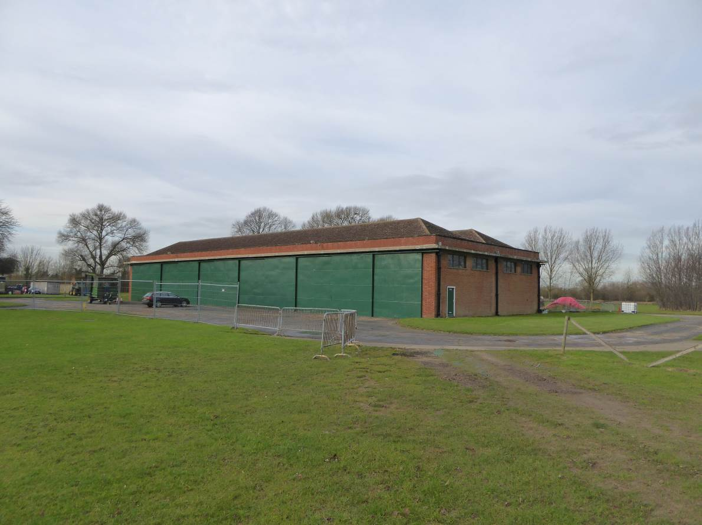
View from the south east

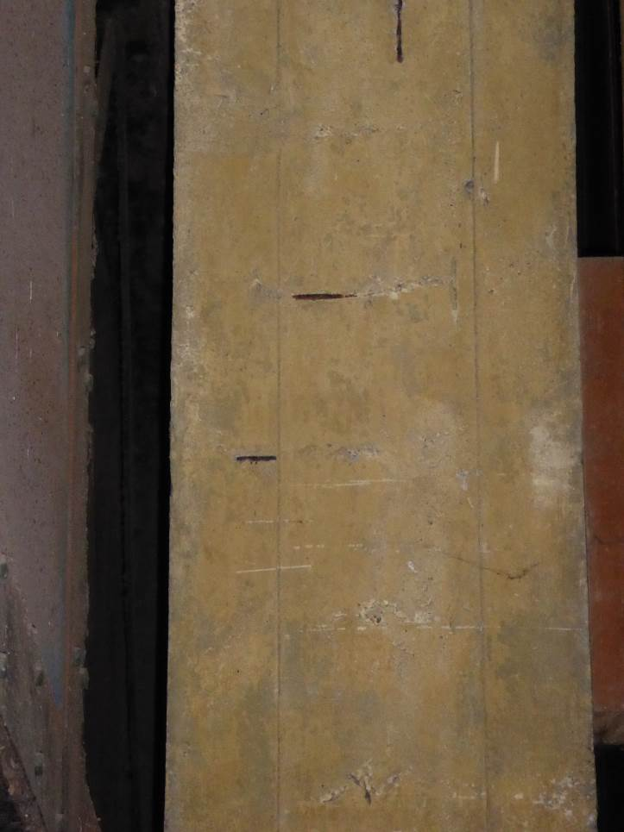
The exposed wrapping reinforcement on one of the stanchions

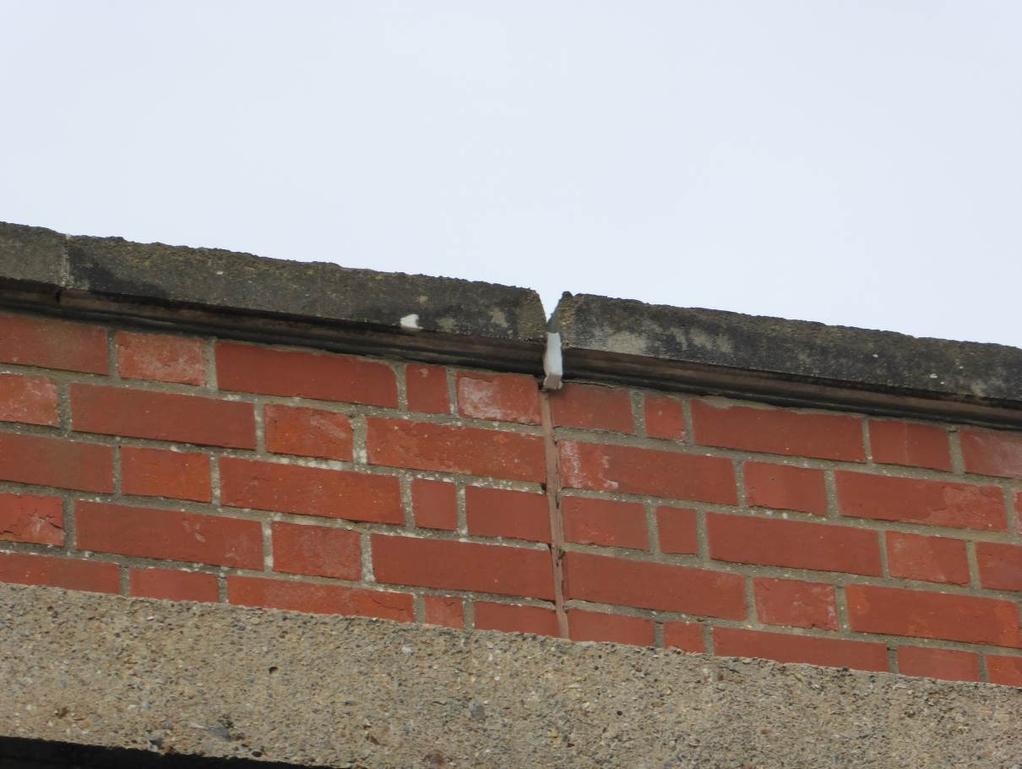
The displaced mastic joint in the parapet wall

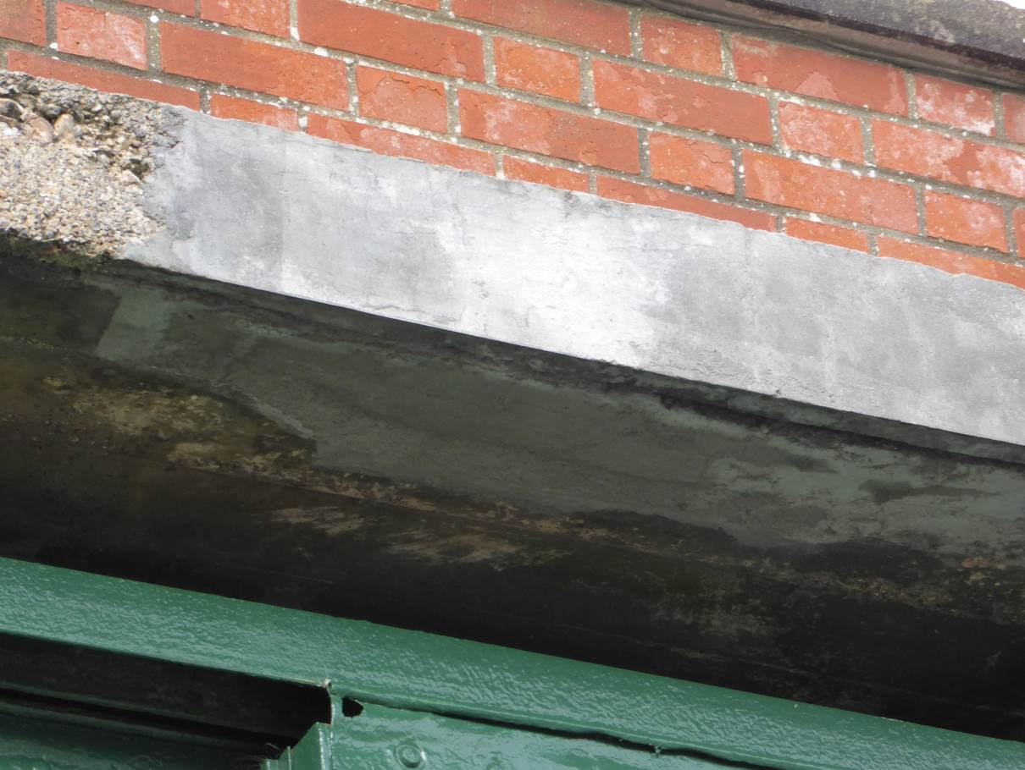
An area of patch repair, also showing a section poor concrete

