Schedule 1 - Requirements Specification and Supplier Response Document

Functional Fit

Overview
This section aims to develop an understanding of how your solution and your product development roadmap will align with our business requirements.

Business Requirements - See Appendix 1 (Spreadsheet)

Question 1.2.1
In the Business Requirements workbook [See Appendix 1 (Spreadsheet)] please complete the columns in the Supplier’s Response section to outline how your solution product aligns to our Business Requirements.

In the workbook, there are 3 columns in the supplier response section:
- Column E: Please provide details of how your solution is able to meet the requirement
- Column F: Self Assessment of your product’s current capabilities (based on options below)
- Column G: Self Assessment further information

The self assessment in column F has a drop down menu for you to use in documenting your product’s current capabilities.
The response options include the following:
- Not possible.
- Possible in the platform with significant customisation (over 20 hours).
- Possible through minor customisation (fewer than 20 hours).
- Not possible in the platform, but the platform integrates out of the box (OOTB) with another solution. There will be no development or customisation required. Please name platform.
- Possible through configuration by supplier.
- Available out of the box (users can configure in fewer than 1 hour).

Please include any commercial considerations / implications driven by your response in the comments section.

Response
<Please return a completed copy of the Business Requirements workbook>

Processes

Question 1.3.1
Please provide high-level logical process maps describing the relevant parts of your system.
Response
<You may prefer to provide process maps in a separate attachment>

Vendor Roadmap

Question 1.4.1
- Please provide a summary of or share details of your product development roadmap for the next three to five years
- Please describe how your clients’ needs are reflected in the roadmap plan and how this process is managed, including any third party supplier requirements.
c) Please specify up to 5 key features on your product roadmap that you feel will be of particular interest or benefit to RCGP. In your response please articulate why you have highlighted the feature and when it will be available in your product roadmap
Response

Question 1.4.2
Please confirm:
a) when your product roadmap was last refined
b) the frequency with which it is refined / iterated
c) when the next version of the roadmap is due to be published
Response

Question 1.4.3
Please list the key software or hardware Partners that you currently work with and the service that they provide. For example, any software, infrastructure or hosting Partners. An example of a partner would be any third party that you use to host your software or provide integration services with other cloud providers.

- Please highlight which of your existing hardware and software alliances you believe are relevant to RCGP and explain the benefit that they may bring

- Please confirm if there are any other planned alliances that may bring benefit to RCGP. Please outline timelines if available / non confidential (for these alliances) and explain the benefit that they may bring

- Please confirm which software or hardware are required to deliver your three to five year product roadmap
Response

Technical Fit

Overview
This section aims to develop an understanding of the technical components of your solution and how they align with our technical needs, standards, policies and procedures. The objective of this section is to understand, challenge and evaluate the level to which your solution product and supporting infrastructure complies with and addresses RCGP technical questions.

Please include any commercial considerations/implications driven by your response in the Cost of Ownership and Commercial workbook (Schedule 4).

Architecture Alignment
The RCGP applications landscape consists of a number of bespoke and standalone applications that have been developed independently over the years. Need for integration and interoperability led to the creation of several components that were responsible for moving data from one application to another. The organic growth of such environment resulted in the utilisation of a wide range of technology. The complexity of today’s architecture is represented by the following high-level diagram:

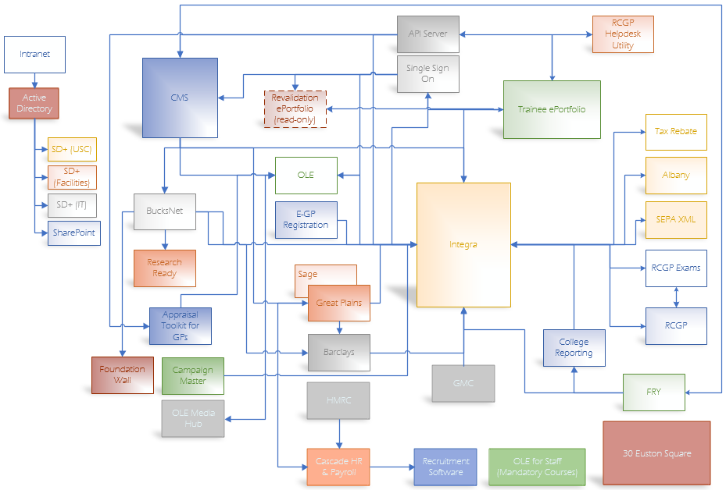

The integration and interoperability functionality is supported by a combination of automated and manual processes making the management of RCGP systems very expensive in terms of time, people and time. The College aspires to simplify the overall architecture complexity and automate as many of the background business processes as possible.

We want to achieve these objectives utilising latest technology capabilities and more up to date architectural patterns and best practices. Service Oriented Architecture (SOA), Enterprise Service Bus (ESB), Application Programming Interface (API), Cloud services, etc. are some of the tools that the intended solution will need to use in order to satisfy the College requirements.

Question 2.2.1 Technical Fit into the current Applications Landscape
With reference to the above scenario, please outline how would your solution product would fit in our current estate?
(Note: a more detailed system view is available upon request along with the receipt of the signed NDA). Please consider in your response existing applications that your product has proven data exchange capabilities with.
Response

The following diagram is a possible scenario (use of an API Server, hosting a number of web services), for simplifying the current systems point-to-point integration.
(Note: this is not the agreed target system architecture and at this point in time it only offers an indication of direction of travel)

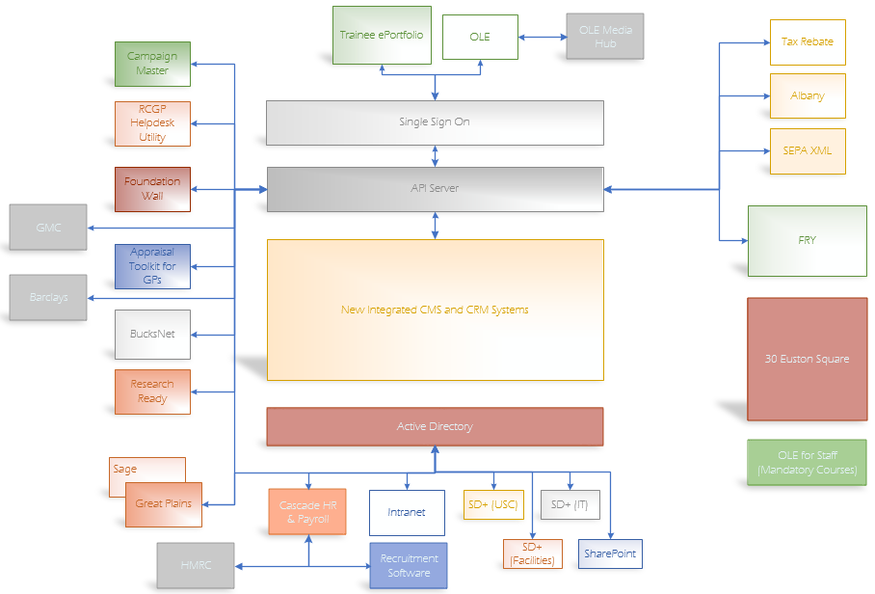

Question 2.2.2 Technical roadmap to a simplified Applications Landscape
Considering the College aspiration to simplify their overall systems architecture (see above diagram), how would your solution product fit in such architecture and how would you envisage further enhancements to it?
Response

Integration

Question 2.3.1 Interaction with External Systems
Please outline in detail how your system solution may receive data from and sends data to the following systems:
Trainee ePortfolio, Fry (exams), Moodle (online eLearning), Sitecore (CMS), Great Plains (Finance), Cascade (HR), Active Directory system and Office Applications (e.g Microsoft and/or Google), with emphasis on a SOA Framework with web services (when appropriate).
Response

Question 2.3.2 Interaction with our Business Intelligence and Big Data capability
Please outline how you would address:
- Transference of bulk data to/from a data warehouse using web services.
- Receipt of data from another external source.
Response

Question 2.3.3 API
If service WSDLs and Schemas are not used, please provide comprehensive technical details of your solutions’ API.
Response

Question 2.3.4 Services, WSDLs, and Schemas
Please provide an overview of your exposed web services and associated WSDLs and Schemas.
Please provide examples of your service’s WSDLs and Schemas (E.g. XSD)
Response

Question 2.3.5 Service Oriented Architecture
Our Integration approach is using services in a Service Oriented Architecture. Please outline the integration methods/protocols that you prefer to adopt when interfacing with our systems. E.g. REST based services; SOAP based messaging.
Response

Data Strategy

Question 2.4.1 Data Management/Creation
Please indicate the capability to extend or modify your data constructs to include additional attributes or data which may be required by one of our systems/applications. Please include who is able to extend the system (e.g. RCGP developers, your in-house developers, third suppliers etc.), who you recommend is permitted to and at what level for certain types of extensions/modifications.
Response

Question 2.4.2 General Data Protection Regulation (GDPR)
The General Data Protection Regulation (GDPR) is set to come in force in 2018. How do you intend to ensure compliance with the law?
Response

Data Migration

Currently the College contains over 104,000 records within its CRM system. Of this 47,000 are non member records, some of which may not be required for migration.

Question 2.5.1 Legacy Data
What do you recommend customers do about importing legacy data (including financial data)?
Response
Question 2.5.2 Data Protection
What services/support do you offer to customers towards data migration, including mapping from legacy to new system? Please ensure you indicate whether this is an additional cost.
Response

Technology and Platform Compatibility

Question 2.6.1 Cloud Hosting, Hosting Infrastructure and Data Hosting Arrangements
Please confirm your cloud hosting arrangements and where this infrastructure would be located / hosted, indicating in your response:

a) Do you use a third party or in house hosting model?
b) Which third party hosting providers you use?
c)The location of the data centre
d) The security level on the data centre
e) Connectivity to the data centre
f) What infrastructure will be shared with other clients versus unique to RCGP? Examples of infrastructure would include hosting, storage or networks.
Response

Question 2.6.2 Operating Systems and Browsers
Please confirm what operating systems and browsers your solution product supports. Please list in your response:
a) What versions of operating systems & browsers you support
b) Whether there are plans (and if so when) to remove support for other operating or browser system versions (I.e. IE 7), and when this support is scheduled to be removed
Response

Question 2.6.3 Scalability
Please outline the process for scaling up or down the following areas of the platform:
a) Network connectivity and bandwidth
b) Storage
c) Horizontal (i.e. add a server) versus vertical (i.e. CPU) scalability
d) What happens if agreed data bandwidth limit is reached? Is service disrupted?
Response

Question 2.6.4 Network Topology
Please provide a summary of your network topology. Please include in your response:
a) A network topology diagram
b) Current network capacity to your data centre
c) Recommended bandwidth between RCGP network and your network
Response

Question 2.6.5 Storage and Archiving Process
Please provide an overview of your storage and archiving process for your solution product. Please include in your response:
a) What data is archived
b) How frequently data is archived
c) Recommendation on storage network usage and frequency
d) Typical recovery response times.
Response

Security

Question 2.7.1 Information Management Security Systems
Is your information security management system certified compliant with ISO 27001? This includes any third parties contracted by you to handle your customers data.
Response

Question 2.7.2 Data Protection
Does your solution adhere to the data protection principles under the UK ‘Data Protection Act 1998’ where data is:
- used fairly and lawfully
- used for limited, specifically stated purposes
- used in a way that is adequate, relevant and not excessive
- accurate
- kept for no longer than is absolutely necessary
- handled according to people’s data protection rights
- kept safe and secure
- not transferred outside the UK without adequate protection

In addition to the data protection act, if data is stored within the E.U, please indicate your adherence to ‘EU Directive 95/46/EC’ by the Organisation for Economic Cooperation and Development (OECD) on the protection of personal data:

- Notice—data subjects should be given notice when their data is being collected
- Purpose—data should only be used for the purpose stated and not for any other purposes
- Consent—data should not be disclosed without the data subject’s consent
- Security—collected data should be kept secure from any potential abuses
- Disclosure—data subjects should be informed as to who is collecting their data
- Access—data subjects should be allowed to access their data and make corrections to any inaccurate data
- Accountability—data subjects should have a method available to them to hold data collectors accountable for following the above principles.

Please indicate in which country our data will be stored, transferred and processed.

If data is stored outside of the U.K / E.U do the provisions of the 'Privacy Shield' meet the 'Data Protection act' and 'EU Directive 95/46/EC on the protection of personal data'?
Response

Portability, Usability and Accessibility

Question 2.8.1 Disability Discrimination Act
Does your product comply with accessibility guidelines such as such as the Equalities Act or W3C?
Response

Compliance, Audit and Control

Question 2.9.1 Auditing
Please provide a redacted audit log from one of your current clients within the past 12 months. This is to enable us to see an example of the audit controls available on your system
Response

Question 2.9.2 Data Change Trail
Please explain the process for making key schema changes.
Response

Question 2.9.3 Security
How do you ensure the application is secure. You may consider Penetration Testing, Vulnerability Scanning, pre-employment screening etc.
Response

Question 2.9.4 Payment Card Industry Data Security Standards (PCI-DSS)
If this service includes processing and/or storing payment card data, please confirm whether you are PCI-DSS compliant and provide the organisation’s merchant number
Response

Question 2.9.6 Incident Response Plan
Do you have an Incident Response Plan? What does it include and how often is it tested? What is the date of the last test?
Response

Solution Delivery and Implementation

Overview
This section aims to develop an understanding of how you will deliver and implement your solution. The objective of this section is to understand, challenge and evaluate the level to which your solution delivery approach complies with and addresses our questions.

Project delivery approach

Question 3.2.1
Please provide an example of your experience in delivering services similar to those required by RCGP for other clients, with specific reference to:
a) The implementation approach
b) The project scope, budget, timeline, team size
c) A detailed explanation on the relevance of each experience and how it can contribute to the effective delivery of RCGP requirements
d) Major risks and issues faced and how these were overcome
e) Lessons learnt
Response

Question 3.2.2
Please can you describe how you will define the most efficient and effective approach required to deliver our business needs:
a) How will you ensure the successful deployment of the project on time
b) How will you ensure the successful deployment of the project on budget
c) How will you model costs including costs for changes to the solution and for integration
d) How will you address change management
e) How will you ensure traceability of the requirements to the solution
f) what delivery approach will you take to minimise the impact to the business
g) How will you ensure quality of the approach
Response

Question 3.2.3
Please provide your perspective on the areas of highest risk for an implementation of this scale & complexity and your recommendations on appropriate risk response(s).
Response

Question 3.2.4
Please provide a timescale for the delivery of the recommended solution, including the implementation and handover phase. Your response should:
a) Indicate how soon could make use of the software following the outcome of this RFP and any proposal for initial engagement, including pre-requisite deliverables, to develop detailed design and confidence in an on going engagement.
b) Outline the procedures and processes used by the proposed team in order to comply with the project timetable
c) Indicate the availability of your project resources, taking existing and planned commitments into account
d) Confirm availability – if selected as preferred supplier - to commence working with RCGP on the project from June 2017, potentially under a letter of intent.
Response

Question 3.2.5
Describe the key skill sets required for the delivery of the recommended solution, and provide brief biographies of key individuals proposed for the implementation. This must include but is not limited to:
a) Employment type i.e. Employee, Contractor
b) Length of employment with yourself
c) Certifications and relevant qualification
Response

Question 3.2.6
Provide a breakdown of the overall number and skill level and availability of resources you have available to support RCGP during an implementation of the recommended solution. Please provide a resource location breakdown for UK, Europe and Worldwide.
Response

Question 3.2.7
Please state if any aspects of your project delivery or account support (including help desk, service desk, Network Operations Centre or billing departments) are outsourced. If so, please state the name of the third party and location.
Response

Question 3.2.8
What other third parties, if any, would you recommend that RCGP considers and why (e.g. business change and training service providers)?
Response

Question 3.2.9
What steps do you take to ensure a professional and efficient engagement is developed and maintained – in particular with regard to communications, commitment and resourcing?
Response

Question 3.2.10
Do you provide, or have you worked with Systems Integrators in previous similar implementations? If so, please indicate
- their names
- the nature of the engagement
- the advantages and disadvantages with this approach from your experience giving examples
- key risks that this approach has had and how you have mitigated these
- the impact this approach has had on the delivery of the project – both positive and negative
- any other key considerations to be aware of using this approach from your previous experience.
Response

Question 3.2.11
Have you ever had an implementation that did not result in a successful go-live, on time and on budget? If so, please detail what, in your view, were the factors that contributed to this.
Response

Detailed Design / Discovery

Question 3.3.1
Please can you describe your approach to this phase and if not covered in other sections, include:-
a) Implementation roadmap
b) Schedule
c) Expected inputs / outputs (including examples and RACI)
d) Quality measures
e) Methodology
f) Relevant factors affecting:-
- Business change
- Module design / enhancement
- Integration
- Data
- Infrastructure
- Environments
g) Key considerations for the phase
Response

Build

Question 3.4.1
Please can you describe your approach to this phase and if not covered in other sections, include:-
a) Implementation roadmap
b) Schedule
c) Expected inputs / outputs (including examples and RACI)
d) Quality measures
e) Methodology
f) Relevant factors affecting:-
- Business change
- Module design / enhancement
- Integration
- Data
- Infrastructure
- Environments
g) Key considerations for the phase
h) location of resources
Response

Question 3.4.2
Do you have a development methodology? If so, please provide case studies of previous successful implementations using this approach.
Response

Question 3.4.3
Please explain what tools and processes you recommend for your product with regards to
a) Version Control and Configuration Management
b) Migration of solution across development, testing and production environments
Response

Testing

We want to understand your approach to testing and working with the RCGP.

Approach to Testing

Question 4.1.1
Please can you describe how Testable your product is? This should be in relation to but not limited to Functional documentation, UI, and Accessibility.
Response

Question 4.1.2
Please describe the reporting data that clients can expect to receive from test results and the collaboration you may be able to provide to the RCGP Functional and Non-Functional test teams.
Response

Question 4.1.3
Please detail any testing risks which are unique to your implementation.
Response

Question 4.1.4
List all types of testing that you would expect to be carried out as part of this project (e.g. functional, non-functional, operational acceptance testing (including Business Continuity testing), performance testing, penetration testing, vulnerability testing, integration testing, cycle testing, accreditation testing if required for regulatory or statutory purposes). State clearly whether you expect in terms of:
- test preparation (including documentation, test scripts, entry and exit criteria)
- test execution
- test data preparation and environment refreshing
- test phase management
- defect triage and defect management
- overall Test Strategy and Test Management
to carry out this testing yourself, whether you expect RCGP to carry out each of these roles. This may be subject to future discussion but in order to provide a price for this work, we need to understand what you have assumed you will and will not cover as part of that price.

Response

Test Environments

Question 4.2.1
Please explain your approach to Test Environment Management along with any appropriate Industry Standards to which you adhere.
Response

Question 4.2.2
Please describe your approach to Application Build, Deployment, and Release Management specifying whether the environments are self-hosted or if hosting would need to be provided by RCGP along with any specific hosting requirements.
Response

Question 4.2.3
Please describe your defect management process within your testing environments
Response

Training Services

Question 4.3.1
Please explain how your training service is structured, with specific reference to:
a) Your capabilities (e.g. training locations, frequency, size, materials, language)
b) Your training offerings (e.g. end-user training, group training, train-the-trainer, Computer Based Training)
c) Typical delivery timescales for this type of project
d) Typical client specific deliverables provided and indication of whether these are part of the commercial offer
Response

IT Project Closure & Transition to Support

Question 4.4.1
Please provide details on your planned post-deployment software support offering (during and post project). Include any hardware or accessories necessary for the running of the solution (if applicable).
Response

Question 5.7.2
Please outline a specific change journey that you would expect RCGP to experience and describe the key change interventions you would use to ensure the experience is a positive and successful one for the business and all of its stakeholders (e.g. end users, project team, sponsors etc).
Response

Project Documentation

Question 4.5.1 Documentation Overview
Please provide a list of documentation for your solution.
A functional document and a technical document for your solution/product should be provided (in their entirety as separate documents).
Response
Document  Name & Version | Type of Documentation  (E.g. Functional, Technical, or Project related) | Overview of Content | Document Location & Accessibility Comments

Question 4.5.2 Documentation Detail
Please confirm for the documentation mentioned
a) The frequency with which that documentation is updated
b) How the documentation distributed to your client base
c) What support you provide as a supplier to help your client understand that documentation
d) Where are the electronic documents that you want to add to the system located?
e) In which formats could the documents be provided? (e.g. Word, PDF, TIFF, JPG)
Response

Operational

Overview
This section aims to develop an understanding of the operational service levels and support and maintenance models. The objective of this section is to understand, challenge and evaluate the level to which your solution product and supporting infrastructure complies with and addresses our questions.

Please provide a written response to all questions

Maintenance and Support

Question 5.2.1
Please give a detailed overview of your post-implementation and BAU support model
Response

Question 5.2.2
What levels of operational support are provided by your standard support and maintenance contract? Please include:
(i) What the processes are for error logging, tracking, triage and response to support requests? Please include evidence of incidence management, change management and release management processes.
(ii) What the escalation process is for bugs and operational problems?
(iii) How you work with other third parties (who may provide hardware)?
(iv) What severity levels and priority levels you use to classify each support request? For each include the SLAs for time to respond and expected time to fix.
Response

Question 5.2.3
Please provide an overview of the release management process for your product. Please consider in your response:
a) Please explain how you manage upgrades and patches to the system? Include how frequently you release upgrades to the system and if this changes depending on which modules we use?
b) How far in advance your clients are provided with notice of the release
c) The delivery mechanism for the release
d) The options available for rollback if the release cannot be deployed successfully
Response

Question 5.2.4
Please provide details of any warranty that is provided with the software. Does this cover just core software, or additionally configuration and/or customisation?
Response

Question 5.2.5
Outline any premium product support services that you offer to your customers. Please include:
(i) Detail on the additional level of service that the premium service offers over your standard support and maintenance contract.
(ii) If you offer tailored SLAs to meet specific customer needs.
Response

Question 5.2.6
Is remote access required by your support team to resolve issues? If so, which components of the solution will require remote access to support?
Response

Question 5.2.7
What third parties are used to provide your support services? Please include detail on:
(i) Are there any limitations in the authorisation of those third parties to install and use support tools (including administration/ error consoles, call centre support etc)?
(ii) What support tools and skills are required within RCGP?
(iii) Where are these third parties located and is there any impact to data access/management if outside EU?
Response

Question 5.2.8
Explain your policy for sharing changes and updates to technical and system documentation
Response

Question 5.2.9
How do you plan to support RCGP in future developments? Please consider enhancements to existing functionality across several business units, how quickly you would respond to a request for change and how your estimating process works?
Response

Question 5.2.10
Describe the administration tools that are bundled with the product and outline if the product be administered by any third party administration tools? If so, state which ones and what advantages they afford RCGP?
Response

Question 5.2.11
RCGP has traditionally approached system monitoring in a tactical fashion concentrating largely on infrastructure monitoring (point solutions for different elements in the technical stack). Please explain how your solution monitors system usage, and describe what a strategic monitoring solution would look like (including any algorithm-based fault prediction technology) – ensure that you include what tooling you would offer to support this or which third party products RCGP should consider purchasing?
Response

Question 5.2.12
Describe the full list of typical IT and non-IT resource requirements you would expect from an operation of RCGP’ size and complexity to support the proposed solution. In you answer, identify the roles and resources required from RCGP, yourselves and any third parties and consider what mix of internal and external support resources would work best.
Response

Question 5.2.13
Indicate who owns the source code and if you include escrow agreements on source code availability?
Response

Question 5.2.14
Is there any requirement for any of the upgrade processes within your system that require all servers and clients, or all clients, to be upgraded at the same time? Can the upgrade be implemented without down time? If not, what are typical maintenance windows for updates and what are the scheduling implications on RCGP?
Response

Question 5.2.15
What are the arrangements for fixing bugs in between releases?
Response

Question 5.2.16
Describe how version controls of your solution (source code, configuration files, executables etc) may be managed by the customer.
Response

Question 5.2.17
What is the process for managing licence and product key expiry dates?
Response

Question 5.2.18
What tools are available to RCGP to create and run ad-hoc user reports, and how long would it typically take to create a simple report?
Response

Question 5.2.19
Does your standard support and maintenance contract include support of data including configuration data? What additional support, if any, would RCGP be expected to provide?
Response

Operational Service Levels

Question 5.3.1
What Service Level Agreements (SLAs) exist between your support organisation and customers? Please provide full details of your support model including the types of support offered (such as telephone support, call out, hours of operation etc.).
Response

Question 5.3.2
On system availability and service performance, please confirm:
a) How many service outages have you experienced in the last two years
b) How long these outages lasted (i.e. in hours or days)
c) What was the root cause for these outages
d) What impact these outages had to the business concerned (i.e. did it prevent critical business processes from being executed)
Response

Question 5.3.3
How do we address requests for development changes? Who is responsible for requesting these changes and what are the lead-time and typical costs?
Response

Question 5.3.4
RCGP have periods of heightened change control, such as our IT freeze period during renewals (February to mid April). If we decided on a cloud based solution, how would you respect and support these periods?
Response

Question 5.3.5
Do we have to/are we advised to take every patch/release? What are the support implications if we don't? If we skip a release is it possible to combine it with the next one that we do take? How many can we skip?
Response

Governance

Question 5.4.1
How frequently are service reviews held, and what process is followed?
Response

Question 5.4.2
Please explain how you manage other similar accounts. In your answer please include information around your resource structure, no. of meetings and any other relevant detail.
Response

Question 5.4.3
Where is your support team based and what hours do they support?
Response

Question 5.4.4
If your helpdesk is located outside the UK, how would time differences be reconciled? Are cases shared between support centres in different countries?
Response

Question 5.4.5
Where is your development team based?
Response

Business Continuity

Question 5.5.1 Disaster Recovery (DR)
Considering the cloud hosting nature of the proposed AMS solution, what is your disaster recovery offering?
Response
Please articulate your DR approach - Backup vs. Replication for Recovery.

Question 5.5.2 DR Strategy
Please provide your insight and recommendations on the following DR approaches:
- Traditional backup and recovery
- Pilot Light
- Warm standby
- Multi-site
Note: Although costs implications should be part of your answer, within the context of this question, affordability is out of scope
Response

Question 5.5.3 DR procedures
Please provide an overview of your disaster recovery procedures, including:
a) Preventative measures
b) Detective measures
c) Corrective measures
d) How often this is tested
e) If there is any impact to RCGP while testing DR and, if so, the notice we would receive
Response

Question 5.5.4 DR processes
Describe the failover and recovery process for each component in the solution. Indicate the steps that occur automatically in the event of a failure and any changes that will have to be made manually to the infrastructure (e.g. repoint application server to the failover database)
Response

User Administration

Question 5.6.1 Licensing model
Based on the, number of users what type of licensing model that you feel would best suit our:
a) Central Office (circa 160 staff)
b) Faculties (circa 90 staff)

Include costs for both Cloud (SaaS/PaaS) and Cloud (IaaS) deployments.
The Licensing model should indicate where model is user / service based.
Response

Question 5.5.2 Licensing Scalability
Please explain the process for increasing the number of licenses once we have made the initial license, software, service purchase. Also, the process for scaling down / decreasing the number of licenses.
Response

Question 5.6.3 Hierarchical Support
Describe the number of levels of an organisational structure or hierarchy that your system supports in terms of user access.
Response

Question 5.6.4 User Group Security
Please explain if user security can be managed by the use of user groups?
Response

