**British Deputy High Commission Lagos, Nigeria**

**Main Works**

**Contract Ref CPG-9053-2022**

We invite you to register your interest for the British Deputy High Commission, Main Works via the Procurement Portal, e-Bravo/Jaggaer.

**BACKGROUND INFORMATION**

The British Deputy High Commission (BDHC) in Lagos is situated in its own small compound in the Victoria Island area of the city. The main building is in a poor state of repair and suffers from ongoing maintenance issues incurring significant costs. There is an over-provision of space within the BDHC compound and consequently, there is an opportunity for estate rationalisation, bringing other services and people connected to the BDHC into one place.

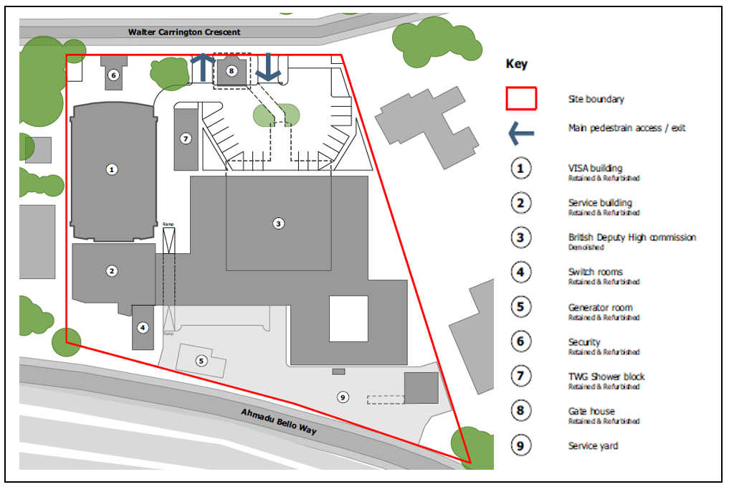There are three main buildings on the site, the UKVI Building, which is to be refurbished, the Service Building, which houses plant feeding the rest of the compound, and the Chancery where staff are currently based. There are also a number of other, smaller buildings such as changing rooms. The plan below identifies the main items on site.

**The Requirement**

This is the pre-qualification questionnaire for the appointment of a contractor to carry out the remodelling and refurbishment of the compound. The contractor will be expected carry out all the works required, with sub-contractors as necessary, according to appropriate legislation.

The contractor’s scope of work includes, but is not limited to:

* Refurbishment of the existing UKVI Building (Building 1 on the site plan)
* Reconfiguration of the Service Building (Building 2 on the site plan), and installation of new mechanical plant to serve the UKVI Building
* Demolition of the Chancery (Building 3 on site the plan)
* Build a new vehicle workshop
* Comprehensive remodelling of the BDHC compound including site-wide infrastructure and removal of fuel tanks
* Construction of concrete security wall with vehicle access gate along the southern boundary of the site

The compound will be occupied throughout and in order to minimise disruption works will be carried out in phases. A separate asbestos removal contract has been undertaken. Specialist works will be carried out by the FCDO directly.

Although being undertaken in Nigeria, the project will be required to comply with UK Building Regulations and British Standards including but not limited to electrical wiring BS 7671 (18th Edition).

The contractor’s roles and responsibilities will be fully detailed in the tender documents but are summarised as follows (full specification and drawings will be issued with the ITT):

* Completion of the project on time, to the agreed quality standard as set out in contract documentation
* Preparation, implementation and maintenance of a construction programme
* Issue of progress reports to an agreed format and at agreed frequency
* Management and responsibility for site health and safety
* Management, responsibility and co-ordination of site logistics including site delivery access and egress
* Provision of satisfactory operation and maintenance documentation
* Preparation and maintenance of a Health & Safety Plan
* Preparation of a proposed final account for agreement with the Cost Manager
* Making good all defects
* Attending/chairing meetings (e.g. progress meeting, site meetings, quality control meetings, defect inspections, etc.)

At this stage, Potential Suppliers are not submitting a price to undertake the contract but providing information relating to their company and experience so we can assess their eligibility as a supplier to be able to deliver the works. Submissions will be evaluated using criteria set out in the SQ and those achieving the highest and acceptable scores will be invited to participate in the ITT. Potential Suppliers will be required submit complete applications which:

* achieve a minimum score of **60**%, and
* obtain a ‘Pass’ in all ‘Pass/Fail’ questions

The ITT will include further details of the site, description of the work and detailed evaluation methodology for contract award. It is anticipated that tenders will be evaluated based on a split between the Commercial, Quality and Social Value aspects of your tender respectively to arrive at the Most Economically Advantageous Tender (MEAT).

The Form of Contract will be the **NEC4 ECC Option A as amended by the FCDO**.

|  |  |  |
| --- | --- | --- |
| **Date or Target Date** | **Duration** | **Activity** |
| **09/12/2022** | ◆ | SQ issued |
| **03/01/2023 12:00 GMT** |  | Clarification Question deadline |
| **10/01/2023 12:00 GMT** |  | Deadline for Authority to response to Clarification Questions |
| **16/01/2023 12:00 GMT** | ◆ | SQ Response Submission Deadline |
| **03/02/2023** | ◆ | ITT issued |
| **TBA – w/c 06/03/2023** |  | Bidders Conference (On Site) |
| **13/04/2023 12:00 BST** |  | Clarification Question deadline |
| **20/04/2023 12:00 BST** |  | Deadline for Authority to response to Clarification Questions |
| **28/04/2023 12:00 BST** | ◆ | ITT Response Deadline |
| **26/06/2023** |  | Notification and start of the 10 days |
| **10/07/2023** | ◆ | Contract award |
| **From** **10/08/2023** |  | Start on site |

Submissions from subcontractors or suppliers for part of the works will not be considered. If the SQ is satisfactory then an invitation to tender (ITT) will be issued electronically via the dedicated FCDO web portal.

In order to be considered for this project and receive pre-qualification and/or tender information it is necessary that you register your company (including any relevant information requested) on the Foreign, Commonwealth & Development Office Procurement Portal, e-Bravo/Jaggaer. **Failure to do this will mean your company may not receive a Tender; no tenders will be issued via open e-mail**.

**Project 9053, PQQ 1320: British Deputy High Commission Lagos, Nigeria**

**Main Works**

**How to Register Your Company/Express Interest in this Project**:

1. Register your company on the eSourcing portal (this is only required once) - Browse to the eSourcing Portal: **https://fcdo.bravosolution.co.uk** and click the link to register. - Accept the terms and conditions and click "continue" - Enter your correct business and user details - Note the username you chose and click "Save" when complete - you will shortly receive an e-mail with your unique password (please keep this secure).

2. Login to the portal with the username/password - Click on the relevant Selection Questionnaire (SQ) - You can now access any attachments by clicking the "Settings and Buyer Attachments" in the "Actions" box;

Responding to the SQ - You can choose to "Reply" or "Reject" (please give a reason if rejecting) - You can now use the 'Messages' function to communicate with the buyer and seek clarification - Note the deadline for completion, - There may be a mixture of online & offline actions for you to perform (there is detailed online help available), You must then publish your reply using the publish button in the "Actions" box on the left-hand side of the page. If you require any further assistance please consult the the online help or contact the eTendering help desk.

Potential Providers should answer all questions as accurately and concisely as possible in the same order as the questions are presented. Where a question is not relevant to the Potential Provider’s

organisation, this should be indicated, with an explanation. Where attachments are requested to be submitted within the electronic SQ, these shall be submitted in a PDF format (Adobe or similar).

SQ or Bids not submitted via the FCDO’s eProcurement portal will not be considered.

**SQ Return Date: 12:00hrs – Friday 16th January 2022 (GMT) – Please note that any SQ’s submitted after the deadline has closed will be considered ‘late’ and may not be accepted for shortlisting.**