**SUNNINGDALE TRACKWAY REPAIR**

The allotment at Sunningdale has 2 ways of entry, the principle entry is from Hathermead Gardens and the other is via the trackway off Monmouth Road.

The allotment site has natural springs which are within the “wildlife area”. The trackway through Sunningdale runs on a steep slope with the Hathermead Gardens entrance sitting higher than the Monmouth Road trackway entrance. When there are significant downpours of rain, the trackway at the bottom gets particularly boggy.

As cars drive up and down the trackway, the trackway has embedded further partially caused by the rainwater saturating the track as it runs down and partially due to natural erosion. The grass mound in the middle of the track has got deeper and is now scuffing the bottom of cars driving up and down the track. The mound in the middle of the trackway is very prominent.

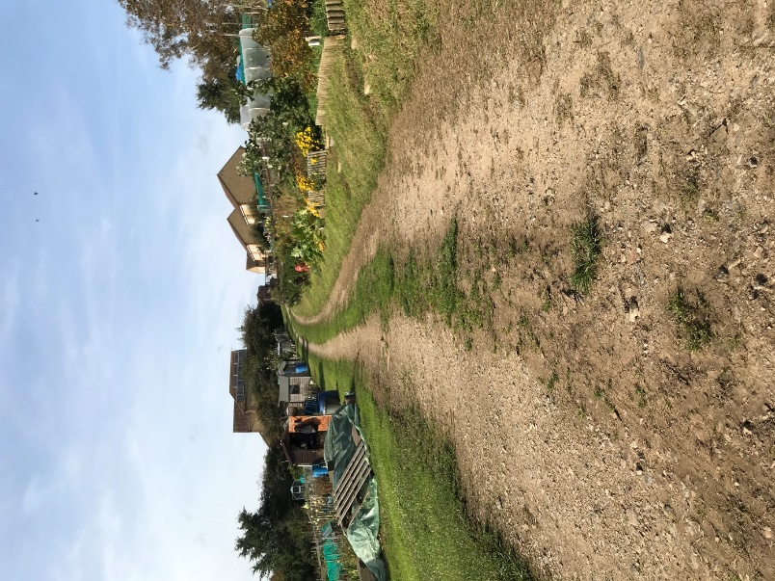

*From corner looking towards Hathermead Gardens*

Please quote for the removal of the centre grass mound and laying and compacting scalpings where required to improve the structure of the trackway.

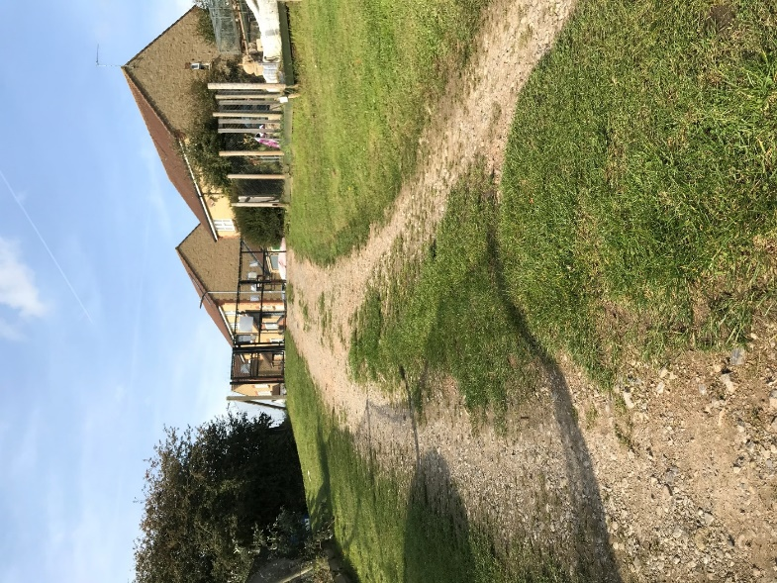

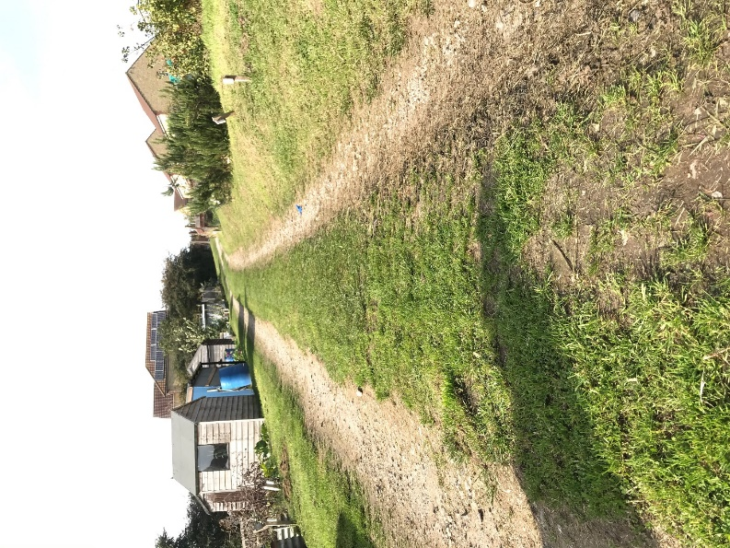

Entrance/exit Hathermead Gardens Trackway leading up to Hathermead Gardens

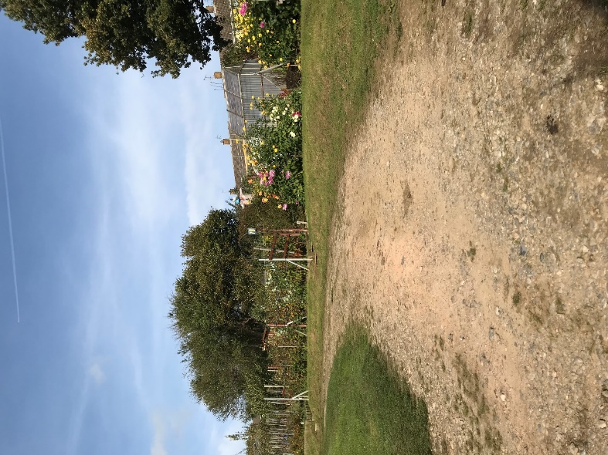

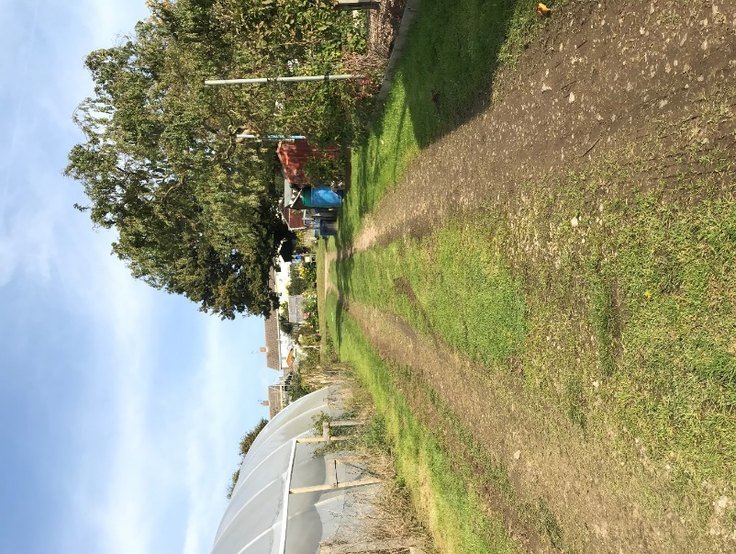

Corner from trackway running parallel with 100 steps Trackway parallel with path up to 100 steps