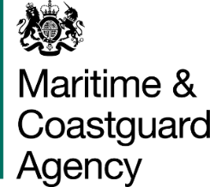

TCA 3/7/1000
INTRINSICALLY SAFE HYDRAULIC POWER PACKS – PRICING SCHEDULE
Tenderers for the above contract should complete the table below, indicating what they would charge for each required element. Please note that all prices must:
- Be stated in Pounds Sterling;
- Include all other charges and overheads associated with the element being priced;
- Exclude VAT.

Requirement | Price (excl VAT)
ATEX Zone 2-compliant Intrinsically Safe Hydraulic Power Pack, including your standard guarantee (please quote a price per unit)
Delivery costs to Barnsley
Commissioning and initial training on the equipment
Annual fee for ongoing maintenance, technical support and training

Stage Payments
Please indicate below whether you would like payment for the power pack(s) to be made in increments in line with section 19 of the specification and if so, whether you are willing to accept the MCA’s proposed increment levels. This is for information only and will not be scored.
We do / do not wish to be paid in increments. (please delete as applicable, and if you would like to be paid in increments, complete the table below).
Milestone | MCA’s Proposed Percentage of the Price | Accept MCA’s Proposed Percentage? | Tenderer’s Proposed Percentage
Design Drawings | 30%
Delivery of Components to Manufacturer | 40%
Successful Factory Test | 20%
Delivery to Barnsley | 10%
Additional Extras
Please state below your recommendations for any ancillaries, spare parts or consumables for the power packs, not already included in the price of the system or annual maintenance/training charge, together with their prices. This is for information only and will not be scored.
Item | Unit Cost | Size of Unit | Recommended Number of Units / Frequency of Purchase

