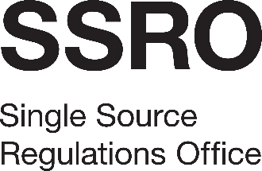

SSRO-C-118 The baseline profit rate capital servicing rates and quality assurance services

Appendix 4: Form of Tender
[Name of Supplier]
To the SSRO:
On behalf of [Name of Supplier], of [Address] (“the Supplier”) –
- Having considered the invitation to tender and all accompanying documents (including without limitation, the Specification) we confirm that we are fully satisfied as to our experience and ability to deliver the services in all respects in accordance with the requirements of this invitation to tender.
- We hereby tender and, if awarded the contract, undertake to provide and complete all the services required to be performed in accordance with the Specification and Contract Terms (including the accompanying documents) for the amounts set out in the Pricing Schedule.
- We agree that any insertion by us of any conditions qualifying this tender may result in the rejection of the tender.
- We agree that this tender shall remain open to be accepted by the SSRO for 90 days from the last date for the receipt of tenders.
- We understand that if we are a subsidiary we may, if requested by the SSRO, be required to secure a Deed of Guarantee in favour of the SSRO from our holding company or ultimate holding company, as determined by the SSRO in their discretion.
- We understand that the SSRO is not bound to accept the lowest priced or any tender it may receive.
- We certify that this is a bona fide tender.

……………………………………………........
Signature (duly authorised to sign tenders on behalf of the Supplier)
Print name:
Date:

