## Term of Reference

## Religious and Interfaith Solutions

## For Low Carbon Development Initiative Phase-2 (LCDI2)

#### **Background**

The Foreign, Commonwealth, and Development Office of the UK Government (FCDO) in collaboration with the Development and Planning Ministry (Bappenas) and the Government of Indonesia, have developed a partnership agreement in the Low Carbon Development Initiative (LCDI) since 2017. The first phase of LCDI was implemented in 2017-2021. Currently, the programme has entered LCDI Phase 2 (LCDI2) for four years. The LCDI Phase 1 focused on the preparation and implementation of the first national low-carbon development plan for Indonesia. One of the major milestones in LCDI Phase 1 is the Government of Indonesia launched a UK-funded report called “*Low Carbon Development: A Paradigm Shift Towards a Green Economy in Indonesia”* (the LCDI Report). This report has been successfully incorporated into the national Medium-Term Development (RPJMN) 2020-2024.

Oxford Policy Management Limited (OPML) has recently contracted by FCDO, with British Embassy Jakarta (BEJ) as its client service, as the Supplier to deliver and manage programme implementation of LCDI2 in collaboration with the Government of Indonesia (GoI), primarily Bappenas, along with relevant line ministries and the pilot provinces of the Programme. This programme will support implementation of the LCDI at both the national and subnational level to support the Government meet its emissions reductions targets in Indonesia’s medium term development plan. In specific, the programme covers:

* Building political support for low-carbon development within and outside of government.
* Building knowledge and understanding of the LCDI approach among those who would be responsible for implementing it within GoI.
* Supporting implementation of the LCDI approach, especially through provincial and national development plans.
* Raising ambition to the highest levels set out in the LCDI report.

#### **Religious and Interfaith Solutions for LCDI Phase 2: A Critical Component**

#### The second phase of the Low Carbon Development Initiative (LCDI2) presents an important opportunity to engage religious and interfaith organizations in promoting sustainable environmental practices. Religious institutions in Indonesia hold significant social influence and often act as moral and community leaders, particularly at the grassroots level. Integrating religious and interfaith solutions within the LCDI2 framework can help amplify environmental stewardship messages, mobilize communities for climate action, and provide platforms for effective collaboration across different sectors of society.

Religious and Interfaith collaboration offers a unique avenue for building a shared vision for low-carbon development, rooted in values that transcend religious divides. These organizations can serve as powerful advocates for sustainability, driving policy dialogues and encouraging shifts in behavior at both the individual and collective levels. By incorporating religious and interfaith approaches into LCDI2, the initiative not only strengthens community-level engagement but also ensures that religious institutions are part of the national effort to achieve long-term climate goals. Their involvement is particularly important in areas where religious organizations have a strong presence, especially in mobilizing communities to adopt sustainable practices and advocating for responsible natural resource management.

**Broader Context and Policy Alignment**

* The UK has actively supported interfaith dialogues at recent COP meetings, including COP26 in Glasgow, to emphasize the importance of including diverse voices, such as religious leaders, in global climate strategies.
* Through frameworks like the Environment Bill and Climate Action Plans, the UK government recognizes the significant role of faith groups in climate action. These policies illustrate the UK's dedication to leveraging faith-based contributions to achieve climate objectives.
* Academic institutions such as the Oxford Centre for Religion and Public Life and the London School of Economics (LSE) conduct research on the intersection of religion and climate policy. Their work supports the integration of religious perspectives into climate strategies.
* The UNDP’s Islamic Finance Initiatives promote financial mechanisms like Zakat and Waqf for sustainable development and climate resilience. The UK's support enhances these tools for community-based climate action.
* In Indonesia, UNDP, with UK support, collaborates with Islamic finance institutions to implement projects that merge environmental sustainability with traditional financial practices. These initiatives utilize Islamic financial tools to bolster community-driven climate resilience.

**Global, National, to Grassroot Initiatives**

* In recent years, Indonesia's religious landscape has played an increasingly pivotal role in addressing climate change. Since the 2007 UN Climate Summit in Bali, religious leaders from various faiths issued an interfaith declaration emphasizing their responsibility to inspire environmental action through religious teachings. This movement has continued to grow, with initiatives such as "Green Mosques" and "Green Churches" that promote sustainable practices. Religious communities have also aligned with indigenous efforts to protect land from environmental exploitation, showing that faith-based activism can be a powerful force for environmental protection.
* Globally, religious leaders have similarly united around the climate cause. The 2016 Interfaith Climate Statement, which called on world leaders to commit to climate agreements like the Paris Accord, demonstrates how religious activism can transcend borders. In Indonesia, fatwas from the Indonesian Ulama Council (MUI) on environmental conservation, along with Pope Francis’ 2015 encyclical *Laudato Si’*, highlight how religious values are increasingly blending with environmental advocacy. This combination underscores the potential for faith-based initiatives to influence both local and global climate policies, advocating for urgent, ethical responses to the climate crisis.
* Recent efforts in Indonesia further reinforce this trend. In 2022, the Ministry of Religious Affairs launched the Eco-Masjid initiative under the broader *Peduli Bumi* (Care for Earth) campaign, promoting tree planting, solar energy use, and waste management in mosques. Meanwhile, Muhammadiyah’s launch of the Muhammadiyah Climate Center (MCC) in 2023 at the Global Forum for Climate Movement showcases the growing coordination of community-based climate initiatives. These efforts signal a promising collaboration between religious communities, policymakers, and scientists to address climate challenges through moral, ethical, and scientific lenses, setting a powerful example for global environmental action.

**Goal**

Harness the collective power of faith communities in Indonesia to address climate challenges through religious and interfaith dialogue, knowledge sharing, and joint action, fostering religious and interfaith collaboration in promoting sustainable environmental practices within the framework of the LCDI at the national level.

**Objective**

1. **Establish a Strategic Framework for Religious and Interfaith Engagement in Climate Action**: Create a comprehensive understanding of religious and interfaith organizations, identifying their climate initiatives and potential alignment with LCDI objectives. This will form the basis for future engagement and collaboration in climate action and low-carbon development.
2. **Improve Climate Literacy and Capacity for Grassroots Advocacy**: Equip religious and interfaith leaders with the knowledge and skills to understand climate change, sustainable resource management, and low-carbon development, empowering them to lead grassroots actions and advocate for environmental sustainability.
3. **Identify and Enhance the Capacity of Religious Organizations to Manage Environmental Risks**: Assess the capacity of religious organizations in managing programs with potential environmental risks, providing recommendations to improve their management practices and ensure alignment with environmental sustainability and LCDI goals.

**Scope of Work**

**Scope of Work with Deliverables, Duration, and Timeline**

|  |  |  |  |  |  |
| --- | --- | --- | --- | --- | --- |
| **Objective** | **Activity** | **Output** | **Deliverable & Potential Tangible Leverage** | **Duration** | **Timeline** |
| 1. Establish a Strategic Framework for Religious and Interfaith Engagement in Climate Action | Mapping and Identification of Religious and Interfaith Organizations | 1. Stakeholder consultation with religious and interfaith organizations. 2. Desk study (literature review) | 1. Mapping report categorizing religious and interfaith organizations based on their climate initiatives and potential alignment with LCDI objectives *>> publication* 2. Insights on the potential engagement of these organizations for future climate actions *>> climate action contributions from non-state actors.* | 2 months | September - October 2024 |
| 2. Improve Climate Literacy and Capacity for Grassroots Advocacy | a. Workshops for religious and interfaith leaders (national level) | Trained leaders equipped to promote climate action, sustainable governance, GESI principles, and the integration of religious teachings into climate advocacy. | 1. Training materials and modules *>> publication and toolkit for next capacity building activity*  2. Participant list 3. Post-workshop evaluation and training outcomes report. | 3 months | November 2024 – February 2025 |
| b. Climate Educators Program to Train Community Organizers | Network of trained climate educators capable of leading grassroots actions and advocating for policy changes at the community level. | 1. Climate education toolkit *>> publication and toolkit for next capacity building activity*  2. Campaign guide for community organizers *>> publication and guidebook for next capacity building activity*  3. List of trained climate educators *>> talent pool for climate trainers.* | 3 months | November 2024 – February 2025 |
| 3. Identify and Enhance the Capacity of Religious Organizations to Manage Environmental Risks | a. Religious and Interfaith Dialogue | Joint statements from religious and interfaith leaders in support of the LCDI goals, enhancing cooperation for environmental sustainability. | 1. List of engaged stakeholders 2. Dialogue summaries 3. Joint statements and policy recommendations *>> policy brief and publication.* | 3 months | November 2024 – February 2025 |
| b. Study on the Capacity and Impact of Religious Organizations in Managing Environmental Risks | Recommendations for improving environmental management practices among religious and interfaith organizations. | 1. Published study with analysis and recommendations *>> policy brief and publication* 2. Presentation summary of findings and recommendations *>> policy brief supporting document.* | 3 months | November 2024 – February 2025 |
| 1. Reporting | | | | 1 month | February – March 2025 |

**Gantt chart**

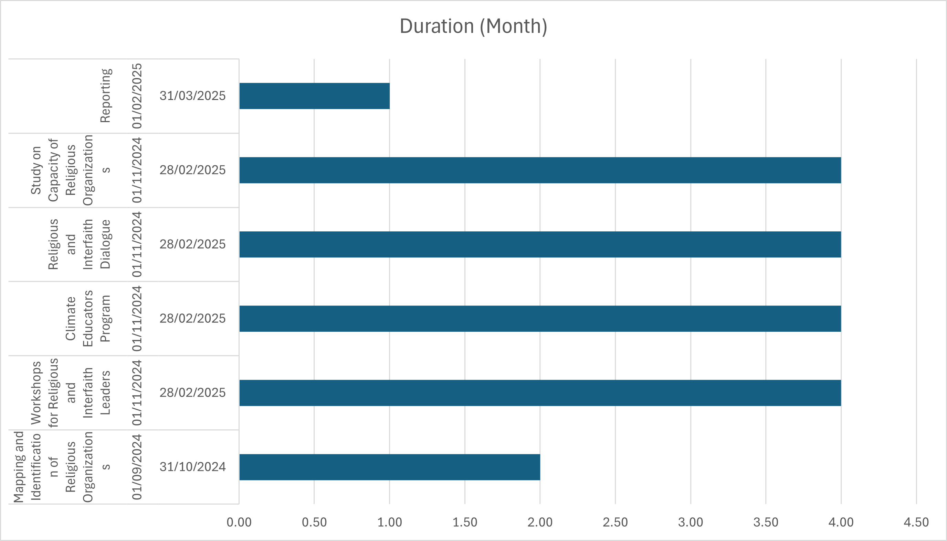

**Governance and Reporting**

The project will be governed and managed under the guidance of OPML, with regular reporting to FCDO, Bappenas, and key LCDI stakeholders. **Progress reports** will be submitted on a monthly basis, with final outputs to be delivered by March 2025.

**\*\*\***