

**REQUEST FOR INFORMATION**

**SUBMARINE DELIVERY AGENCY**

**Supply of Submarine Spares and Repairs**

**Relating to Mechanical Equipment Systems**

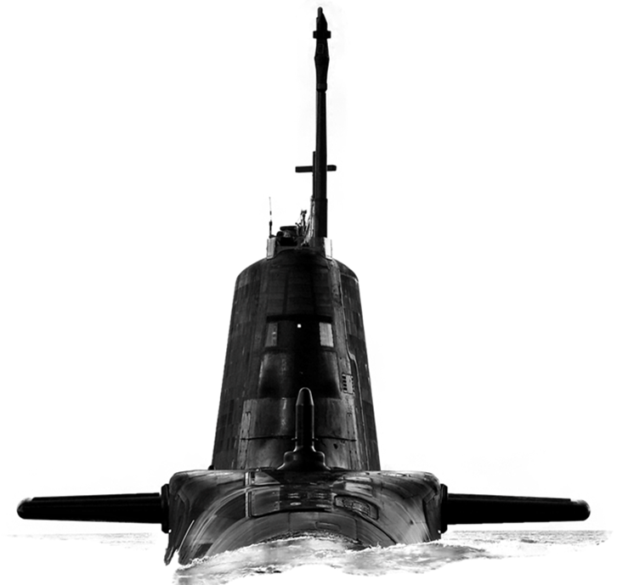

Version: 2.0

Date: 05 May 2022

**CONTENTS**

Confidentiality..............................................................................................................3

Introduction..................................................................................................................3

Background…………...................................................................................................3

Purpose of the Request for Information (RFI)........................................................... 3

RFI Procedure............................................................................................................ 4

How to Delivery Responses to this RFI………............................................................4

Contacts......................................................................................................................4

Timeframe...................................................................................................................5

Annex A - Request for Information Questionnaire……….........................................A-1

**Confidentiality**

1. All information included in this Request for Information (RFI) is confidential and only for the named addressee. No information included in your response, or in discussions connected to it, will be disclosed to any other party.

**Introduction**

1. The Submarine Delivery Agency (SDA) has been sourcing the submarine spares and repairs described in this RFI the same way for a number of years. This RFI covers a broad range of equipment and seeks to understand the scope for exploiting synergies in approach as well as the potential benefits associated with smaller groups of equipment.
2. The effective supply of submarine spares and repairs is crucial to achieving platform availability. The SDA is seeking opportunities to reduce lead times and friction in the delivery of spares and repairs and we would like to invite your company to answer a few questions to explore ways in which this can be achieved.
3. This RFI is not a bidding opportunity but a means by which industry can provide information. Any resulting procurement activity will be conducted competitively.

**Background**

1. Mechanical Equipment is a range of equipment used primarily by submarine platforms and is comprised of both first and non-first level items. First level items generally legislated for by document SSP-25 (Quality Assurance for Safety in Submarines)
2. Mechanical Equipments are many and varied and covers, but is not limited to, NAB castings, tail cones, mast fittings, submarine acoustic tiles, the indicator buoy line management system and other bespoke equipments on V, T, and A Class submarines.
3. Mechanical Equipment consisting of approximately 9000 line items all of which are NATO Codified. Of these lines items around 1500 are regularly ordered.
4. The Submarine Delivery Agency has a requirement to source consumables, permanent stock items, survey and repair of the equipment described above once the current contact provision ends in early 2023.
5. The Authority anticipates a planned demand against 409 consumable, 10 capital spare and 8 repairable stock items.

**Purpose of the RFI**

1. This RFI aims to achieve 4 outcomes:
2. To gather information about the current market offering for the provision of submarine spares and repairs;
3. To explore the ways in which a future contract or contracts could be structured to enable a high performing supply and repair service which offers reliability and responsiveness in order to improve frontline platform availability;
4. Develop a Procurement Strategy that will deliver best value for money for Defence;
5. To inform a Procurement Strategy that enables the enables a provision to be in place in early 2023.

**RFI Procedure**

1. This Request for Information will be advertised on the Defence Sourcing Portal (DSP) and Contracts Finder and issued to all who request an RFI together with other companies whom the MOD believes may be able to provide useful intelligence on this requirement.
2. Responses to this RFI will be reviewed by subject matter experts from different functional areas within the Submarine Delivery Agency. Following receipt of responses to this RFI the Authority may initiate follow on engagement with either individual potential suppliers, groups of potential suppliers or all potential suppliers. This may be undertaken in writing or through virtual meetings.
3. Any details provided in response to this RFI or during subsequent engagement will be used for information purposes only and will not be used to determine the potential suppliers who will be invited to bid, should the Authority proceed to tender.
4. The results and analysis of this RFI shall not constitute any form of pre-qualification exercise. Any formal procurement process will be undertaken in accordance with EU Procurement Law.
5. Nothing in this RFI, or any other engagements with Industry prior to a formal procurement process, shall be construed as a representation as to the Authority’s ultimate decision in relation to the future requirement.

**How to deliver responses to this RFI**

1. To respond to this RFI please complete the form at Annex A and return electronically to [Thomas.Parry102@mod.gov.uk](mailto:Thomas.Parry102@mod.gov.uk) via the DSP no later than 13:00 27 May 2022. Responses will be acknowledged by email.

**Contacts**

1. Please raise questions relating to this RFI by email to [Thomas.Parry102@mod.gov.uk](mailto:Thomas.Parry102@mod.gov.uk)

**Timeframe**

1. This is the timeframe for the RFI and follow on activity:

5 May 2022 - RFI Published on Defence Sourcing Portal.

13.00 – 27 May 2022 – Last date for submission of answers to RFI.

**Submarine Spares and Repairs Request For Information**

|  |  |
| --- | --- |
| **Question** | **Answer** |
| Company Name |  |
| Company Address |  |
|  |  |
| Name of Company representative completing the RFI |  |
| Contact details (e-mail and telephone number) |  |
| Company web site address |  |
|  |  |
| Main products/services/line of business |  |
| Main market sector/customers |  |
| Number of years in this market sector |  |
|  |  |
| Pricing |  |
| 1. For a contract of 3 years in duration within the current market, would it be possible to hold firm prices for the duration of contract. If not please state the maximum and preferred duration for which pricing could be held. |  |
| 1. Where anticipated demand can be provided for the majority of items, does this support longer duration firm pricing. |  |
| 1. Where items do not have a demand but may be required on an ad hoc basis, what would be the anticipated lead time for the provision of a price? |  |
| 4a) Where a demand plan has been provided, how feasible would it be to provide an all inclusive price per item to include all sourcing and management fees? |  |
| 4b) Are there any services that could not be captured within an all inclusive price which you would normally provide or envisage providing for this requirement which would have an impact upon the level of service. |  |
| 1. The Authority is required to FIRM price Contracts up to a duration of 5 years. Is there an alternative pricing mechanism be more suitable to this market? Can you describe the best value options for pricing? |  |
| 1. The Authority is required to consider the use of Reverse Auctions in procurement Activity. What, if any impact would a Reverse Auction have on your ability or decision to bid? |  |
| Order Quantity/Contract Duration |  |
| 1. Where an anticipated demand plan can be provided for the majority of items, to what extent will this impact upon lead times? |  |
| 1. To what extent would guaranteed order quantities drive value and efficiency? |  |
| 1. To what extent would minimum order quantities drive competitive pricing |  |
| 1. To what extent can discounts be offered on volume orders and at what level might these be available? |  |
| 1. What contract duration would be the most attractive to your organisation and why? |  |
| Contract composition |  |
| 1. Does your organisation envisage being able to cover all of the requirement described above, or part of it? Please explain which part of the requirement could be covered by your organisation |  |
| 1. Please describe the ideal model for your company to deliver this service; would your organisation prefer to bid to deliver this service as a whole, or to deliver part of the service such as specific groups of equipments. |  |
| 1. What are the main benefits of your preferred delivery model for both your organisation and for the SDA? |  |
| 1. Are there any risks or concerns specific to this market that the SDA should be aware of? |  |
| 1. Are there any opportunities to streamline the delivery of spares and repairs that we have not considered above? If so, please describe these. |  |
| Social Value | |
| 1. Central Government seeks to identify opportunities to increase social value across its contracts. What opportunities for added social value are relevant to the supply of submarine spares and repairs and how could your company work with the SDA in pursuit of these. Further information on the Government’s approach to Social Value can be found on .gov.uk |  |