Corby Heritage Trail Pump Track

Document Two

Specification

CONTENTS

- Definitions Page 3
- Introduction Page 3
- Background Page 3
- Scope Page 3
- Service Conditions and Environmental Factors Page 4
- Statement of Requirements Page 4
- Construction Charter Page 6
- Data Management / General Data Protection Regulation (GDPR) Page 6
- Quality Requirements Page 7
- Security Page 7
- Implementation Criteria Page 7
- Project Management Page 8
- Risk Management Page 8
- Other Relevant Details Page 9
- Corporate Social Responsibility Page 9
- Annexes and Appendices Page 11

- Definitions

  - The definitions of terms and/or acronyms used within this procurement are set out in the Preliminaries & General Conditions.

- Introduction

  - The Council is seeking a suitably qualified and experienced Contractor to create a Pump Track at West Glebe Park to enable those new to cycling to gain confidence and cycling ability as well as provide an area for proficient cyclists to develop further skills.

- Background

  - Working collaboratively with a number of stakeholders including Friends of Parks/Open Spaces, Rockingham Wheelers, British Cycling, KHL Big Local, education and health sectors; the Pump Track will also increase user presence within the park, improving health & safety and potentially reducing anti-social behaviour.

  - The Pump Track forms part of the wider Corby Heritage Trail bid. The heritage network between the green spaces will be accessible by foot, bike and car providing all potential visitors with an opportunity to take part. The Council aims to access those hard to reach communities that historically have not engaged such as NEET young adults and people with English as a second language through a wide range of techniques. Translation will be available when required, events will be held in the heart of the communities and the Heritage Volunteer Officer post will be committed to delivering activities directly targeted to those groups. Those events will all be fully evaluated with data collected for ongoing analysis.

  - The Council intend to tackle the town’s inequality gap by targeting Kingswood, one of the most deprived areas within the borough through close partnership links with the KHL Big Local community group and by utilising the newly appointed Heritage Volunteer Officer post to support and engage with hard to reach communities. KHL were awarded lottery funding to engage with the residents based in Kingswood and Hazel Leys, with the primary role of improving the well-being of its residents. Last year The Bike Project was supported by KHL and Groundwork Trust which enabled young people to learn about bike maintenance. The Council would work in partnership again to further expand this offering to include sessions at West Glebe Park.

  - With good links to nearby schools West Glebe is ideally placed to deliver Bikeability sessions and partnership working with Rockingham Wheelers Cycling Club.

  - England Heritage as part of the funding criteria, require a full and ongoing evaluation as will other funding bodies.

- Scope

  - This project will replace the outdated and largely unused soil BMX track at West Glebe Park, (which was formed over ten (10) years ago using the arisings from the nearby play area), with a modern, surfaced, Pump Track extended to cover an area of approximately 45m x 25m.

  - The project will create a new accessible cycling opportunity for those aged four (4) to five (5) years plus, to enjoy in a safe environment and will provide a gateway for cyclists to progress onto the heritage cycling trail and woodland paths.

  - The scheme is to be designed to a budget of £55,000.

  - The Contractor’s proposed Design will be evaluated and scored on Overall Track Length, the Number of Physical Features (e.g. platforms, straights, corners, berms, jumps, etc.) and User Group Consultation.

  - The Contract must be completed by no later than Wednesday, 31st March 2021.

- Service Conditions and Environmental Factors

  - The site is located in the south west corner of the municipal park, near existing play / recreation facilities and bordered at least in part by an existing footpath and illuminated cycle way.

  - The existing soil infrastructure of the current BMX track is to be utilised within the groundwork to create the new modern track, negating the need for removal and minimising the potential requirement for additional material.

- Statement of Requirements

  - The Contractor shall design & construct a modern bitumen macadam surfaced Cycle Pump Track incorporating the following requirements:
    - A flowing fun design that provides riders of all abilities from the following six Main User Types, the opportunity to progress and gain confidence:
      - Mountain Bikes;
      - BMX Bikes;
      - BMX Cruisers;
      - Skateboards;
      - Micro Scooters; and
      - Rollerblades.
    - Maximise track length & number of features (e.g. platforms, straights, corners and a variety of berms & jumps / obstacles) within the available “footprint” of 45m x 25m and budget of £55,000.
    - Track surface tread to be a minimum width of 2m.
    - A flexible design that can see the Track used in sections, areas or a continuous loop and provides All Ability Loop(s) from a Starting Platform.
    - Two (2) separate DDA accessible elevated Starting Platforms with good sight lines sized for up to twenty-five (25) users.
    - Constructed to align with ROSPA Wheeled Sports Guidance, including a ROSPA Post-Installation Report confirming compliance.
    - Directional arrows for user safety.
    - Construction:
- The Contractor shall provide details of their Design Proposal for approval by the Employer, which should incorporate the following minimum requirements:
- Strip & store existing turf & top soil for making good disturbed ground on completion;
- Re-use existing BMX earthworks to avoid disposal offsite and minimise any imported material;
- Material to be compacted in layers, with geo-reinforcement installed as required; and
- All formations are to be constructed above ground level to safe angles and laid to falls to prevent standing water.
- Track Surface:
- Permeable geotextile membrane shall be fixed in position to minimise organic growth;
- MOT Type 1 sub-base in compacted layers to a depth of 175mm;
- Track to be surfaced in bitumen macadam in either two layers (50mm of Dense 20mm Base & 25mm of Medium 6mm Wearing) or a 75mm specialised single layer bitumen macadam mix (min. 10mm), all laid to British Standards;
- Successive layers shall be battered back at the edges to form a kerb-less shoulder, leaving a clear 2m wide surface tread;
- Surface shall be “crowned” a minimum of 100mm above ground level; and
- Where possible all layers are to be consolidated by whacker plate or roller, with surfaces left free of associated marks.

- Drainage
        - The soil at West Glebe Park is typified by heavy clay;
        - Nevertheless, the Track should be drained at c.10 strategic locations using 100mm land-drains, piped to multiple soakaways totalling a min. 15m³ of void space using drainage crates;
        - Soakaways to be lined and topped with permeable membrane; and
        - System shall be accessible for future maintenance.
- Landscaping
        - Track to be accessed via a new DDA compliant bitumen macadam path from an existing path;
        - Area within “footprint” of Track to receive top-soil and turf;
        - Remaining areas of disturbed / damaged ground to be top-dressed and grass seeded; and
        - Site to be re-inspected after growing season, with areas of poor growth top-dressed / re-seeded as required.
- Other
        - Supply & install double-sided A0 sign (design / content TBA) from anti-vandal aluminium, with 75mm aluminium posts erected to British Standards;
        - Supply & install 4no. accessible benches (locations TBA) using insitu concrete;
        - Litter bin(s) shall be provided / installed by the Council; and
        - Also see embedded Preambles at the Annexes of this Specification.
- Defects & Maintenance
      - The Contract includes a twelve (12) month Defects Period for all works and products from the Date of Practical Completion as certified by the Employer;
      - The Contractor shall attend to any defects during the twelve (12) month Defects Period within ten (10) working days of being reported;
      - The surface shall be guaranteed for a minimum of ten years against cracks, defects and slippage; and
      - Latent defects in design / workmanship (not wear & tear) shall be liable under the Contract (signed under Deed) for twelve (12) years.
- Consultation
  - Provide within your electronic Tender submission, a single, full-colour Consultation Illustration of your proposed new Pump Track, in a pdf format. The illustration shall provide views in plan, elevation(s) and perspective.
  - Concurrently, Bidders must also provide a laminated copy (up to size A1 (594 x 841mm or 23.4 x 33.1 inch)) of their Consultation Illustration, addressed to:
  - Liz Hudson, c/o Lodge Park Sports Centre, 263 Shetland Way, Corby, Northamptonshire NN17 2SG.
This copy will be used by the Council to demonstrate the proposed design to selected User Groups (i.e. local schools & cycle club, etc.) to undertake the User Group Consultation element of the procurement.
  - By submitting a response for evaluation, Bidders accept other Bidders may provide a Consultation Illustration up to A1 size for evaluation by the Evaluation Panel and during the User Group Consultation.
  - Bidders MUST NOT INCLUDE the following on their Consultation Illustration, so as not to influence anyone in the User Group Consultation process:
- Company name;
- Any other identifying logo or marking;
- Any games, quizzes, etc.
- Any links or references to other intellectual property (e.g. Marvel, Disney, Star Wars, etc.); and/or
- Any superfluous images, such as cyclists, users or spectators.
- Planning
        - The size of the proposed development exceeds the Council’s delegated authority for a municipal development and as such, they require Full Planning Permission for the successful design;
        - Therefore, the successful Contractor will be required to assist in the preparation of the Planning Application and provide a scaled drawing of their propose Design in Plan & Elevations; and
        - Whilst the Council does not foresee any difficulties, if planning permission is not granted for this project for any reason, the Contract will not commence/progress.

- Construction Charter

  - Corby Borough Council signed up to the Construction Charter on Monday, 12th November 2018 and adopted, in full, the provisions of the Charter and publicly affirmed our commitment to work with Unite and other appropriate trade unions to ensure the provisions of the Charter are applied in all construction projects we are involved with.

  - The Charter states that the Council, as a responsible client, enter into this agreement and commit to working with the appropriate trade unions, in order to achieve the highest standards in respect of; direct employment status, Health & Safety, standard of work, apprenticeship training and the implementation of appropriate nationally agreed terms and conditions of employment.

  - In order to be considered for this project, the successful bidder(s) must agree to adhere to the provisions of the Charter, which can be accessed by double clicking on the link below.

- Data Management / General Data Protection Regulation (GDPR)

  - For the purposes of this Section, the Council is the data “Controller” and the Contractor is the data “Processor”.

  - Any information provided or accessed by the Contractor as a part of this Contract are subject to the General Data Protection Regulations, with which the Contractor must comply. If the Contractor does not follow the requirements of the GDPR, they will be in breach of contract.

  - The Contractor must:
    - process the personal data only on the documented instructions of the Council;
    - comply with security obligations equivalent to those imposed on the Council (implementing a level of security for the personal data appropriate to the risk);
    - ensure that persons authorised to process the personal data have committed themselves to confidentiality or are under an appropriate statutory obligation of confidentiality;
    - only distribute personal data with the Council’s prior specific or general written authorisation. Any party to whom the successful bidder is authorised to distribute the personal data shall be bound by these terms. The successful bidder must inform the Council of intended changes in arrangements with any persons to whom they have distributed these details;
    - make available to the Council all information necessary to demonstrate compliance with the obligations laid down in Article 28 GDPR and allow for and contribute to audits, including inspections, conducted by the Council or another auditor mandated by the Council - and the successful bidder shall immediately inform the Council if, in its opinion, an instruction infringes GDPR or other EU or member state data protection provisions;
    - assist the Council in carrying out its obligations with regard to requests by data subjects to exercise their rights under chapter III of the GDPR, noting different rights may apply depending on the specific legal basis for the processing activity (and should be clarified by the Council up-front);
    - assist the Council in ensuring compliance with the obligations to implementing a level of security for the personal data appropriate to the risk, taking into account the nature of processing and the information available to the successful bidder;
    - assist the Council in ensuring compliance with the obligations to carry out Data Protection Impact Assessments, taking into account the nature of processing and the information available to the successful bidder; and
    - notify the Council without undue delay after becoming aware of a personal data breach.

- Quality Requirements

  - The Contractor is expected to provide the goods, services, supplies and/or works with all the reasonable skill, care and diligence to be expected of a qualified and experienced member of the Contractor's profession undertaking and/or providing goods, services, supplies and/or works to those required by the Council, as detailed and/or referred to in this Specification and/or any and all supporting documents.

  - All materials, components and workmanship shall comply with the latest British / European Standards, Codes of Practice / Guidance and where applicable, a British Board of Agrément (BBA) Certificate.

  - All materials and components incorporated into the Works shall be handled, stored and fixed strictly in accordance with the manufacturer’s recommendations.

  - The Contractor must ensure key staff who undertake work on this project have previous experience on pump cycle track construction projects and that any junior staff are appropriately supervised.

- Security

  - West Glebe Park does experience some anti-social behaviour and as such, the Contractor should be mindful of this in their security arrangements and the sequencing of vulnerable aspects of the work.

- Implementation Criteria

  - An indicative Procurement Timetable is included within the Council’s Document 1 – Instructions to Bidders.

  - The Contractor shall provide a Programme of Works within their Tender Response, where additional Tender Evaluation Scores are available for Contractors striving to achieve early completion.

  - The Contractor will be required to attend both a Pre-Contract and Pre-Start Meeting.

  - The Contractor shall also provide an updated Master Programme once the Contract has been signed, along with a Construction Phase Health & Safety Plan that includes their RAMS.

  - Due to external funding deadlines, the Works are to be completed by 31st March 2021, subject to the terms of the JCT Contract and any contractually legitimate Extension of Time.

  - See also Document 3 – Preliminaries & General Conditions.

- Project management

  - The Contractor shall at all times provide the Works to meet or exceed the requirements set out in this Specification and any associated documents.

  - The Contractor and the Council shall each appoint a Project Manager, through whom the provision of the Works shall be managed day-to-day.

  - The Contractor and the Council shall ensure that appropriate resource is made available on a regular basis such that the aims, objectives and specific provisions of these Works can be fully realised.

  - Routine inspections will be carried out at any location by the Council’s Representative. Such operations will be carried out throughout the Contract period in order to check that the Works are being carried out or have been carried out in all respects in accordance with this Specification and any and all supporting documents.

  - The Council’s Representative will record the date, time and main findings of all such inspections. In the event of any works which fail to meet the required standards being discovered, then the Council’s Representative shall notify the Supplier of the elements of works which fail to meet the required standard and the Supplier shall remedy same within forty-eight (48) hours of such notification.

  - Following the Monitoring Arrangements set out above, if the level of performance of the Supplier:
    - is likely to or fails to meet any Performance Standard; or
    - is likely to cause or causes a Critical Failure to occur, the Supplier shall immediately notify the Council in writing and the Council, in its absolute discretion and without limiting any other of its rights, may:
- require the Supplier to immediately take all remedial action that is reasonable to mitigate the impact on the Council and to rectify or prevent a Performance Standard failure or Critical Failure from taking place or recurring; and/or
- if Performance Standards have not been met, make the deductions set out in the Contract; and/or
- if a Critical Failure has occurred, exercise its right to terminate for material default.

  - The Contractor and the Council shall attend Progress Meetings to discuss progress on the project. These Progress Meetings will be the forum for the review by the Contractor and the Council of progress against the project. These meetings shall:
    - take place on site within normal business hours as the Council shall reasonably require; and
    - be attended by the Contractor's Representative and the Council’s Representative.

  - The Contractor shall provide to the Council such documentation as the Council may reasonably require as a part of this project.

  - Any concerns raised by the Council will be remedied by the Supplier within forty-eight (48) hours.

- Risk Management

  - The Contractor and the Council shall pro-actively manage risks attributed to them under the terms of this Contract.

  - The Contractor shall develop, operate, maintain and amend, as agreed with the Council, processes for:
    - the identification and management of risks;
    - the identification and management of issues; and
    - monitoring and controlling project plans.

  - The Contractor will allow the Council to inspect, at any time within working hours, the accounts and records which the Contractor is required to keep.

  - The Contractor will maintain a risk register of the risks relating to the Service, which the Council and the Contractor have identified.

  - COVID-19
    - The Contractor shall undertake works on-site in full compliance with the latest Government Guidance on social distancing and mitigation measures agreed for the Construction Sector; and
    - Where such Government Guidance suspends the Works, then the JCT Force Majeure Clause shall be enacted, resulting in a “no cost” extension of time.

- Other Relevant Details

  - For the avoidance of doubt please be aware that following award of contract should the successful Contractor subsequently find that its proposed solution is not accurate and sustainable then the successful Contractor will not be permitted to amend their pricing bid so as to request any further monies associated with the full provision of this service.

- Corporate Social Responsibility

  - Requirements
    - In February 2019, HM Government published a Supplier Code of Conduct setting out the standards and behaviours expected of Suppliers who work with government. (https://assets.publishing.service.gov.uk/government/uploads/system/uploads/attachment_data/file/779660/20190220-Supplier_Code_of_Conduct.pdf)
    - The Council expects its Contractors and Sub-Contractors to meet the standards set out in that Code. In addition, the Council expects its Contractors and Sub-Contractors to comply with the standards set out in this Section.
    - The Contractor acknowledges that the Council may have additional requirements in relation to corporate social responsibility. The Council expects that the Contractor and its Sub-Contractors will comply with such corporate social responsibility requirements as the Council may notify to the Contractor from time to time.

  - Equality and Accessibility
    - In addition to legal obligations, the Contractor shall support the Council in fulfilling its Public Sector Equality duty under S149 of the Equality Act 2010 by ensuring that it fulfils its obligations under each Contract in a way that seeks to:
- eliminate discrimination, harassment or victimisation of any kind; and
- advance equality of opportunity and good relations between those with a protected characteristic (age, disability, gender reassignment, pregnancy and maternity, race, religion or belief, sex, sexual orientation, and marriage and civil partnership) and those who do not share it.

  - Modern Slavery, Child Labour and Inhumane Treatment
    - Modern Slavery Helpline - means the mechanism for reporting suspicion, seeking help or advice and information on the subject of modern slavery available online at https://www.modernslaveryhelpline.org/report or by telephone on 08000 121 700.
    - The Contractor:
- shall not use, nor allow its Sub-Contractors to use forced, bonded or involuntary prison labour;
- shall not require any Contractor Staff or Sub-Contractor Staff to lodge deposits or identify papers with the Employer and shall be free to leave their employer after reasonable notice;
- warrants and represents that it has not been convicted of any slavery or human tracking offenses anywhere around the world;
- warrants that to the best of its knowledge it is not currently under investigation, inquiry or enforcement proceedings in relation to any allegation of slavery or human tracking offenses anywhere around the world;
- shall make reasonable enquires to ensure that its officers, employees and Sub-Contractors have not been convicted of slavery or human tracking offenses anywhere around the world;
- shall have and maintain throughout the term of any of its Contracts, its own policies and procedures to ensure its compliance with the Modern Slavery Act and include in its contracts with its Sub-Contractors anti-slavery and human trafficking provisions;
- shall implement due diligence procedures to ensure that there is no slavery or human trafficking in any part of its supply chain performing obligations under any of its Contract;
- shall prepare and deliver to the Council, upon request, a slavery and human trafficking report, setting out the steps it has taken to ensure that slavery and human trafficking is not taking place in any of its supply chains or in any part of its business with an annual certification of compliance;
- shall not use, nor allow its employees or Sub-Contractors to use physical abuse or discipline, the threat of physical abuse, sexual or other harassment and verbal abuse or other forms of intimidation of its employees or Sub-Contractors;
- shall not use or allow child or slave labour to be used by its Sub-Contractors;
- shall report the discovery or suspicion of any slavery or trafficking by it or its Sub-Contractors to the Council and Modern Slavery Helpline.

  - Income Security
    - The Contractor shall:
- ensure that that all wages and benefits paid for a standard working week meet, at a minimum, national legal standards in the country of employment;
- ensure that all Contractor Staff are provided with written and understandable Information about their employment conditions in respect to wages before they enter employment and about the particulars of their wages for the pay period concerned each time that they are paid;
- All workers shall be provided with written and understandable Information about their employment conditions in respect to wages before they enter employment and about the particulars of their wages for the pay period concerned each time that they are paid;
- not make deductions from wages:
  - as a disciplinary measure;
  - except where permitted by law; or
  - without expressed permission of the worker concerned.
- record all disciplinary measures taken against Contractor Staff; and
- ensure that Contractor Staff are engaged under a recognised employment relationship established through national law and practice.

  - Working Hours
    - The Contractor shall:
- ensure that the working hours of Contractor Staff comply with national laws, and any collective agreements;
- that the working hours of Contractor Staff, excluding overtime, shall be defined by contract, and shall not exceed forty-eight (48) hours per week unless the individual has agreed in writing;
- ensure that use of overtime used responsibly, taking into account:
- the extent;
- frequency; and
- hours worked; by individuals and by the Contractor Staff as a whole.
    - The total hours worked in any seven day period shall not exceed sixty (60) hours, except where covered by Paragraph 5.3 below.
    - Working hours may exceed sixty (60) hours in any seven day period only in exceptional circumstances where all of the following are met:
- this is allowed by national law;
- this is allowed by a collective agreement freely negotiated with a workers’ organisation representing a significant portion of the workforce; appropriate safeguards are taken to protect the workers’ health and safety; and
- the employer can demonstrate that exceptional circumstances apply such as unexpected production peaks, accidents or emergencies.
    - All Contractor Staff shall be provided with at least one (1) day off in every seven (7) day period or, where allowed by national law, two (2) days off in every fourteen (14) day period.

  - Sustainability
    - The Contractor shall meet the applicable Government Buying Standards, which can be found online at: https://www.gov.uk/government/collections/sustainable-procurement-the-government-buying-standards-gbs

- Annexes and Appendices

  - To open the embedded annex, double click on the document icon.

    - Annex 1 – Preambles

    - Appendix 1 – Photographs of Existing BMX Track (four (4) photographs)

Photograph 1/4
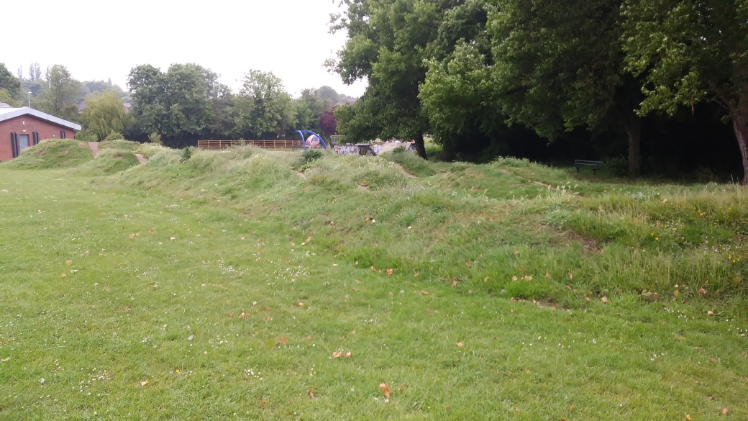

Photograph 2/4
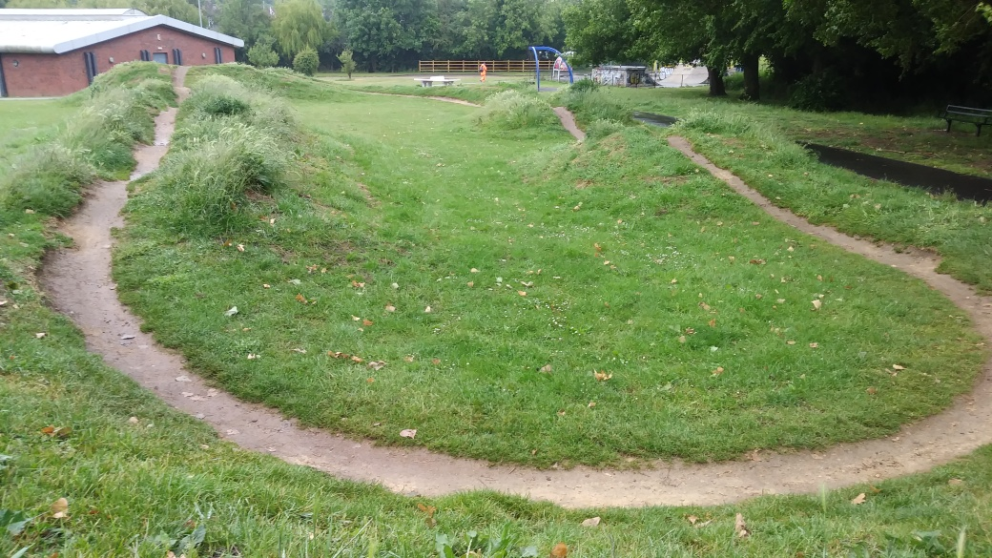

Photograph 3/4
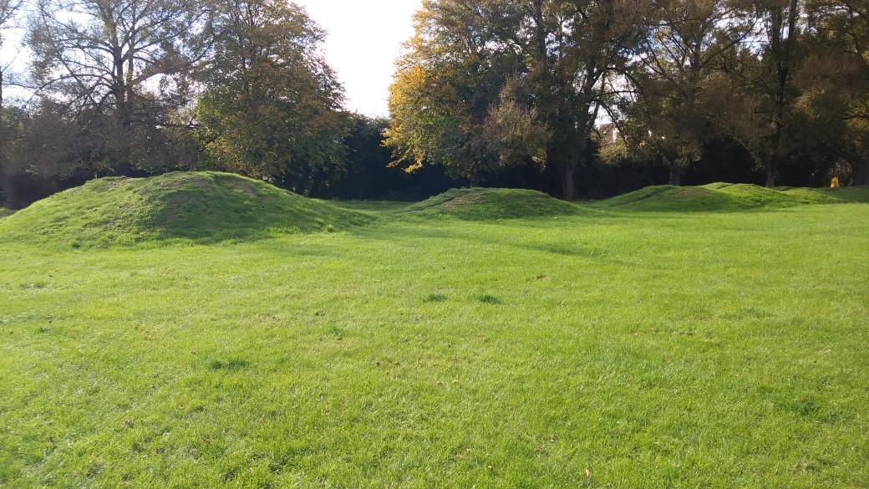

Photograph 4/4
