THE ROYAL BOROUGH OF KENSINGTON
AND CHELSEA

CONTRACT FOR UK PROPERTY MANAGEMENT SERVICES FOR THE
ROYAL BOROUGH OF KENSINGTON AND CHELSEA PENSION FUND

INSTRUCTIONS TO TENDERERS

1. INTRODUCTION

The Royal Borough of Kensington and Chelsea Pension Fund the (‘Pension Fund’) operating under the Local Government Pension Scheme (Management and Investment of Funds) Regulations 2016 (SI 2016/946) is seeking to increase its allocation to UK property investments from the current level of around 5% to around 20%, through a bespoke segregated property portfolio. This Invitation to Tender invites proposals from parties with the capability to help the Pension Fund build and maintain a direct property portfolio and/or to provide on-going management services for the portfolio, including to:

• Advise on property acquisitions and disposals;

• Execute acquisitions and disposals, including contract negotiations and executions;

• Manage interacting with tenants and property management, including rent roll;

• Advise the Investment Committee on strategy; and

• Consider and implement structures to hold assets.

.
  - In this document, the words ‘We’ and ‘Us’ mean the Council which is acting as the contracting authority.
  - The word ‘You’ means the organisation on whose behalf the Tender is being submitted. The word ‘Your’ should be construed accordingly.

1.3 Unless otherwise indicated, the meanings of all other words and expressions that begin with an initial capital letter are set out in the Conditions of Contract.

1.4 This document explains:
- what you have to do to make a bid
- what rules the Council will apply to the competition
- how your bid will be evaluated
- what We want to buy (‘the Specification’) and
- the terms and conditions that will apply to the Contract.

1.5 The Contract Period has no Fixed Term and the Council expects it to subsist for a number of years. However, tenderers should note that there are provisions in the Conditions of Contract which permit the Council to determine the Contract in certain circumstances.

1.6 The Council requires tenderers to submit offers for all the Services to be provided under the Contract. Tenderers may, however, submit offers as Group. Please refer to the guidance contained in the separate document entitled “Tendering as a Group” that is included in the Attachments area on capitalEsourcing. The guidance explains the rules concerning reliance on group members.

1.7 The Council is happy to receive tenders from companies with relatively low levels of AUA/AUM and with a relatively short track record provided the individuals assigned to this Contract have demonstrable expertise and a track record of success.

2. PROVISIONAL PROCUREMENT timetable

This is the provisional timetable:

Activity | Date (and Time)
Publish Contract Notices inviting Tenders | 21 January 2019
Closing date for submission of Tenderers’ clarification questions | 18 February 2019
Closing date for receipt of Tenders | 25 Feb 2019 12:00
Evaluation of Tenders by the Pension Fund and Discussions held with the Committee | w/c 8 April 2019
Adviser Interviews (if required) | n/a
Final Evaluation; Due Diligence; Contract Formation | w/c 15 April 2019
Completion of Governance Procedure | w/c 22 April 2019
Notification of Award of Contract | 29 April 2019
Standstill Period Ends | 9 May 2019
Commencement Date of Contract | 10 May 2019
Transition of Assets | w/c 13 May 2019

3. RIGHT TO VARY OR CANCEL THE PROCUREMENT

3.1 If it is necessary, We have the right to:
- abandon the procurement at any time
- not award the Contract
- ask You to clarify anything that You have sent us
- ask You to provide missing or incomplete information and/or
- amend the terms and conditions of the tendering process, including the timetable.

4. BEFORE SUBMITTING YOUR TENDER

4.1 You must:
- carefully read everything in these Instructions to Tenderers
- understand what you need do to submit a valid Tender
- carry out any research, checks or investigations so that you understand the Specification
- work out what people, plant and equipment you will need to perform the Contract.

4.2 YOUR COSTS AND EXPENSES

4.2.1 You must bear all costs, expenses and liabilities in connection with Your Tender. Under no circumstances will the Council contribute to Your costs, even if we abandon the procurement for any reason.

4.3 QUESTIONS AND FURTHER INFORMATION

4.3.1 If You have any questions about this procurement, You must submit them via the capitalEsourcing Portal. The last date for questions is stated in the timetable in clause 2.

4.3.2 Your queries will be secure and cannot be seen by other Tenderers. We will publish all questions and answers in a way that protects the identity of the person who asked the question.

5. RESPONSE ENVELOPES AND THE TENDER

5.1 In the ITT on capitalEsourcing, there are three electronic ‘Response Envelopes’ that You must complete.

5.2 The Qualification Envelope – this contains:

5.2.1 Form of Tender, Bona Fide Tendering and Anti-Collusion Certificate and FOIA Schedule of Confidential Information

The Form of Tender and Anti-Collusion Certificate and, if applicable, the FOIA Schedule of Confidential Information should be completed (see paragraph 11.1 for further information).

5.2.2 The Qualification Envelope also contains a number of questions that require you to make declarations and affirmations.

5.3 The Technical Envelope – You must submit responses to the questions and requests for information in the Technical Envelope. The questions relate to the Award Criteria.

5.4 The Commercial Envelope – You must submit responses to the questions asked about fees.

5.5 Conditions of Contract

You are invited to submit the terms and conditions under which You propose to perform the Contract. However, We have set out some stipulations concerning indemnity and termination in the Procurement Documents which you must address in Your response.

6. RETURN OF TENDERS
6.1 You must provide the information requested using the capitalEsourcing Portal by the stated deadline. The Portal is easy to use - but allow yourself enough time to ask for help if you need it.

6.2 We will use only the details that you give Us to contact You. It is Your responsibility to make sure they are up-to-date and accurate. You may not receive important messages if You do not. If You need to change Your contact information, use the Portal to do so.

If You need help with the Portal, contact the capitalEsourcing helpdesk between 8.00am and 6.00pm Monday to Friday on 0800 069 8630 (or +442033496601 if outside the UK) or e-mail help@capitalesourcing.com.) This email address should only be used where there are technical issues with the Portal. Otherwise, all questions and queries relating to this procurement should be submitted via the Portal.

6.3 You MUST submit all of Your Envelope responses via the Portal by the deadline. A pop-up box will appear to tell You that Your responses have been successfully transmitted. You are advised to allow Yourself plenty of time to make Your submissions.

7. REJECTION OF TENDERS

7.1 We have the right to reject Your Tender if:

7.1.1 You do not submit Your Tender in accordance with the instructions in this ITT;

7.1.2 You e-mail or submit the whole or any part of Your responses by any means other than through the Portal;

7.1.3 You submit the whole or any part of Your Responses after the expiry of the deadline;

7.1.4 Your responses are incomplete or specific documents are missing, however We may request the economic operators concerned to submit, supplement, clarify or complete the relevant information or documentation within an appropriate time limit, provided that such requests are made in full compliance with the principles of equal treatment and transparency;

7.1.5 You have qualified your offer by altering any of the documents (e.g. the specification, the terms and conditions, the pricing schedule etc.) or otherwise made your offer conditional;

7.1.6 You choose not to accept the Terms and Conditions of Contract in answer to the relevant question in the Qualification Envelope on capitalEsourcing;

7.1.7 You try to distort the competition by telling other people Your prices (other than for proper reasons) or fixing Your prices with other potential bidders;

7.1.8 You collude with other potential bidders over who should bid and who should not; or

7.1.9 You attempt to bribe or corrupt anyone or seek the help of anyone to improperly influence the outcome.

8. TENDER EVALUATION AND AWARD PROCEDURE

8.1 We will check that You have complied with all the instructions in this ITT and that Your responses to the questions in the Qualification Envelope are satisfactory.

8.2 We may want to clarify some points with You by e-mail or at a meeting.

8.3 We will evaluate Your responses to the Award Criteria as well as the contents of the Commercial Envelope. We may want to take up references.

8.4 We will award the Contract to the bidder that submits ‘the most economically advantageous tender’. This means the tender that offers Us the best value taking into account the technical (quality) score and the commercial (price) offer.

8.5 The main Award Criteria are weighted:
- Technical (Quality) 60%
- Commercial (Price) 40%

8.6 The Quality criteria is made up of several sub-criteria which are set out in Table 2 of Appendix 1. The sub-criteria are also weighted.

8.7 The Marking Scheme that We will apply to scoring the quality criteria is set out in Table 3 in Appendix 4. The method of commercial evaluation is set out in paragraph 3 of Appendix 1.

8.8 We have the right to not award the Contract to anyone if We feel that it is not in Our interests to do so.

9. ACCEPTANCE OF TENDER

9.1 We will let all bidders know the outcome as soon as possible. Regulation 85 of the Public Contracts Regulation applies to this procurement and the Council will observe a Standstill Period before awarding the Contract. Until the execution of the formal Contract, Our Acceptance Letter to the winning bidder shall form a binding agreement between us on the terms set out in the procurement documents. The formal Contract will be signed or sealed by both parties.

10. TRANSFER OF UNDERTAKINGS (PROTECTION OF EMPLOYMENT) REGULATIONS (TUPE)

10.1 We do not believe that the TUPE Regulations (as amended) apply to this Contract.

11. FREEDOM OF INFORMATION ACT 2000 (FOIA)

11.1 We must comply with FOIA and the Environmental Regulations 2004. You must state in the FOIA Schedule of Confidential Information in the Qualification Envelope what (if any) information You want Us to treat as commercially sensitive. If We are requested to disclose any of that information, We will try to consult You first but must, in all circumstances, comply with the law.

12. TENDERER’S WARRANTIES

12.1 In submitting a Tender, You promise that:

12.1.1 You have carried out Your own investigations and research into the requirements of the Contract and have not simply relied upon what We have said;

12.1.2 You have not done any of the things listed in paragraph 7 that would give Us a reason to reject Your Tender;

12.1.2 Everything that You have told us in Your responses is true;

12.1.3 You will tell Us if anything of significance that You have told Us changes or ceases to be true;

12.1.4 You have full power to enter into the Contract and perform the Services and have made sure that You have the working capital, staff and equipment to perform the Contract during the Contract Period.

Appendix 1 of the Instructions to Tenderers

TENDER EVALUATION AND AWARD CRITERIA
1.1 We will award the Contract to the most economically advantageous Tender based on a combination of price and quality. This section is provided in the interests of transparency and fair competition and sets out and explains how that evaluation will be carried out.
- Stage 1 – Compliance – Qualification Envelope

Each Tender must achieve a minimum level of acceptability as defined by the compliance standards set out in Table 1 below. We reserve the right to reject without further discussion any Tender which does not meet the compliance standards.

TABLE 1

Compliance Standard | Rationale
Compliant and bona fide Tender | Each Tender shall be checked to ensure that there is no material breach of the Instructions to Tenderers; that the Tender is complete; that there is no collusion or corruption or anti-competitive behaviour; and that all required information is provided.
Legal Acceptability | Each Tender shall be checked to ensure that there is no legal impediment to the Council entering a contract with the successful Tenderer.
Complete Tender | Each Tender shall be assessed as to whether the Tenderer has confirmed that it is able to provide the Services as detailed within the Specification.
Minimum Standards | Tenderers must meet the minimum standards set out in the Qualification Envelope in terms of:  - Economic and Financial Standing  - Insurance Requirements  - Professional and Technical Ability

The Authority’s Minimum Standard for Economic and Financial Standing

1.2 Whenever possible, We will use CreditSafe to obtain financial reports and accounts appertaining to Candidates and use it to verify that you satisfy the standard below.

If the reports obtainable from CreditSafe do not provide us with reasonable assurance that You are financially sound and have the economic resources to perform the Contract, we may ask you to provide additional information. We reserve the right to disqualify You if we are not satisfied that you meet the standard set out below.

1.3 You must affirm that you meet the standard for economic and financial standing set out in the ITT:

You must demonstrate that You are financially sound and have sufficient economic resources to perform the contract. Relevant factors include Your annual turnover, liquidity, gearing and cash flow.

1.4 If You are intending to submit an offer as part of a group, please refer to the guidance contained in the separate document entitled “Tendering as a Group” that is included in the Attachments area on capitalEsourcing. The guidance explains the rules concerning reliance on group members.

The Authority’s Minimum Standard for Insurance

1.5 The Council will require the winning bidder to provide evidence that it has not less than £10m of Employers’ Liability Insurance and not less than £10m of Public Liability Insurance and not less than £25m of Professional Indemnity Insurance and that you have not less than £5m of Cyber Liability cover.

- Stage 2 - Award Criteria

2.1 Technical (Quality) Award Criteria

The Technical (Quality) Award are set out in the Technical Envelope.

Table 2

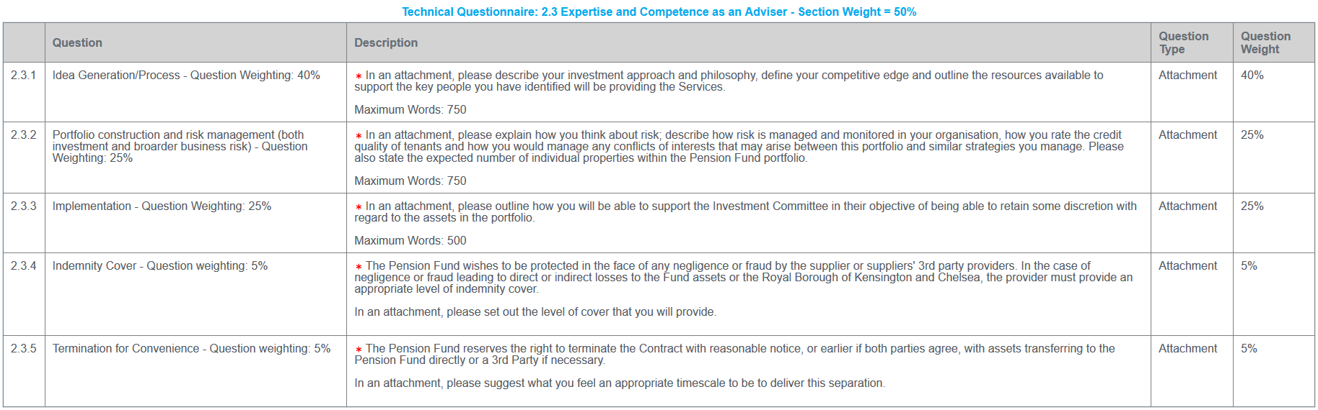
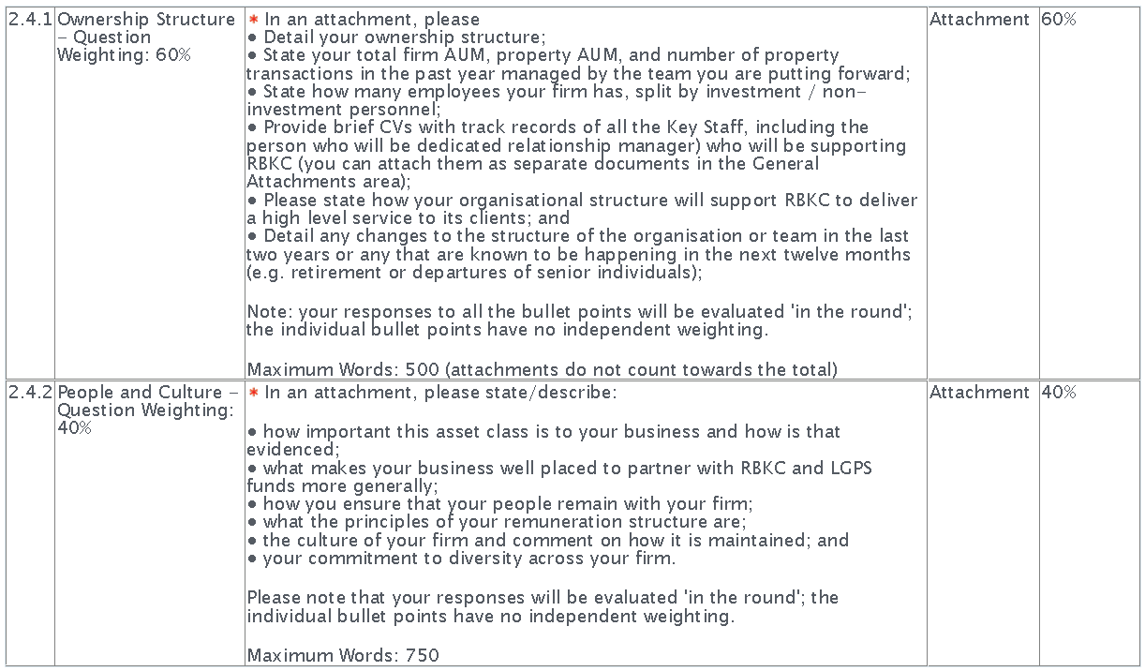
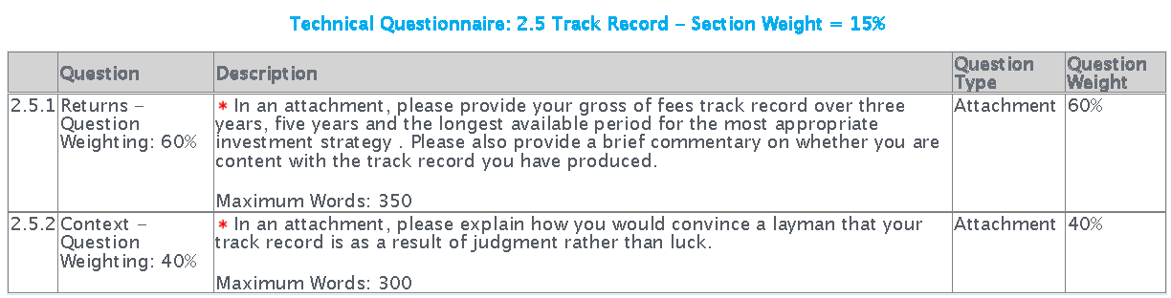
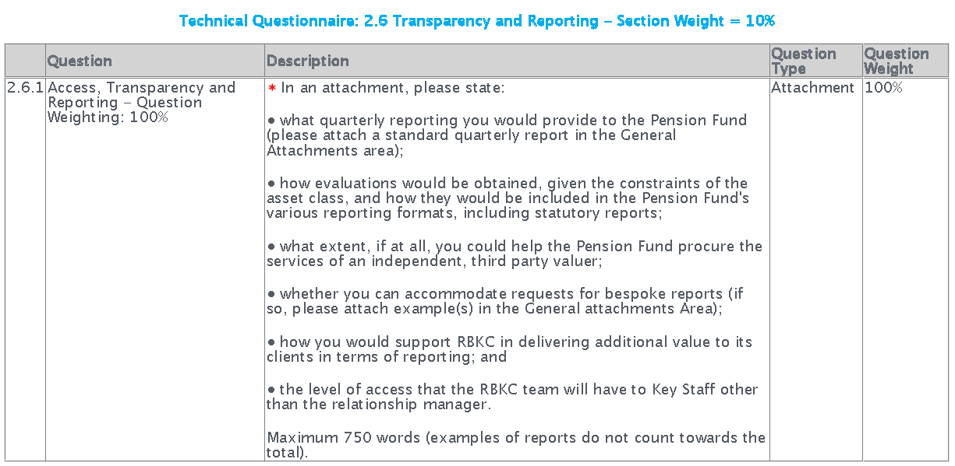

2.2 Technical (Quality): 60% Weighting
2.2.1 Quality will be assessed on the basis of Your written submissions in the Technical Envelope to the Award criteria as set out above by individual members of the evaluation panel.

2.2.2 The information will not initially be shared between members of the panel. Each award criterion has a sub-weighting to ensure that its relative importance is reflected in the overall scores.

2.2.3 The marking scheme, set out in Appendix 2 below, shows the possible scores that may be given and the general principles and descriptions that panel members will have regard to. When considering Your Submission.

2.2.4 If Your consensus score for any criterion is less than 2 out of 5, Your Tender will not be considered further and will be rejected.

2.2.5 Each score for a response to an award criterion will be multiplied by the relevant sub- weighting to arrive at a weighted score. Weighted scores will be added together to produce a total score out of 100. The overall quality weighting of 60% will then be applied.

2.3 PRICE: Weighting 40%
2.3.1 The Commercial Envelope in capitalEsourcing requires You to provide an overall fee assuming a 15 year holding period. You are also required to provide an annual breakdown of the fee together with an explanation of it. Prices must include all costs that may properly be included except VAT.
2.3.2 The Pension Fund will welcome innovative fee structures with a clear alignment of interests. However, the Fund will not consider fees expressed as a percentage of the value of the portfolio for on-going advice or management. An acceptable structure could be, for example, a sourcing fee for the establishment of the initial portfolio followed by an annual advice and management fee. In your response, please differentiate between acquisition/disposal, ongoing advice and ongoing management.
2.3.4 Reflecting the above, price will be scored by considering the total applicable fee over a fifteen-year holding period.
2.3.5 The Authority will not pay costs that were not included in the Commercial Envelope of the Tenderer submitting the offer that the Authority accepts (except VAT).

2.3.6 The lowest price will automatically be awarded full marks (40%) unless the Authority believes that it is an abnormally low tender. Thereafter each other quotation is compared against the lowest priced quotation in accordance with the following formula:

(A÷B) x C = X

Where:

A = the lowest total price submitted

B = the total price submitted by supplier

C = the maximum percentage score i.e. 40%

X = the score for Price

2.3.7 Tenderer’s weighted Technical (Quality) score will be added to their weighted price score to produce a total.

2.3.8 The highest total score (representing the most economically advantageous offer) will determine which offer provides best value.

2.3.9 The chosen supplier will be awarded the contract subject to verification that their solution satisfies all the Essential Requirements set out in the Technical (Quality) Envelope and their responses to the questions in the Qualification Envelope are satisfactory.

12 Acceptance Of quotation

12.1 Any acceptance by the Authority of a Tender shall be notified to the successful supplier in writing by the Authority following the end of the statutory standstill period.

Appendix 2 of the Instructions to Tenderers

TABLE 3: Marking Scheme for the Technical (Quality) Award Criteria

Score | Rating | Criteria for Awarding Score
0 | Unacceptable | The information is omitted/no details provided, or irrelevant answer provided.
1 | Poor | The Authority has serious reservations that the Candidate understands the requirement in the question. The proposal provides very limited evidence and assurance that the relevant aspect of the service would be delivered to the expected standard and there are serious doubts about aspects of the response.
2 | Fair | The submission is superficial and generic in its scope. The Authority has some reservations that the Candidate understands the requirement in the question. The proposal provides some limited evidence and assurance that the relevant aspect of the service or requirement would be delivered to a satisfactory standard.
3 | Satisfactory | The Authority is reasonably confident that the Candidate understands the requirement in the question and the proposal provides some satisfactory evidence and assurance that the relevant aspect of the service or requirement would be delivered to a satisfactory standard.
4 | Good | The submission is robust and well documented. The Authority is confident that the Candidate understands the requirement in the question and the proposal provides good evidence and assurance that the relevant aspect of the service or requirement would be delivered to a good standard.
5 | Excellent | The proposal is innovative and adds value. The Authority is completely confident that the Candidate understands the requirement in the question and the proposal provides very good evidence and assurance that the relevant aspects of the service or requirement would be delivered to an excellent standard.

Please Note: If you are awarded a consensus score of less than 2 for any of the Award criteria, your Tender will be rejected

